### Lab Description

The purpose of this lab is to use the real dataset from the U.S. Small Business Administration (SBA) to predict the risk level of small business loan and the SBA approval amount based on the loan condition and gross approval amount, in order to support the decision to approve the new loan.

Our goal is to ingest SBA loan data to Azure Synapse data platform and train ML model based on the SBA loan history data and then build a data engineering pipeline which can further process the prediction of loan risk for one or many new loan requests coming in as either API or Batch requests.

In the lab, we will first deploy the Azure storage (blob and data lake), Azure Synapse Analytics and Azure Machine Learning service platforms, and then build data pipeline to ingest SBA loan history data to Azure Data Lake, execute data clean, transform and run initial data analysis on Synapse and Power BI. After that, we will use Azure Machine Learning Studio to train the SBA history data, evaluate the ML models result and then deploy the ML models to be used for predicting the risk and SBA amount of new loan requests coming either via real time API or batch requests. Finally, we will save the prediction result to the Azure Blob Storage, so you can either download the file or use Power BI to run further analysis and integrate the result to the dashboard.

Here is the system architecture to be built:

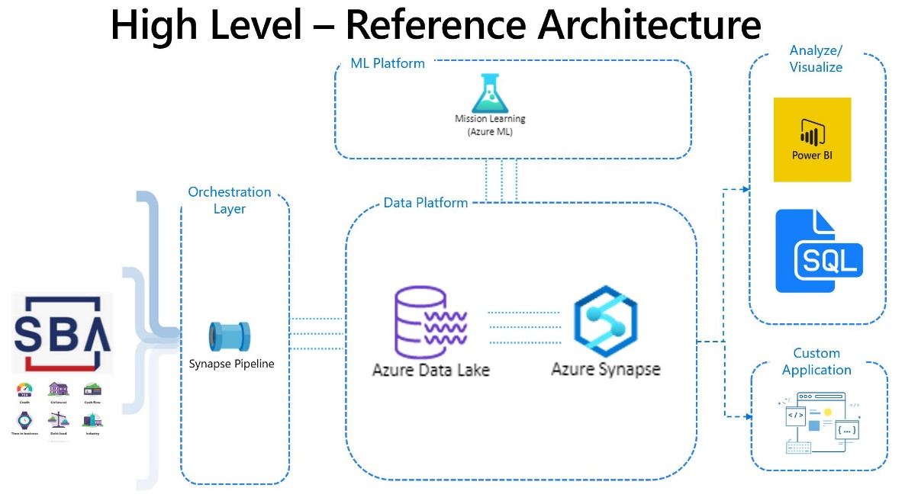

Below is the SBA history dataset variables and description: (file: SBAnational2.csv in sample data folder)

|  |  |  |
| --- | --- | --- |
| **Variable name** | **Data type** | **Description of variable** |
| LoanNr_ChkDgt | Text | Identifier – Primary key |
| Name | Text | Borrower name |
| City | Text | Borrower city |
| State | Text | Borrower state |
| Zip | Text | Borrower zip code |
| Bank | Text | Bank name |
| BankState | Text | Bank state |
| NAICS | Text | North American industry classification system code |
| ApprovalDate | Date/Time | Date SBA commitment issued |
| ApprovalFY | Text | Fiscal year of commitment |
| Term | Number | Loan term in months |
| NoEmp | Number | Number of business employees |
| NewExist | Text | 1 D Existing business, 2 D New business |
| CreateJob | Number | Number of jobs created |
| RetainedJob | Number | Number of jobs retained |
| FranchiseCode | Text | Franchise code, (00000 or 00001) D No franchise |
| UrbanRural | Text | 1 D Urban, 2 D rural, 0 D undefined |
| RevLineCr | Text | Revolving line of credit: Y D Yes, N D No |
| LowDoc | Text | LowDoc Loan Program: Y D Yes, N D No |
| ChgOffDate | Date/Time | The date when a loan is declared to be in default |
| DisbursementDate | Date/Time | Disbursement date |
| DisbursementGross | Currency | Amount disbursed |
| BalanceGross | Currency | Gross amount outstanding |
| MIS_Status | Text | Loan status charged off D CHGOFF, Paid in full D PIF |
| ChgOffPrinGr | Currency | Charged-off amount |
| GrAppv | Currency | Gross amount of loan approved by bank |
| SBA_Appv | Currency | SBA’s guaranteed amount of approved loan |

To predict the loan risk, our strategy is to use indicator MIS_Status to evaluate loan risk: (as bank attempts to minimize the risk of charged off and only approve loans that are likely to be paid in full later.)

So we will add column RISK to SBA history table:

* If MIS_Status = PIF(Paid in full), it means loan risk is Low. (Risk = Low)
* If MIS_Status = CHGOFF (Loan status charged off D CHGOFF), it means loan has overdue amount, thus loan risk is High. (Risk = High)

There are a number of variables can be considered as indicators of risk predictors to train the ML model. Such as: Location(State, City..), Industry (based on NAICS code), Gross Disbursement amount, New versus Established Business… which are all considered impact to the loan risk level.

In this example, we will pick following predicators to train the classification ML model:

City,State,Term,NoEmp,NewExist,CreateJob,RetainedJob,FranchiseCode,UrbanRural,RevLineCr,LowDoc,DisbursementGross,GrAppv,SBA_Appv,,Bank,BankState and IndustryCode**.

** We will add columns: IndustryCode and Industry (description) which is based on the first 2 digitals of NAICS number in SBA dataset and NAICS table (File NAICS.csv in sample data folder also provide the description of the first two digits of NAICS code.)

And in order to predict the SBA approval amount (Column: SBA_Appv), we will pick following as the predicators to train the regression ML model:

Term,GrAppv,City,State,Bank,BankState,NoEmp,NewExist,CreateJob,RetainedJob,FranchiseCode,UrbanRural,RevLineCr,LowDoc,DisbursementGross,IndustryCode

You are free to select different variables based on your own idea to train the model and evaluate the results. Or you can choose other ML model on Azure to predict different topics. Furthermore, you can also ingest your own business data to Synapse to start work on your real business problems based on the similar architecture. All the purpose of this Lab is to help you to build the foundation of the big data and machine learning platform on cloud in a codeless way to start your big data journey on Azure.

I hope you enjoy the lab!

### Step 1: Create a blob storage account for SBA Data

Login to Azure platform: <https://portal.azure.com>.

Search on storage account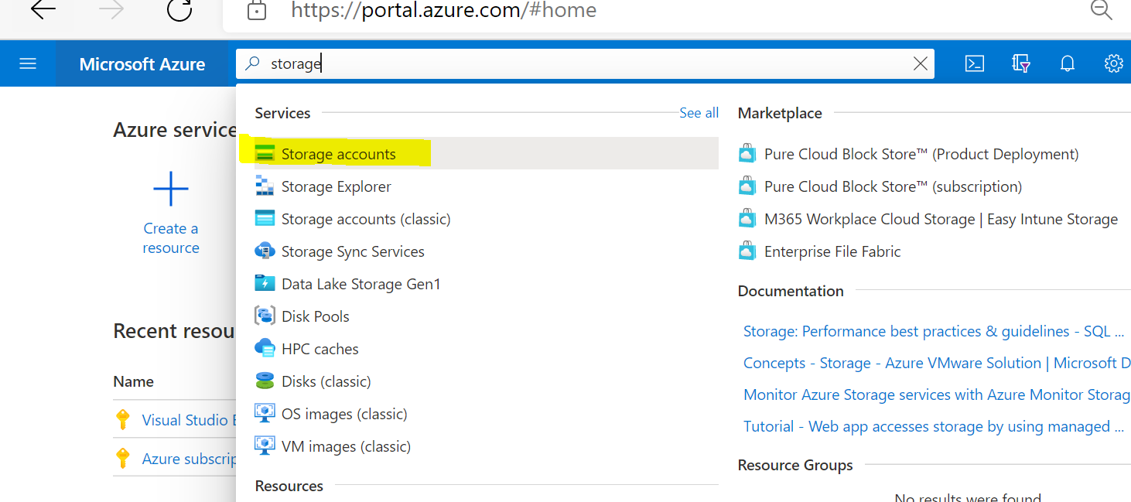

Click to create storage account

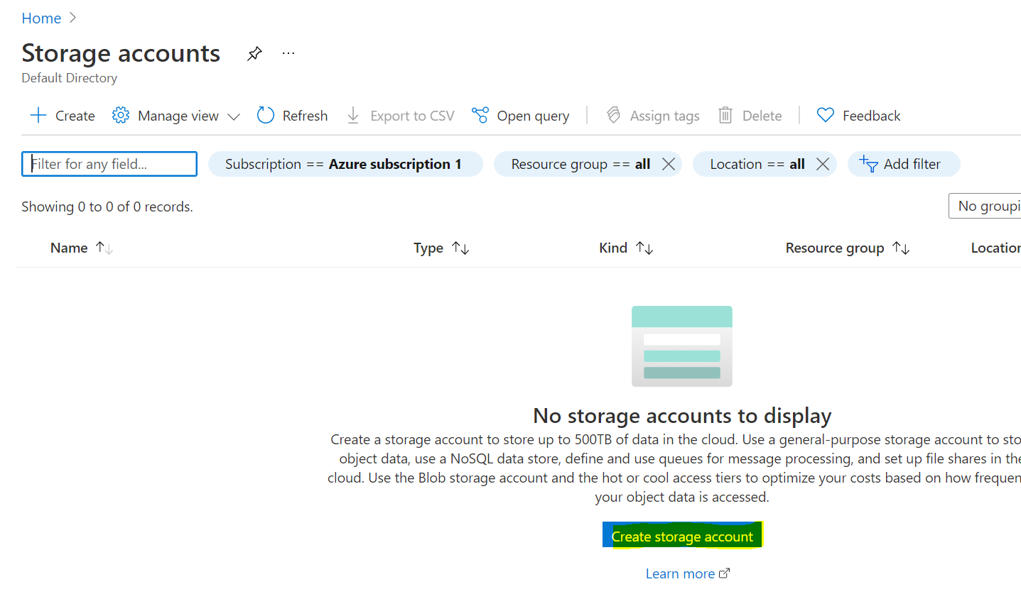

Create a new resource group and use it for all the steps in this lab.

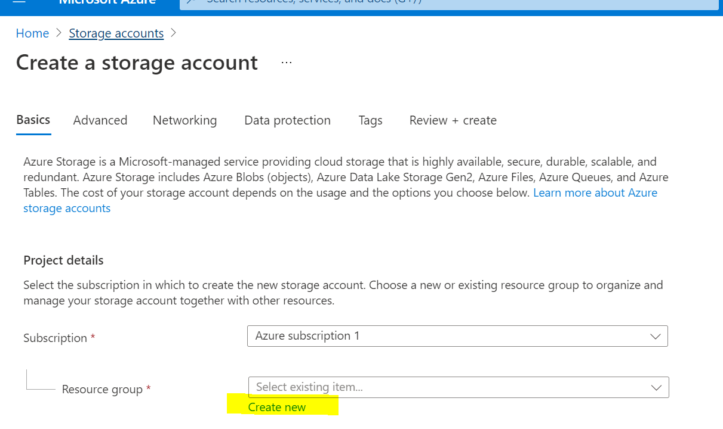

Give the resource group name:

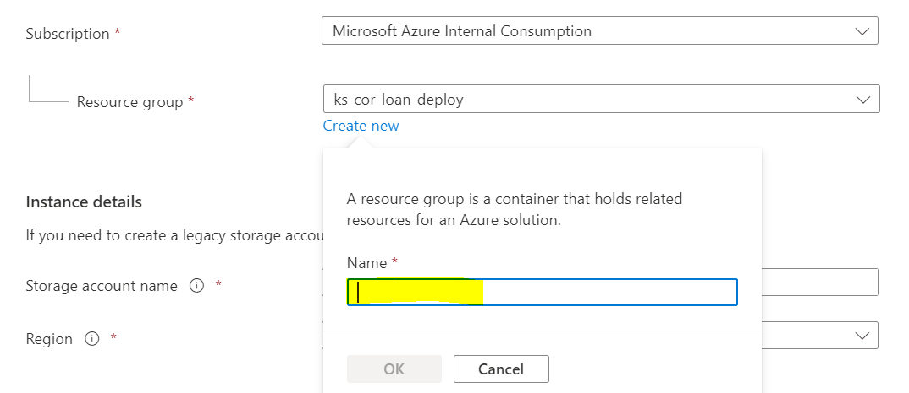

Fill storage account name, pick the Region close to your area, performance as standard, Redundancy as LRS.

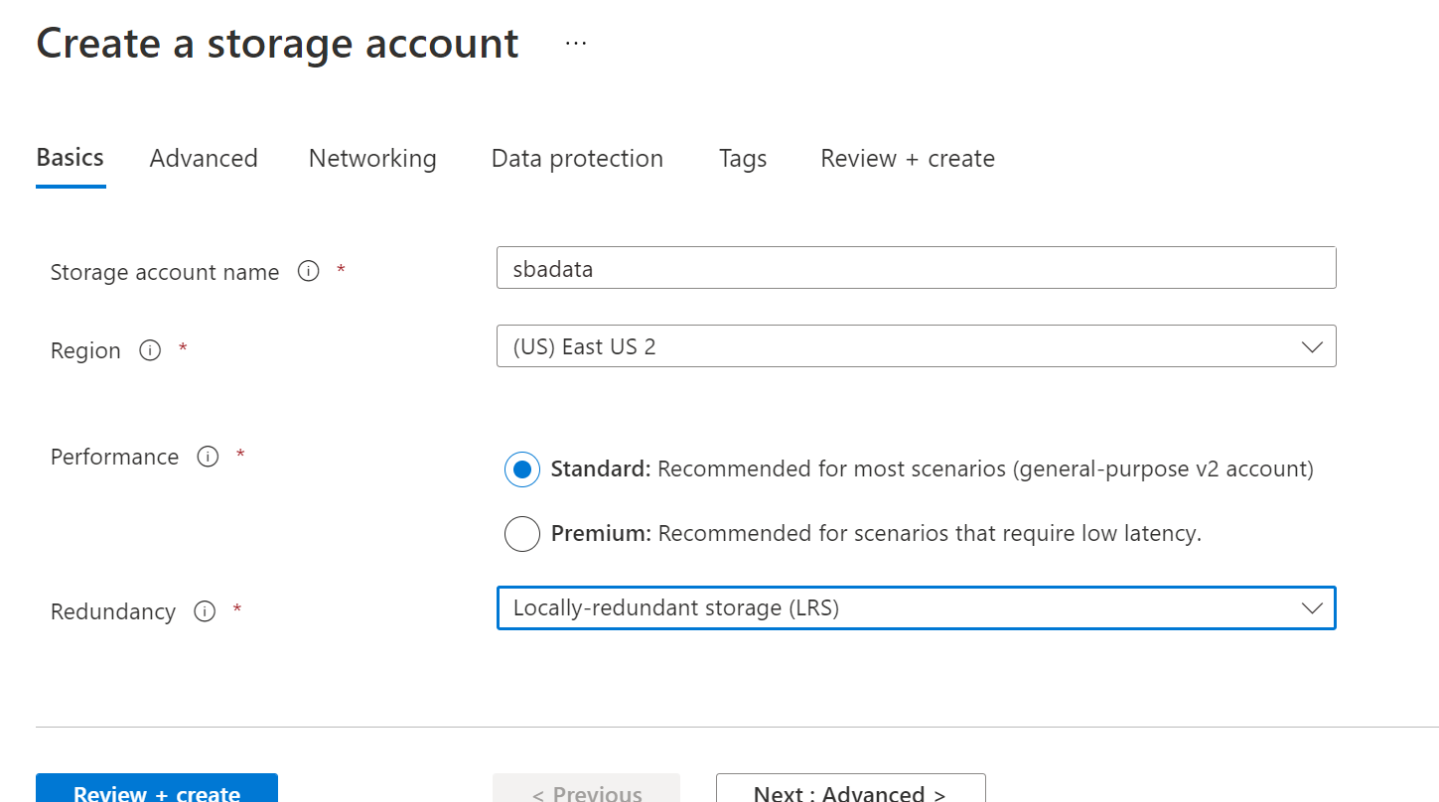

Click Review and Create.

After that, create container: Input folder and Output folder

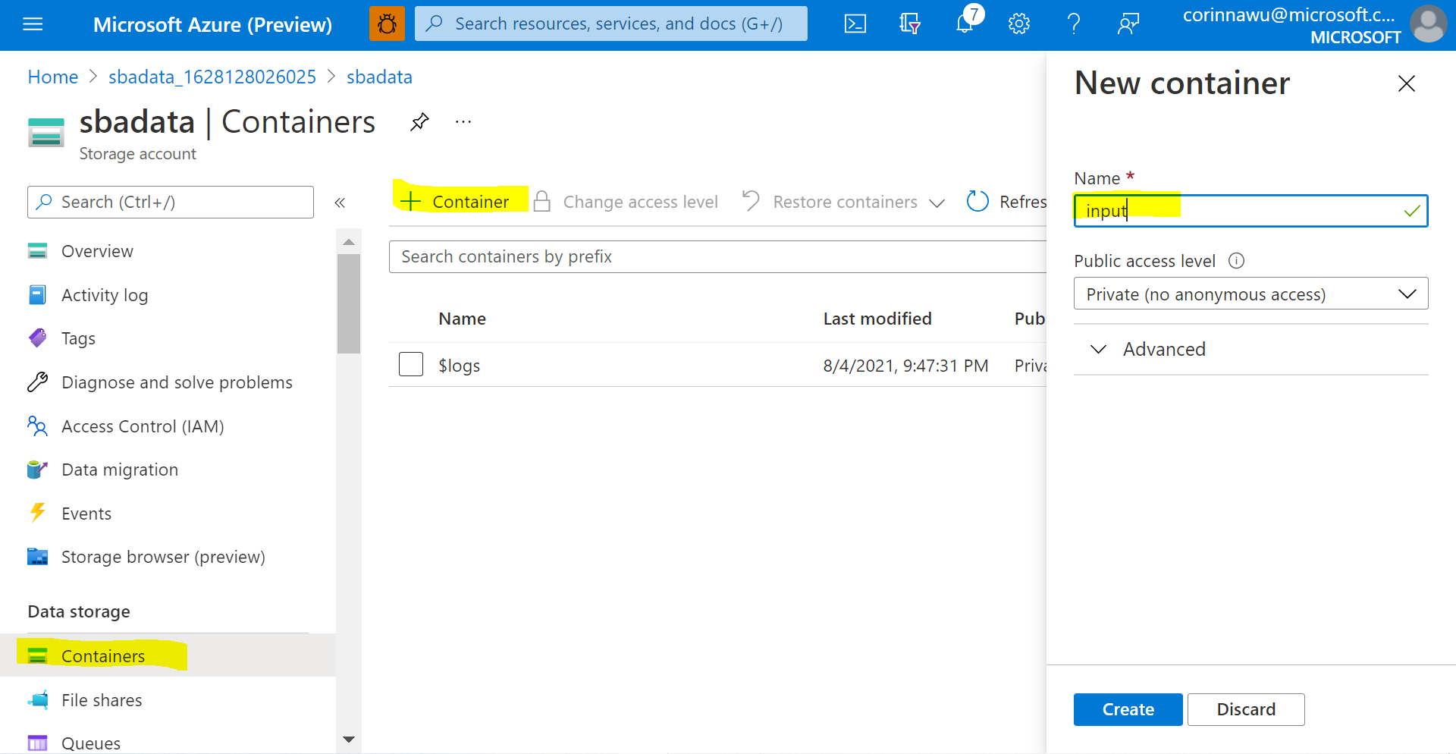

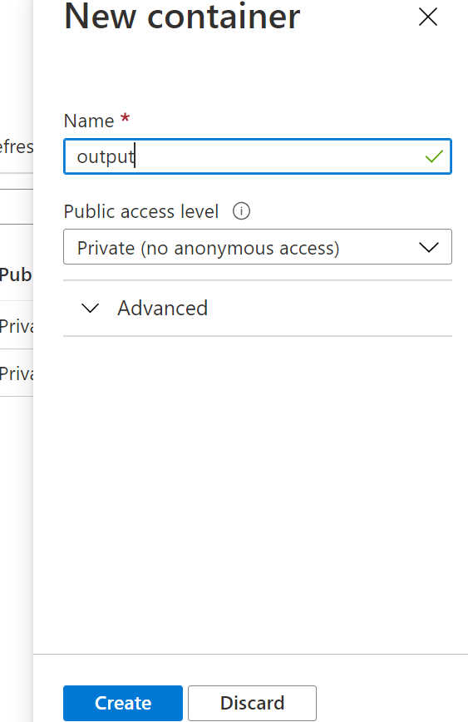

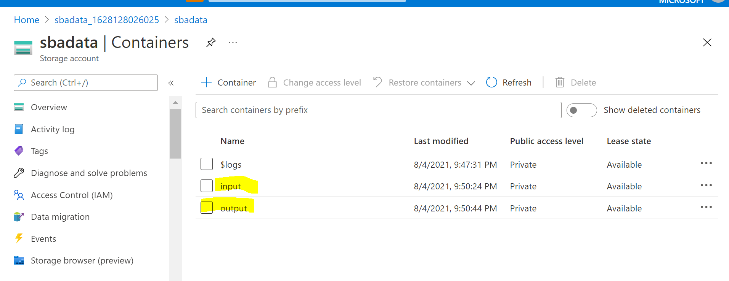

Upload source files: SBAnational2.csv and NAICS.csv to the input folder

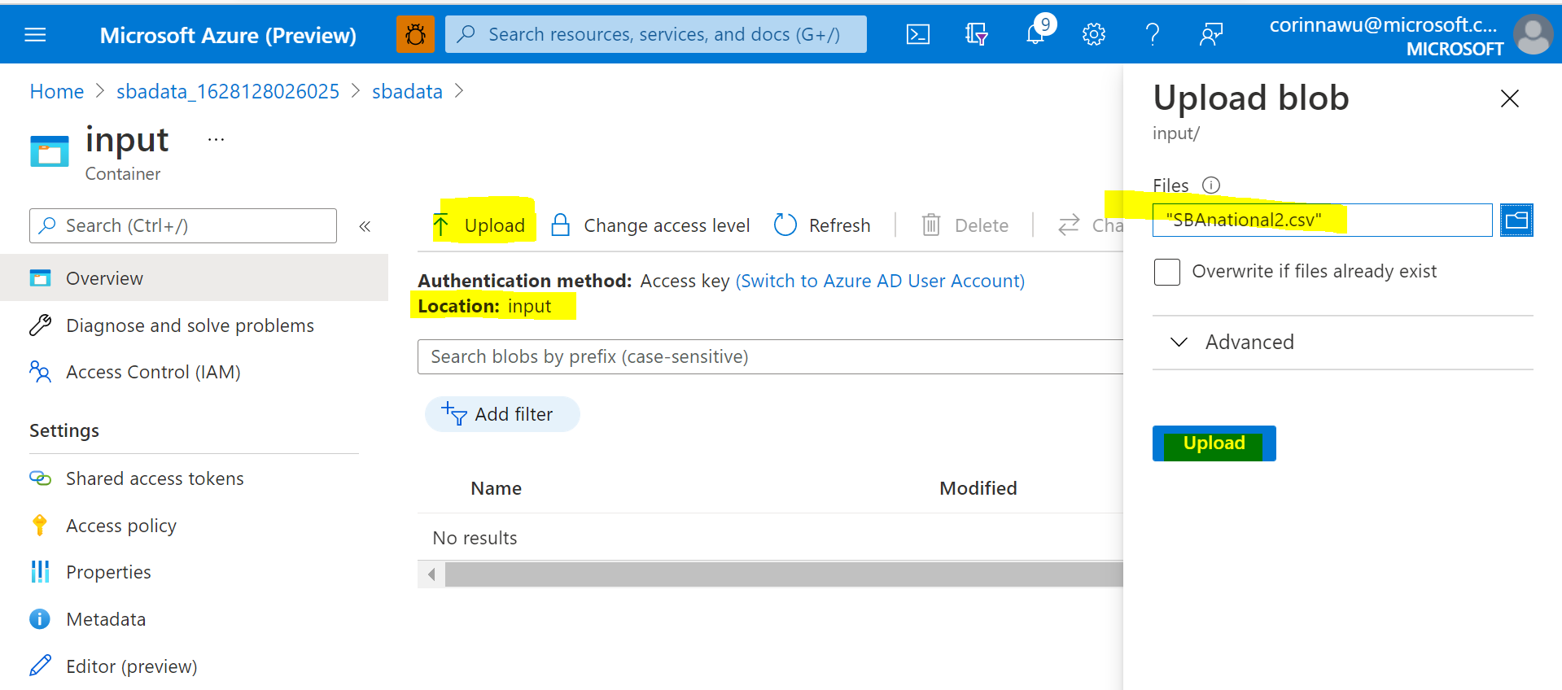

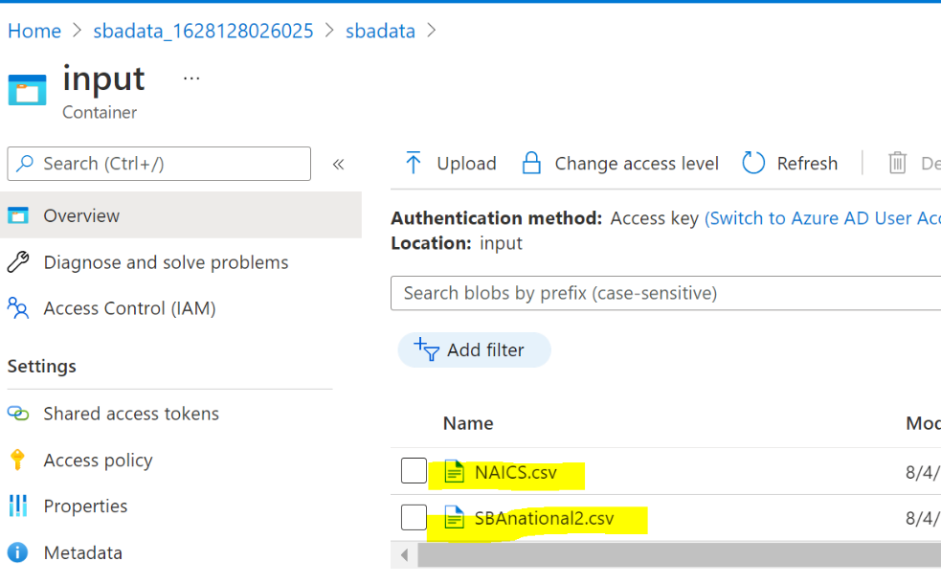

### Step 2: Create Synapse Analytics Workspace

Launch to Azure Synapse Analytics:

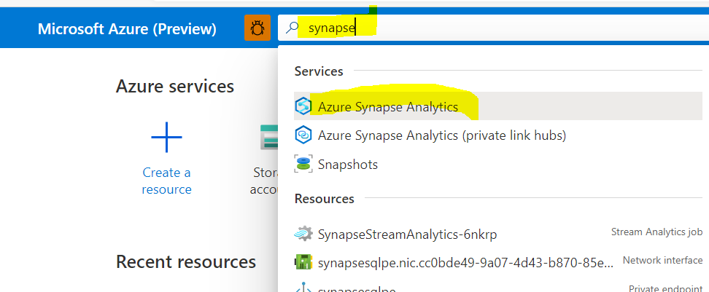

Click Create:

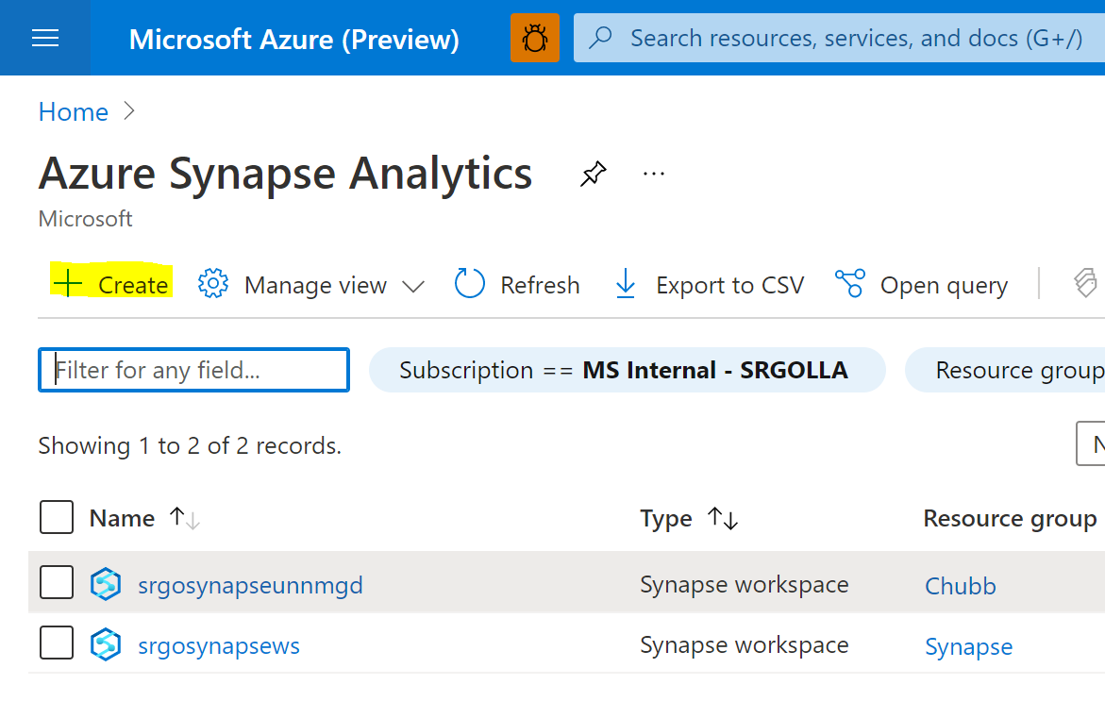

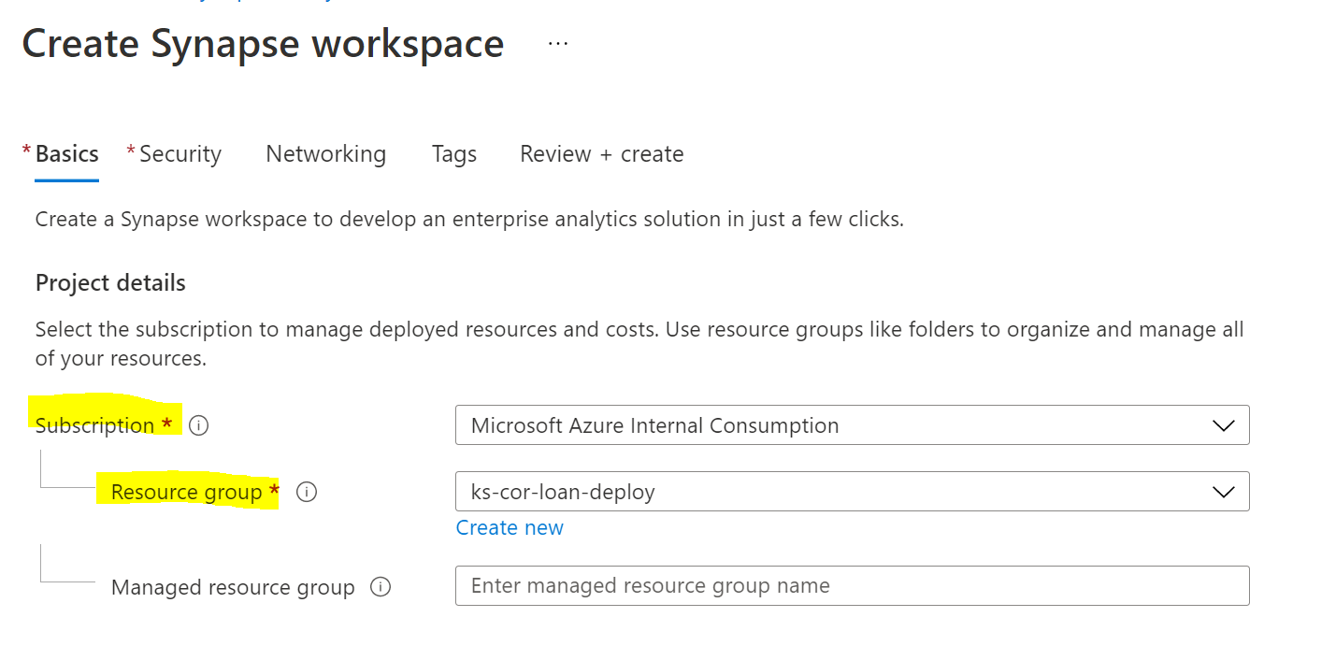

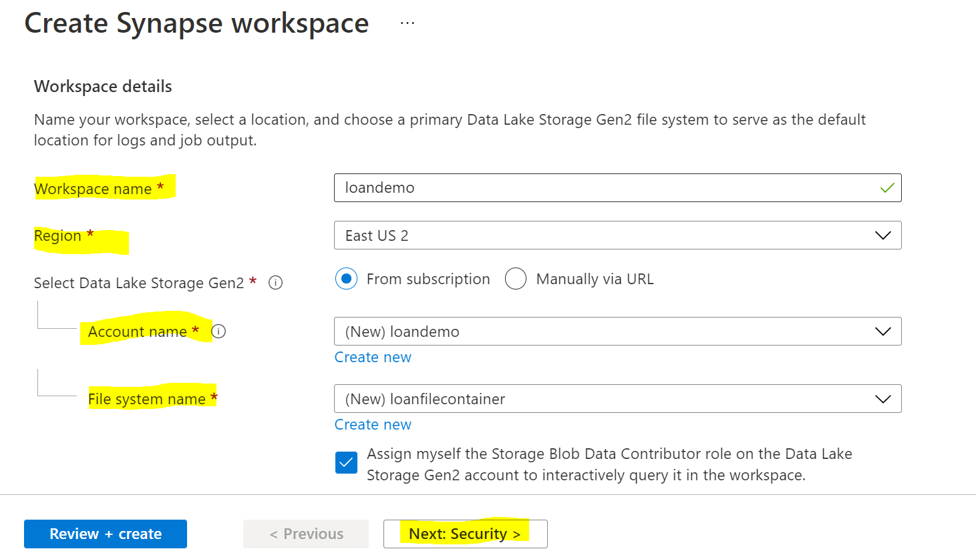

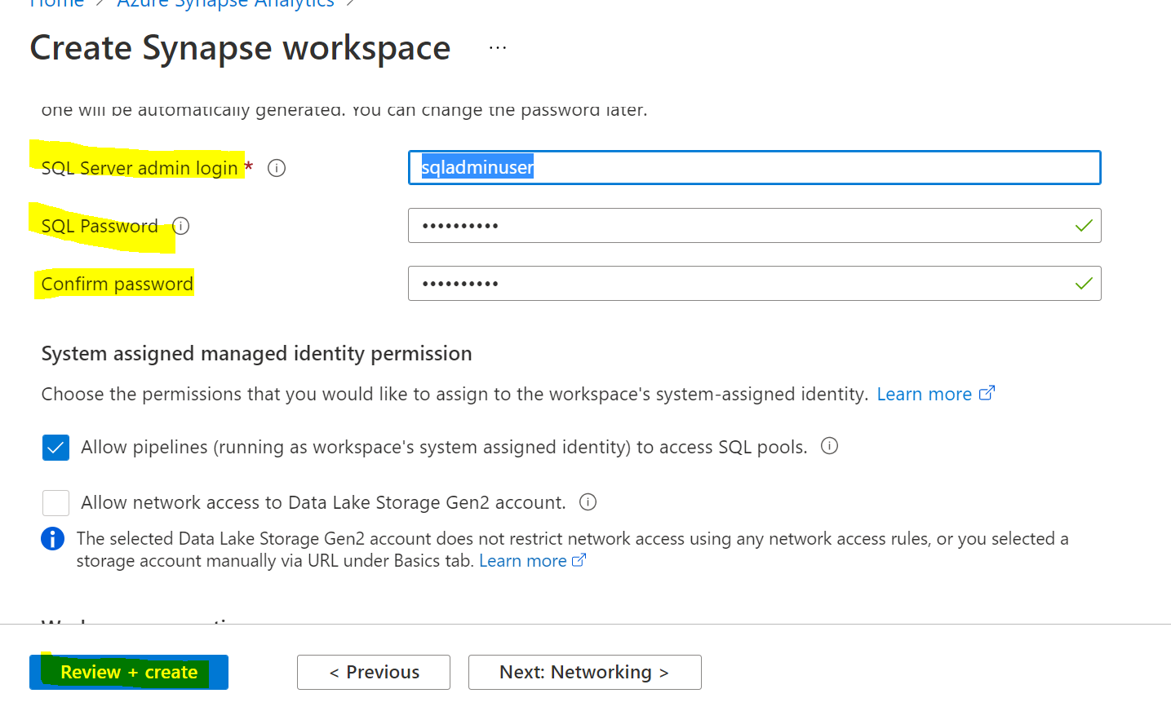

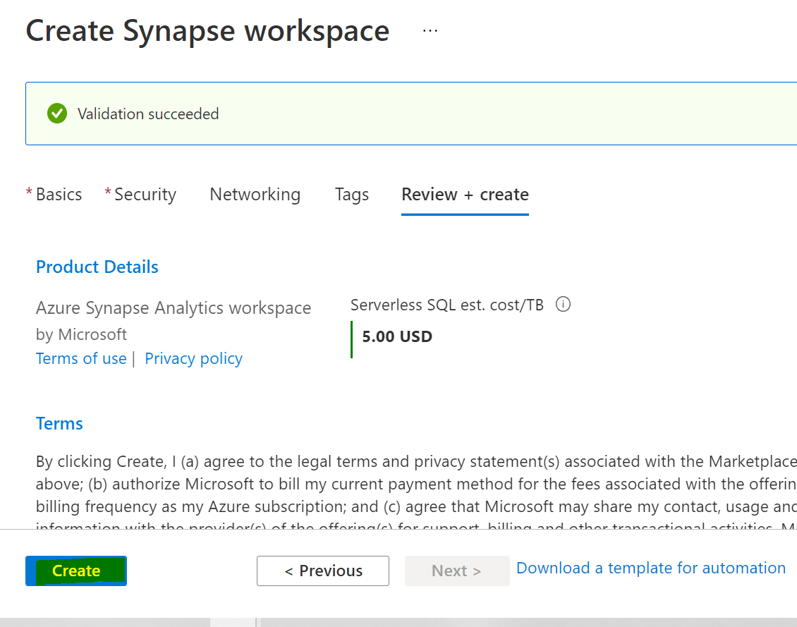

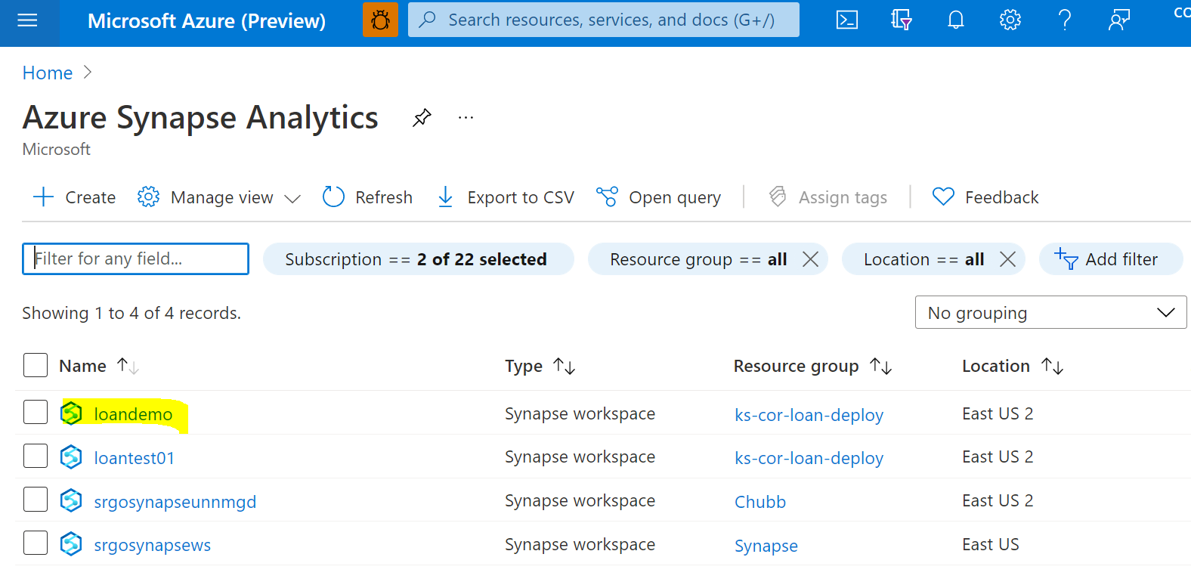

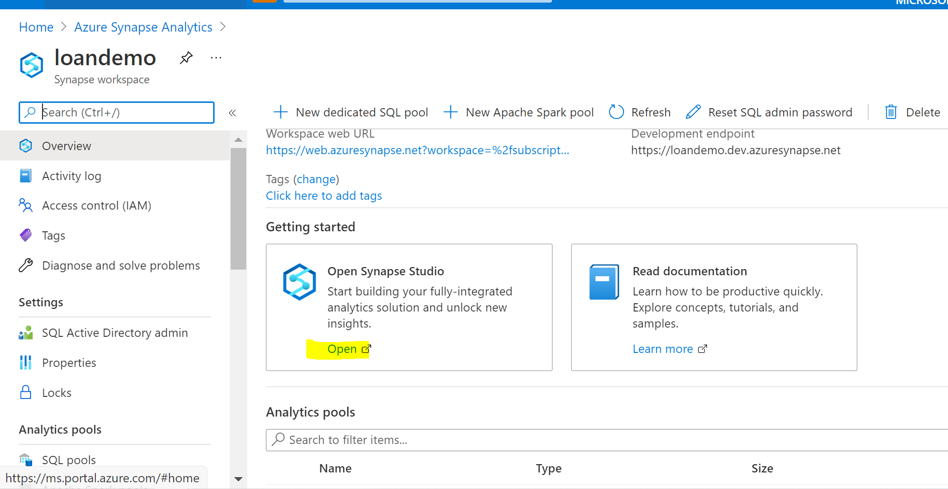

### Step 3: Create dedicated SQL pool

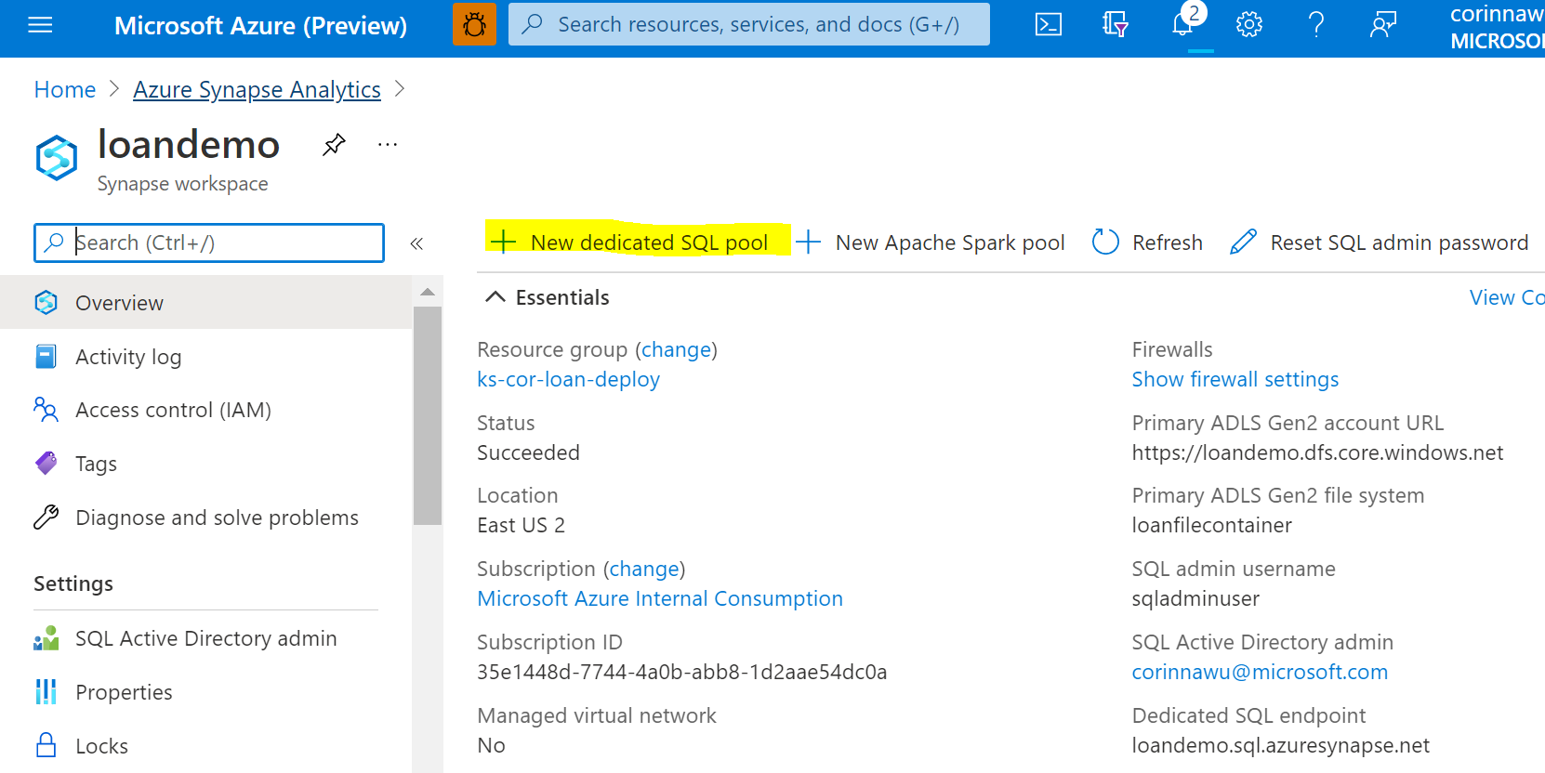

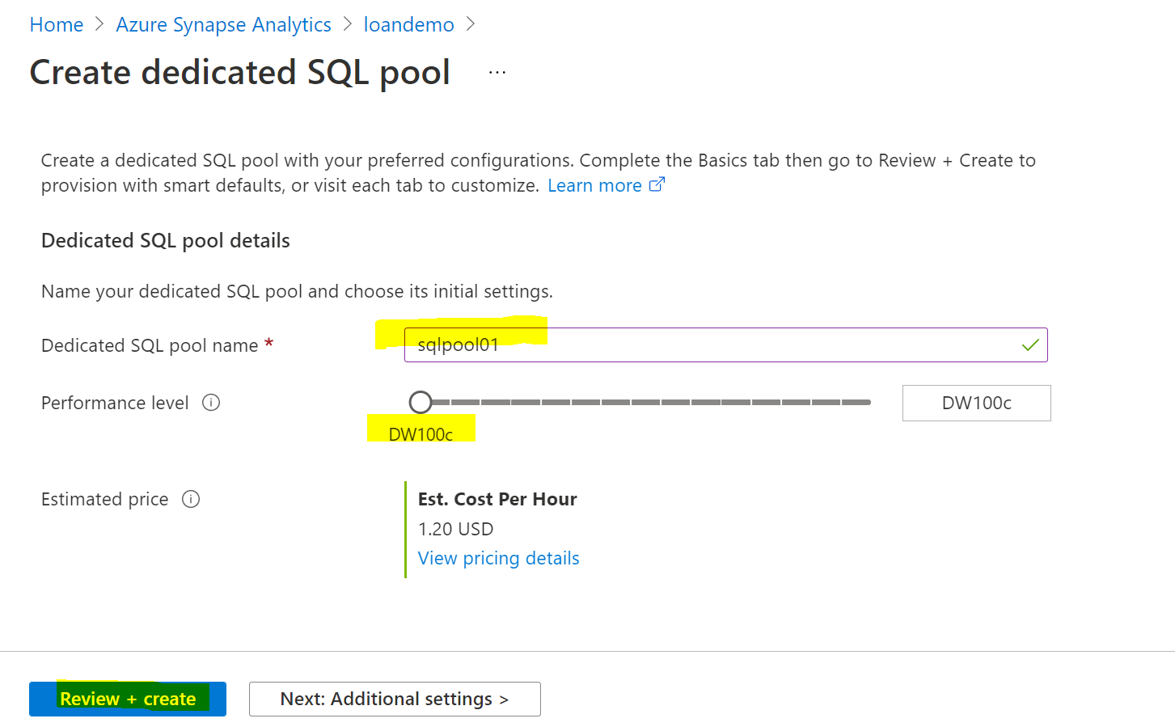

### Step 4: Create Apache Spark Pool

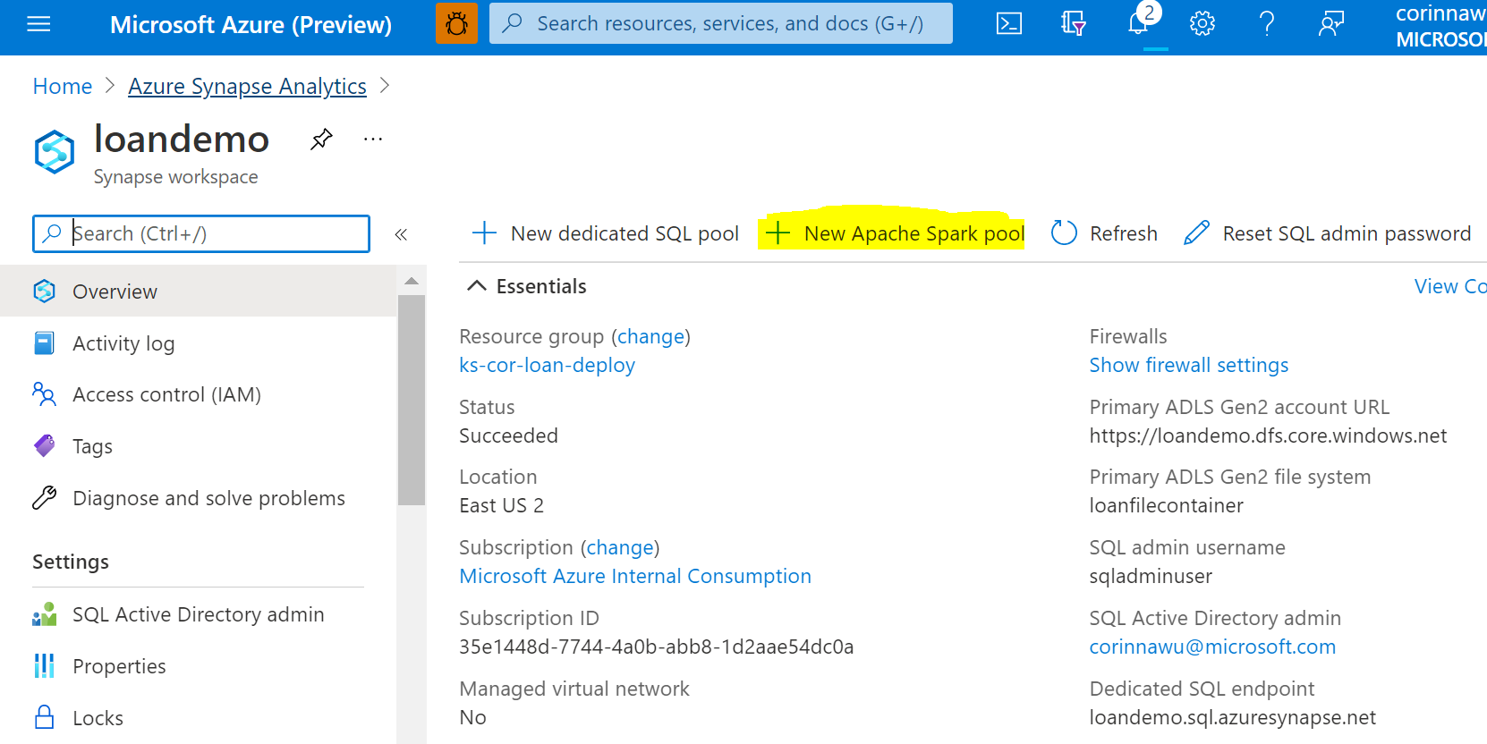

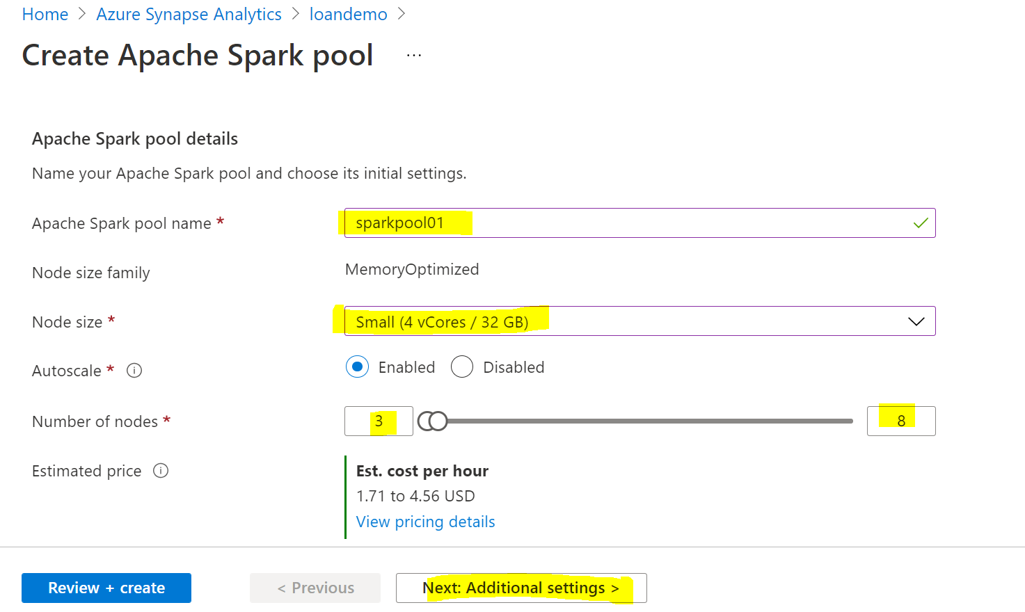

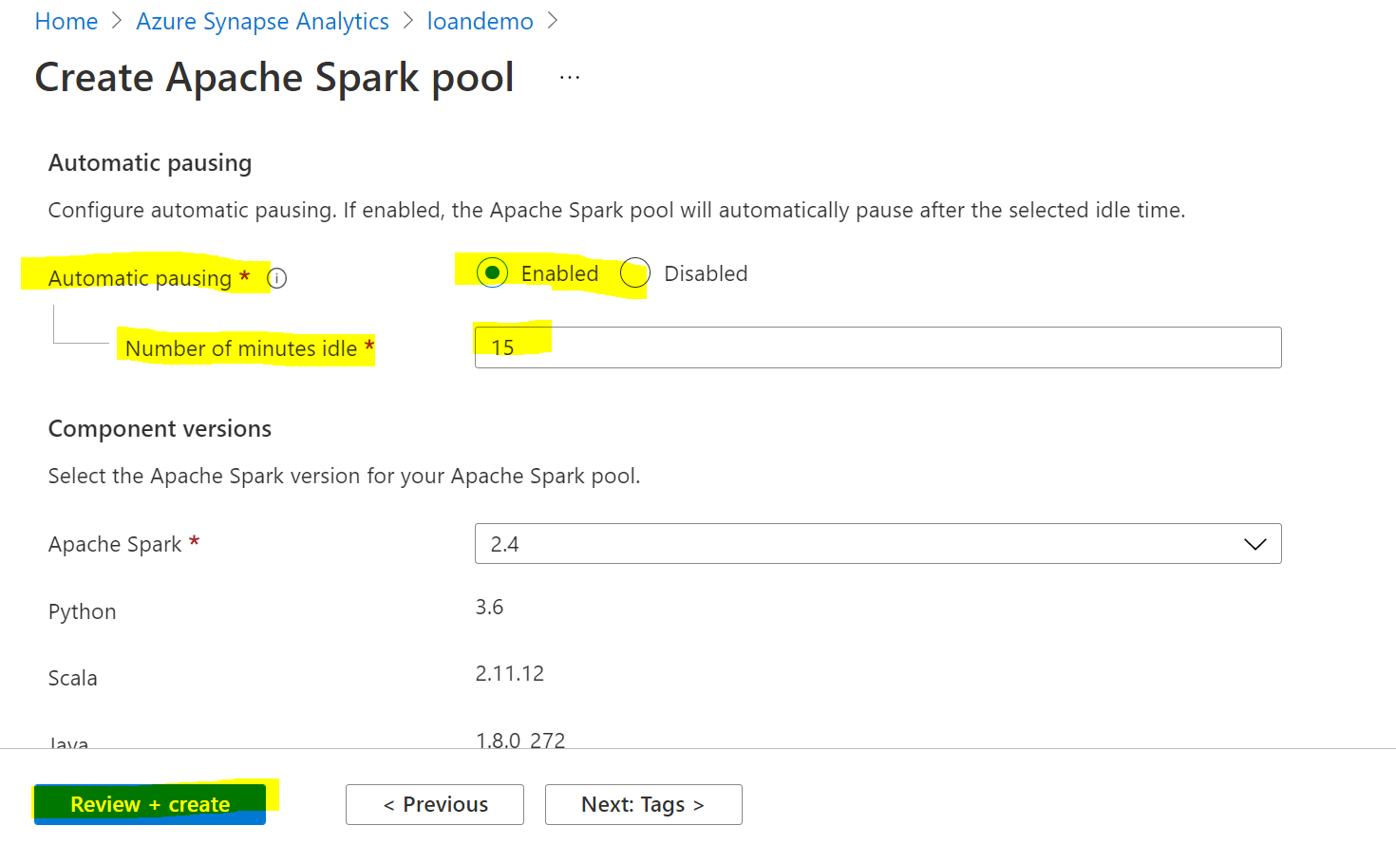

Got to next page and click Create, wait for deployment complete.

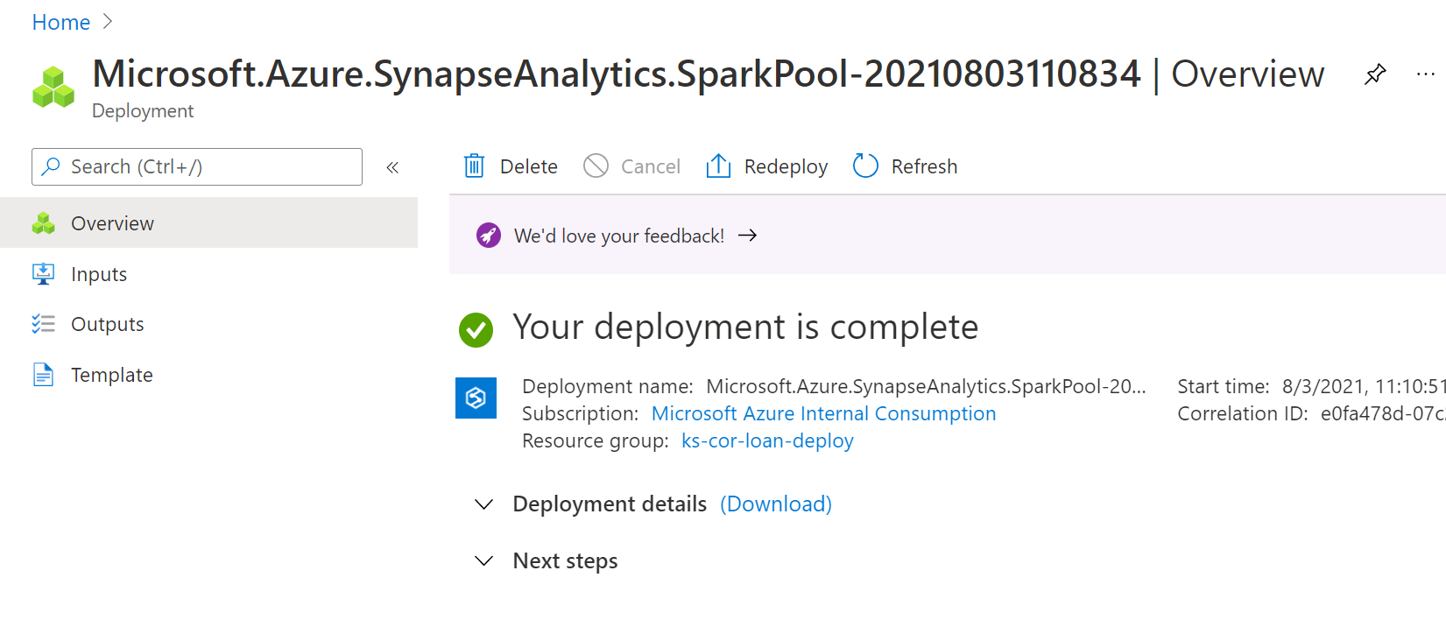

Review the results in Synapse Analytics Workspace:

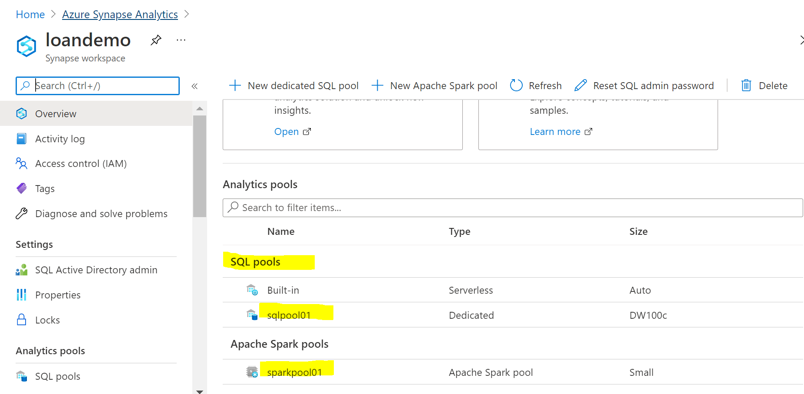

** Click the sqlpool01, you will launch to this dedicated SQL pool in order to manage it. For example, pause the SQL Pool to save the cost when you no need to use it.

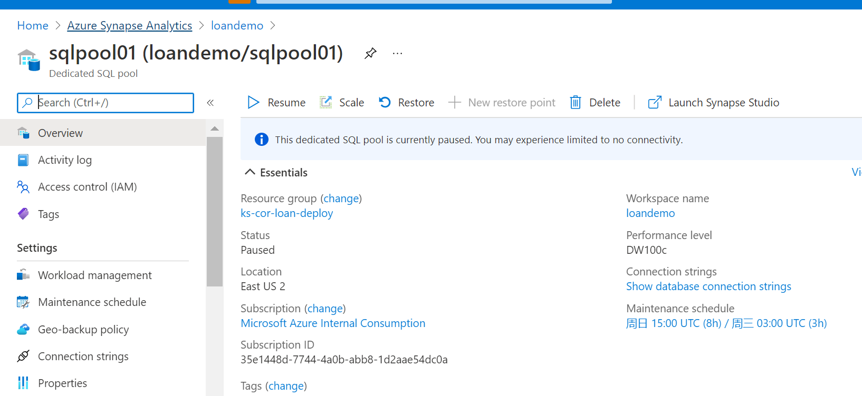

### Step 5 Create Data Pipeline and ingest source data to data lake

Back to Synapse Analytics Overview page, click Open Synapse Studio

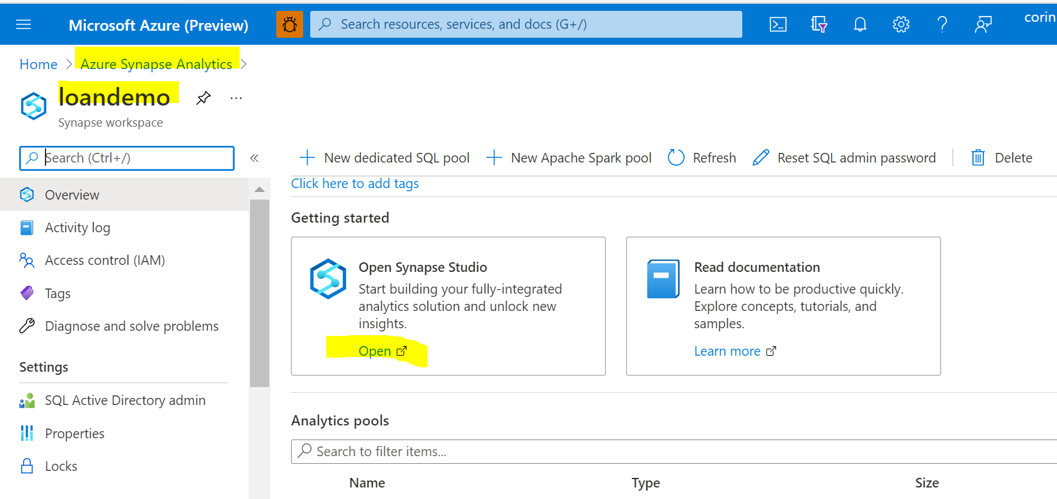

Click the Integrate icon:

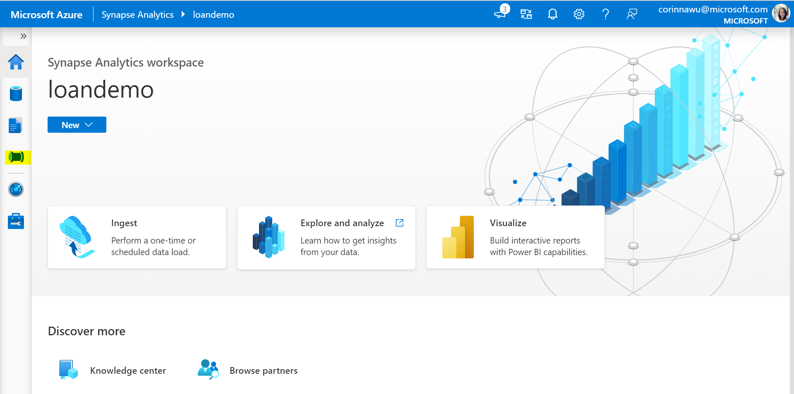

Click ‘+’ to create new Pipeline

We will build a data pipeline to ingest and transform the SBA source data

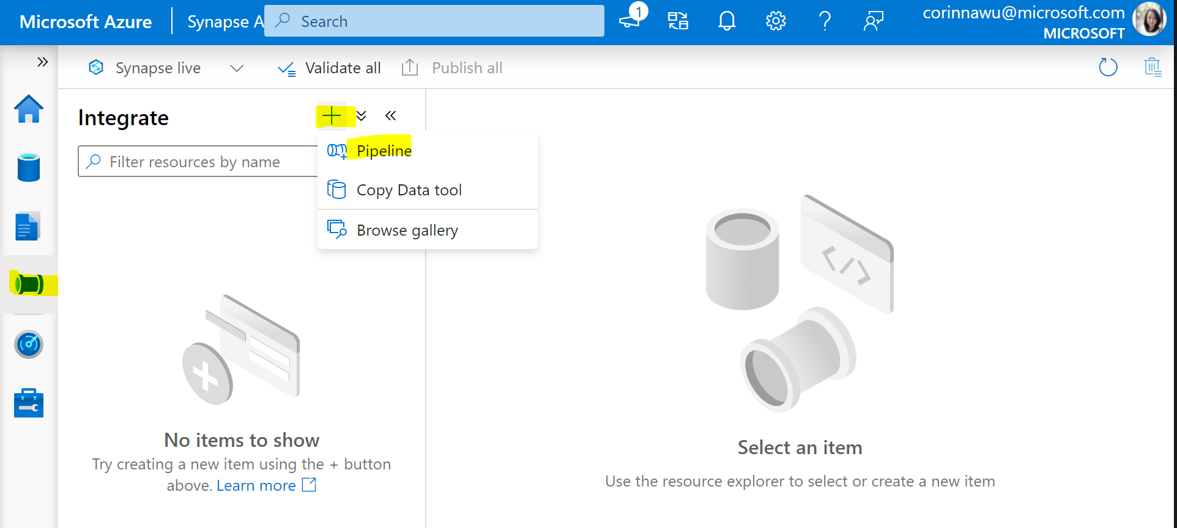

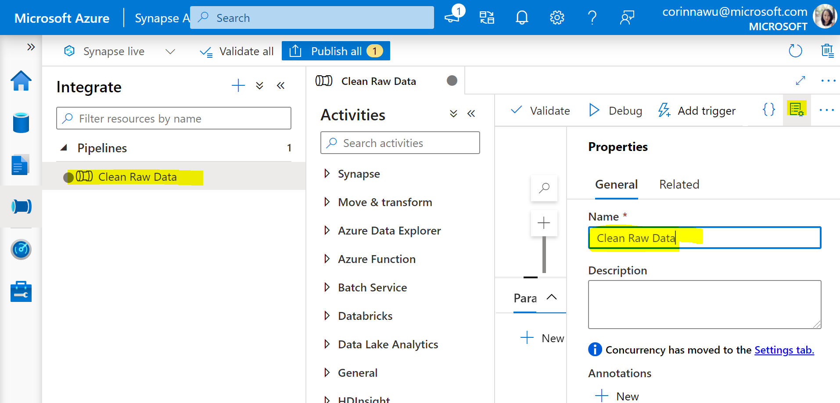

Create COPY Data Activity

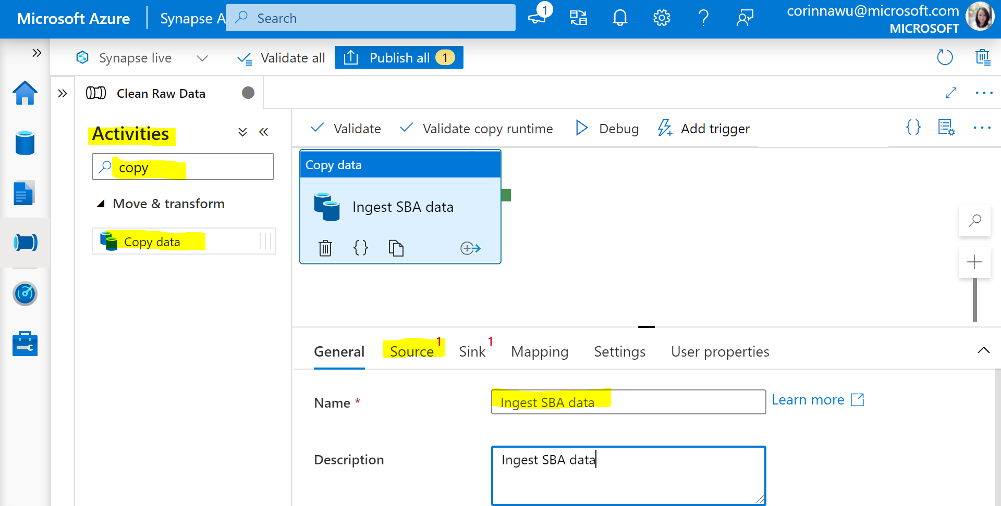

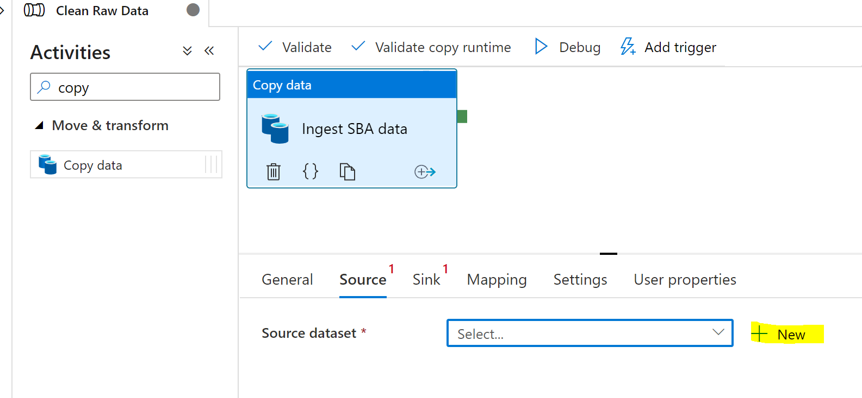

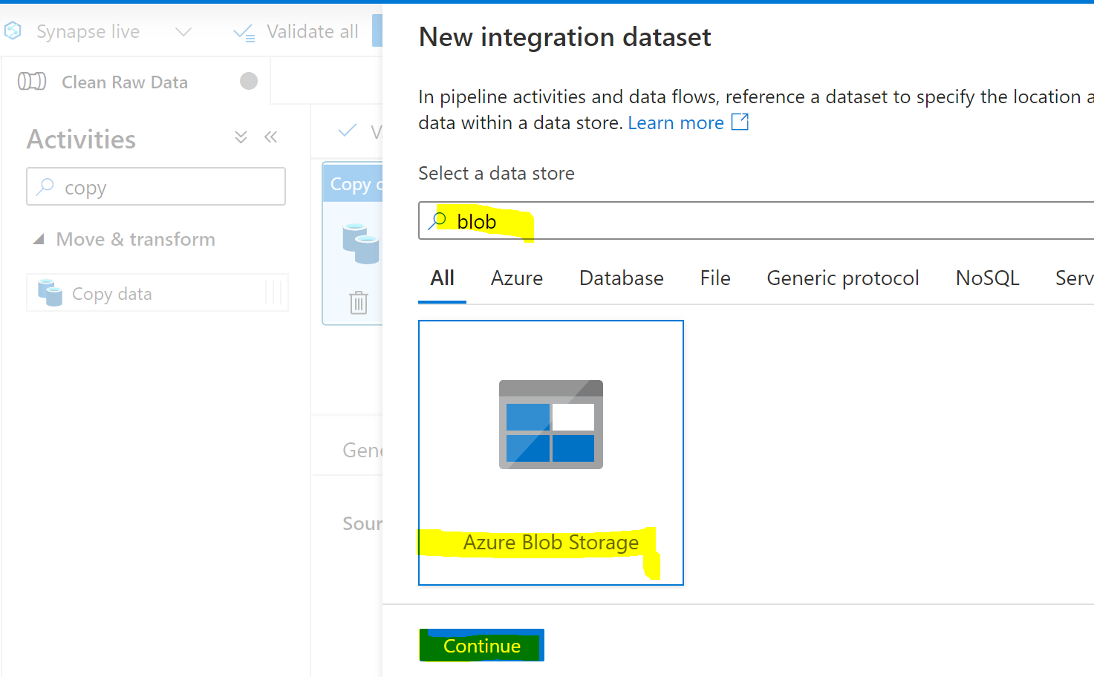

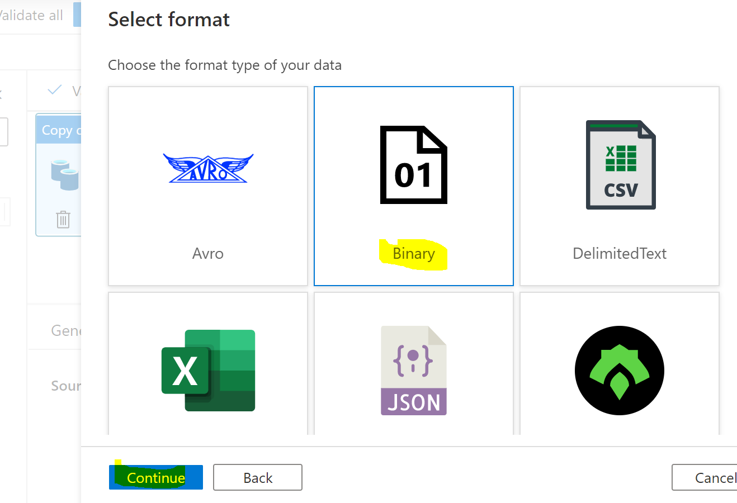

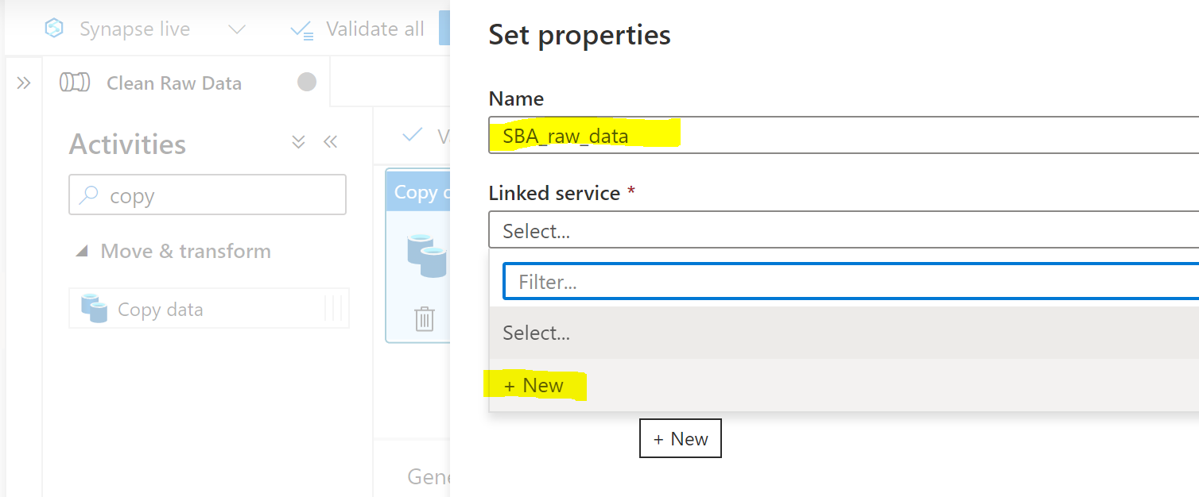

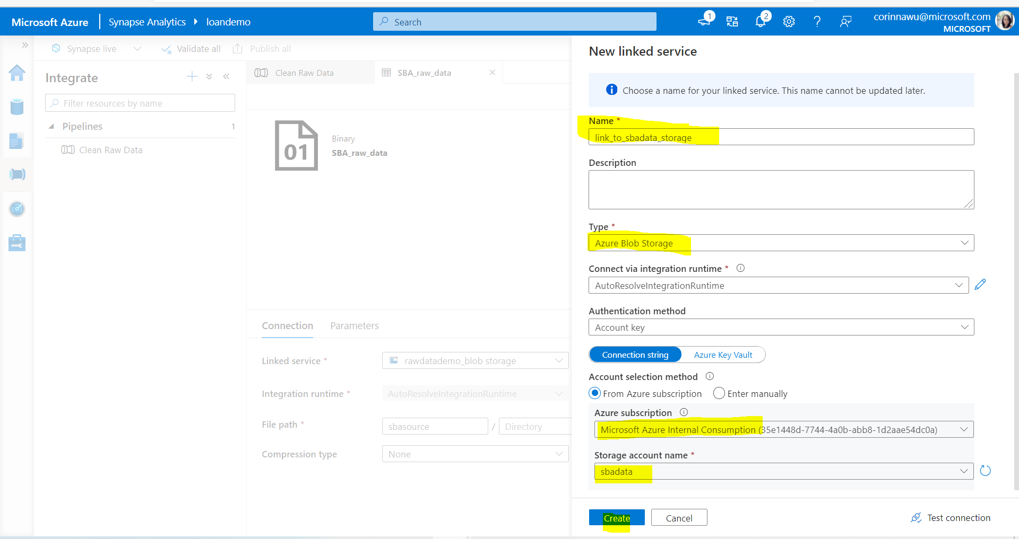

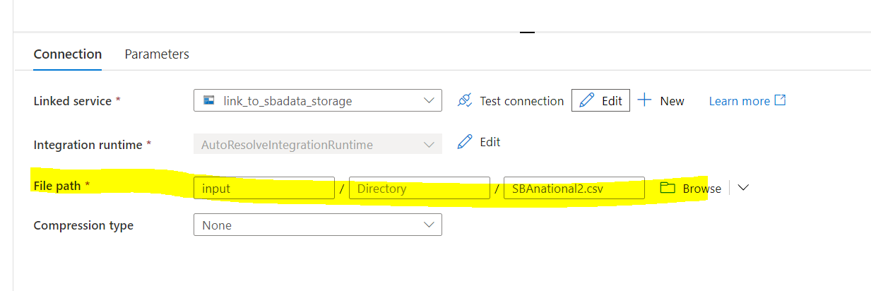

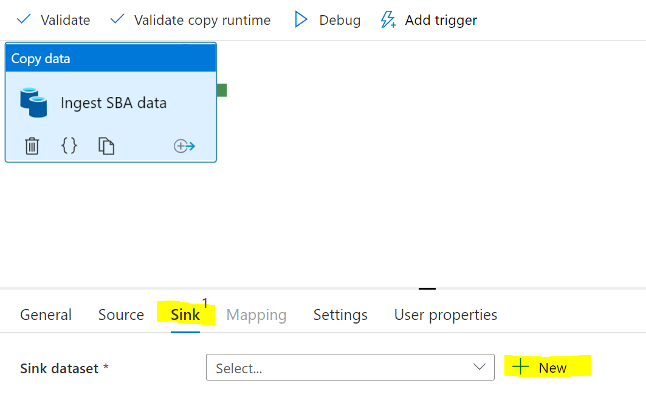

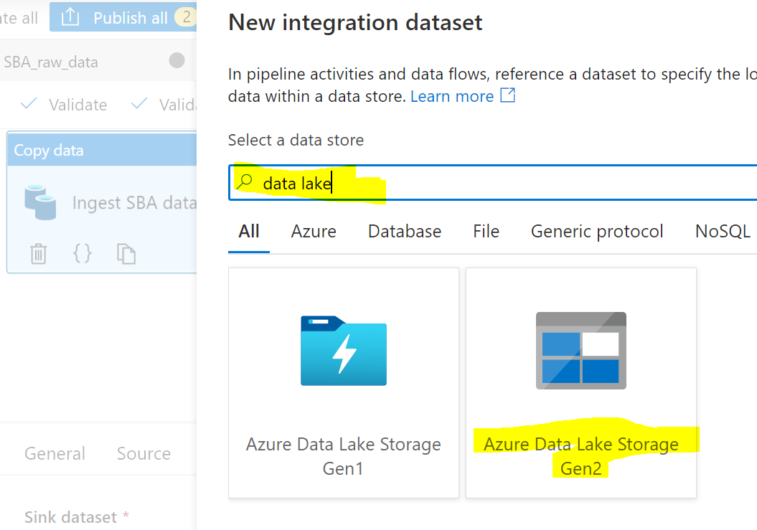

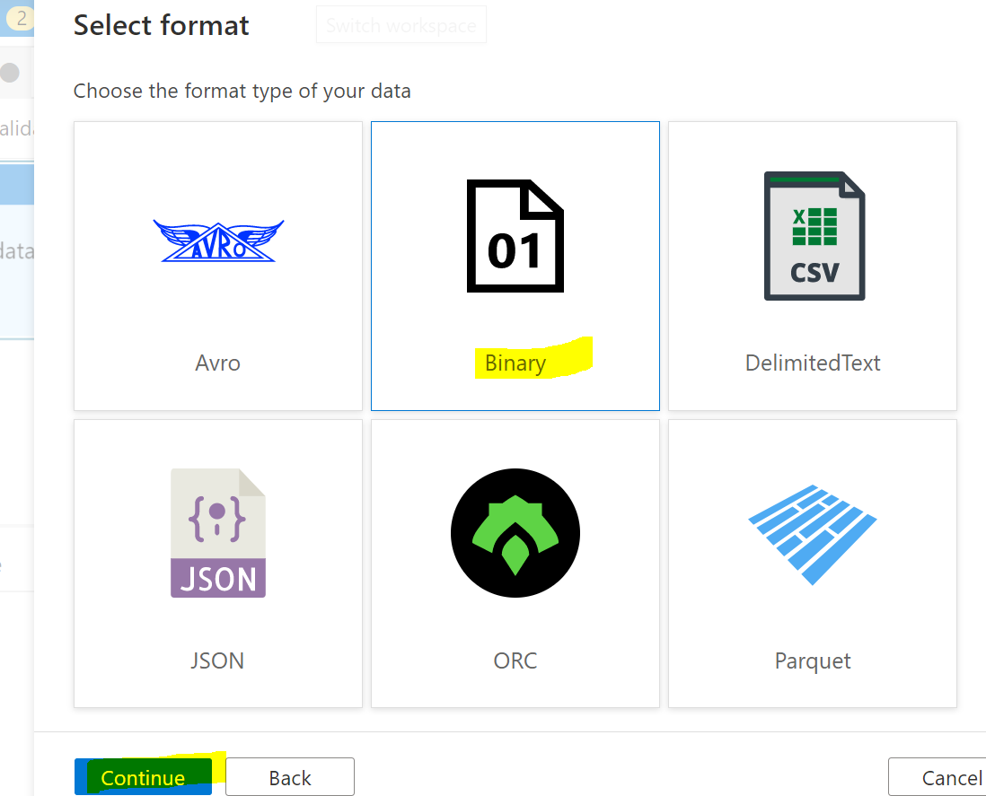

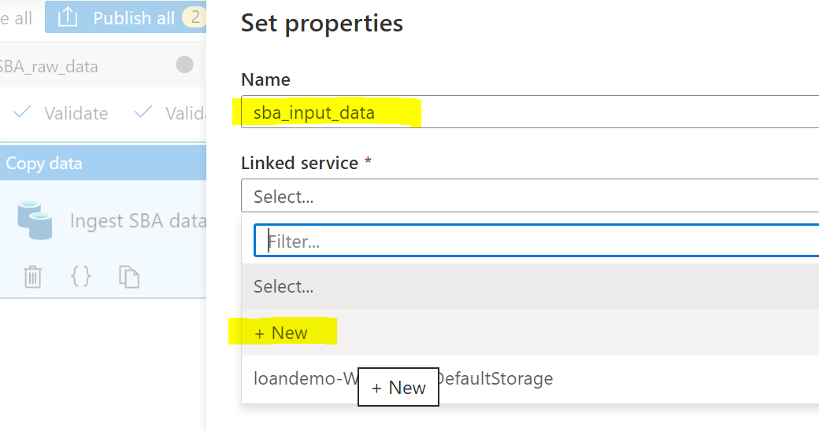

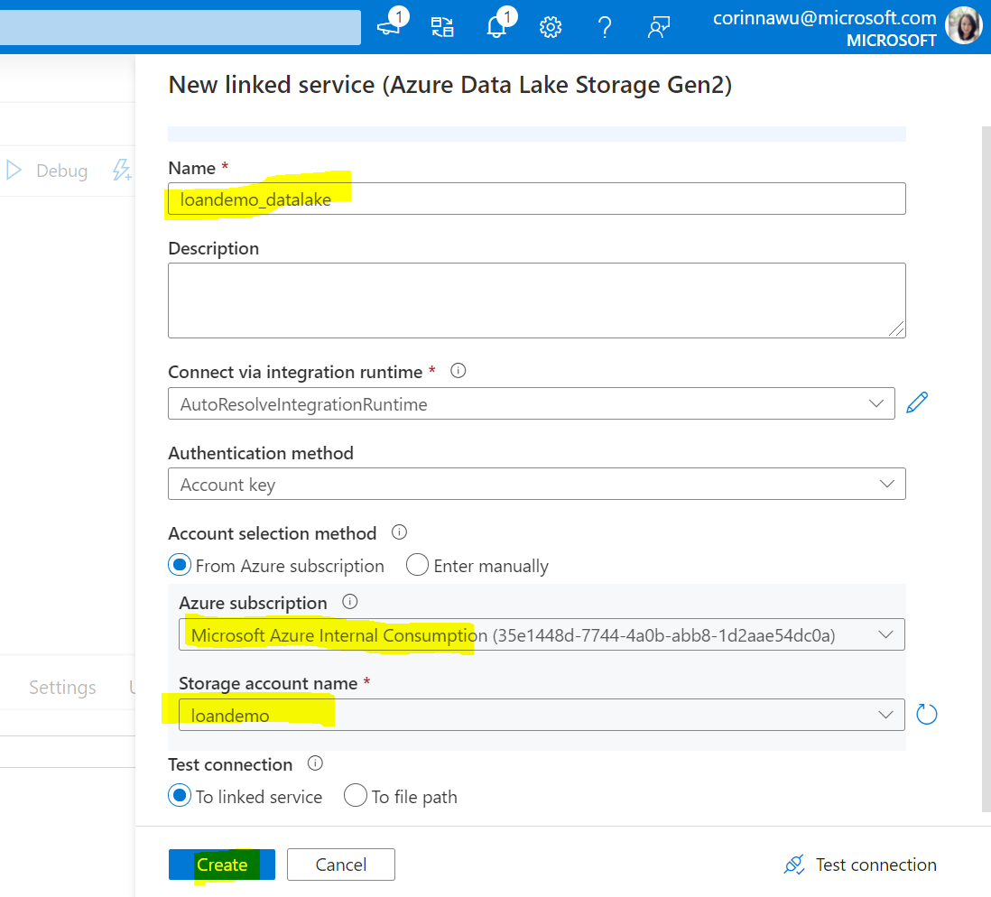

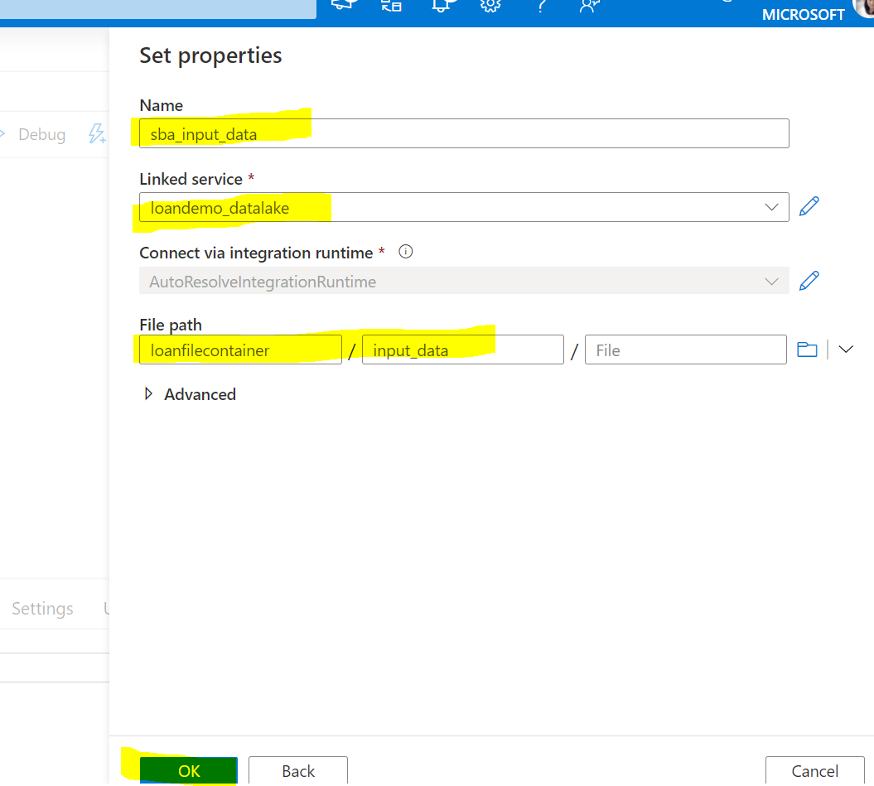

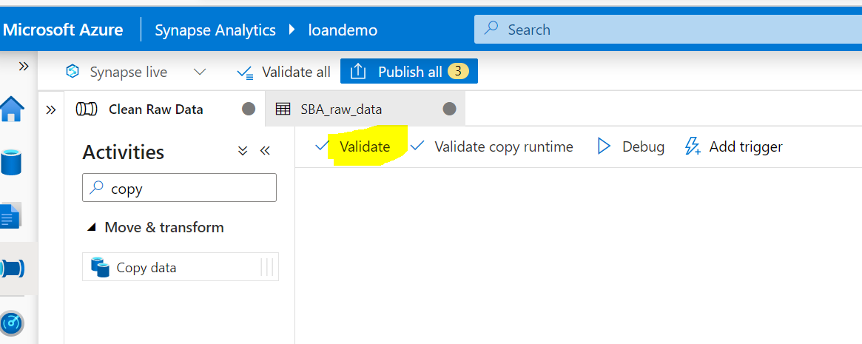

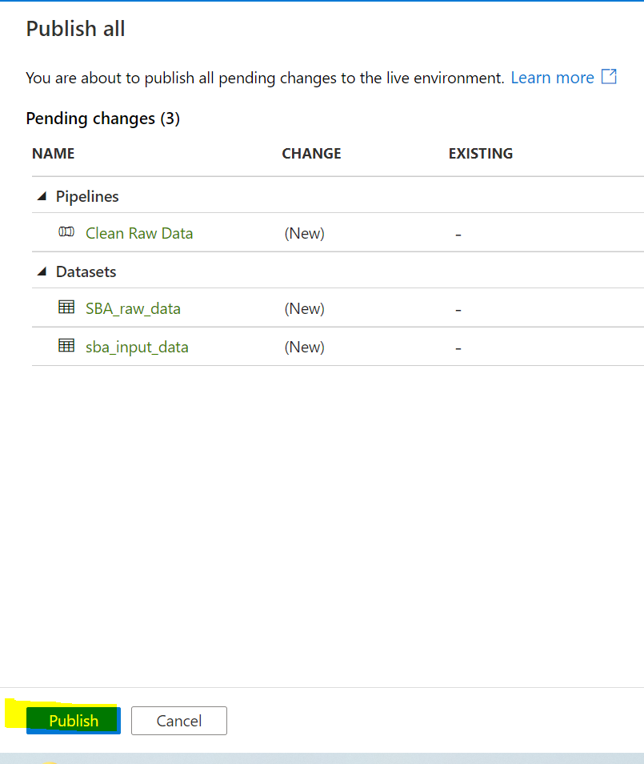

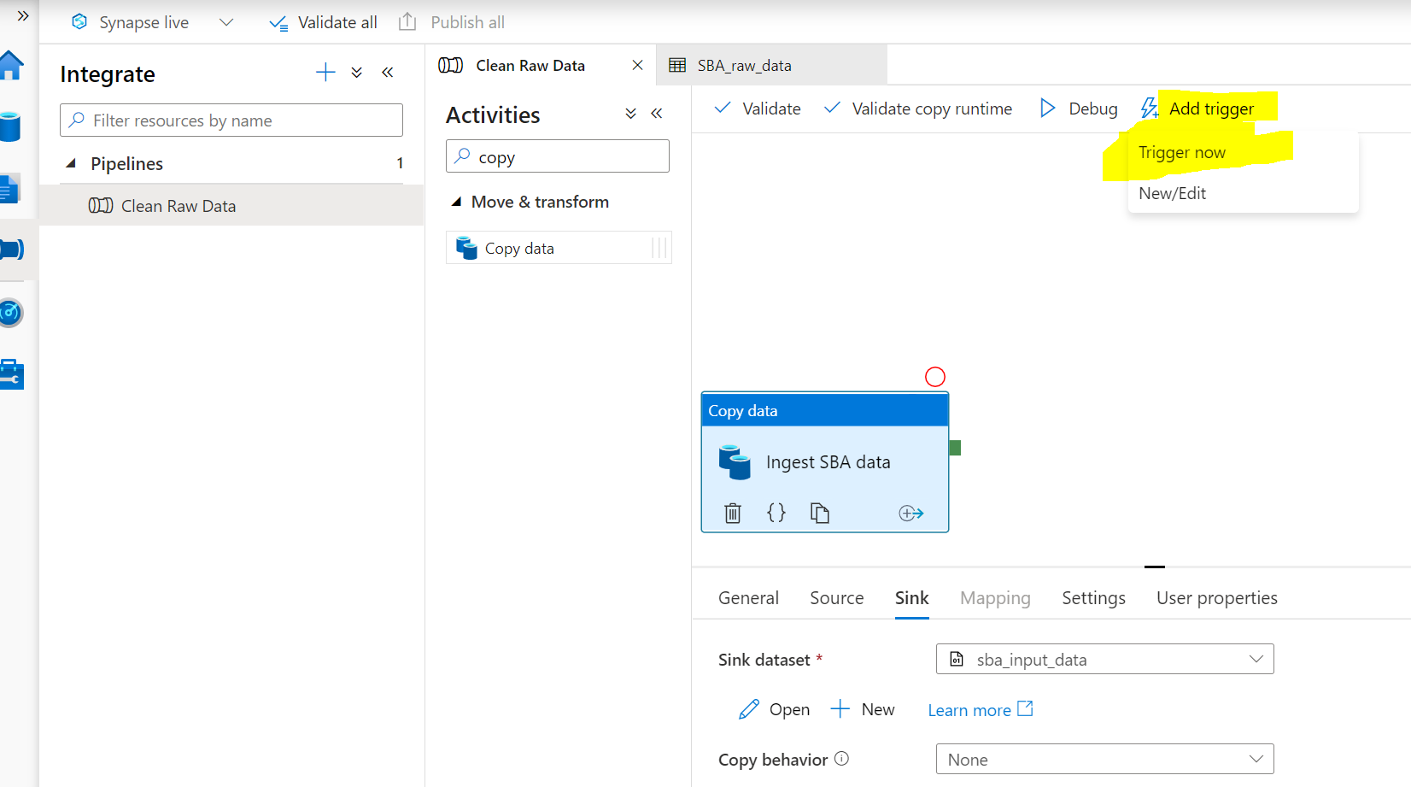

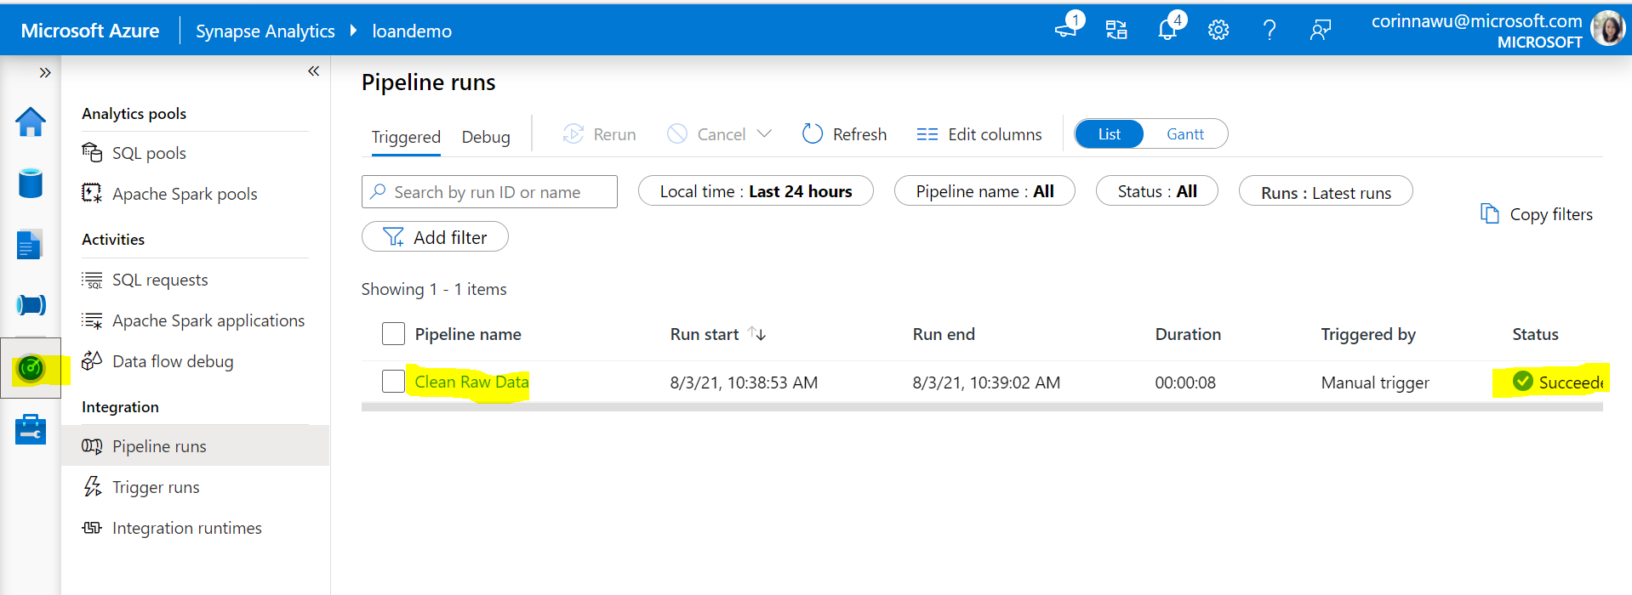

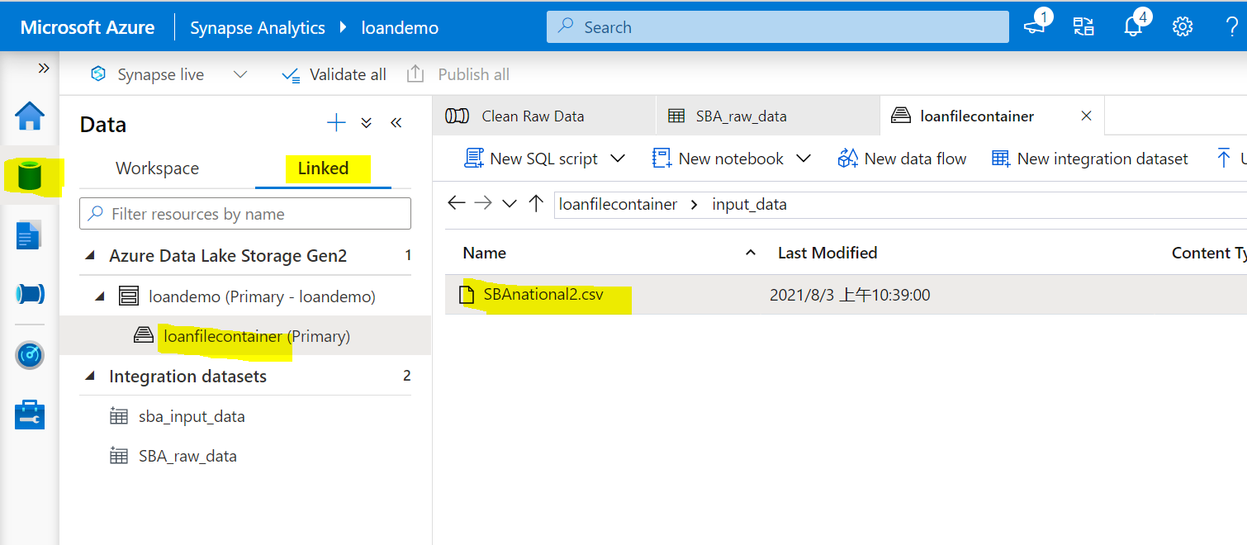

### Step 6: Create Dataflow to prepare data for Machine Learning

Turn on data flow debug

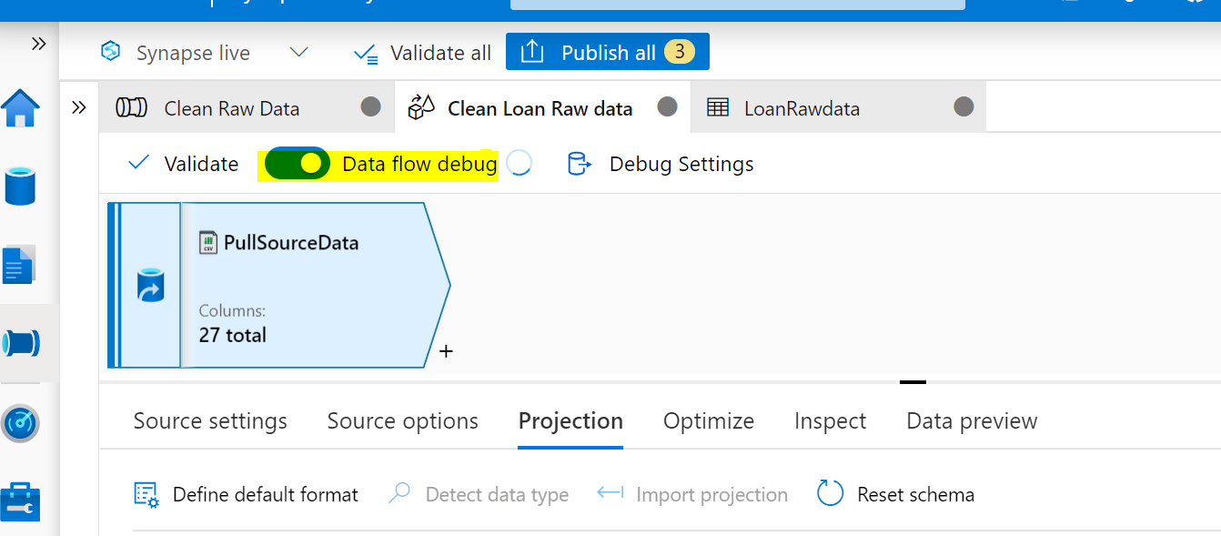

You can create data flow after the Copy data activity in the same pipeline or create a new pipeline separately for data flow activity depends on the real data flow requirements

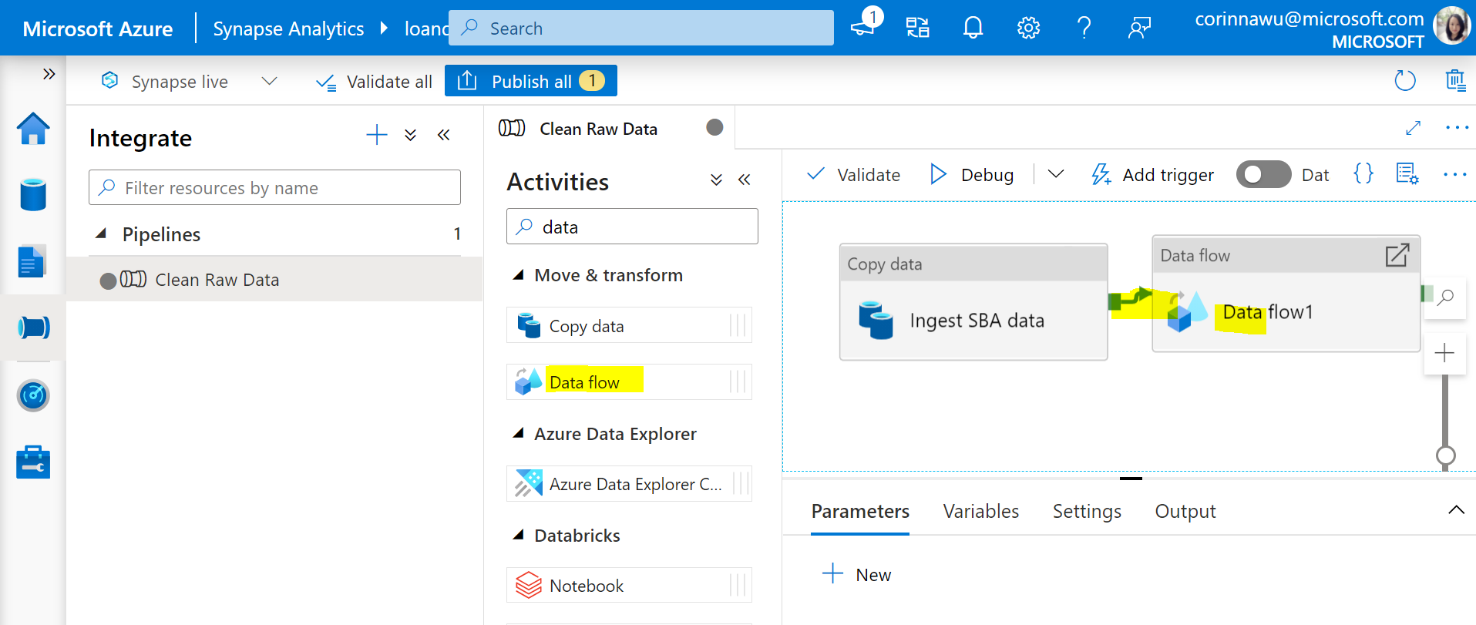

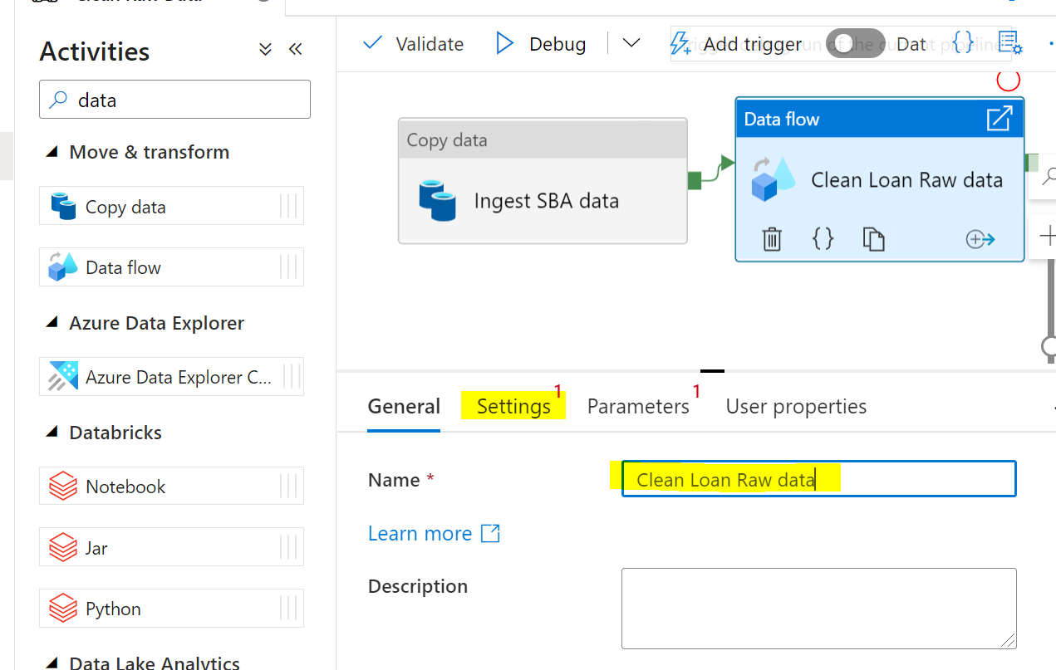

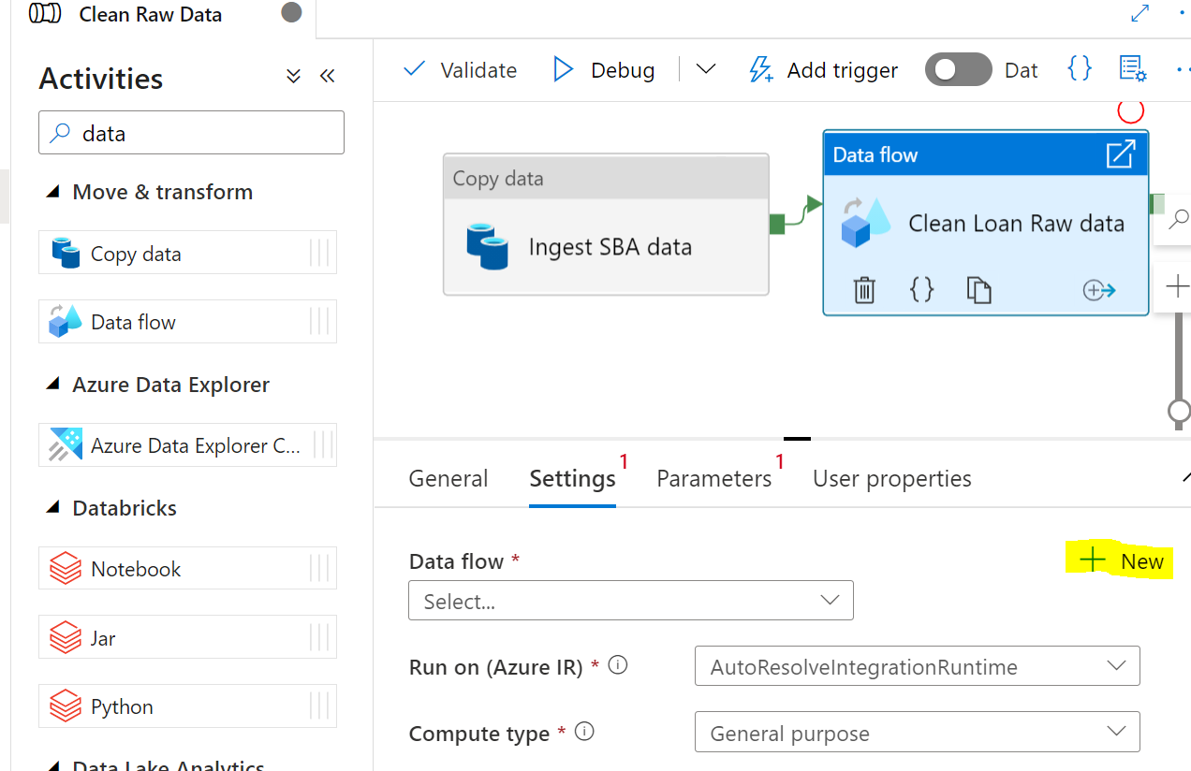

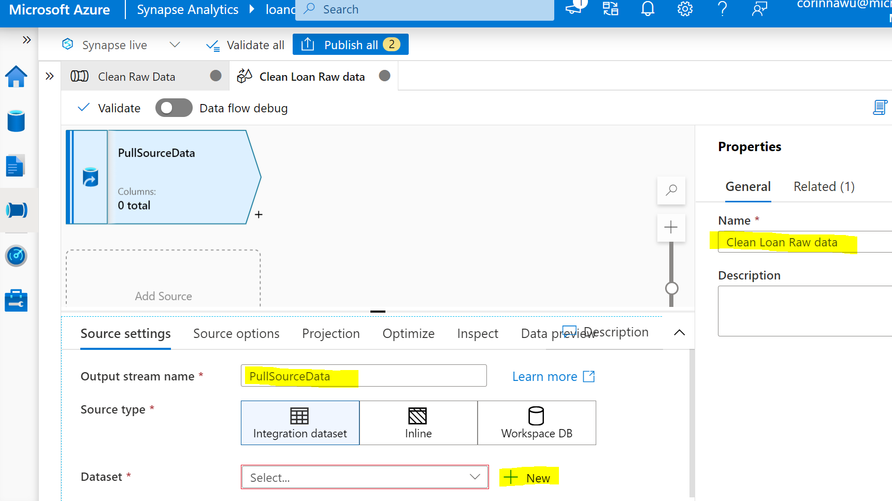

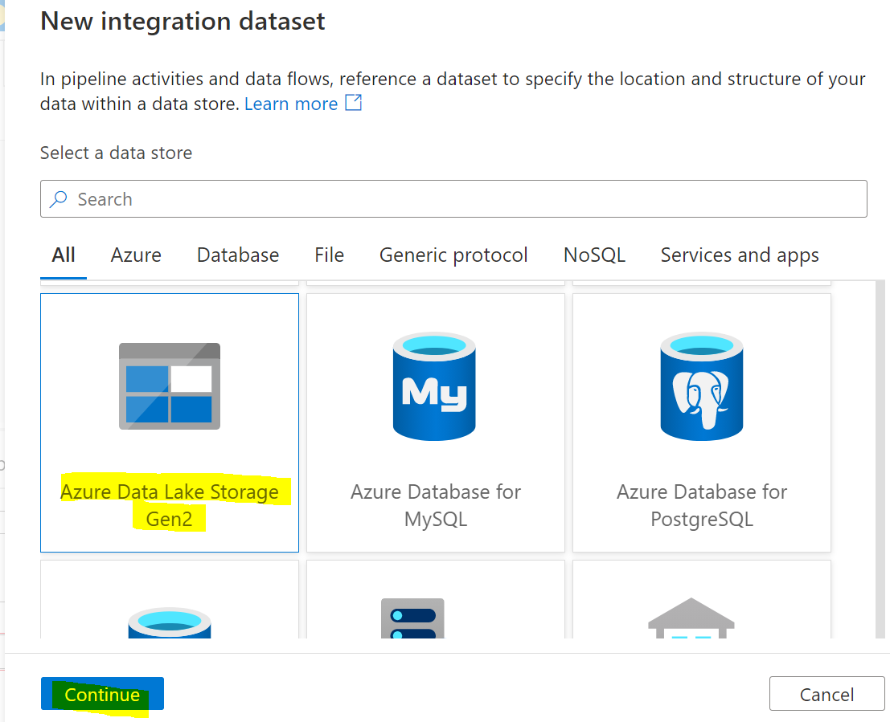

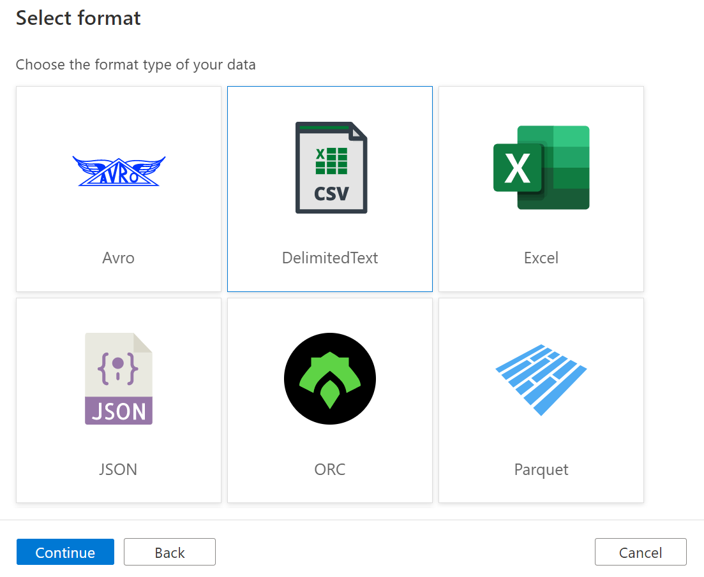

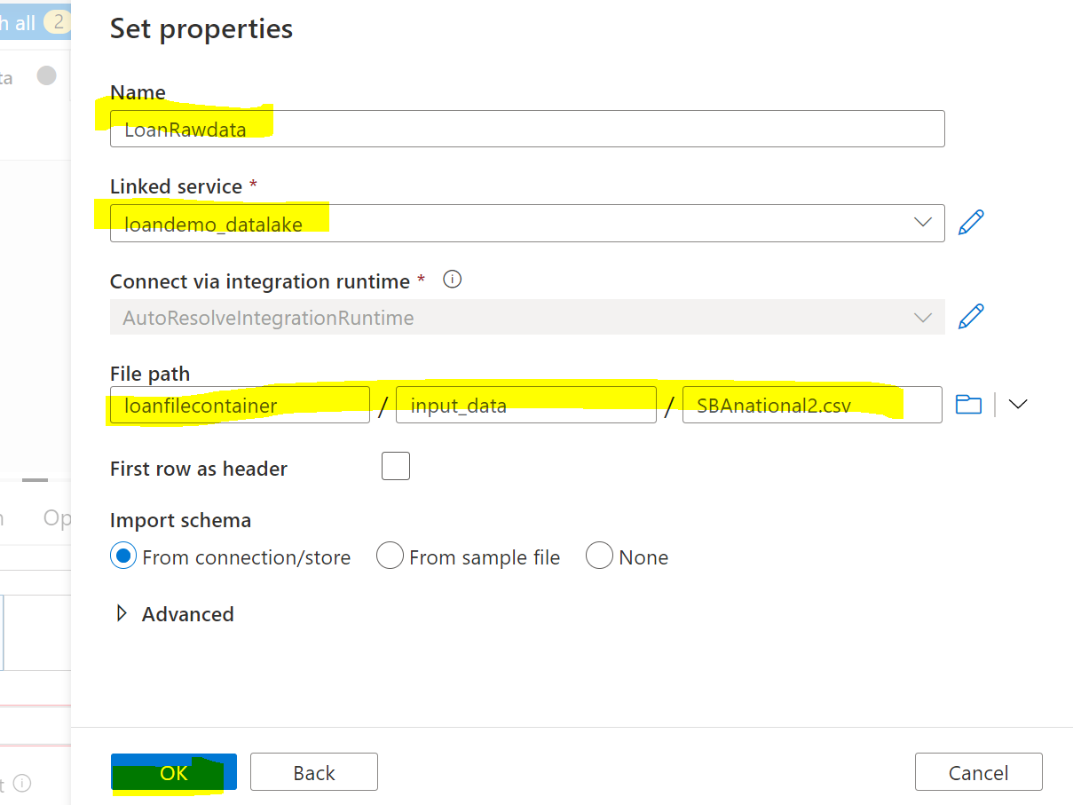

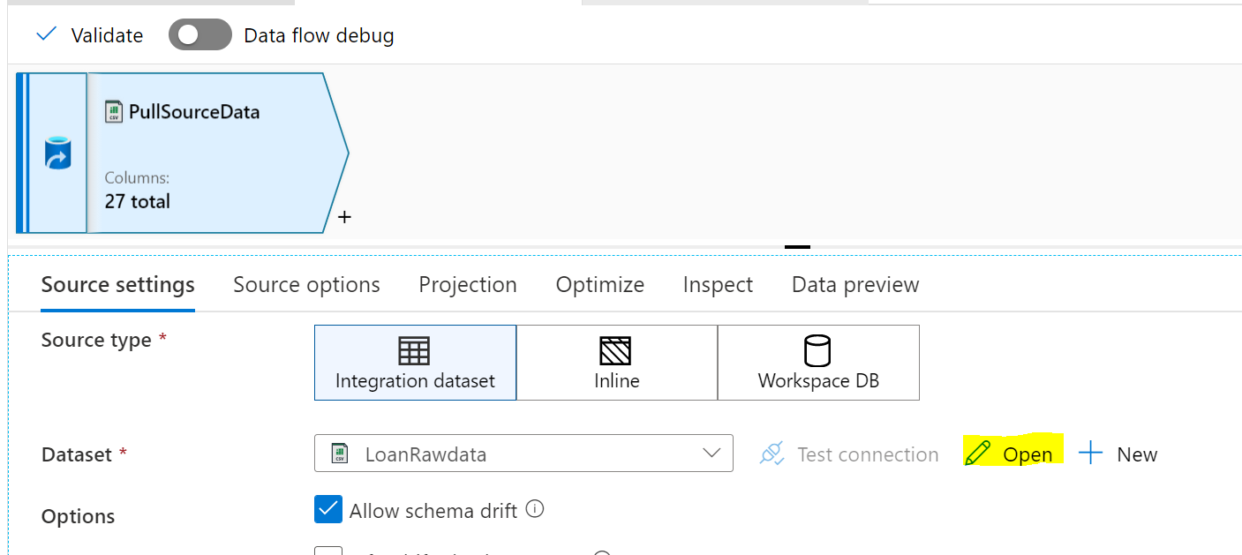

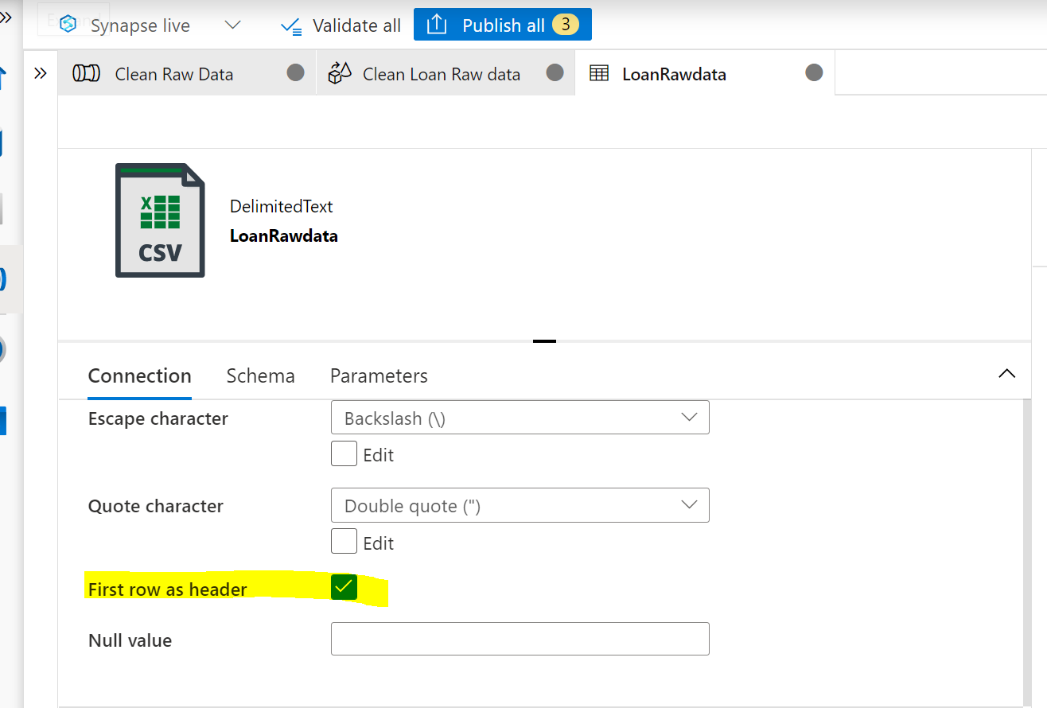

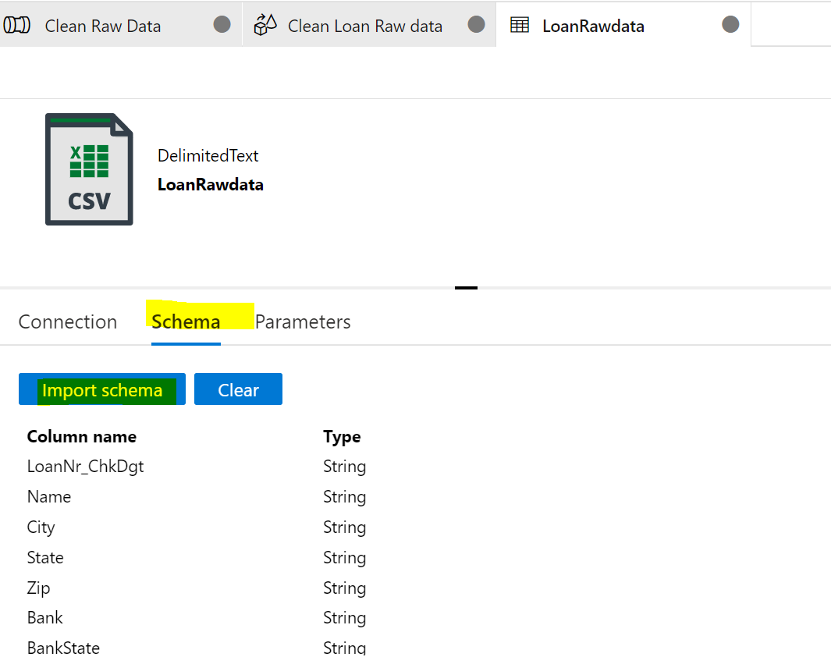

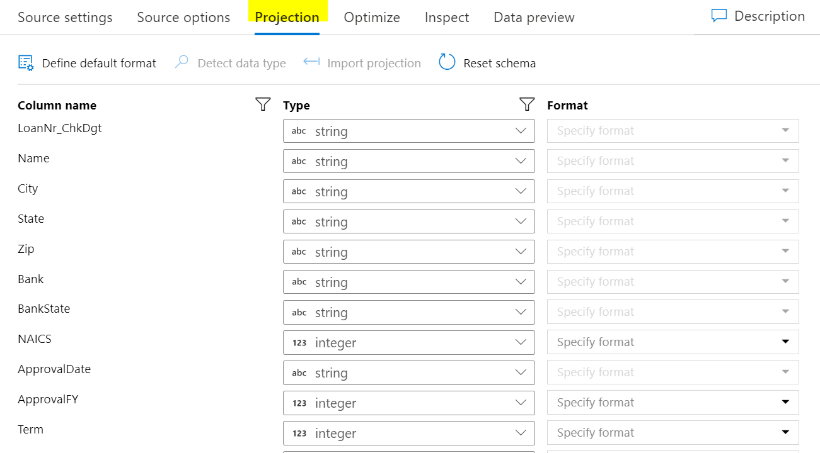

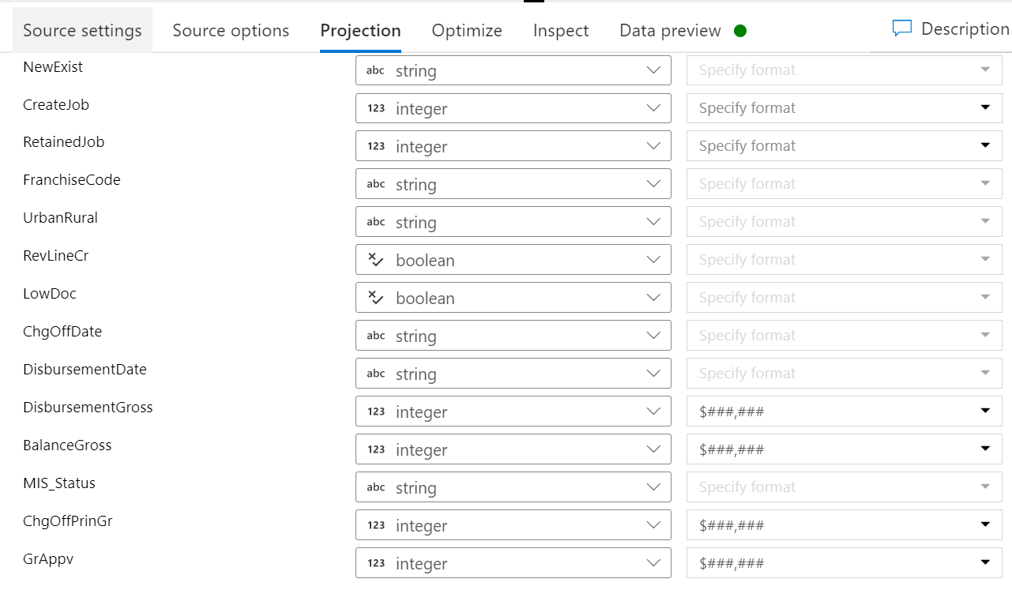



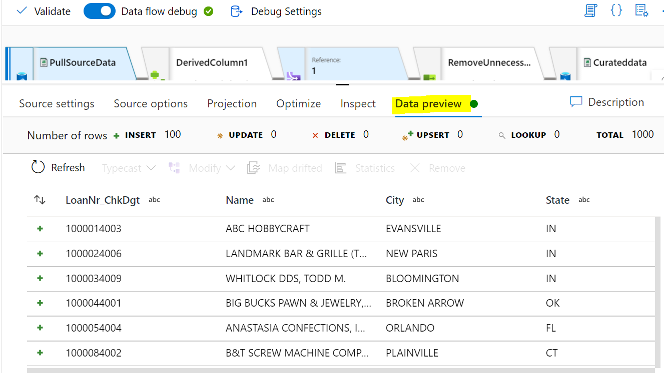

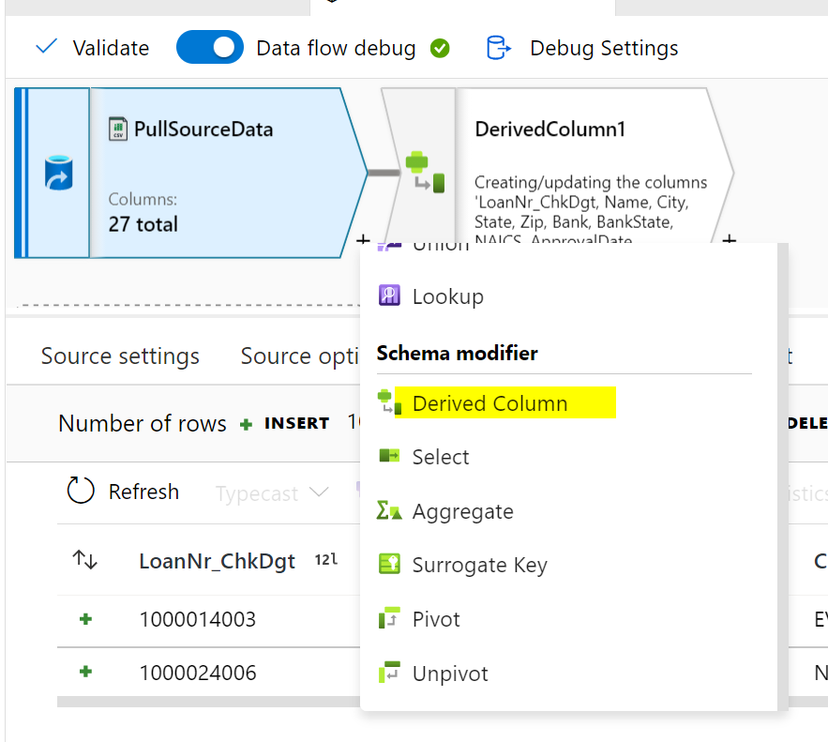

Add following Columns:

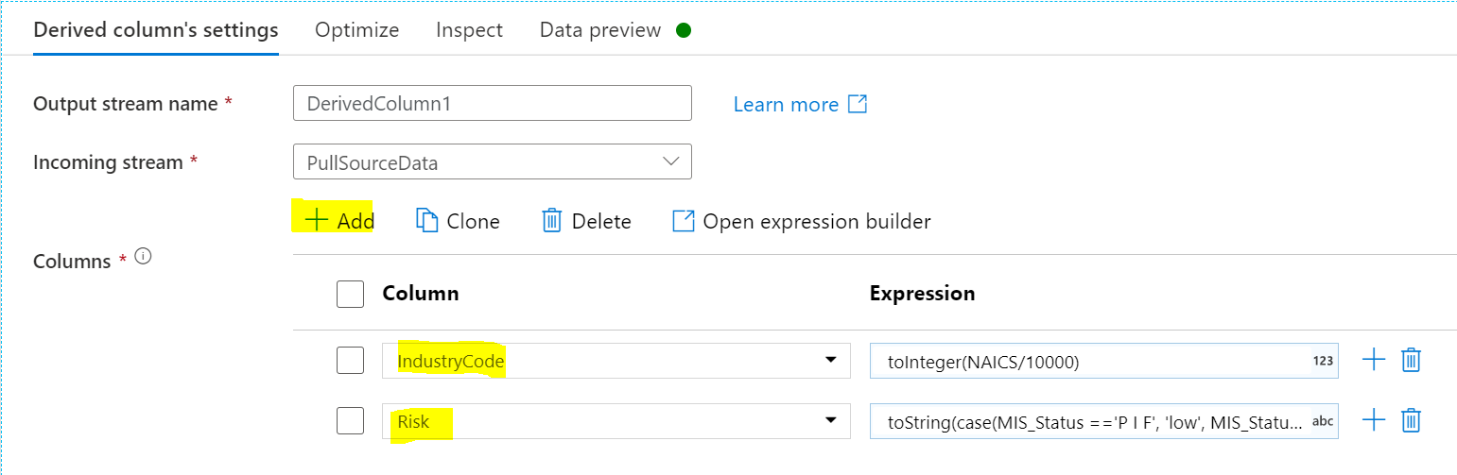

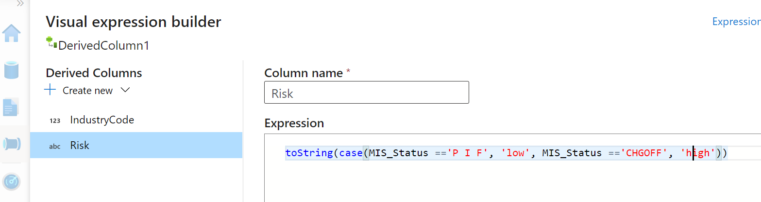

toString(case(MIS_Status =='P I F', 'low', MIS_Status =='CHGOFF', 'high'))

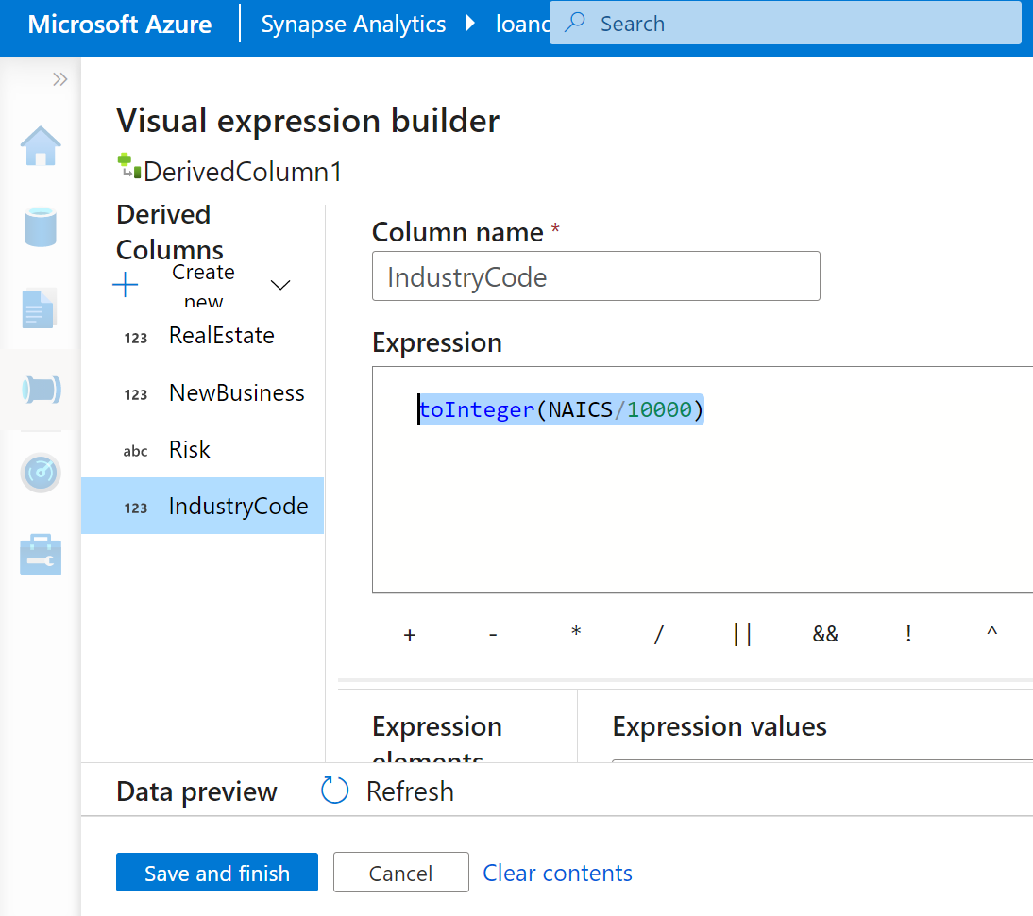

toInteger(NAICS/10000)

Preview the data:

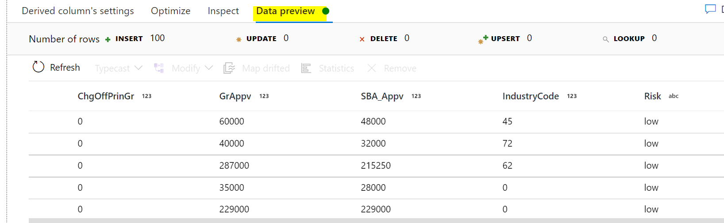

Create another data source:

Click Add source

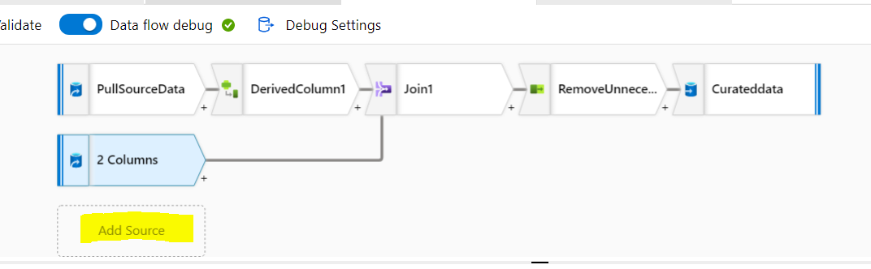

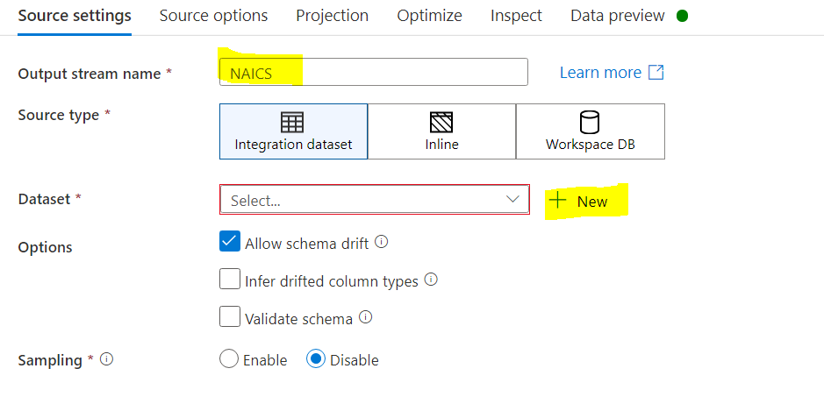

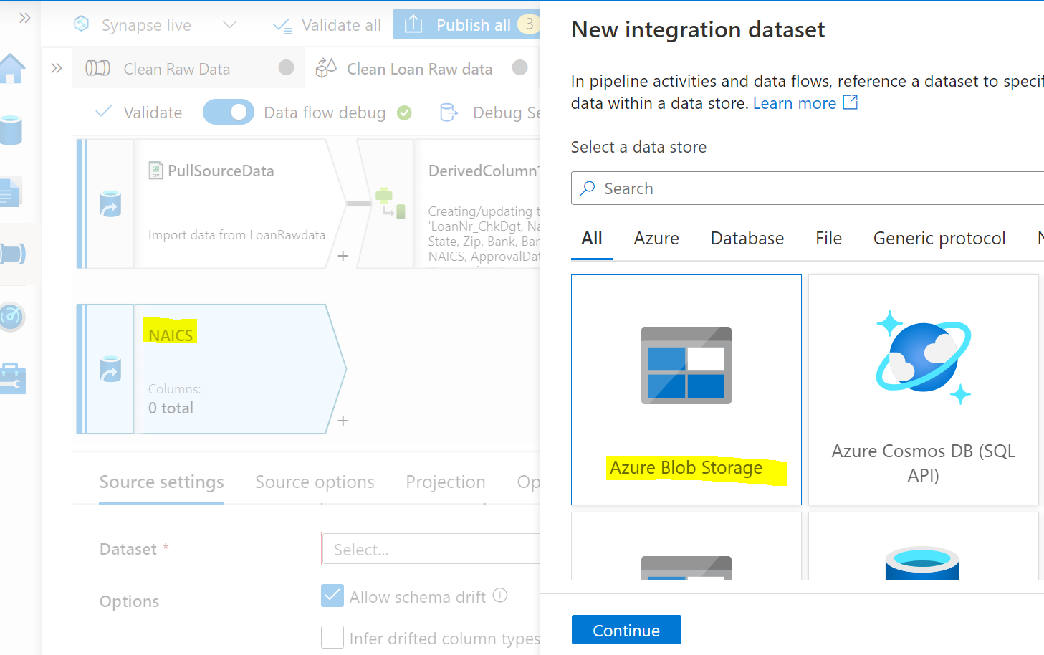

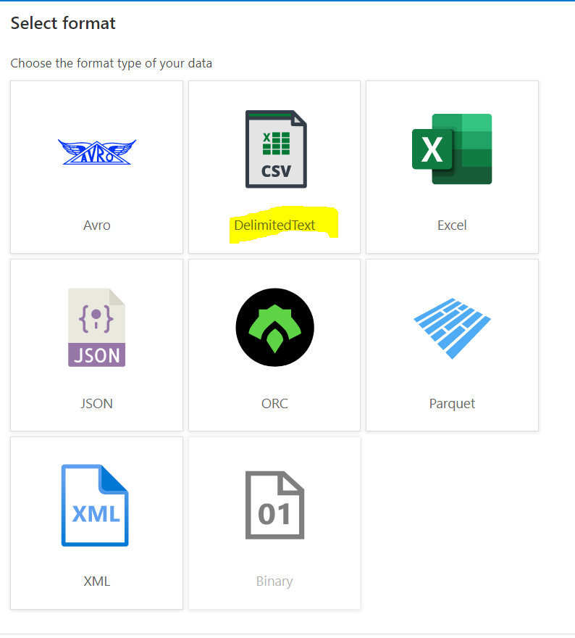

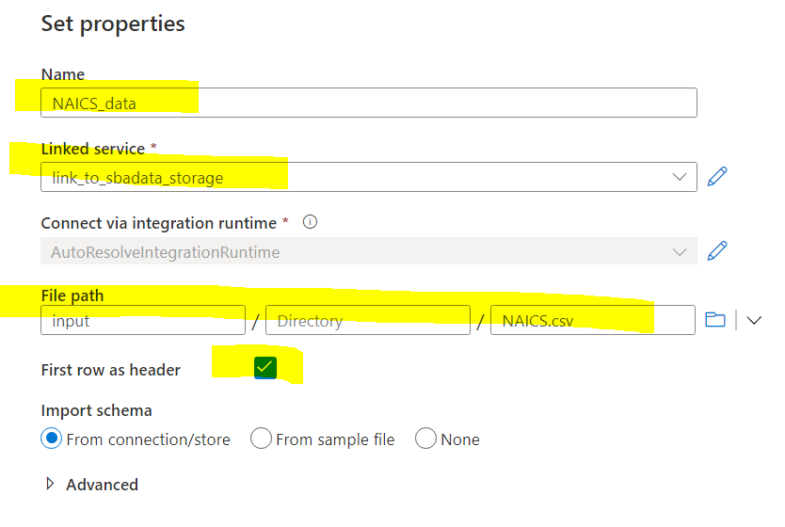

Make sure you mark the First row as header:

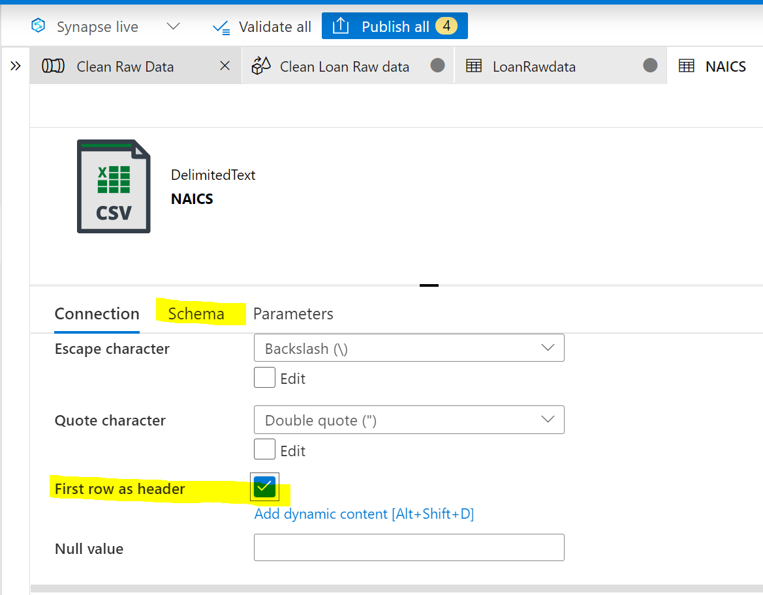

Check the projection

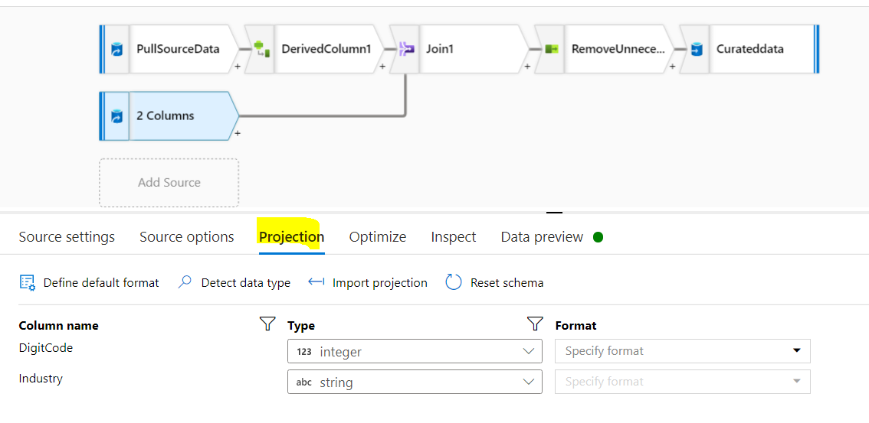

Check data preview:

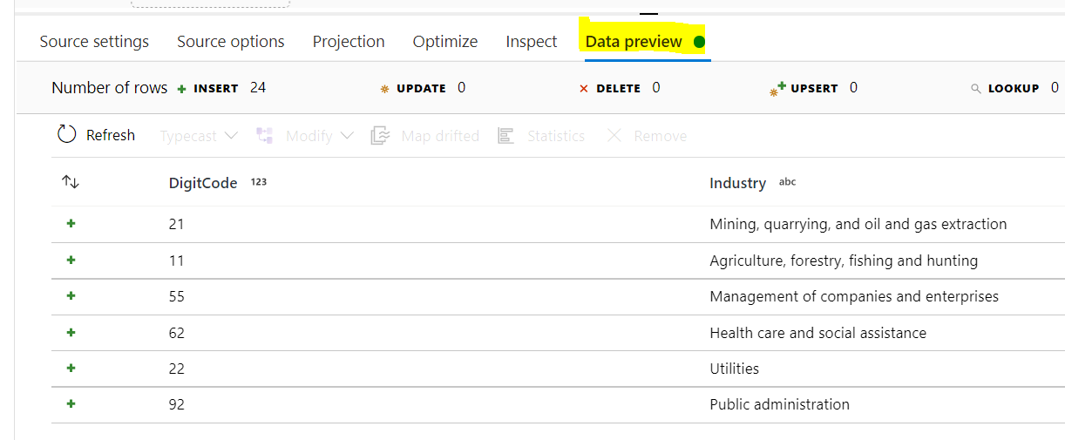

Create step to join the table of SBA dataset and NAICS

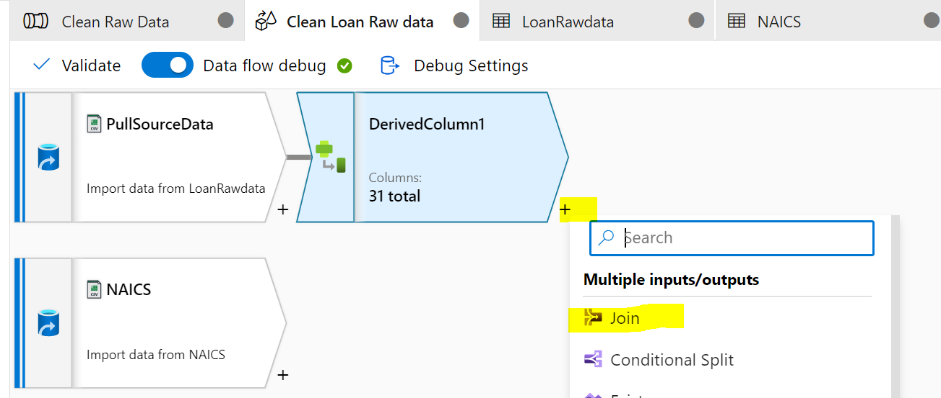

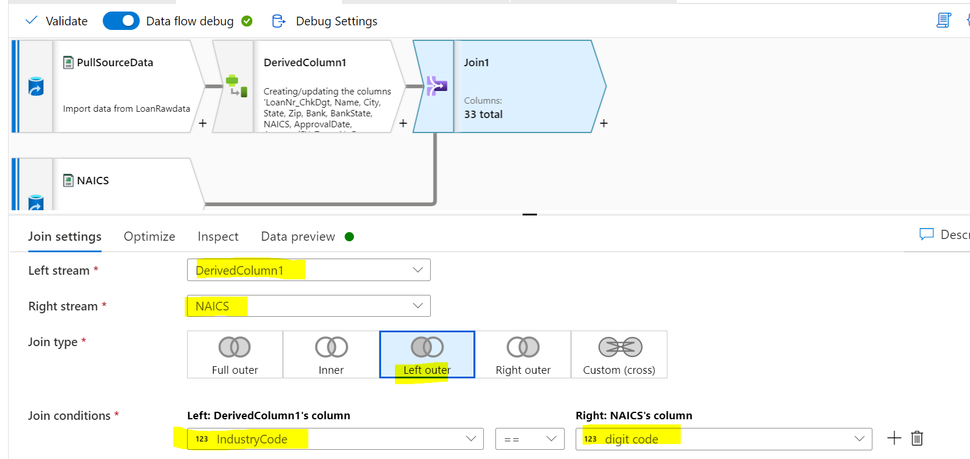

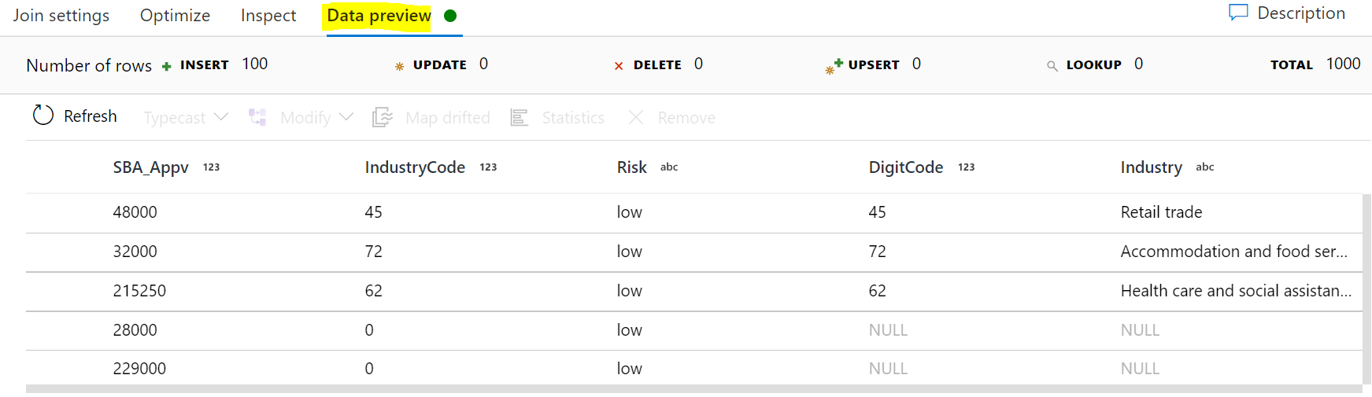

Remove unnecessary columns:

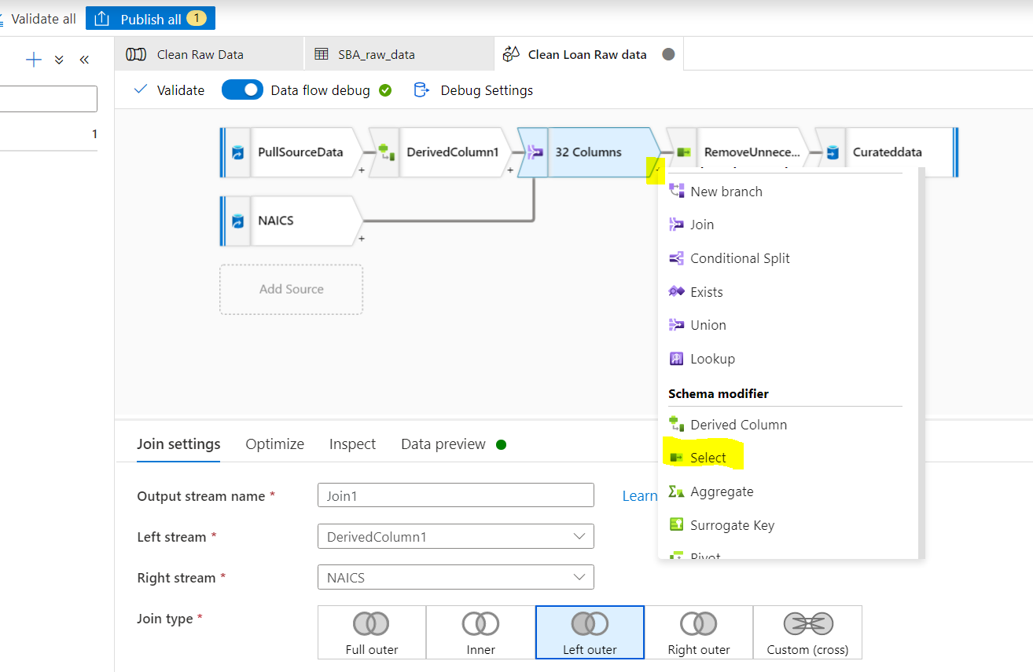

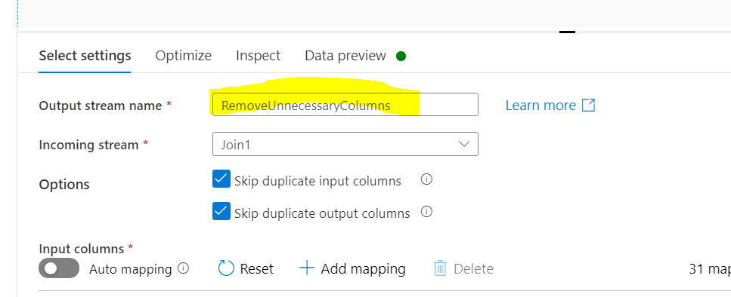

Remove unnecessary columns such as DigitCode (duplicate)

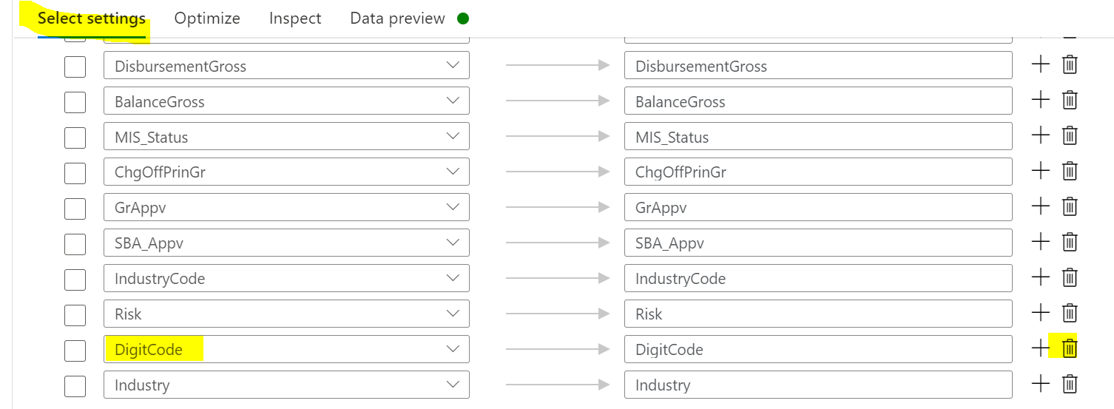

Add sink for the cleaned & transformed data:

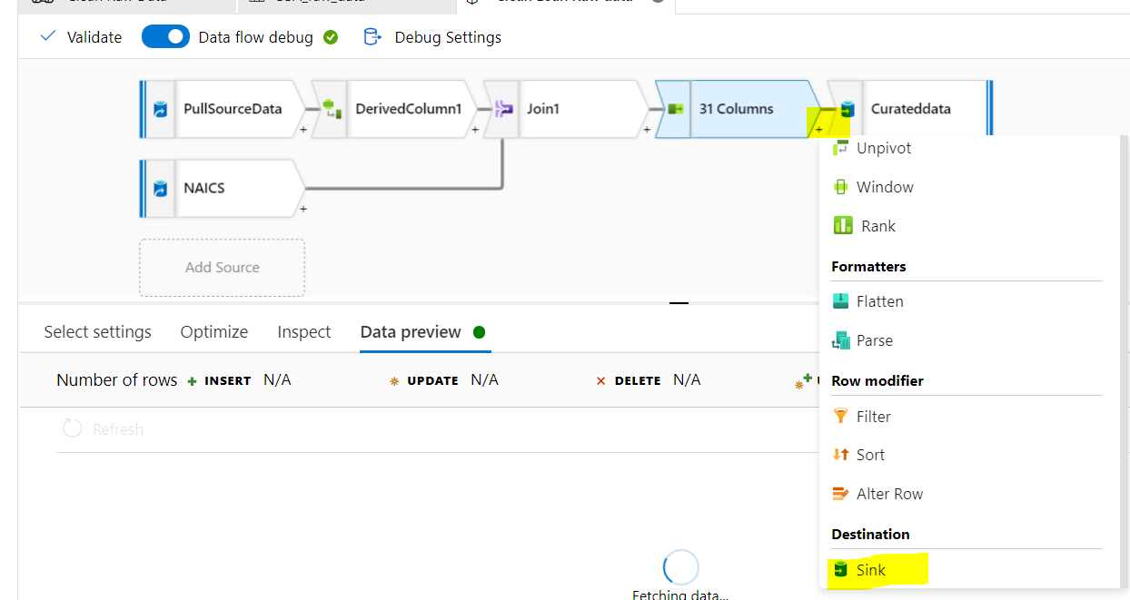

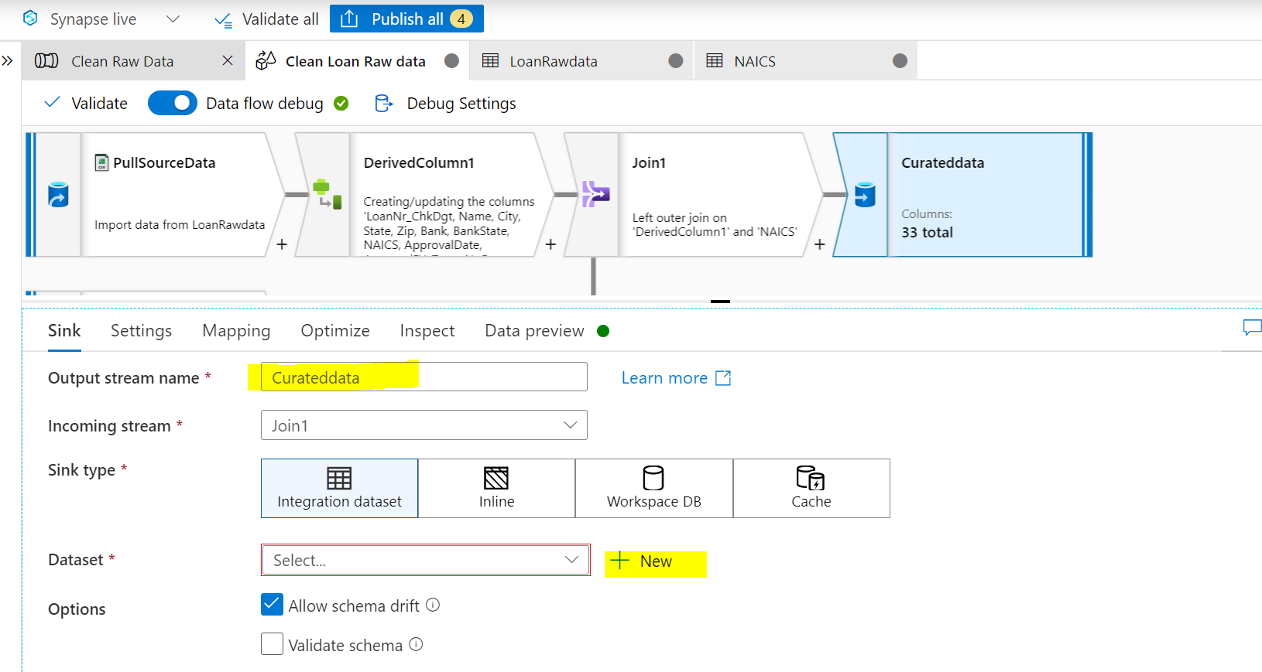

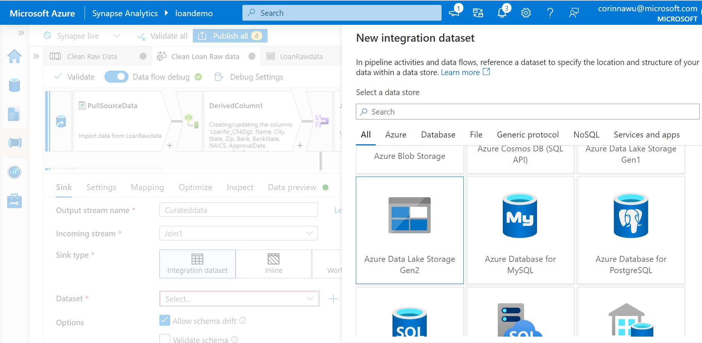

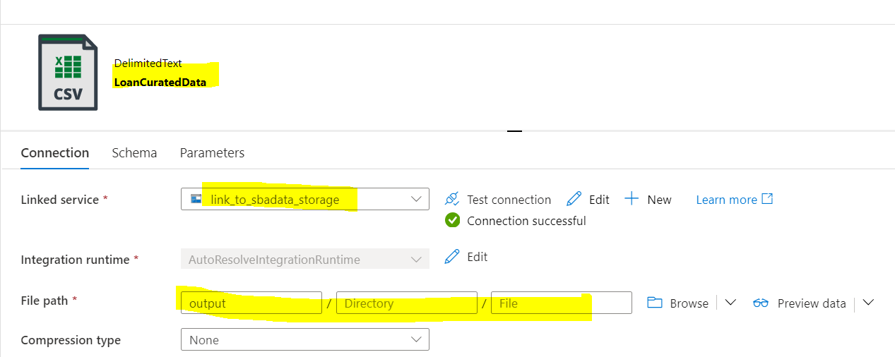

Optional settings:

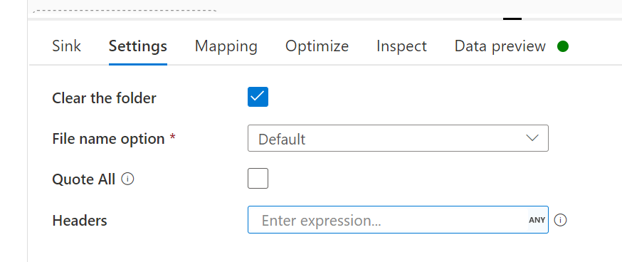

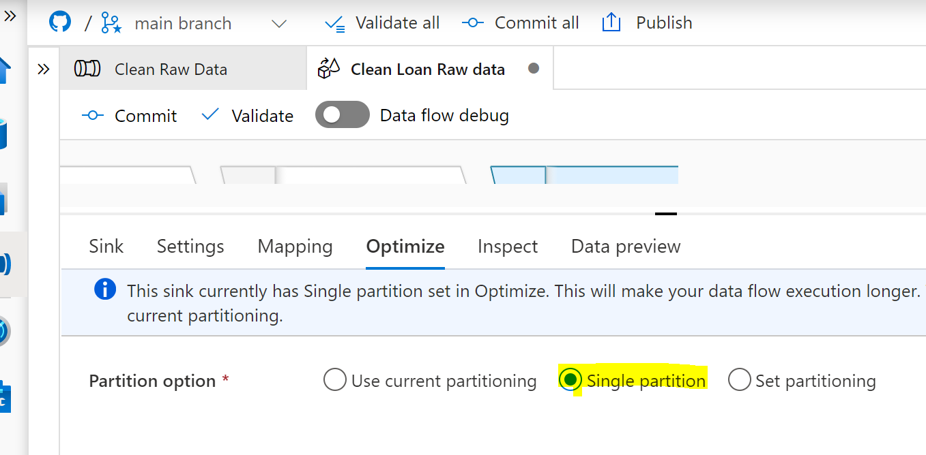

Preview data:

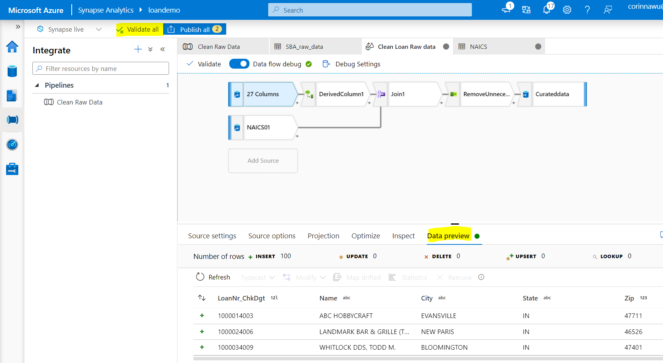

Validate all, then Publish all, then Add trigger ->run now

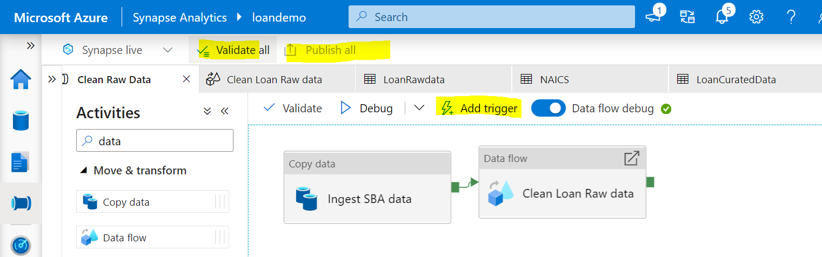

Go to Monitor tab, check Pipeline run status:

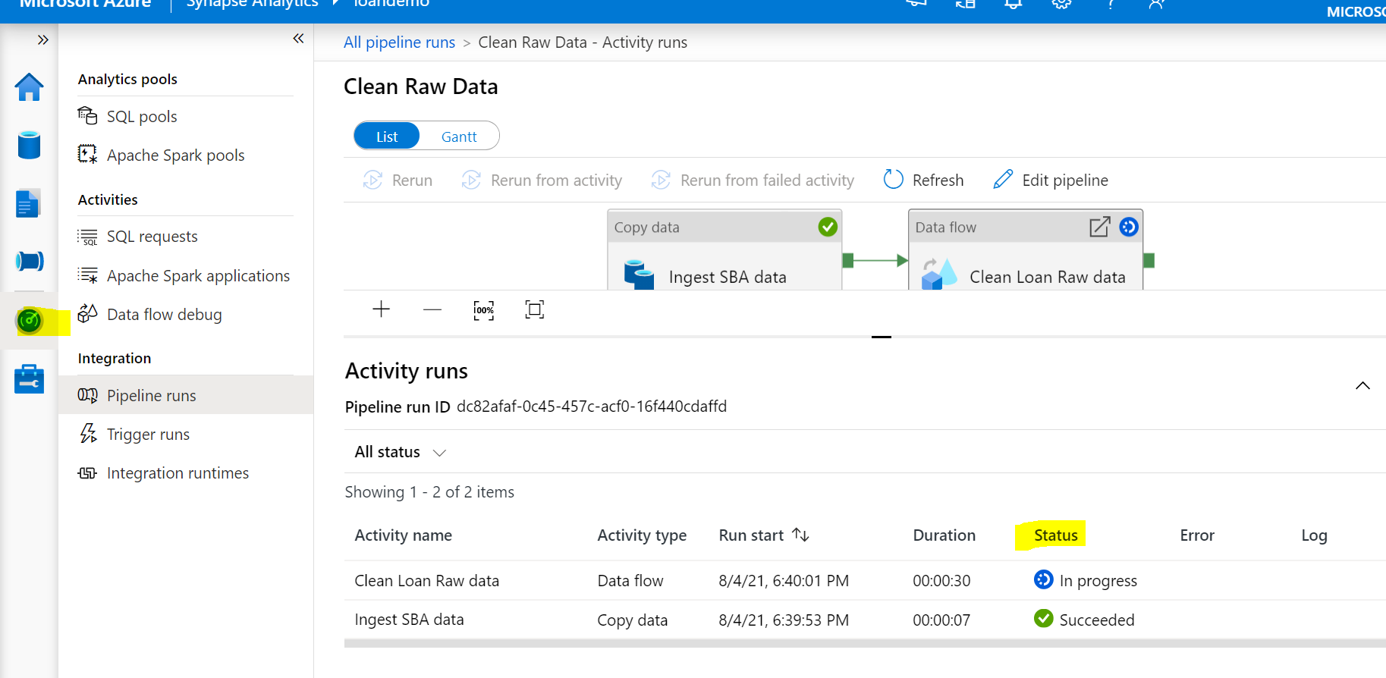

### Step 7: Run data analysis on Synapse and Power BI

Check data result in SBADATA storage output folder:

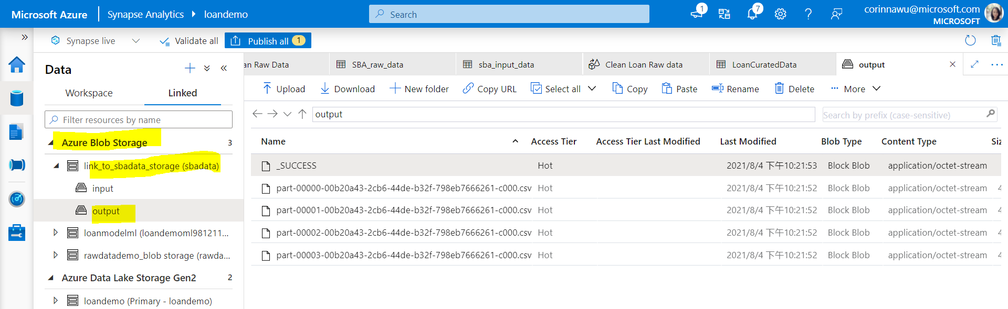

Create Spark table for the data result:

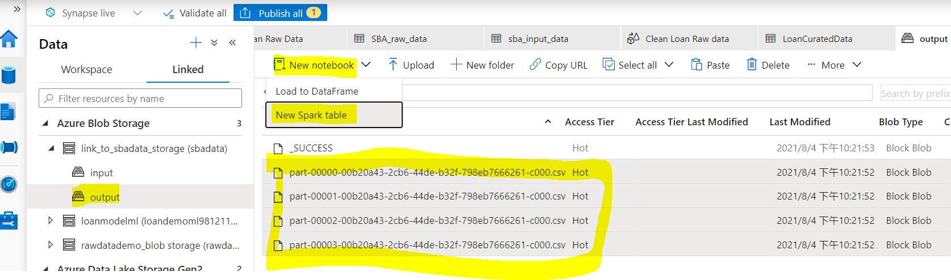

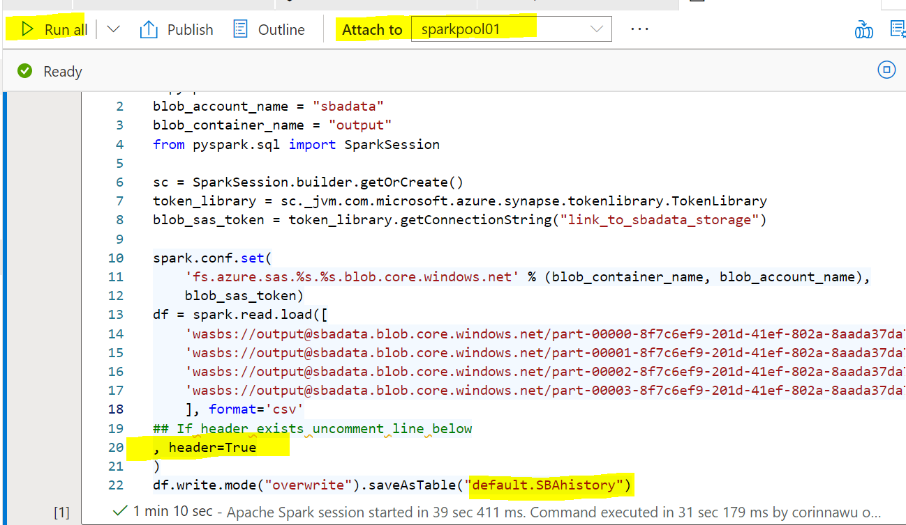

Once execution is complete, click refresh to check table in Spark pool:

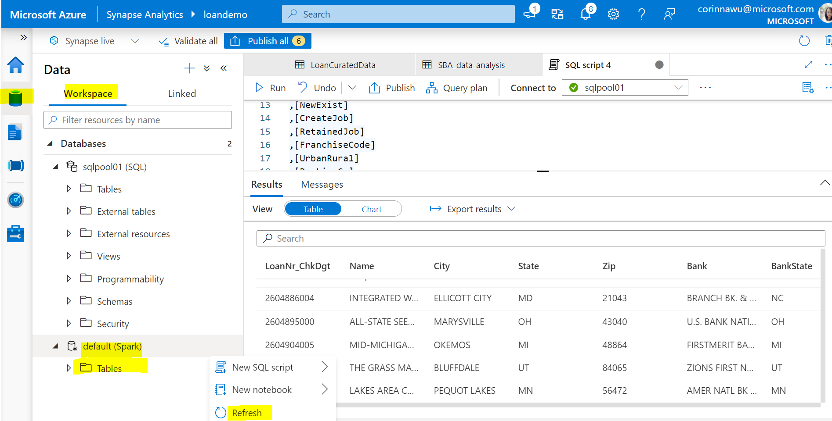

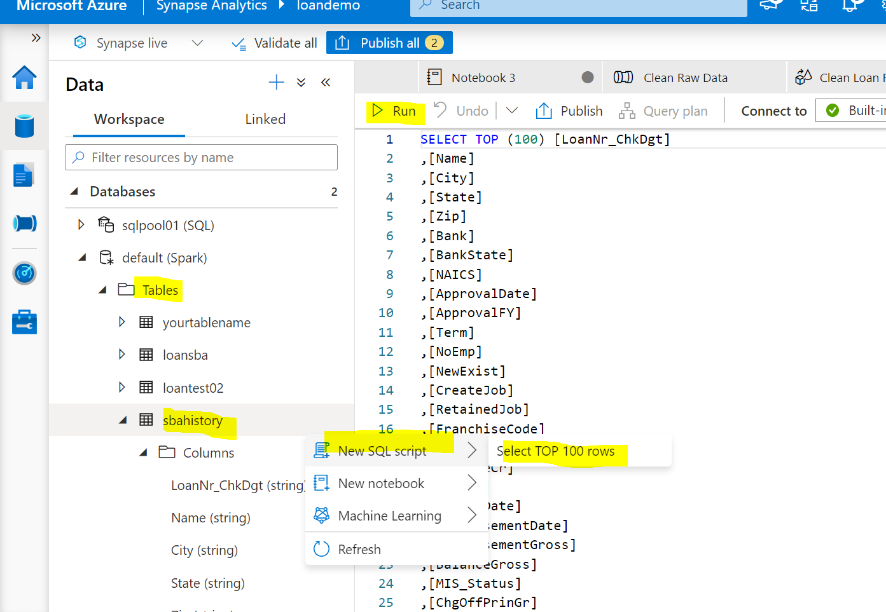

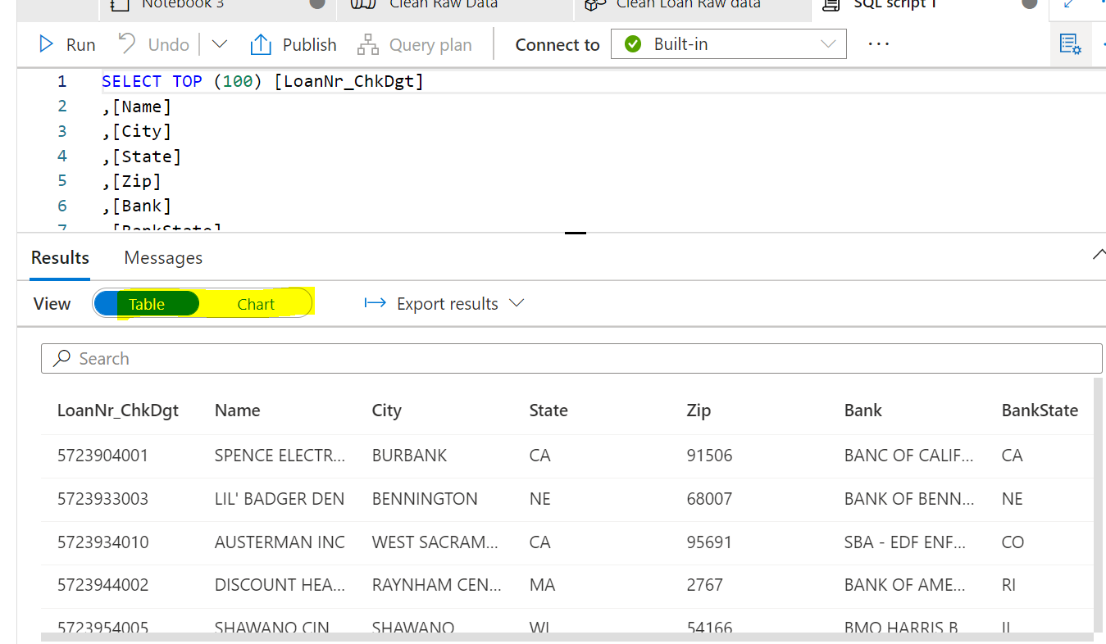

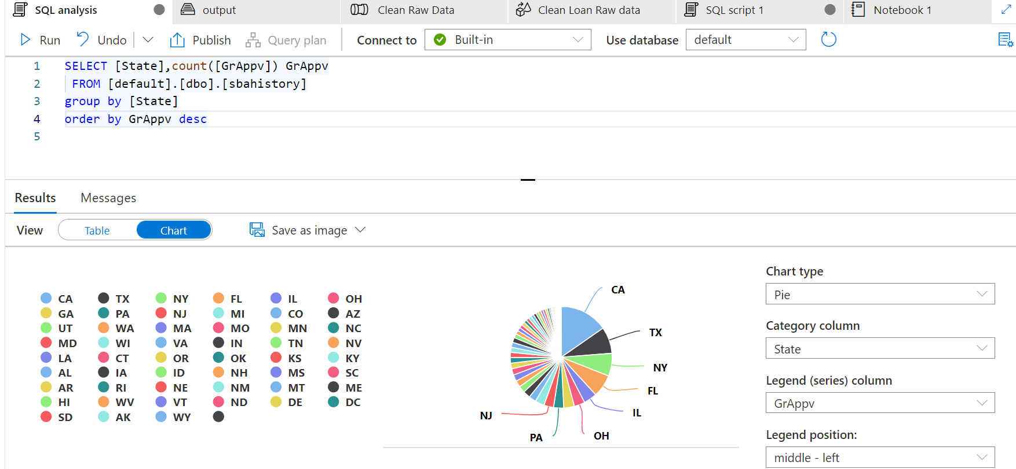

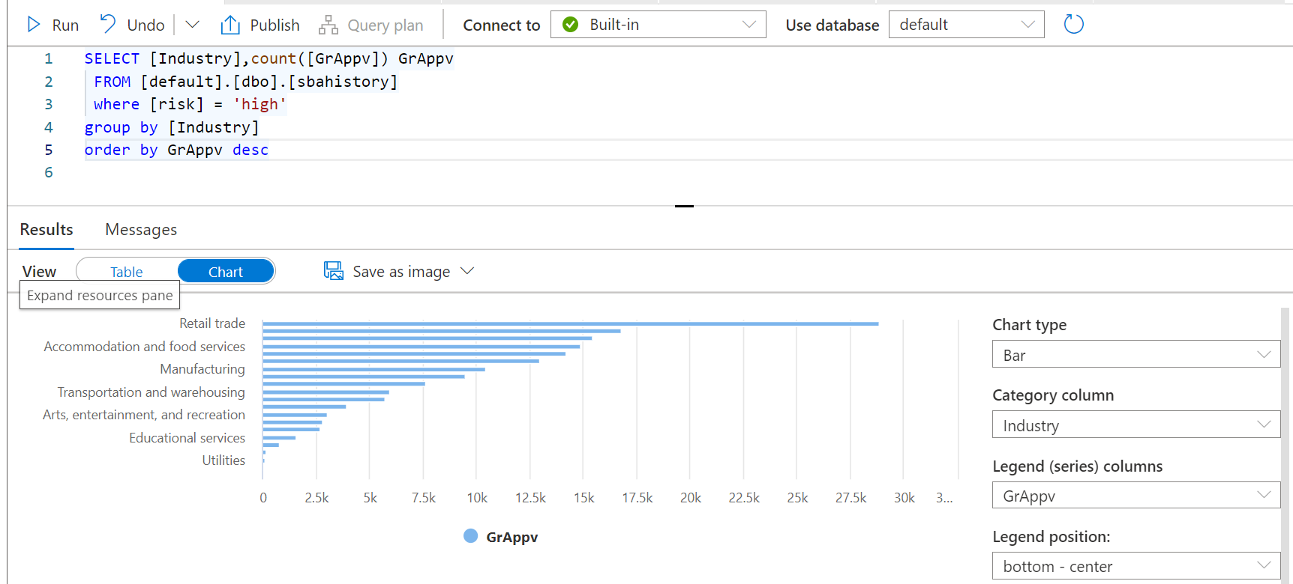

Launch to Power BI desktop:

(download free version from: [Power BI Desktop—Interactive Reports | Microsoft Power BI](https://powerbi.microsoft.com/en-us/desktop/))

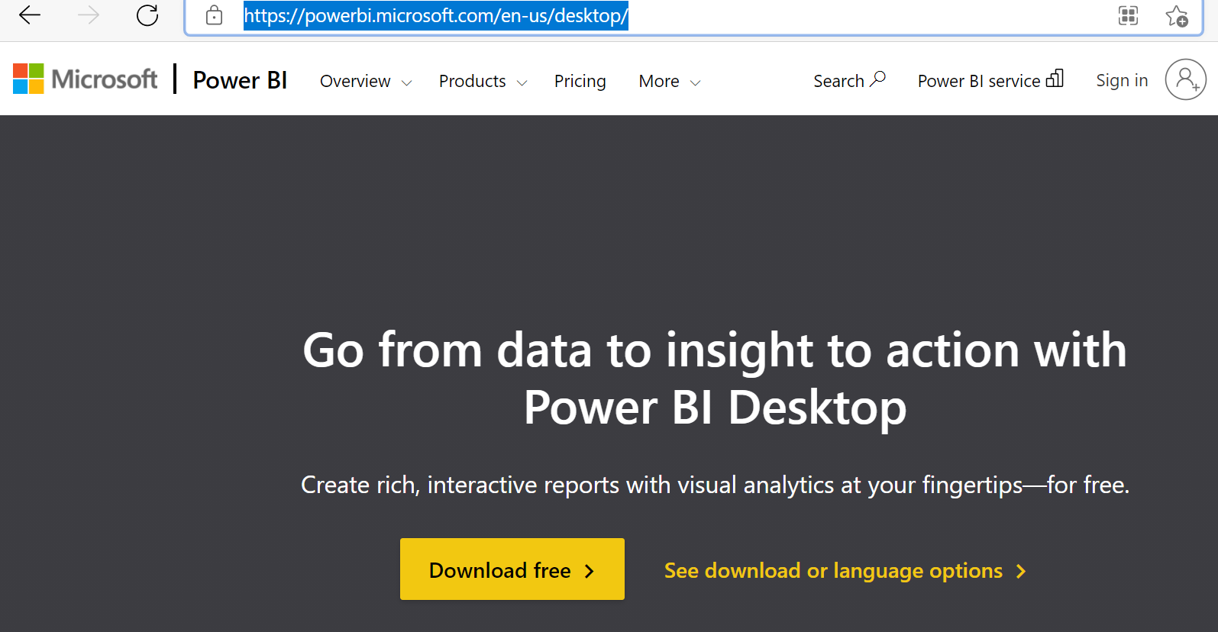

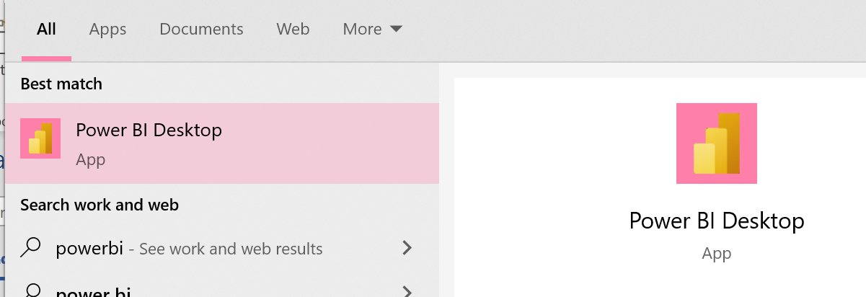

Goto file ->Get data

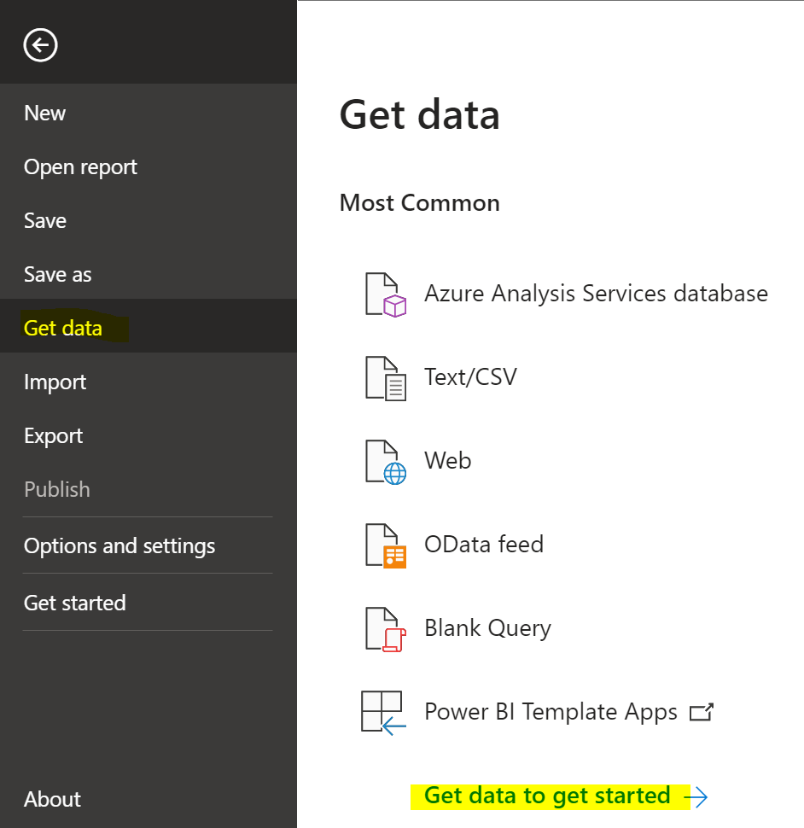

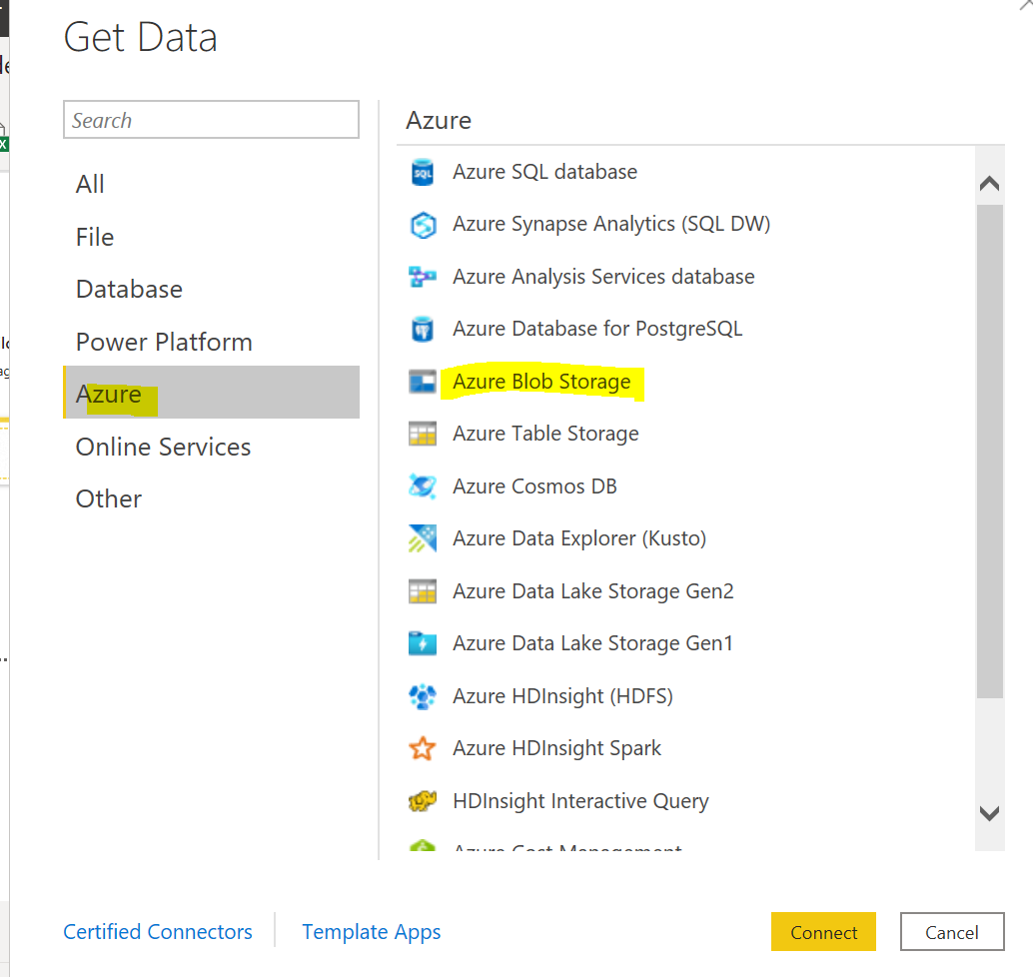

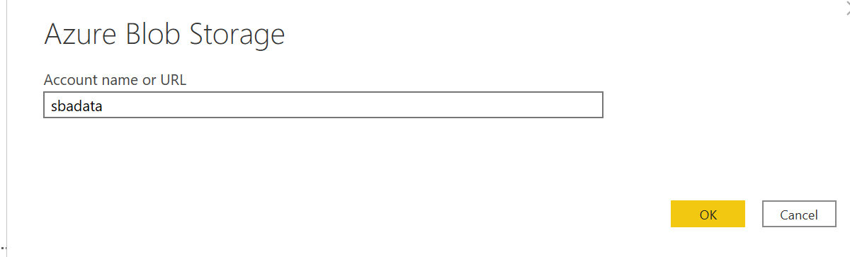

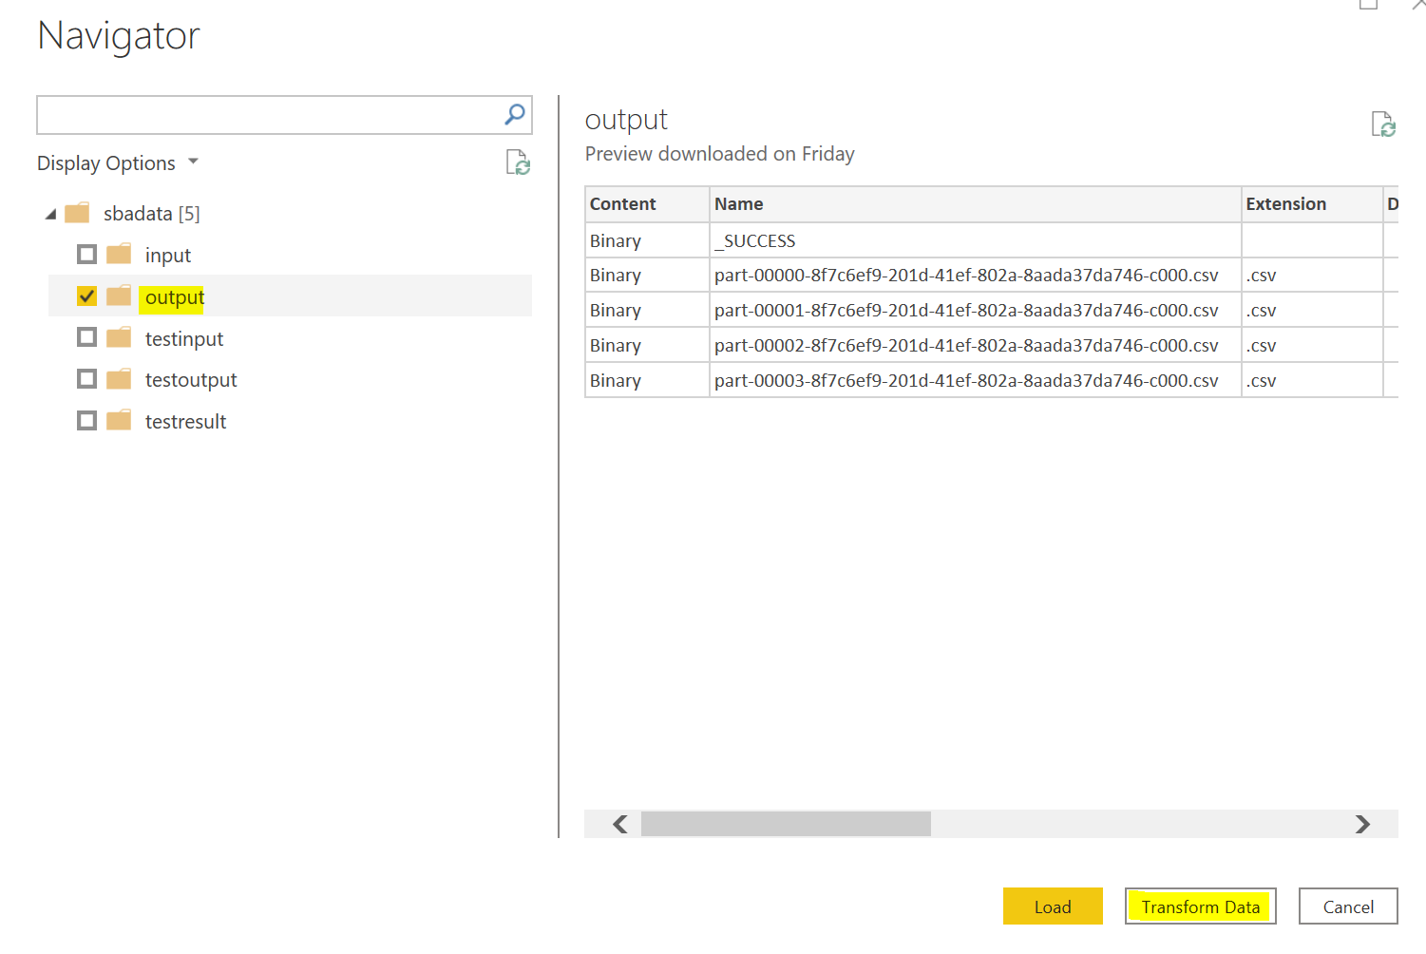

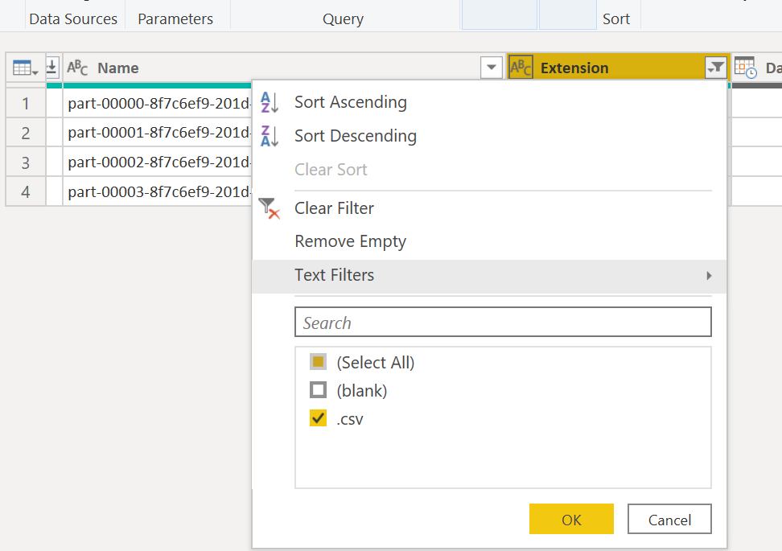

Click merge file icon:

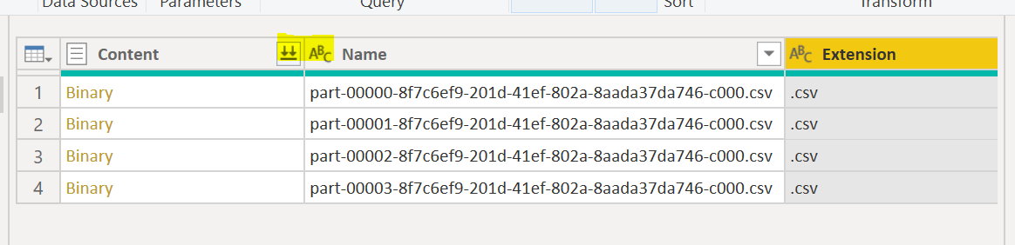

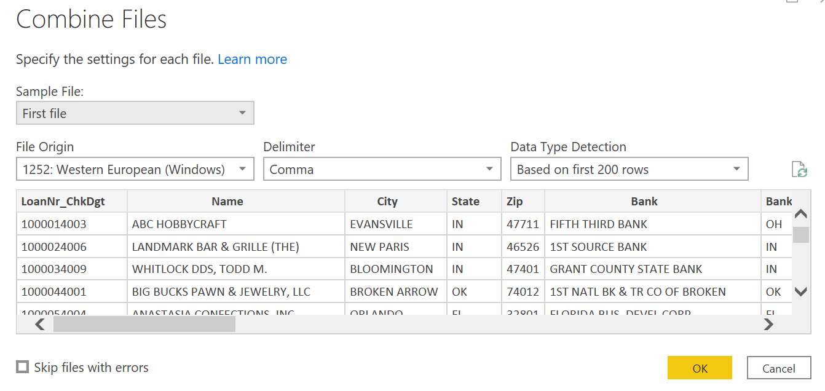

Close and Apply，create dashboard:

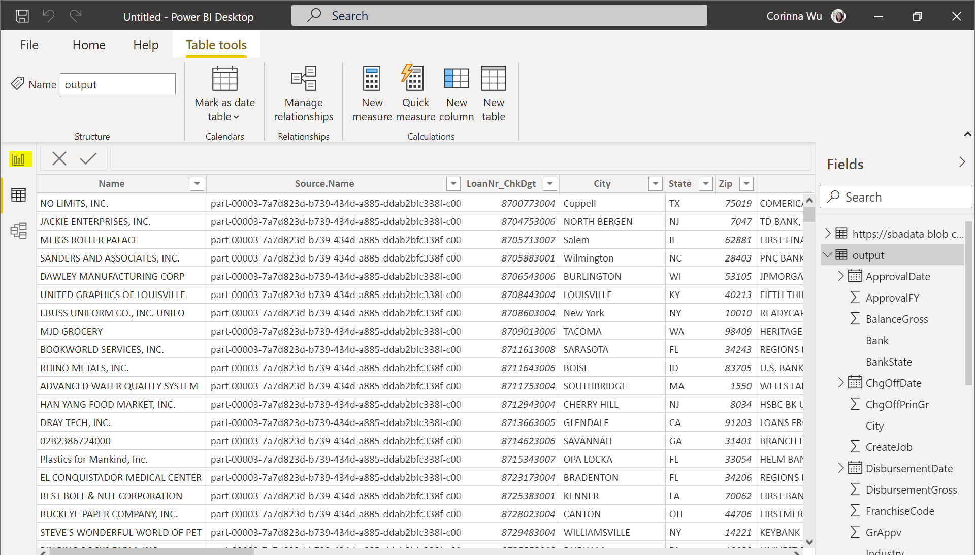

Using the visualization tools to build your own dashboard on power BI, for example:

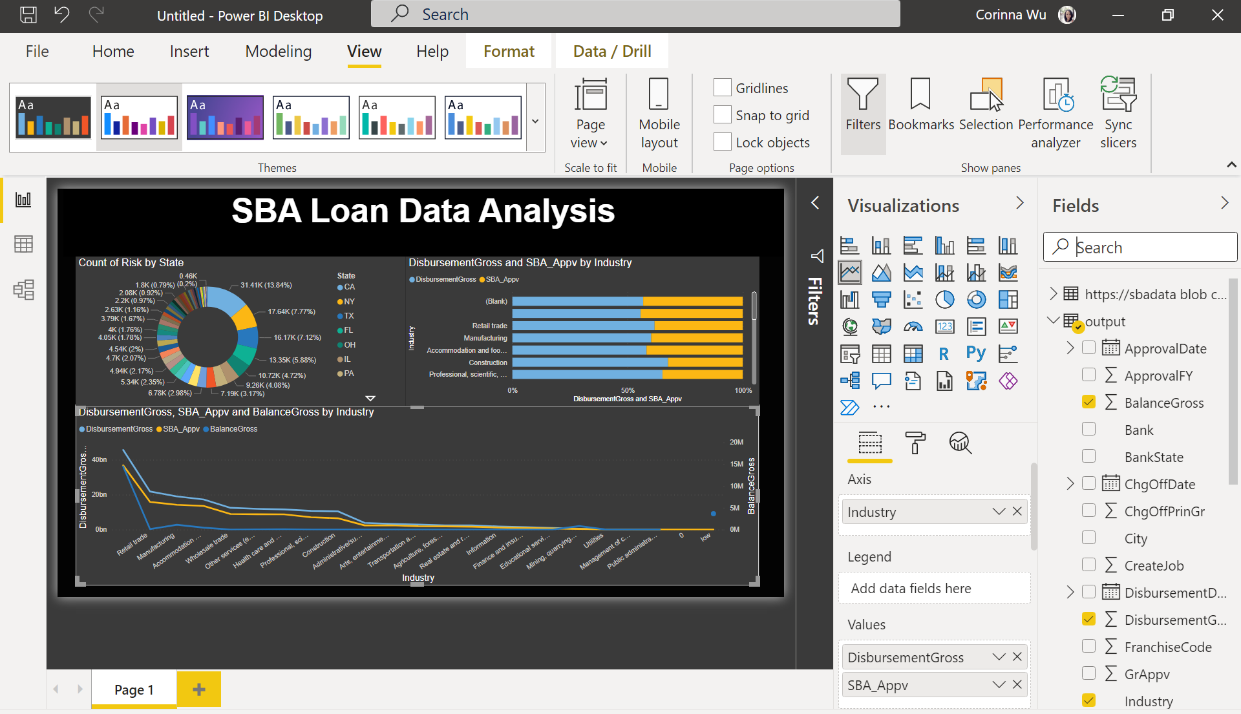

### Step 8: Create Azure Machine Learning Workspace

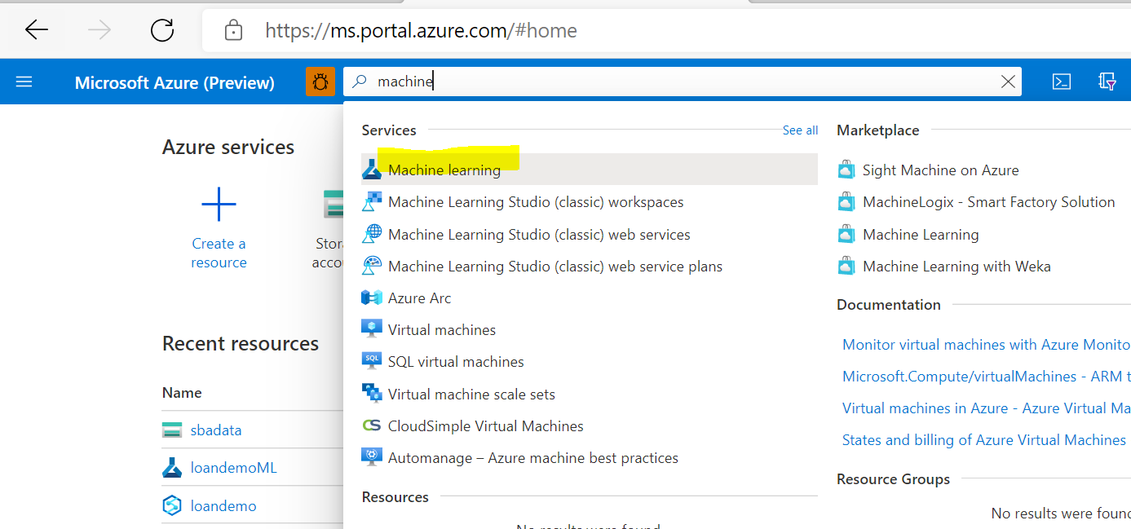

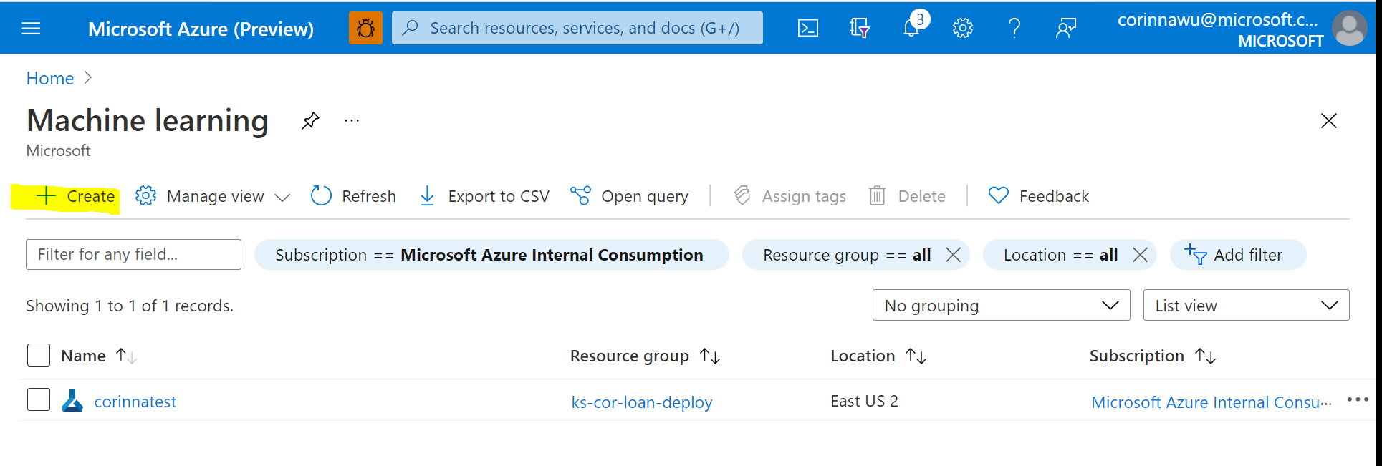

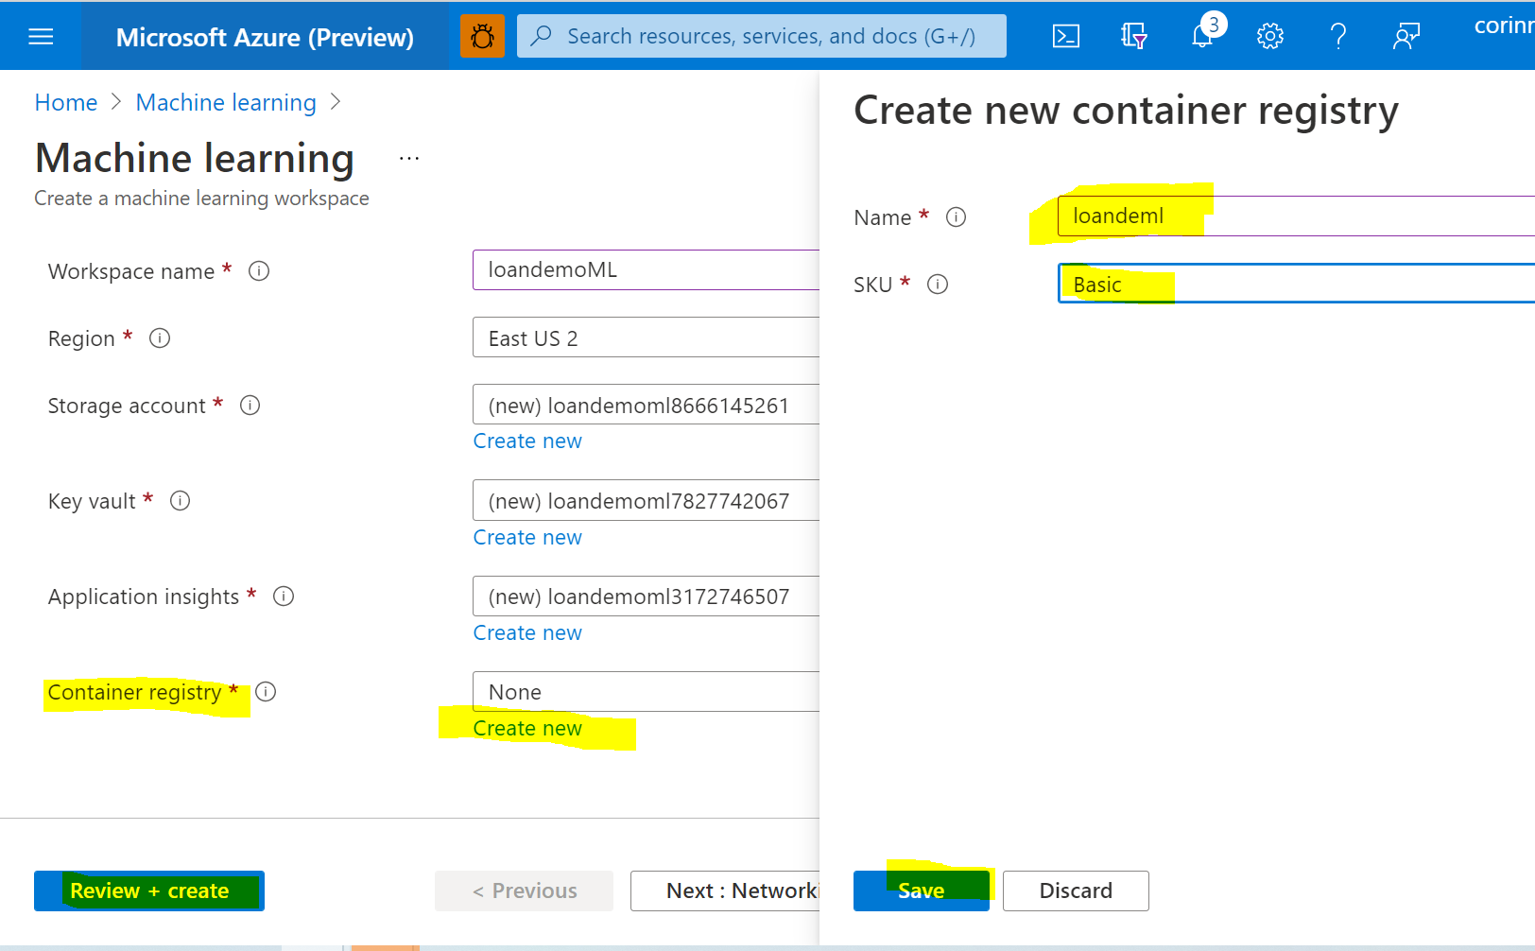

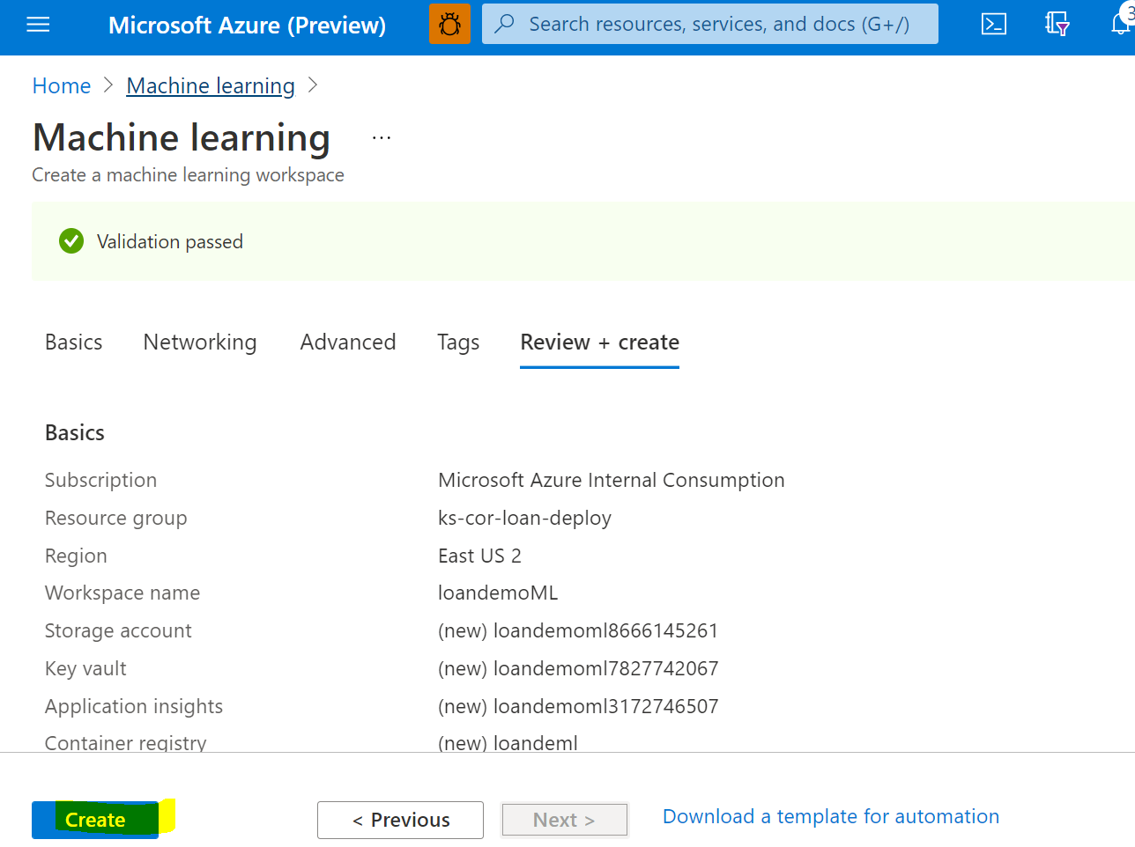

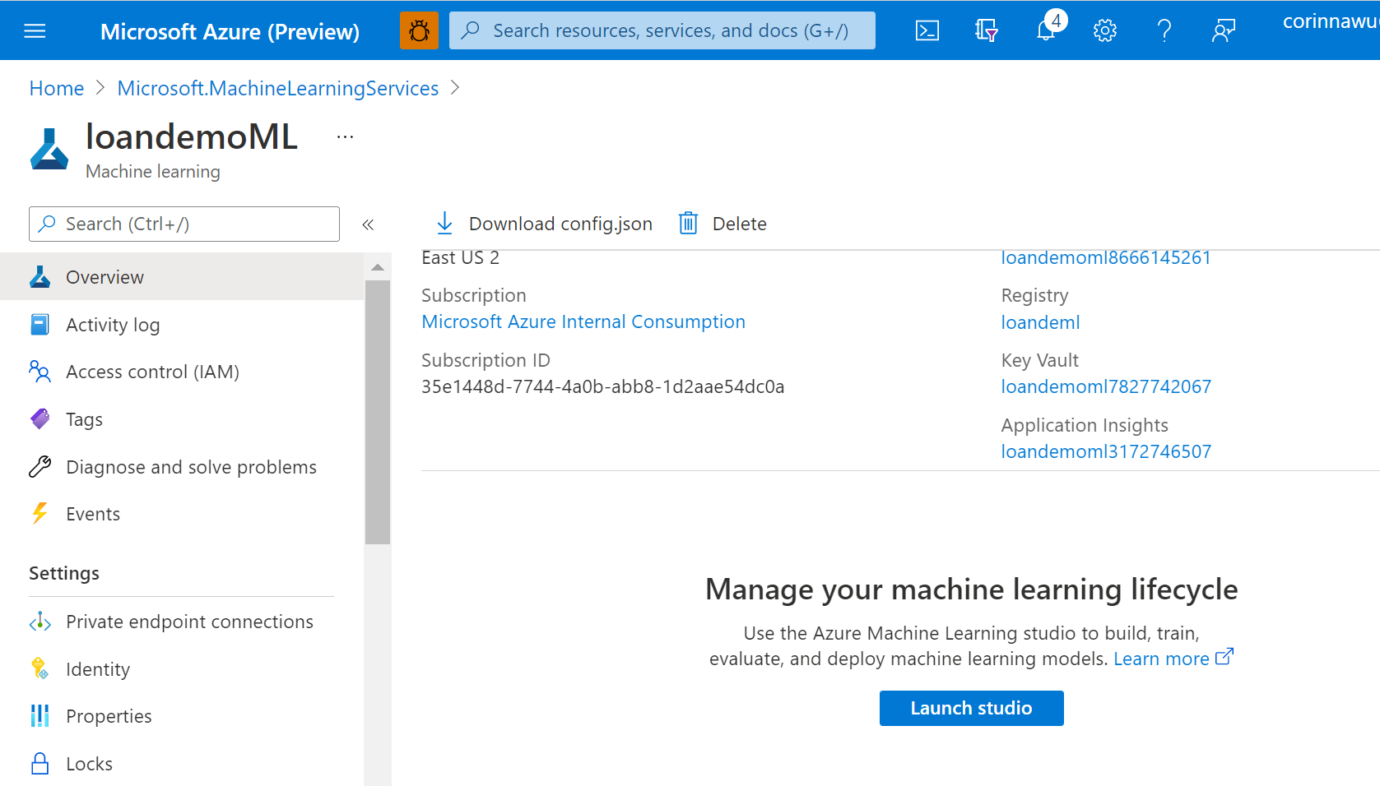

Create compute resource

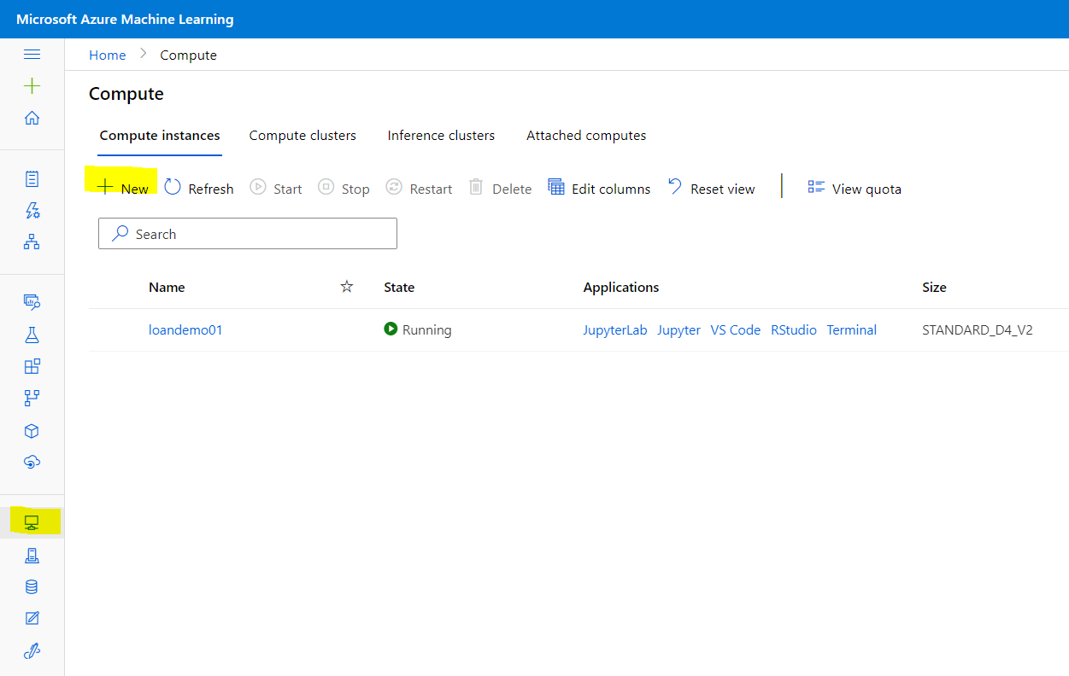

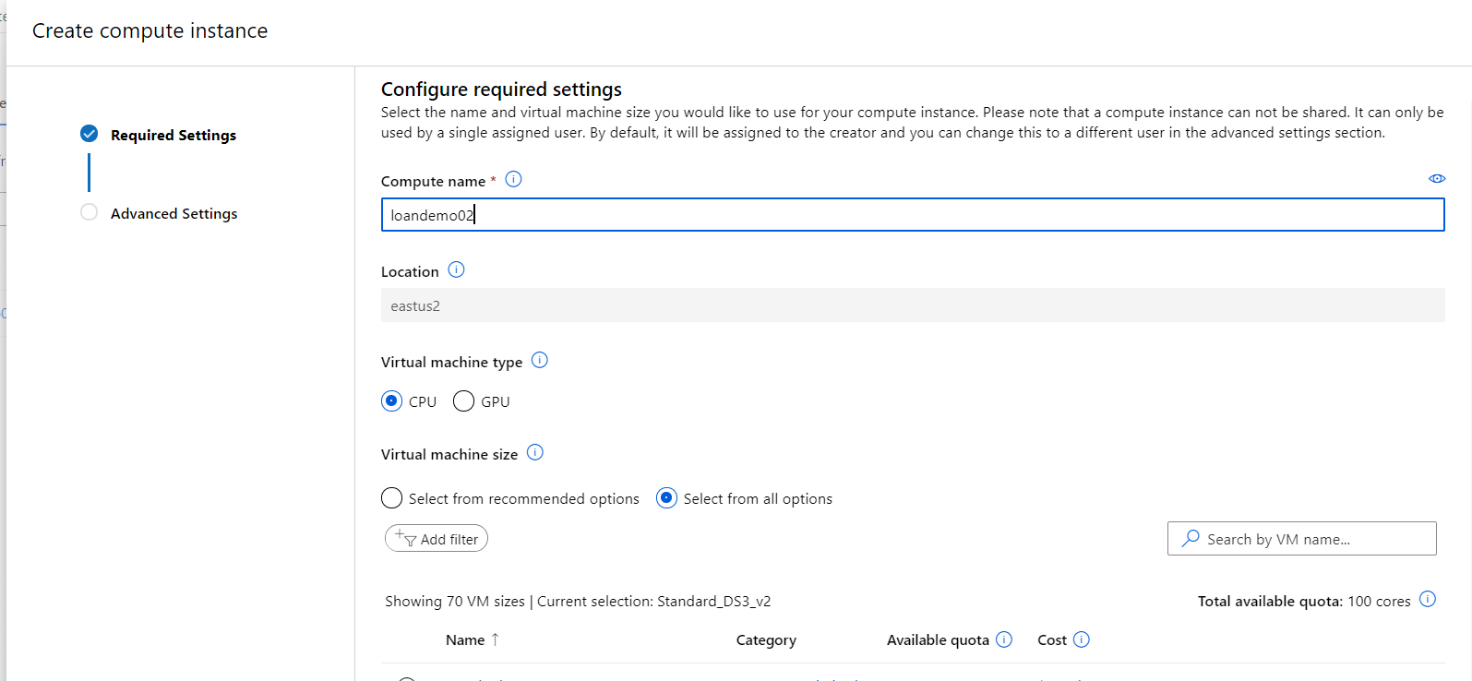

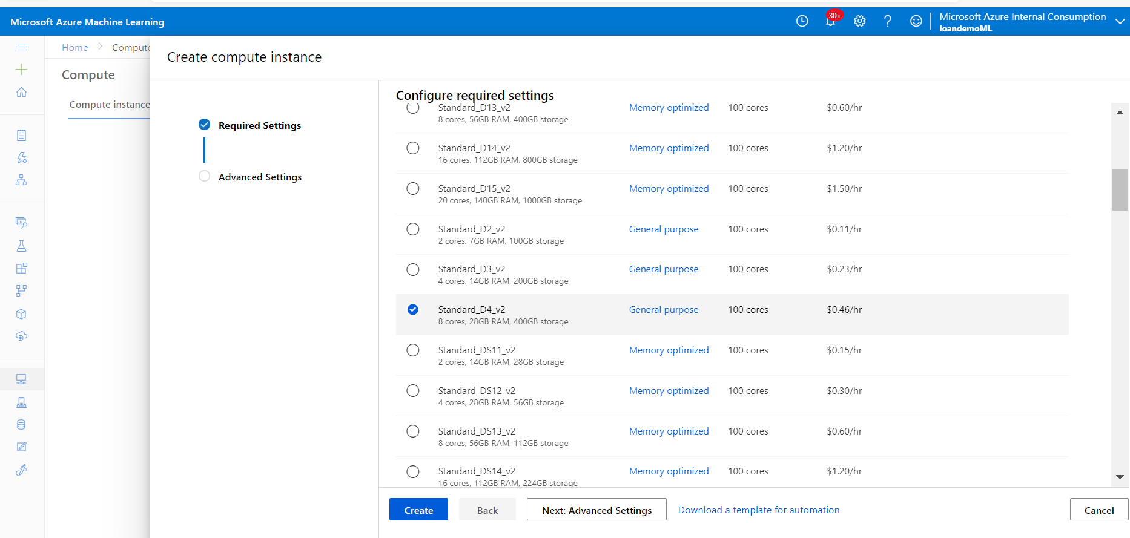

### Step 9: Create Data Store and Dataset in Machine Learning Studio

Go to Storage Account and copy the account key:

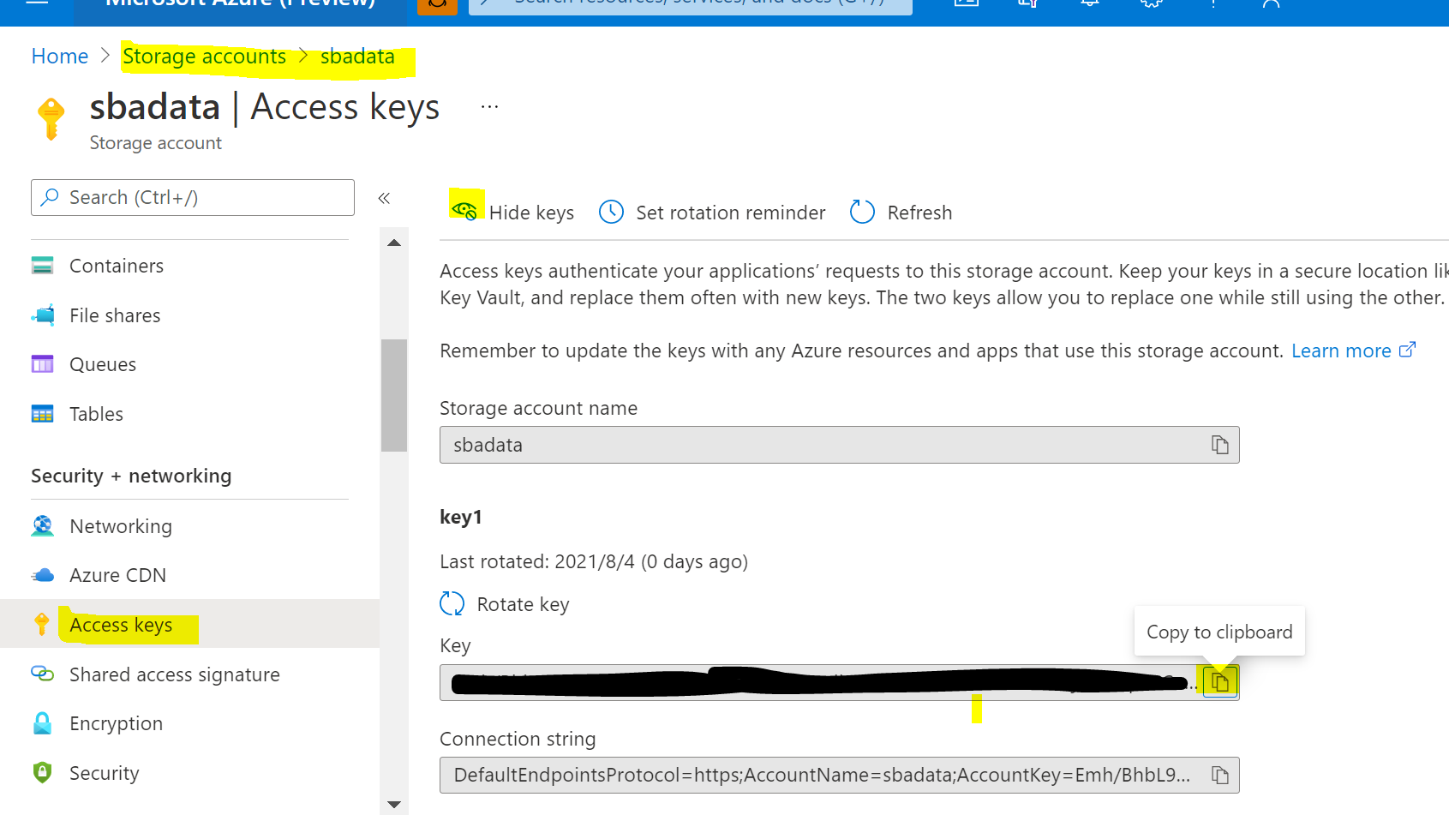

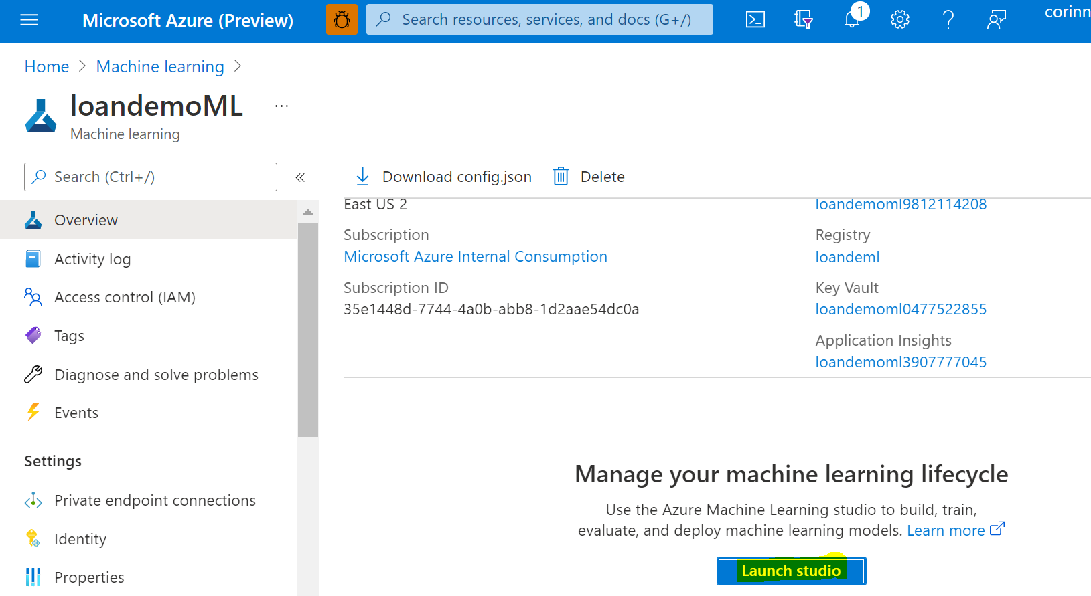

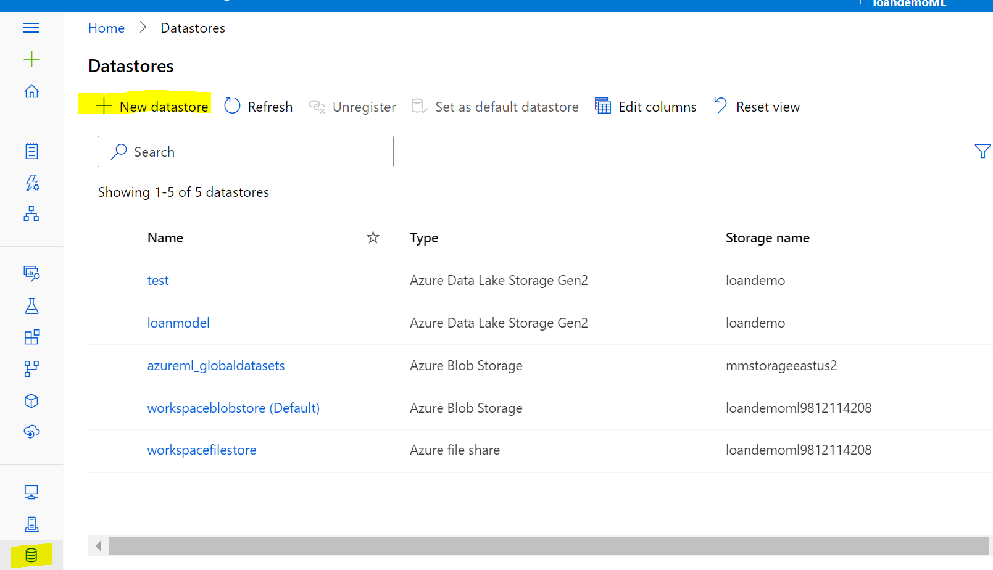

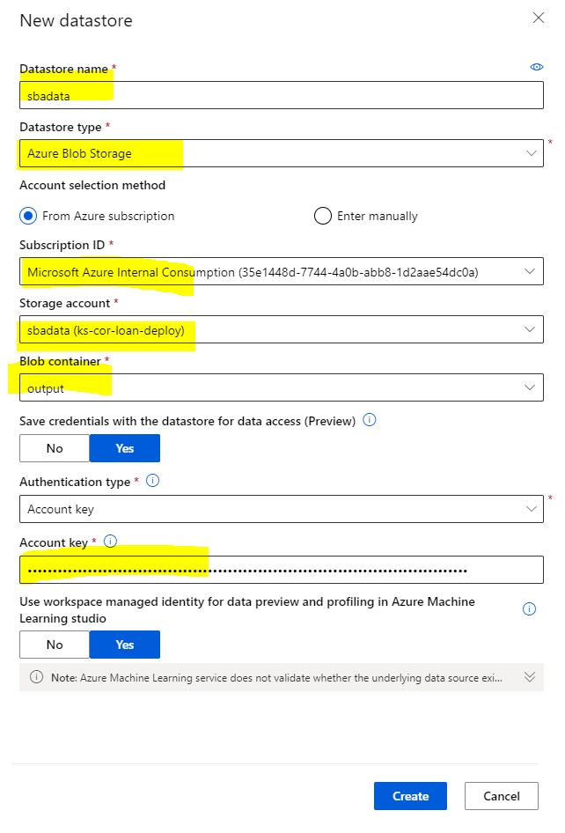

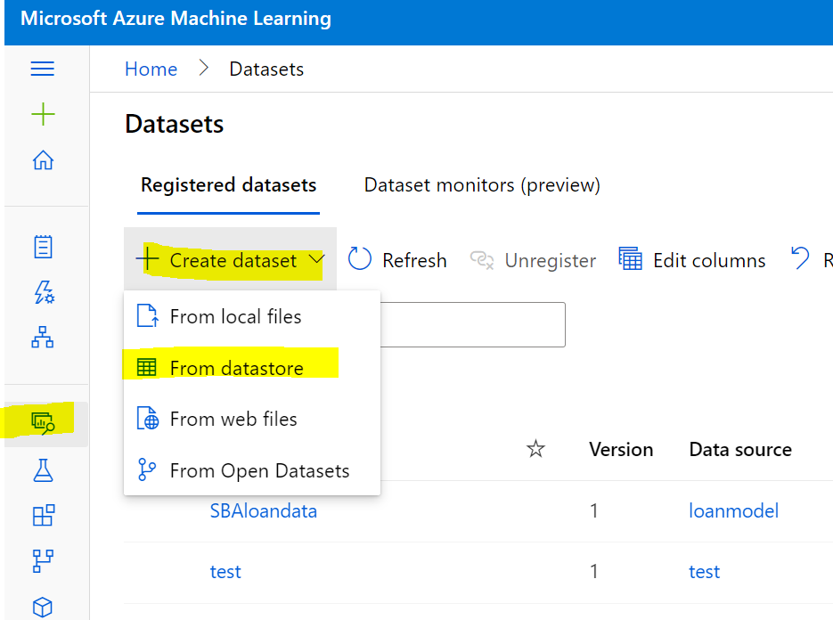

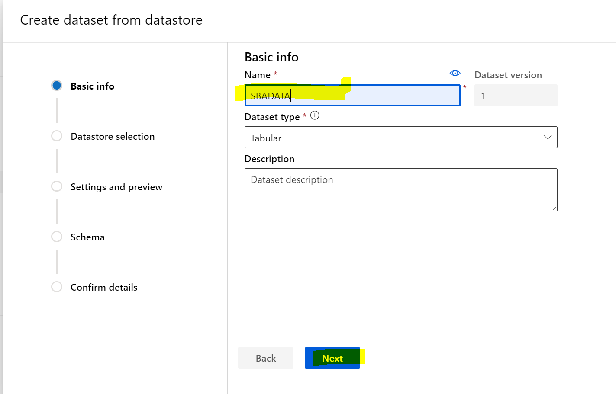

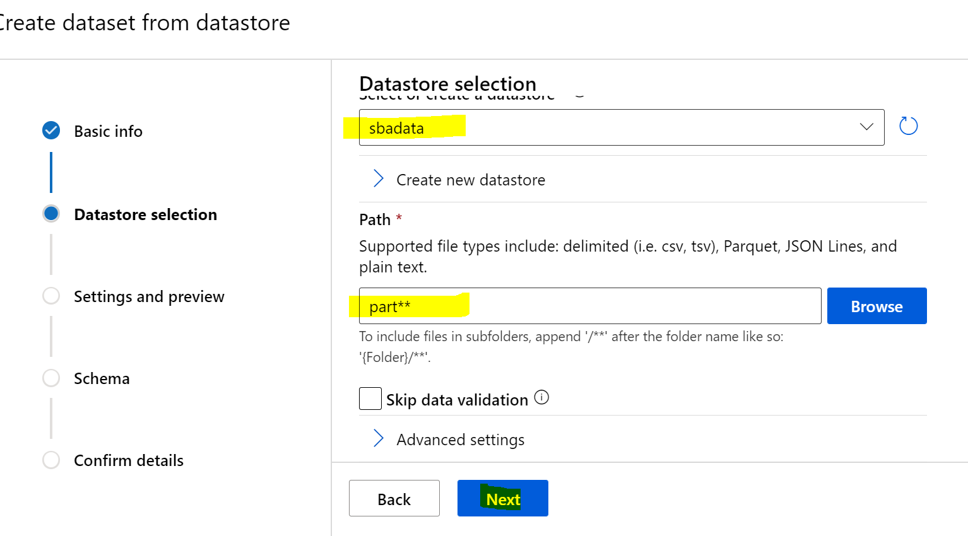

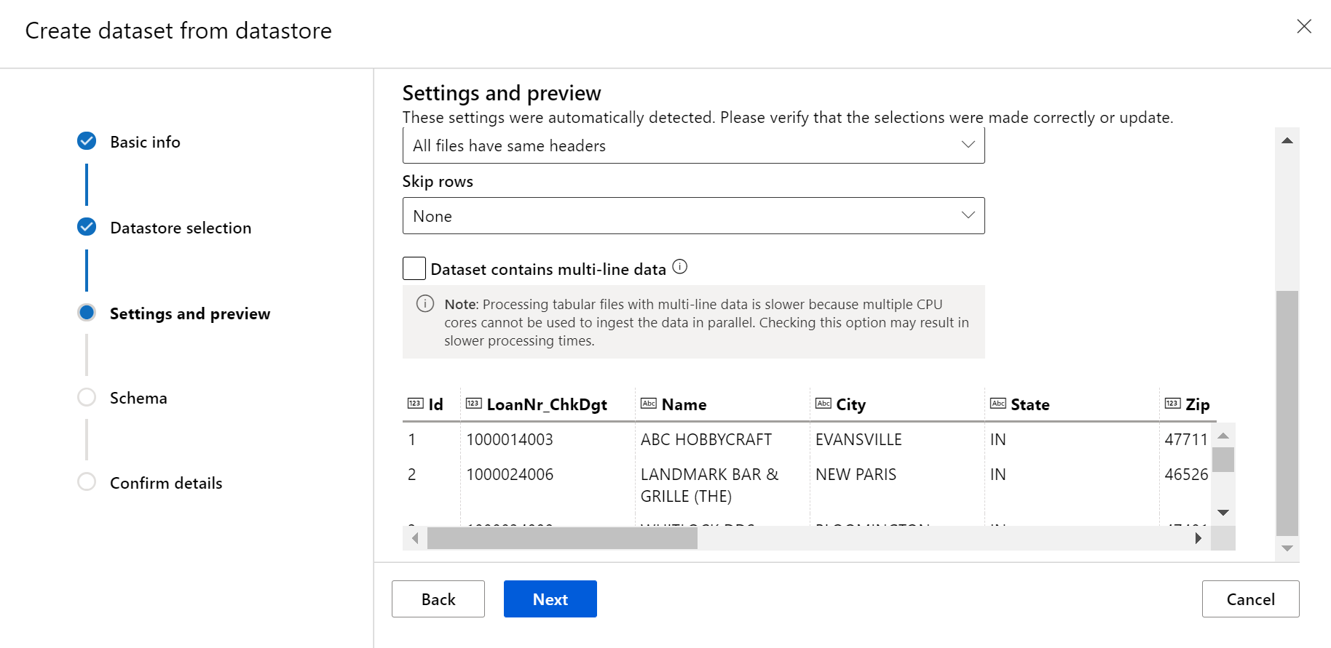

Check & correct the schema:

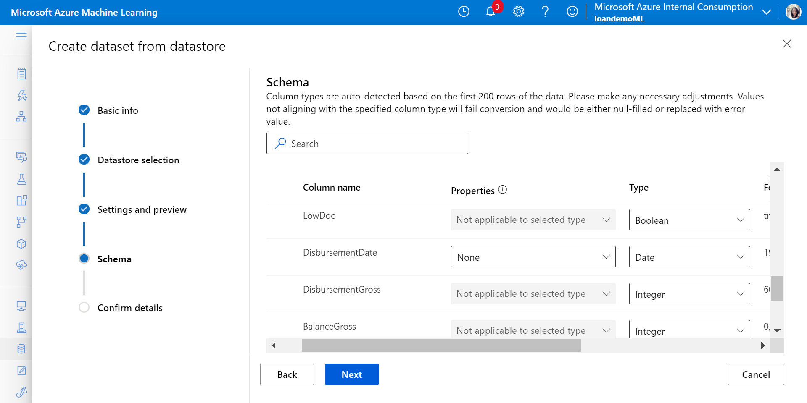

Click next and create.

After creation, view the dataset:

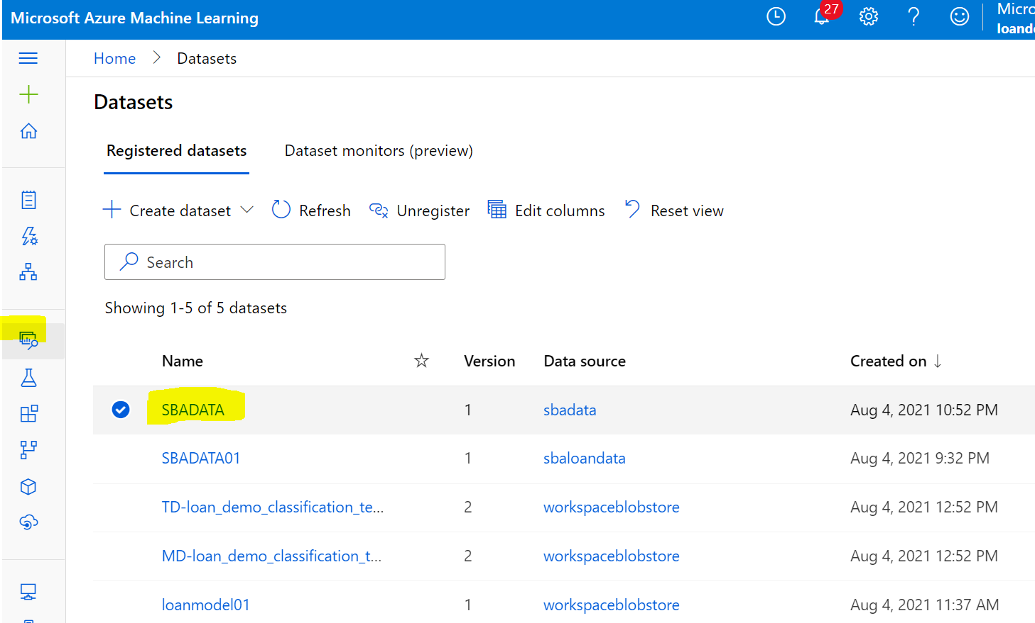

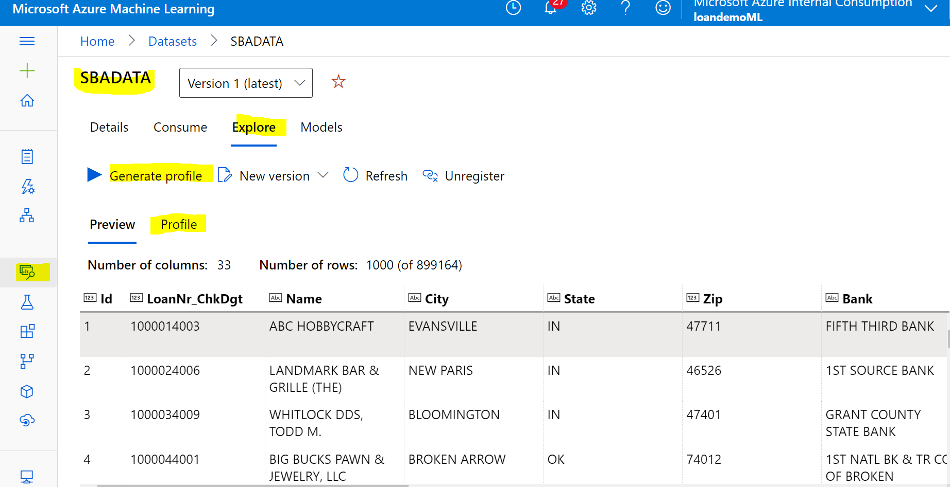

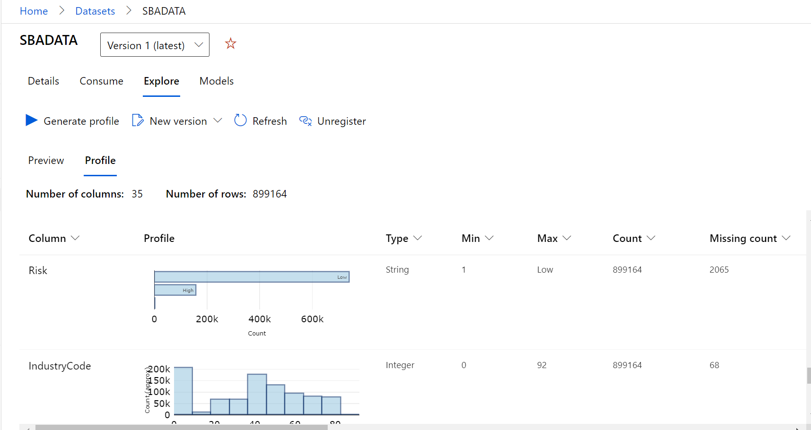

### Step 10: Create New Pipeline for ML Training Model

1) Predict Loan Risk via Classification Model

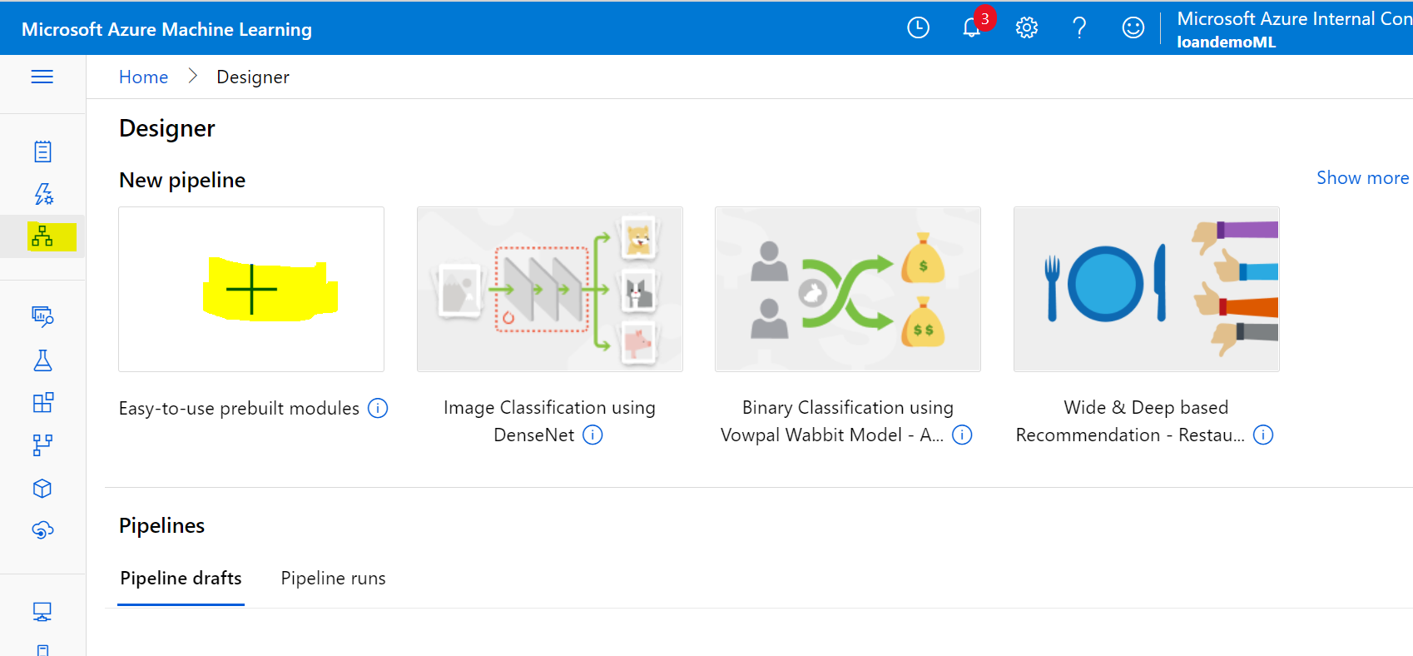

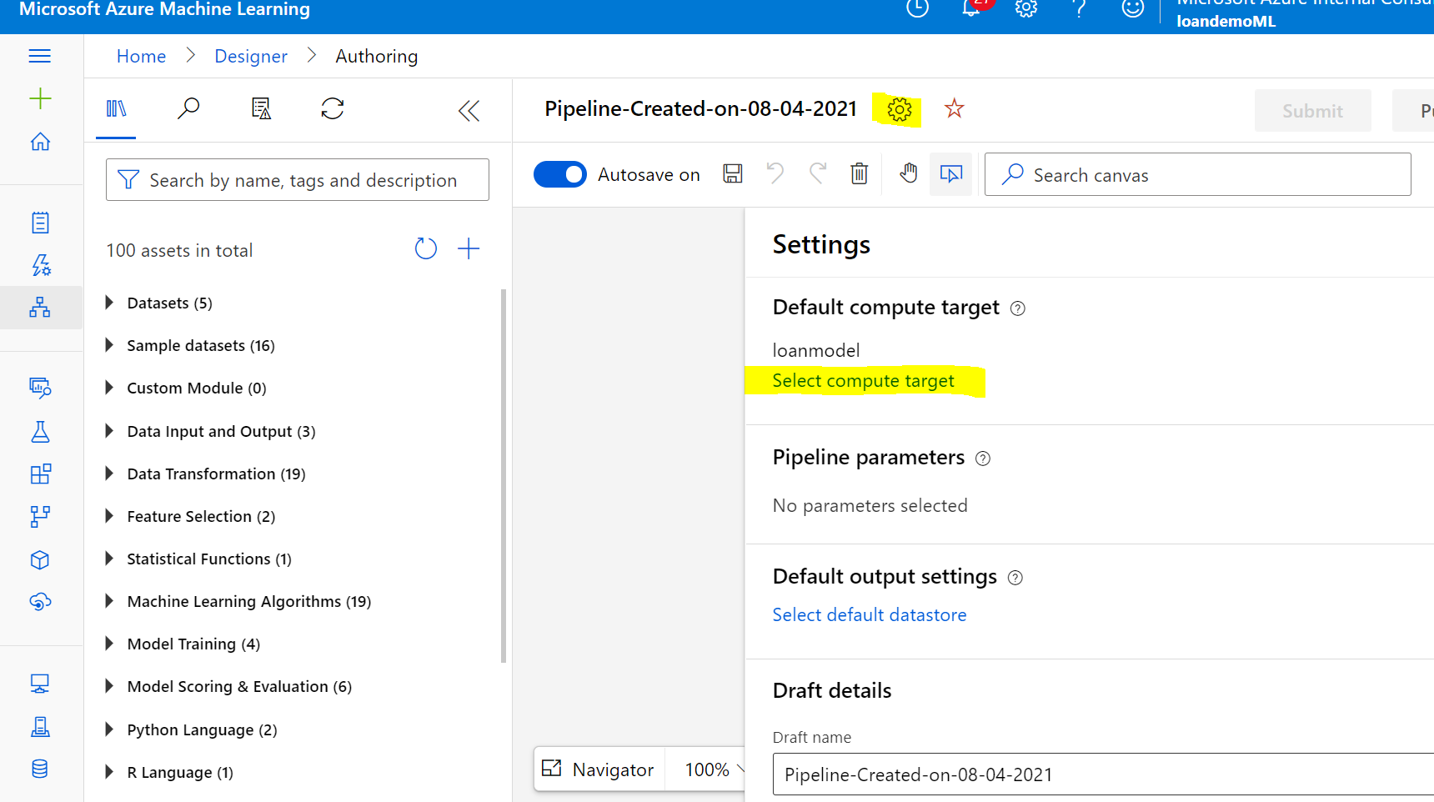

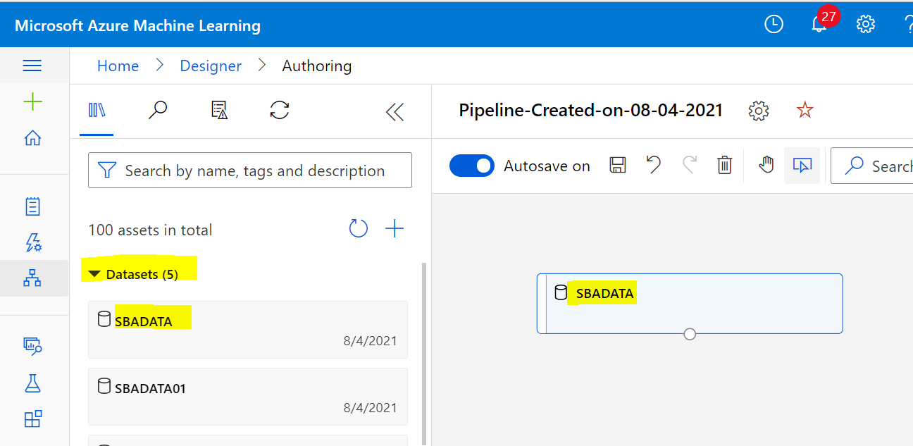

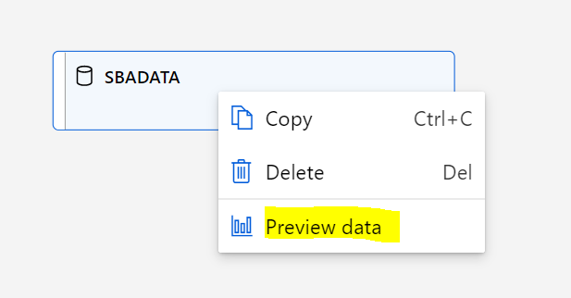

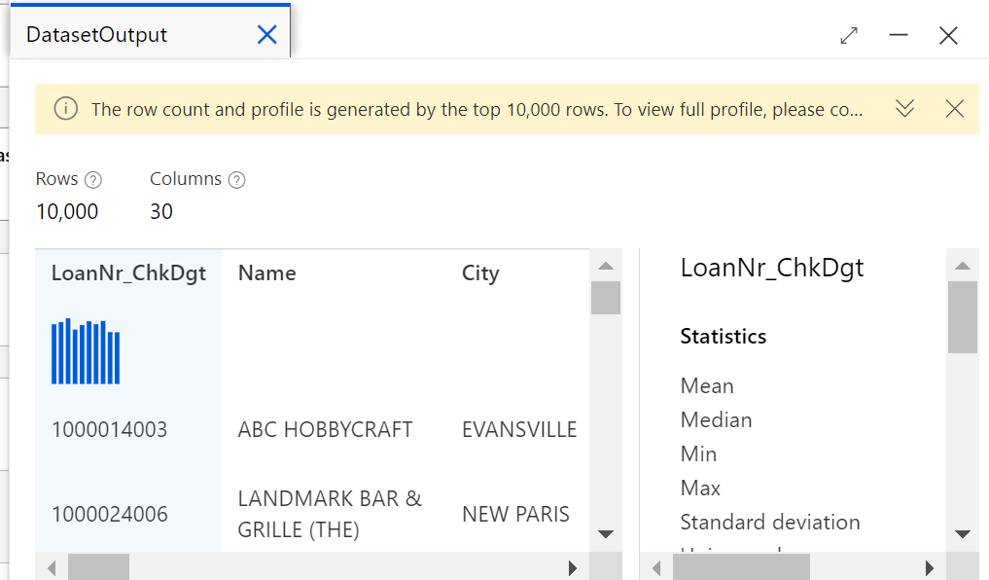

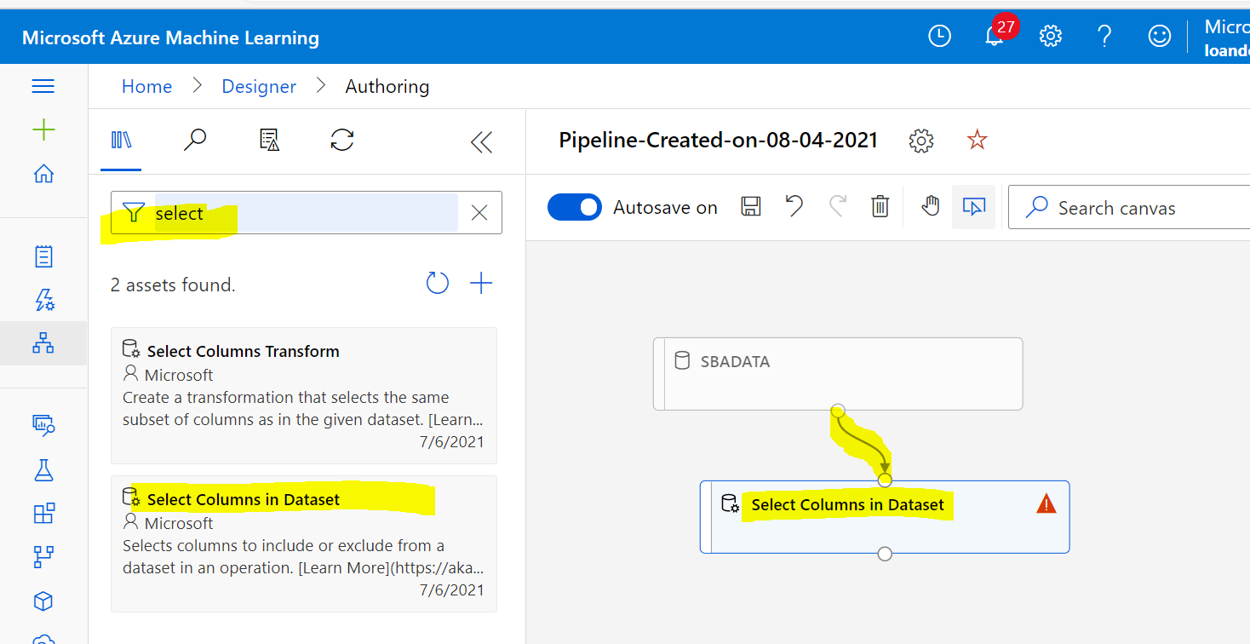

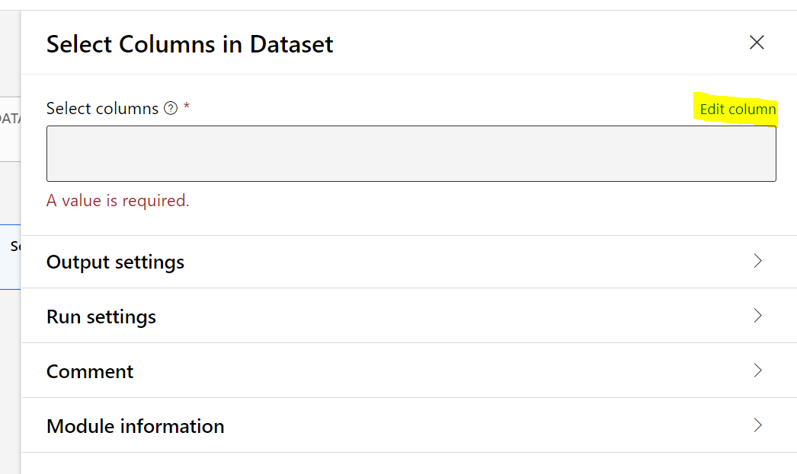

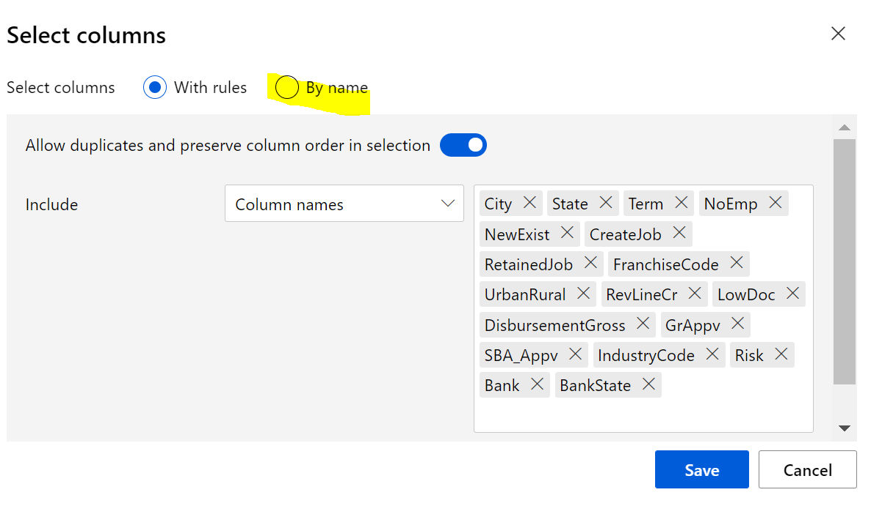

City,State,Bank,BankState,Term,NoEmp,NewExist,CreateJob,RetainedJob,FranchiseCode,UrbanRural,RevLineCr,LowDoc,DisbursementGross,GrAppv,SBA_Appv,IndustryCode,Risk

Pick predictors by name: (include column: RISK too)

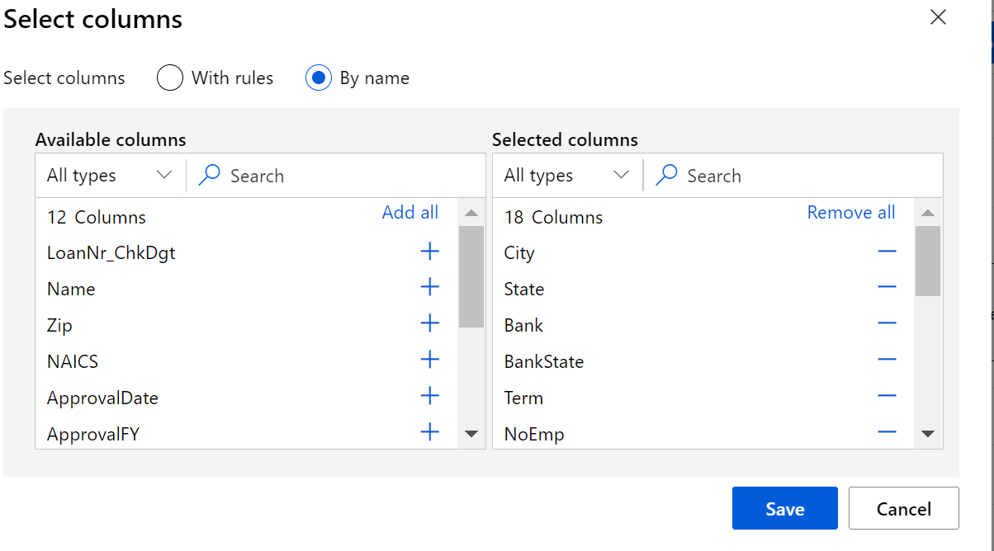

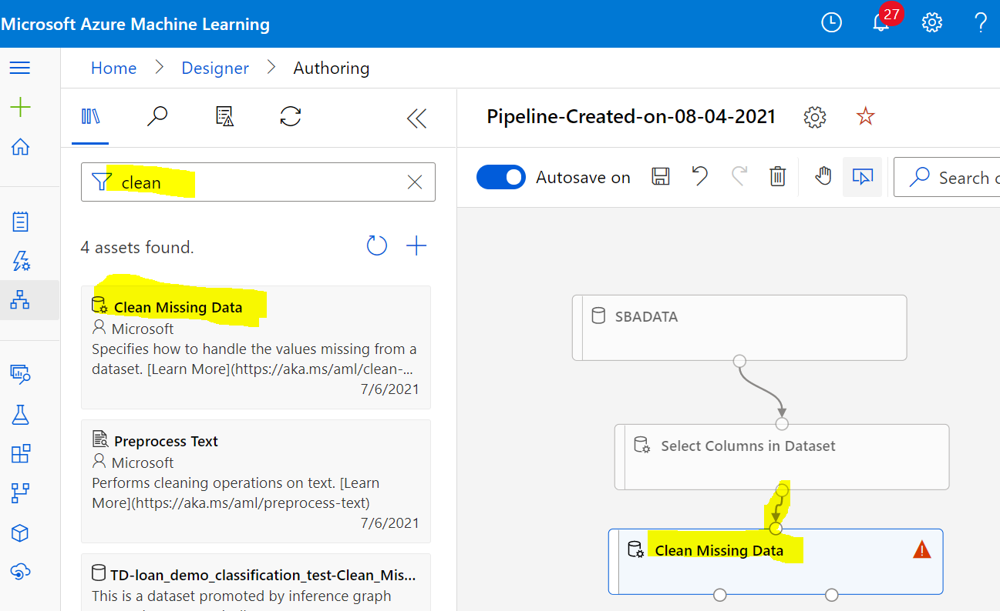

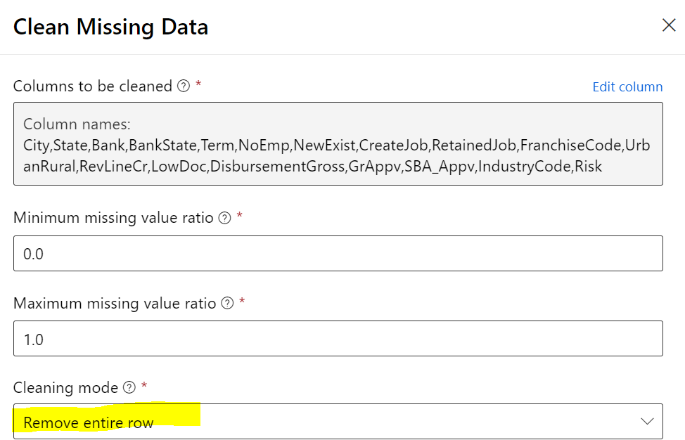

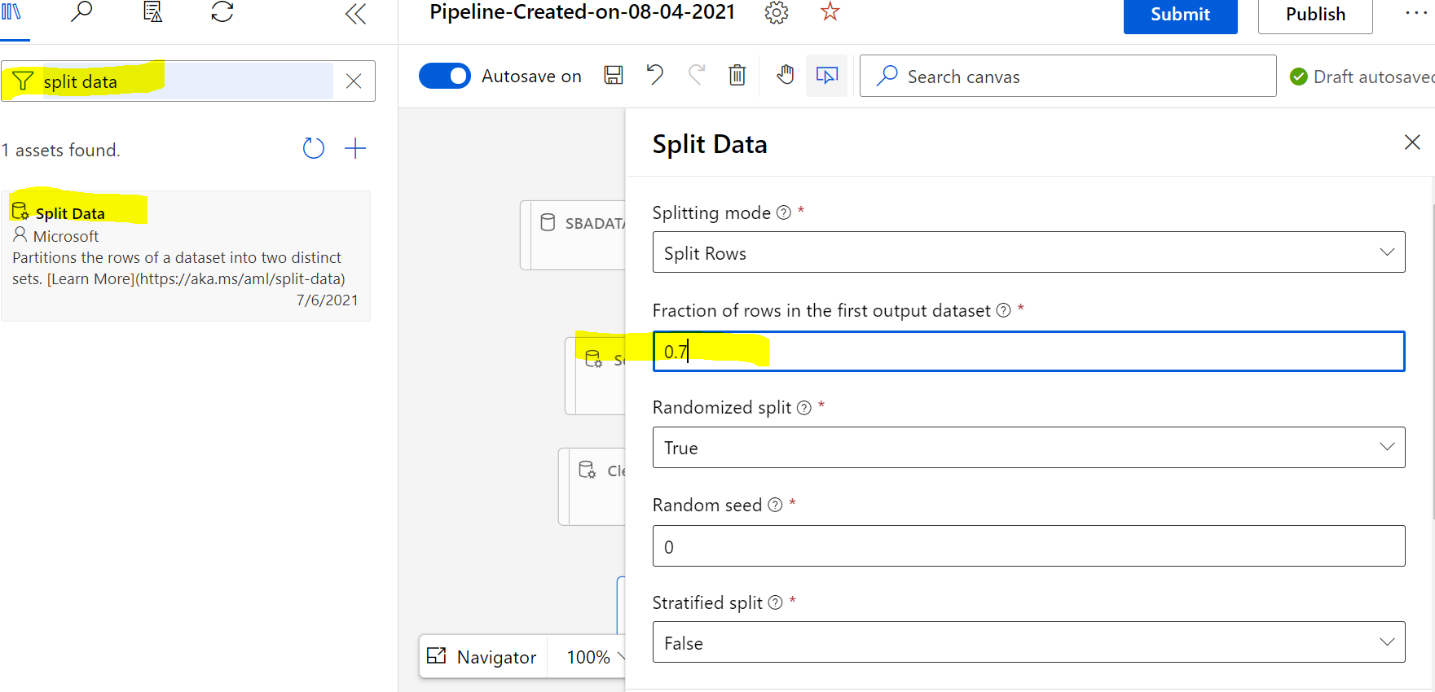

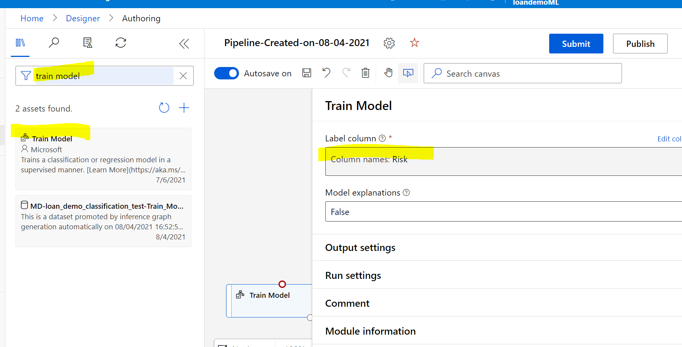

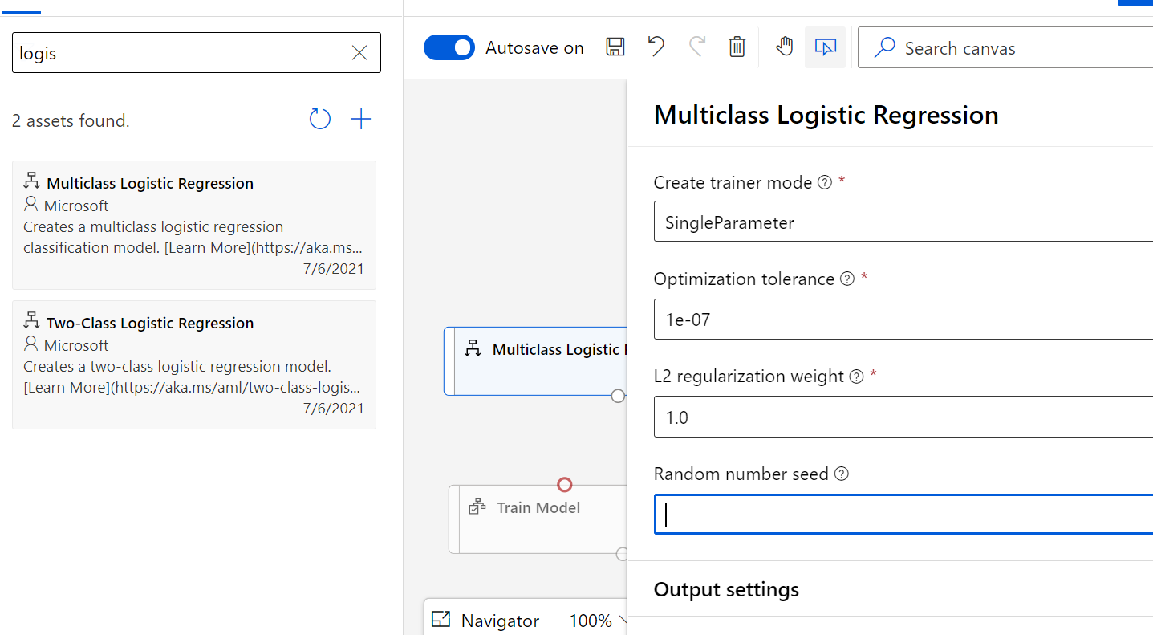

**You can refer to **the Azure Machine Learning Algorithm Cheat Sheet** tochoose the right algorithm from the designer for a predictive analytics model.

[Machine Learning Algorithm Cheat Sheet - designer - Azure Machine Learning | Microsoft Docs](https://docs.microsoft.com/en-us/azure/machine-learning/algorithm-cheat-sheet)

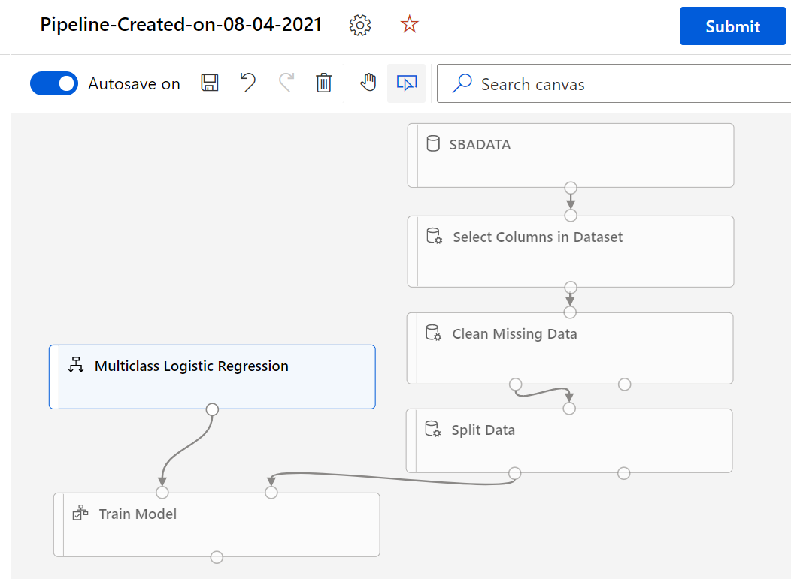

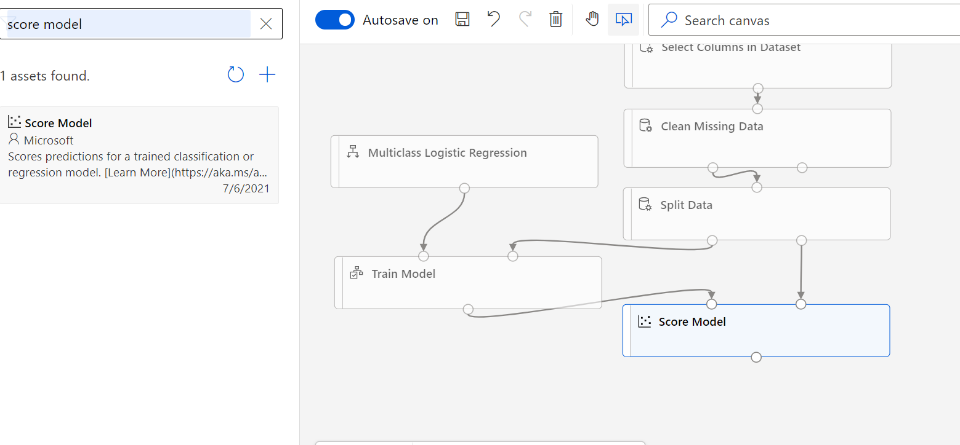

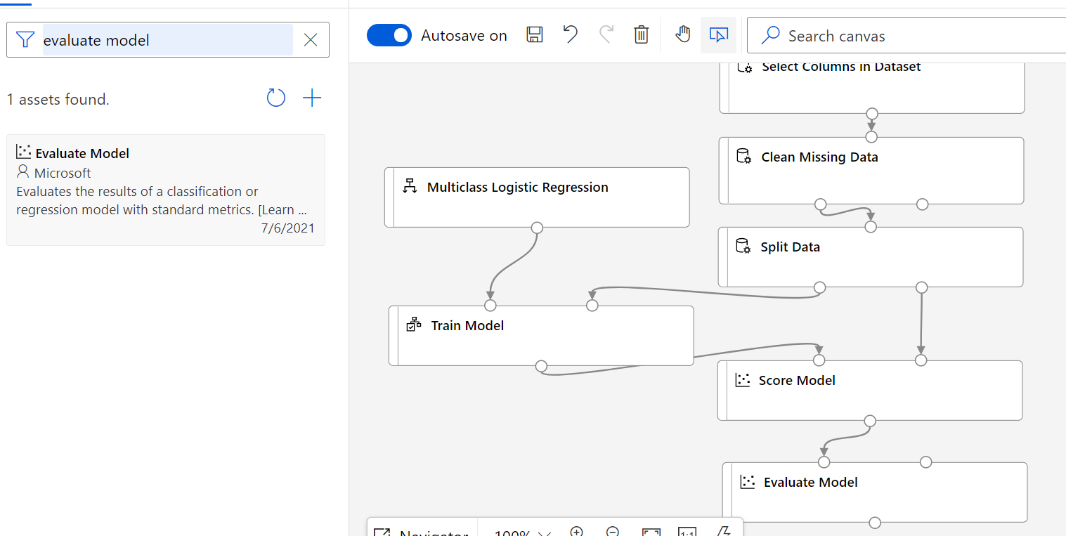

Update the pipeline description:

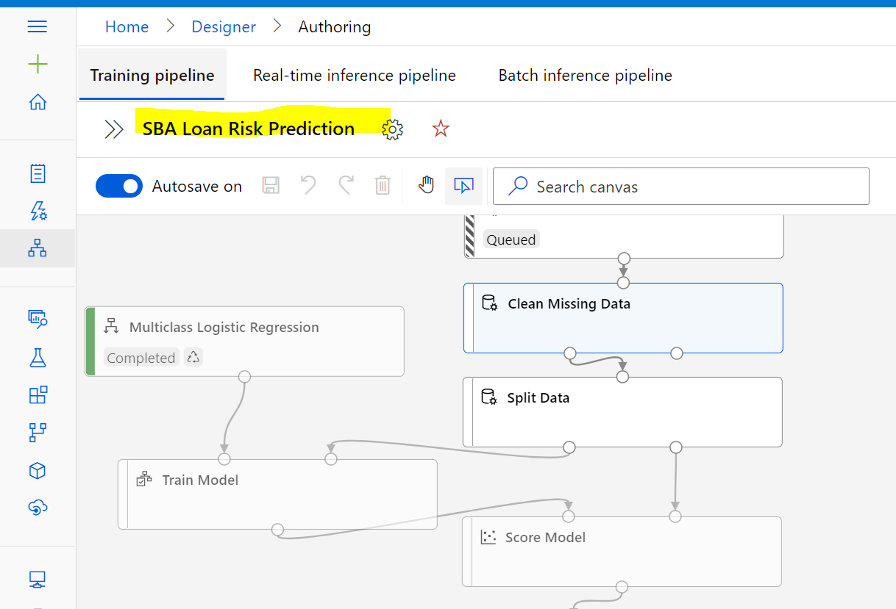

Submit (Create new pipeline for first time run)

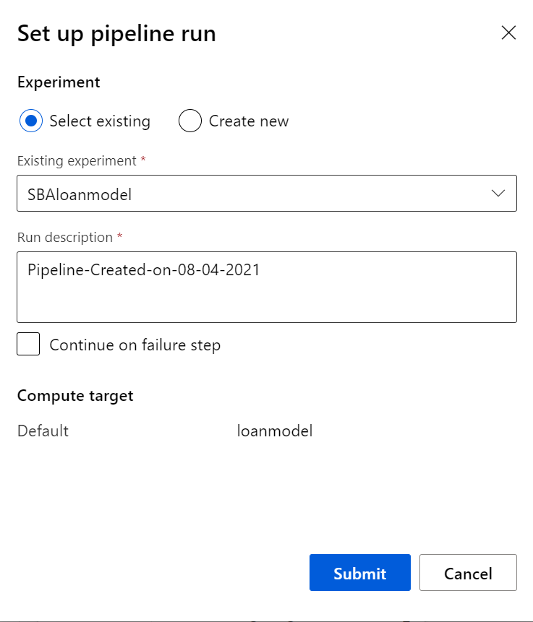

Monitor the job results:

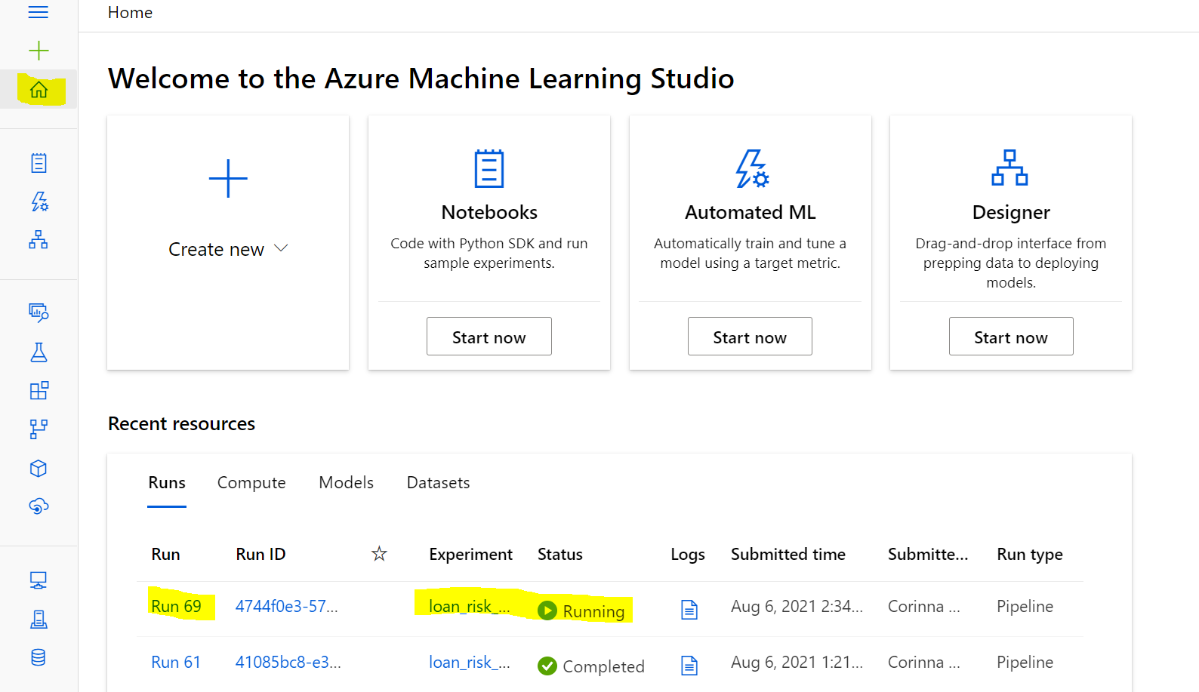

Or check status via Experiments:

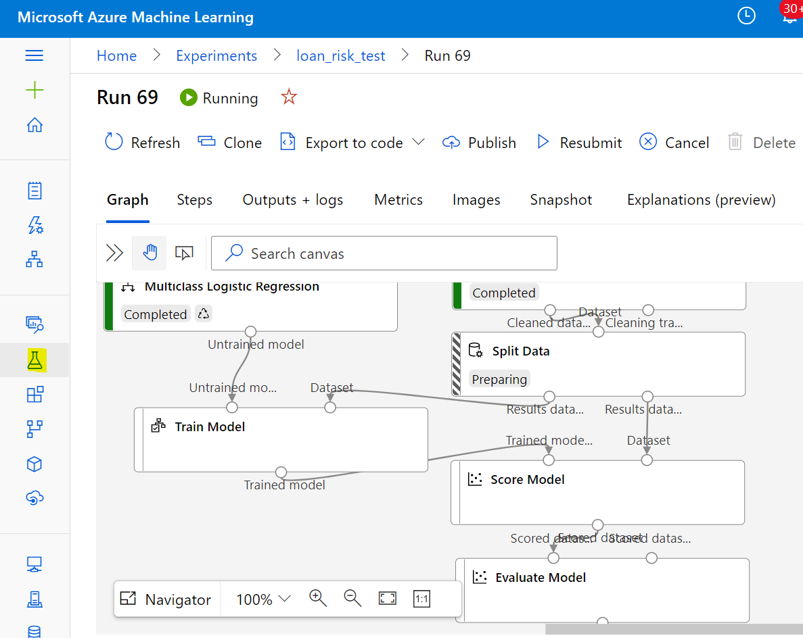

When job is complete, evaluate the Model Result:

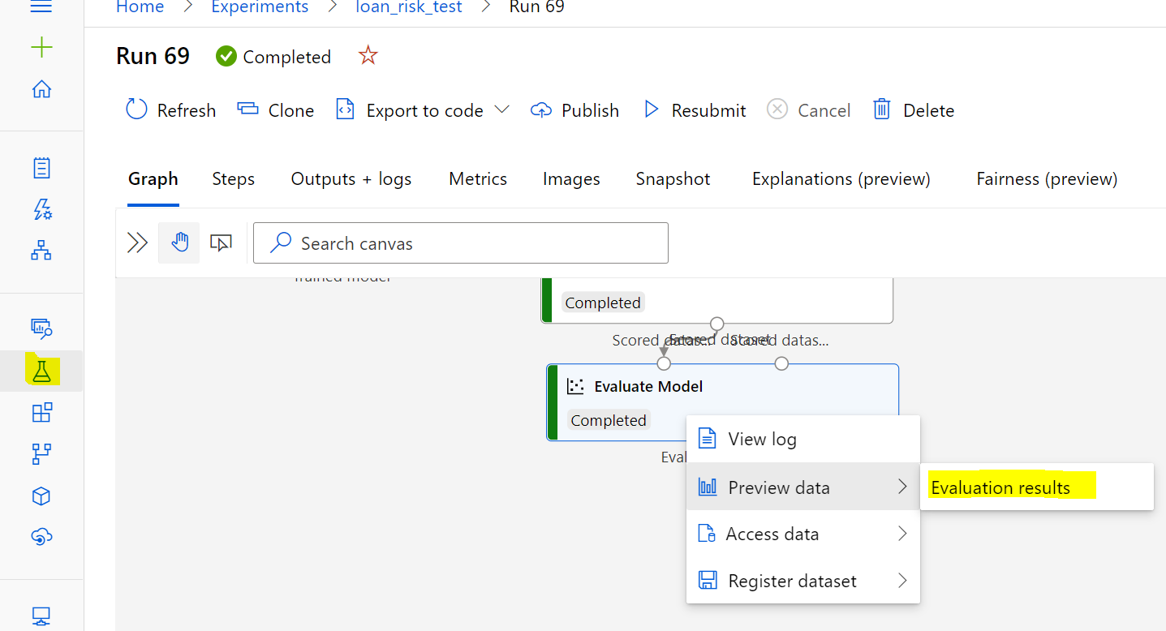

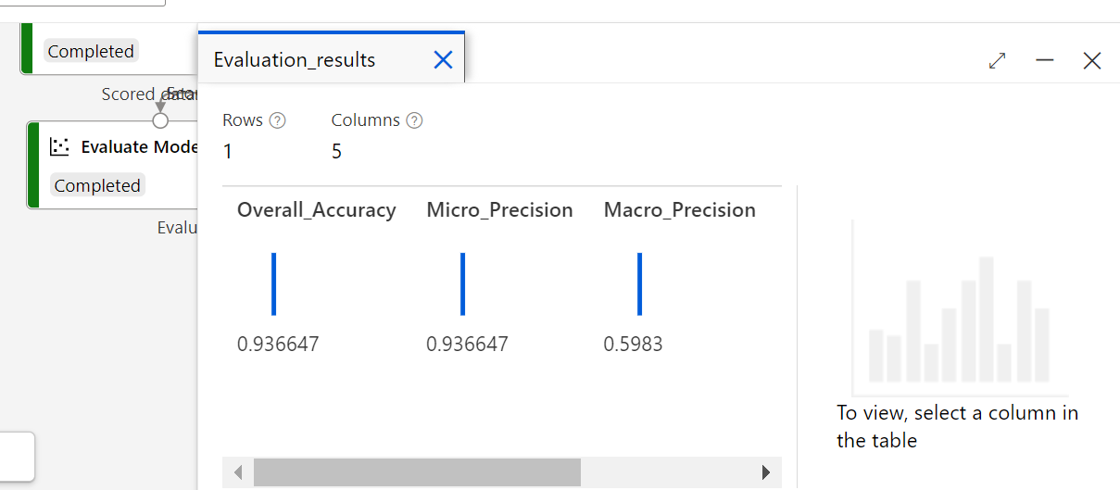

You can back to tab Designer in order to adjust model variables and re-train the model until the result is satisfied.

2) Use similar way to create regression model to predict SBA approval amount

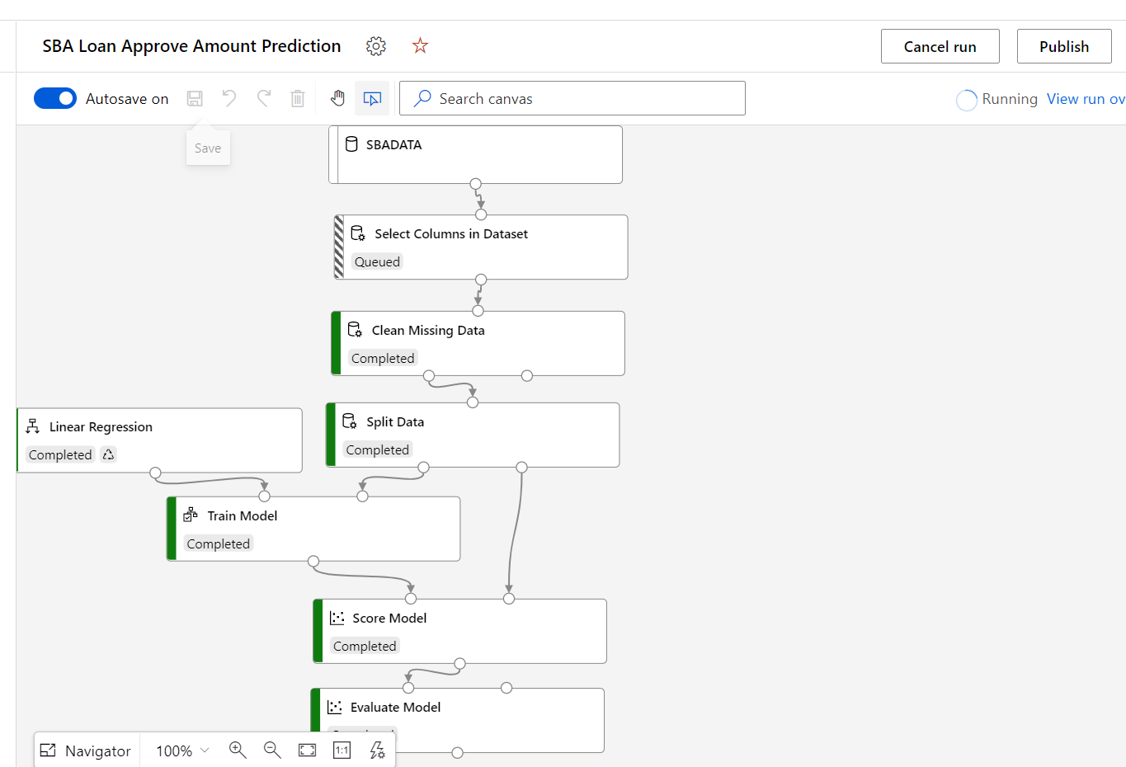

Pick following as the Selection Columns & Clean Missing Data columns:

Term,GrAppv,SBA_Appv,City,State,Bank,BankState,NoEmp,NewExist,CreateJob,RetainedJob,FranchiseCode,UrbanRural,RevLineCr,LowDoc,DisbursementGross,IndustryCode

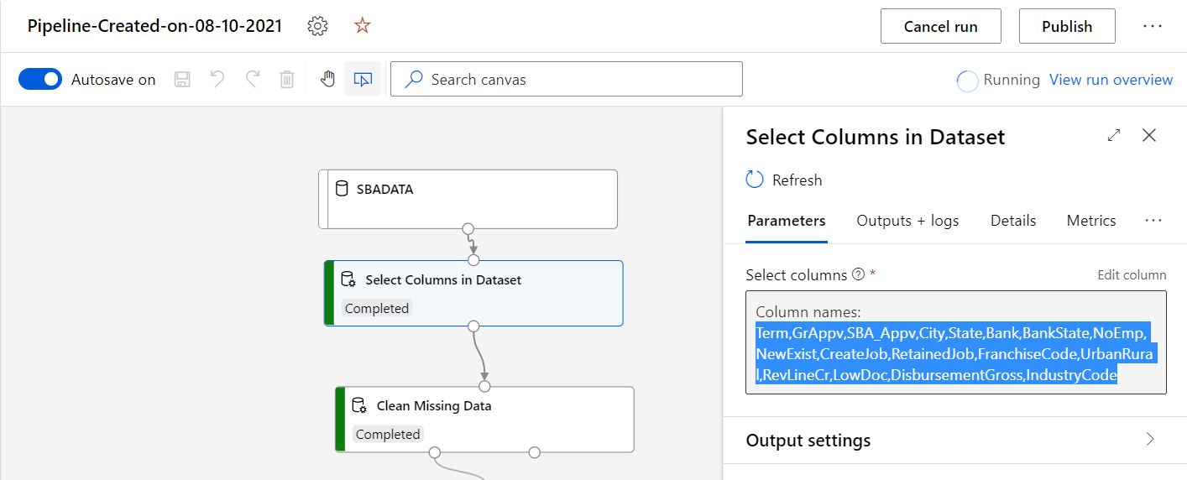

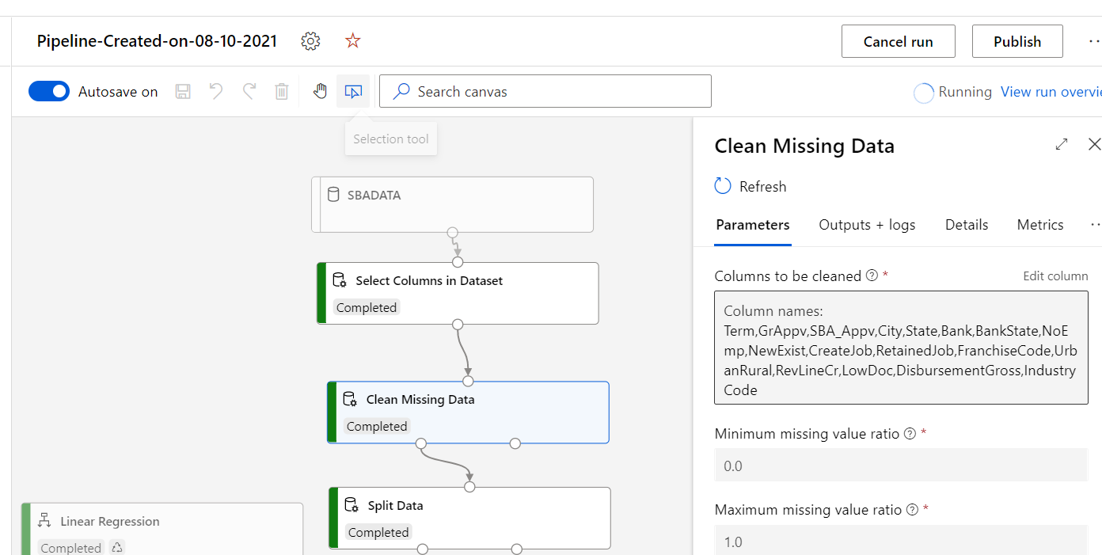

Once training job is complete, check the result via preview the Evaluate Model

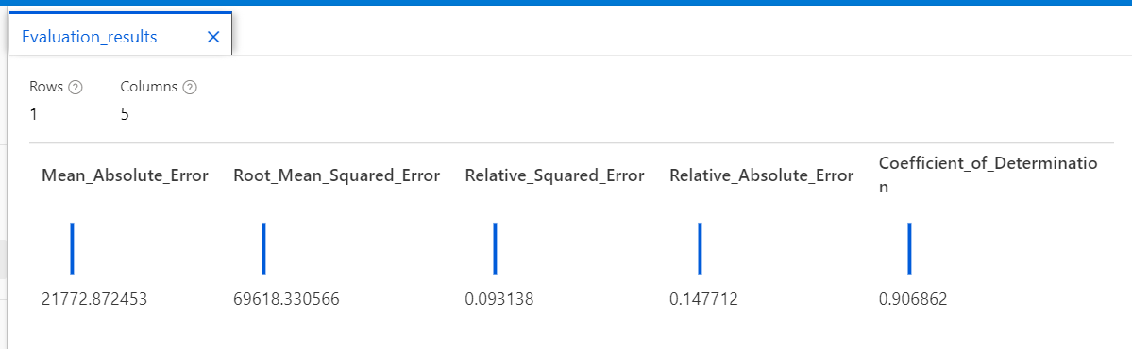

### Step 11: Deploy the Batch Processing ML Model

Go to SBADATA storage account, add test folders: testinput, testoutput,testresult

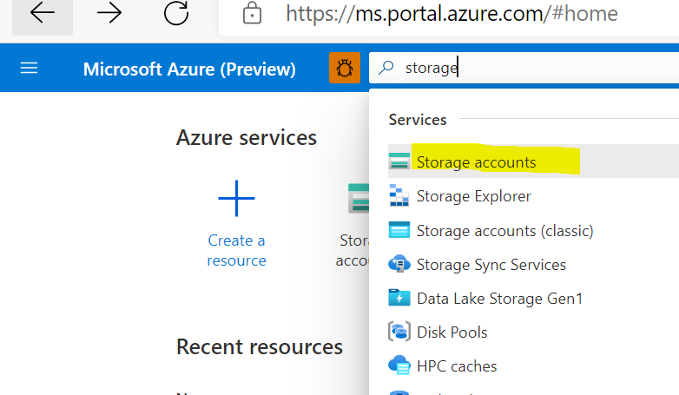

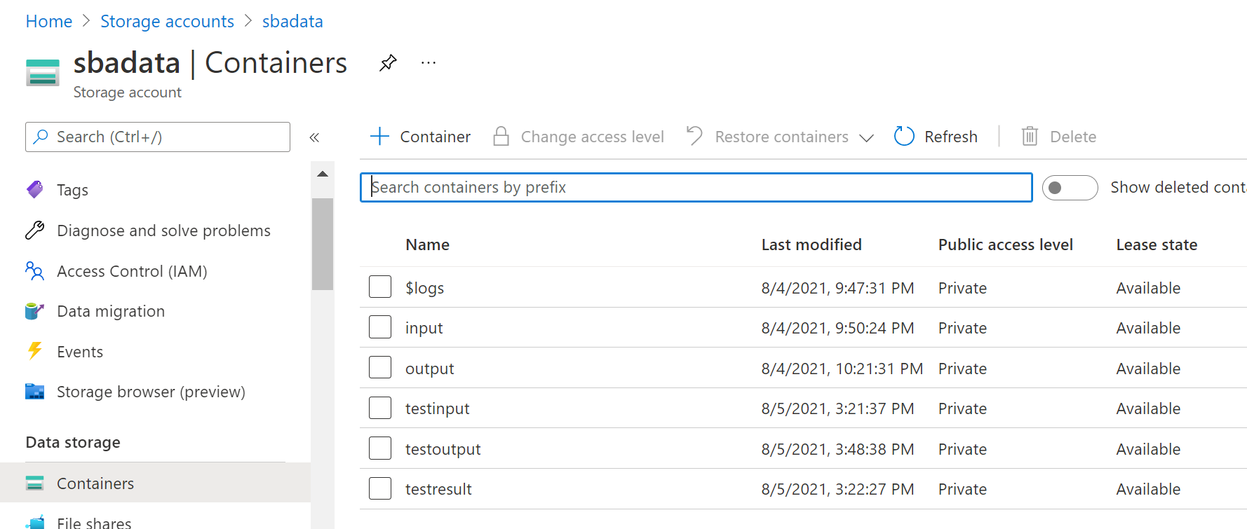

Upload test file to the testinput folder in SBADATA storage

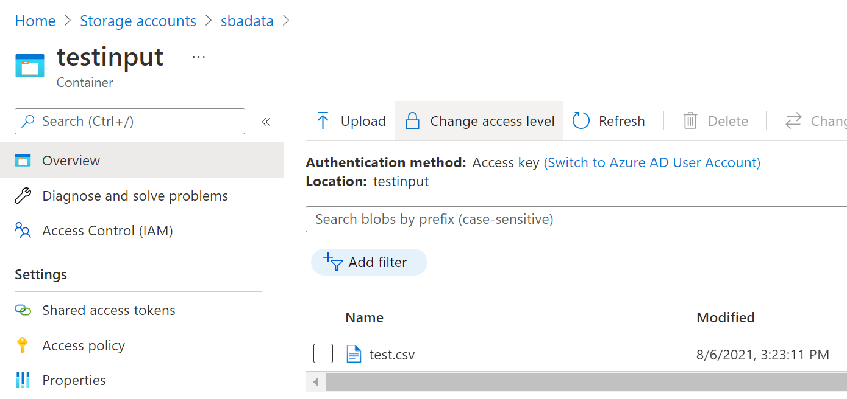

Launch to Synapse studio, build data pipeline to ingest test file

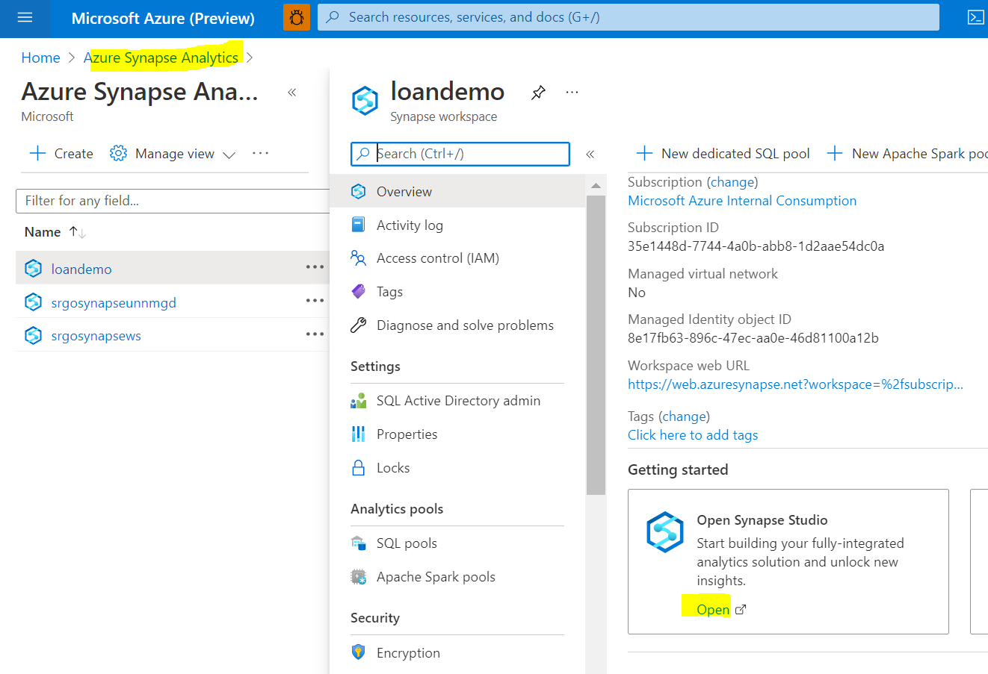

You can create a new Pipeline or use Copy Data tool function

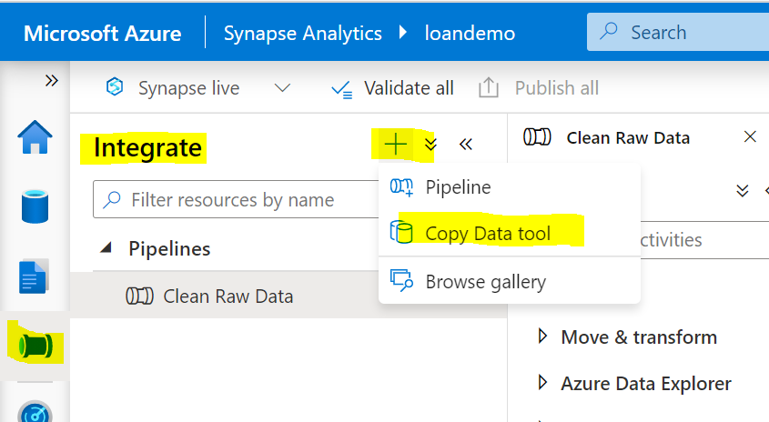

For lab purpose, choose built-in copy task and run once now

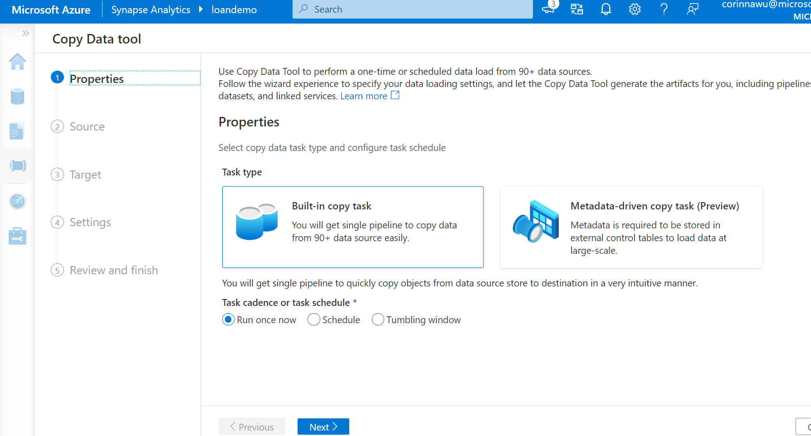

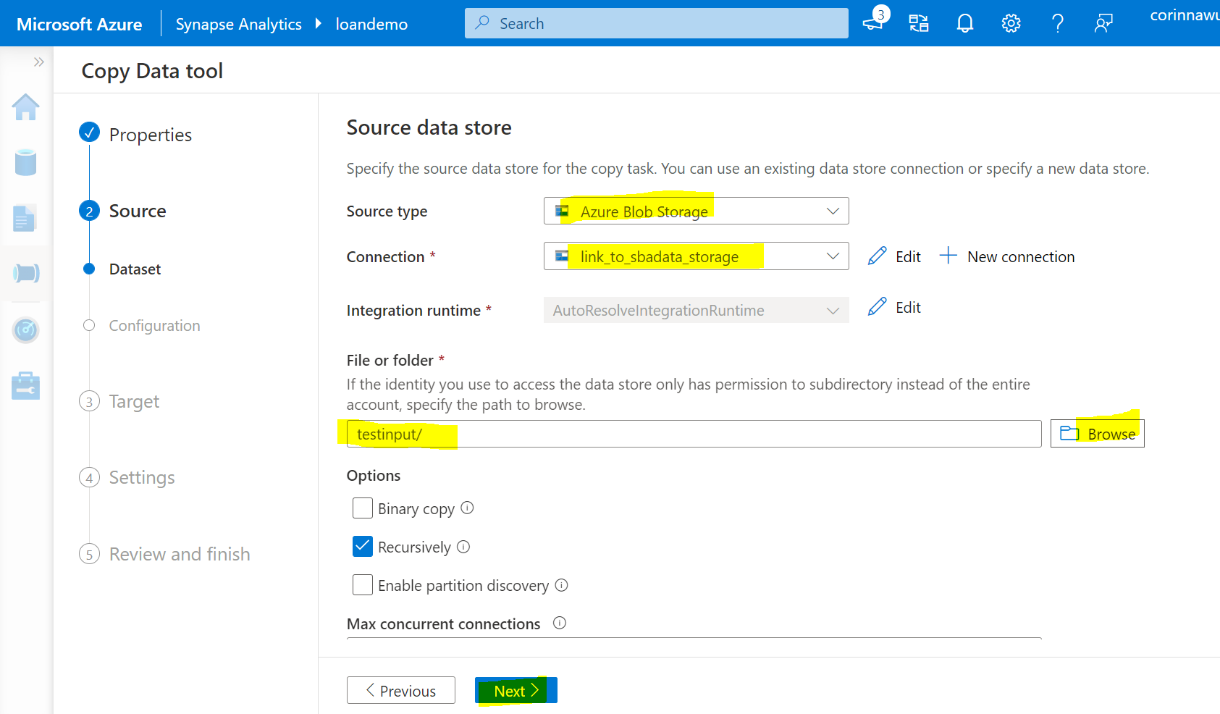

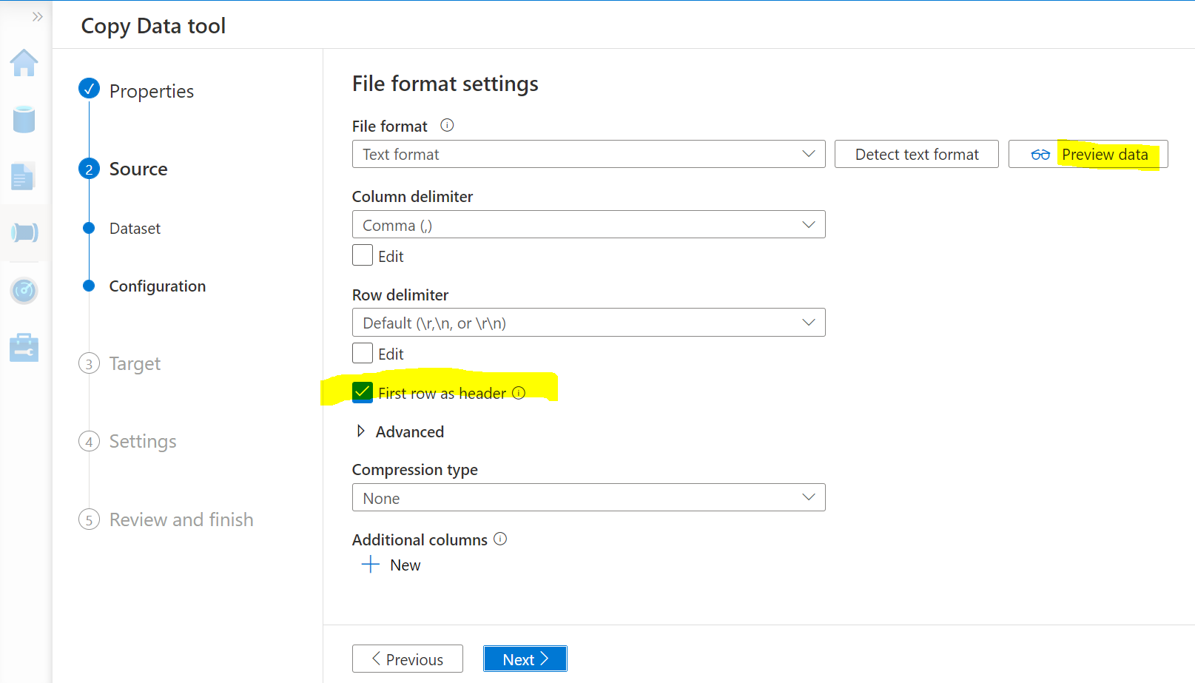

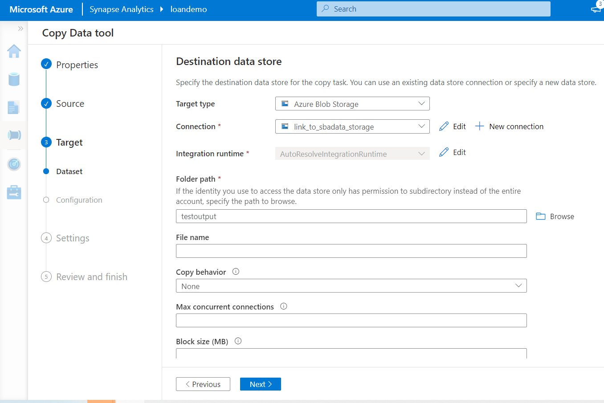

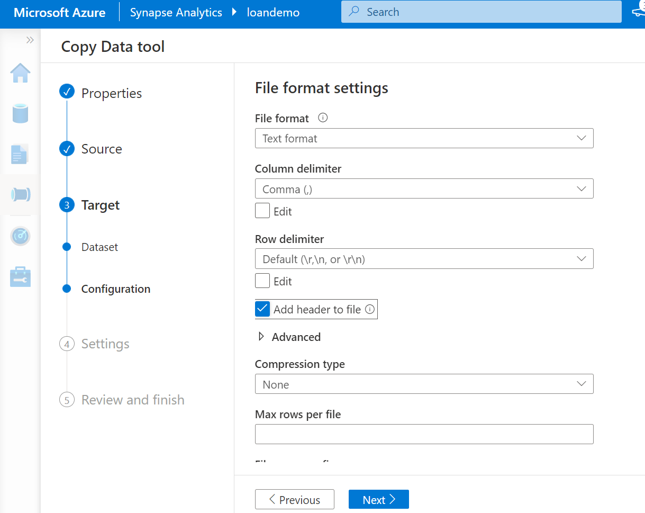

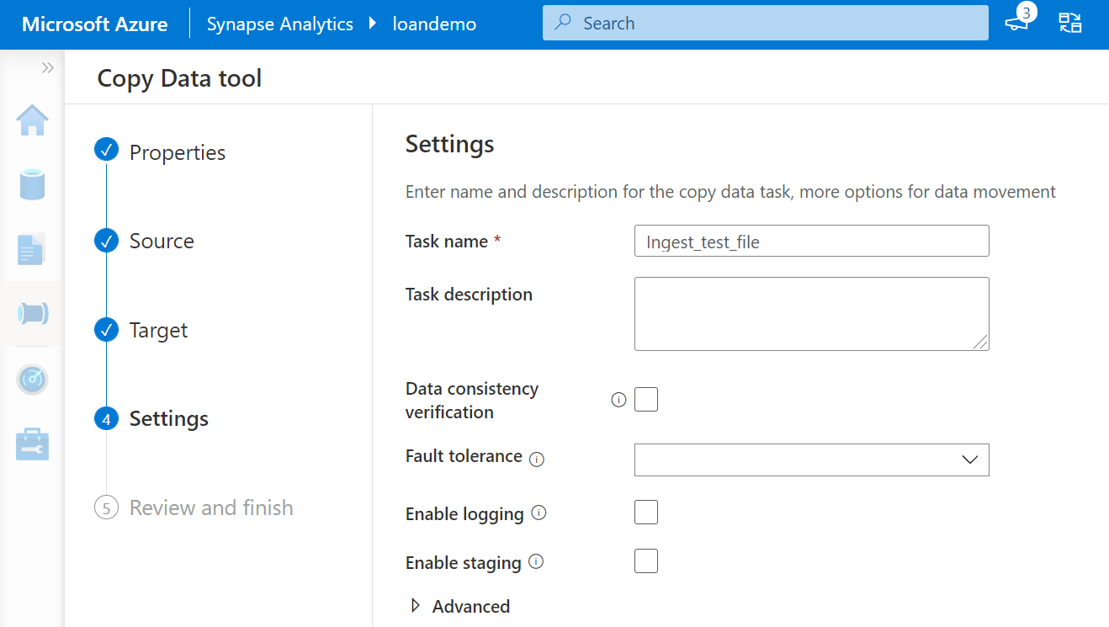

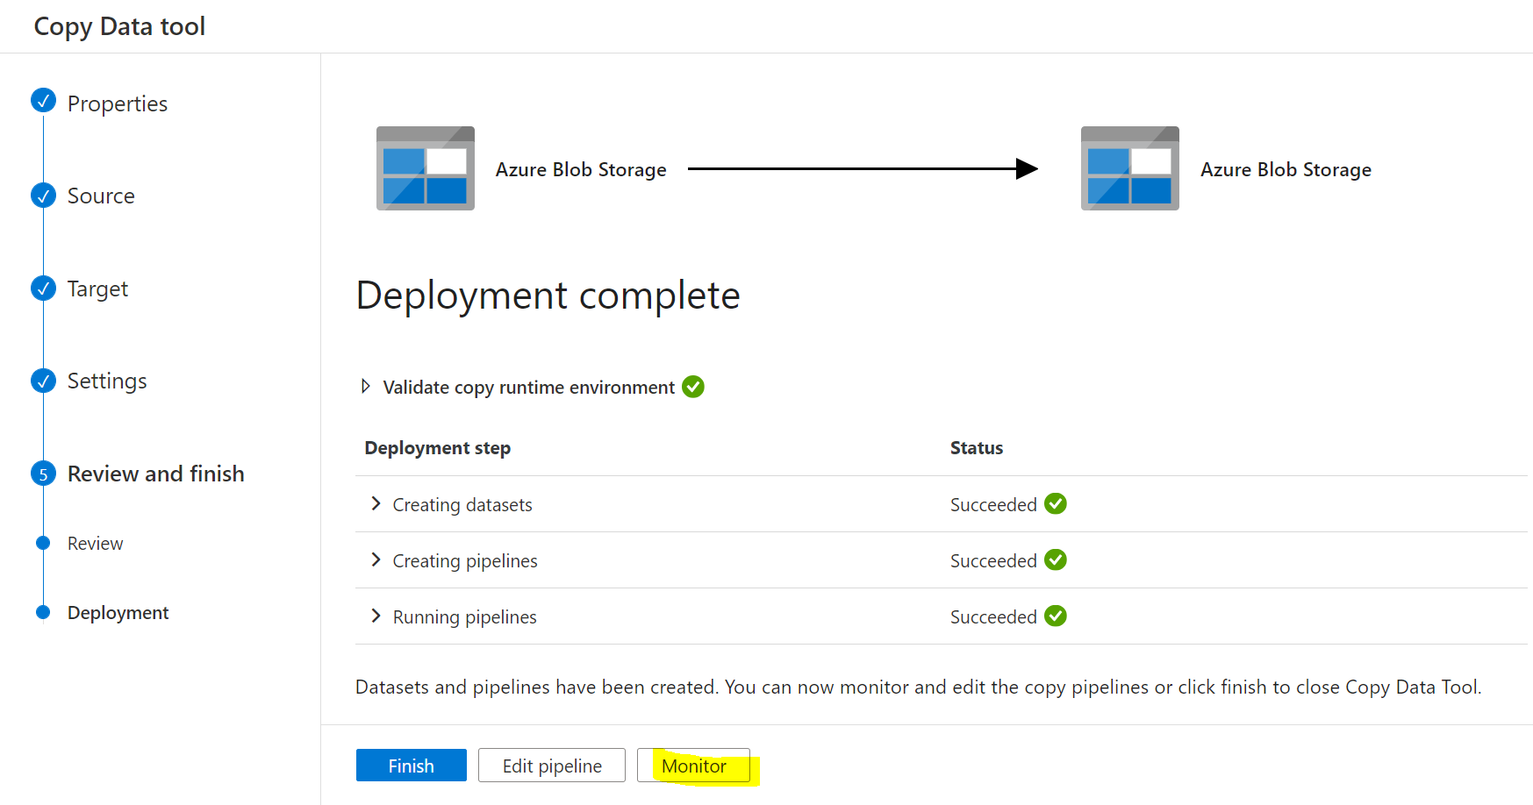

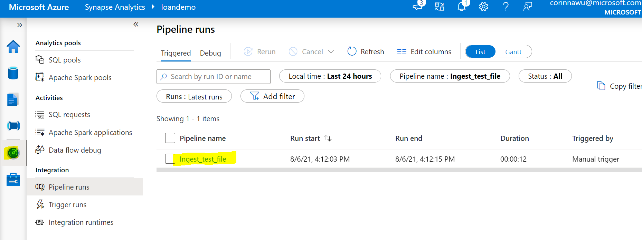

Add storage event trigger that whenever new file upload to input folder, it will automatically trigger the test ingest pipeline to copy the test file to output folder

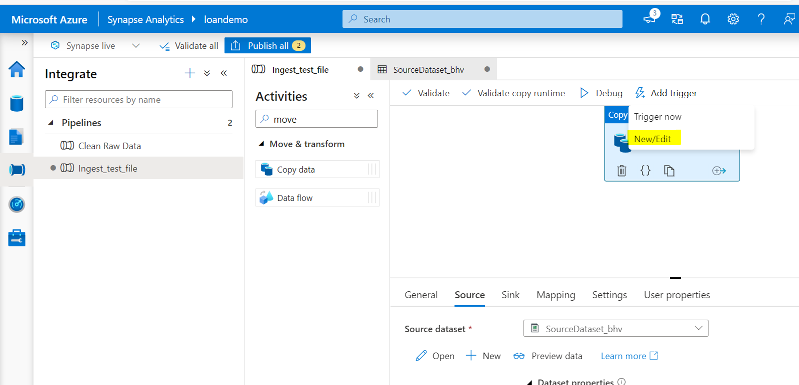

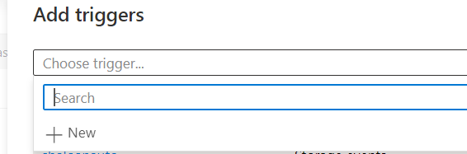

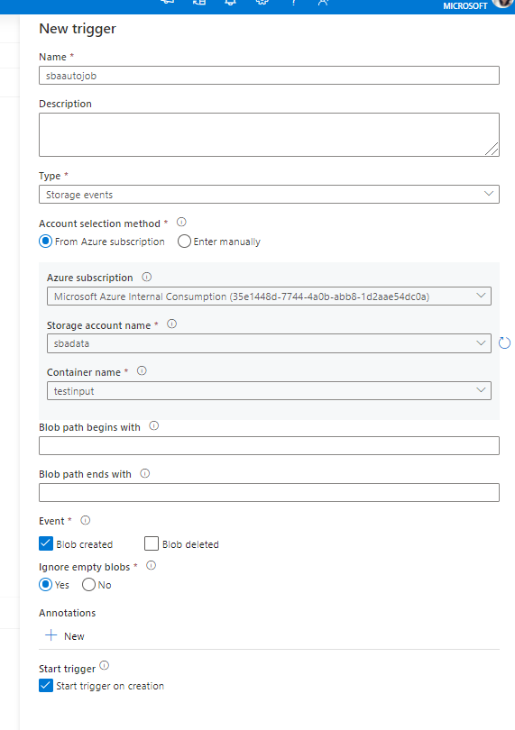

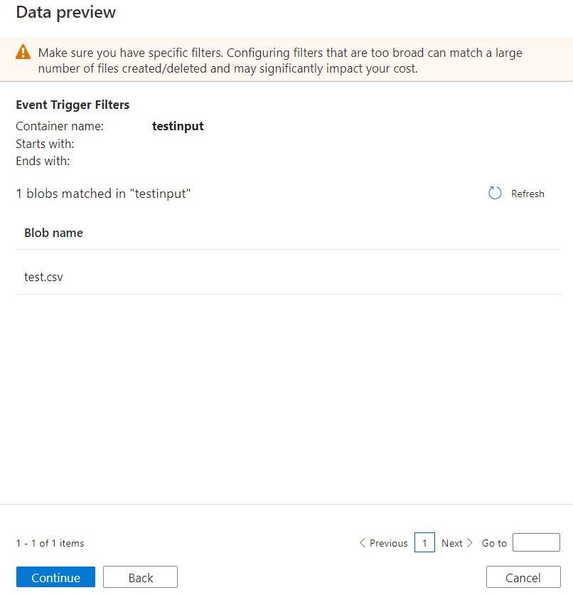

After creating the trigger, let’s run a test:

Upload test02.csv file to SBA/testinput folder

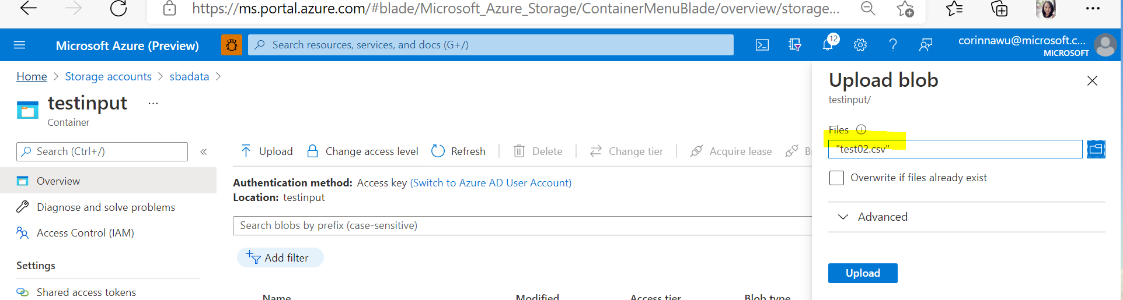

Check the testoutput folder, the file is automatically copied.

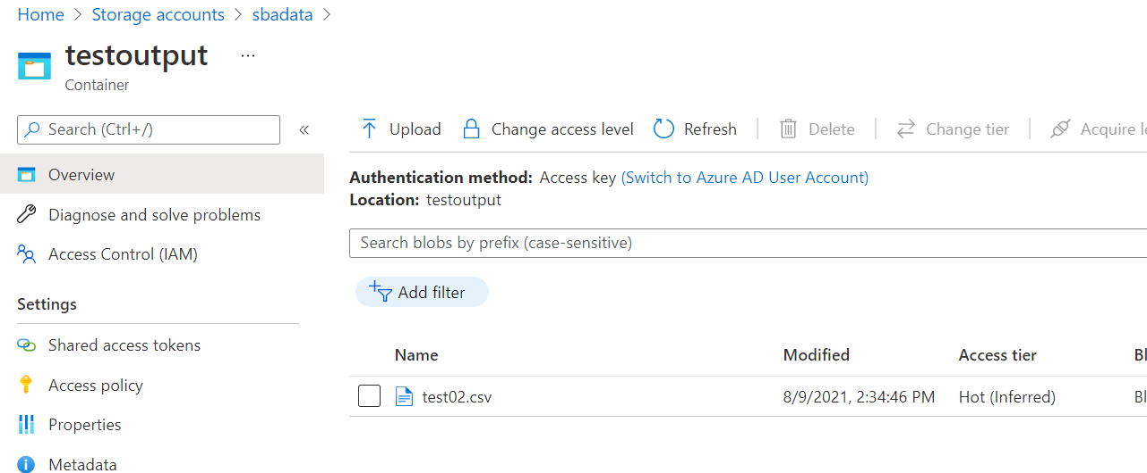

Launch to ML studio, Create Data Store and Dataset for test data, link to the testinput folder

New datastore：loantest

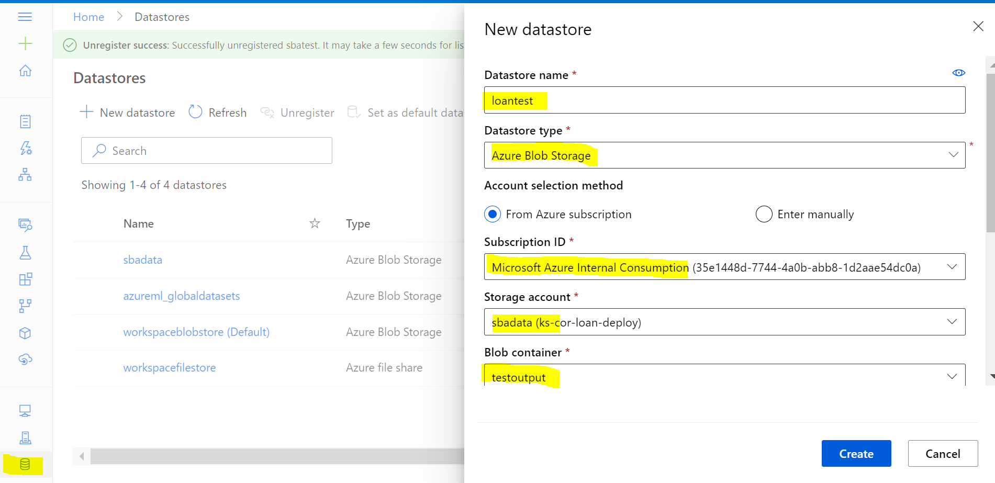

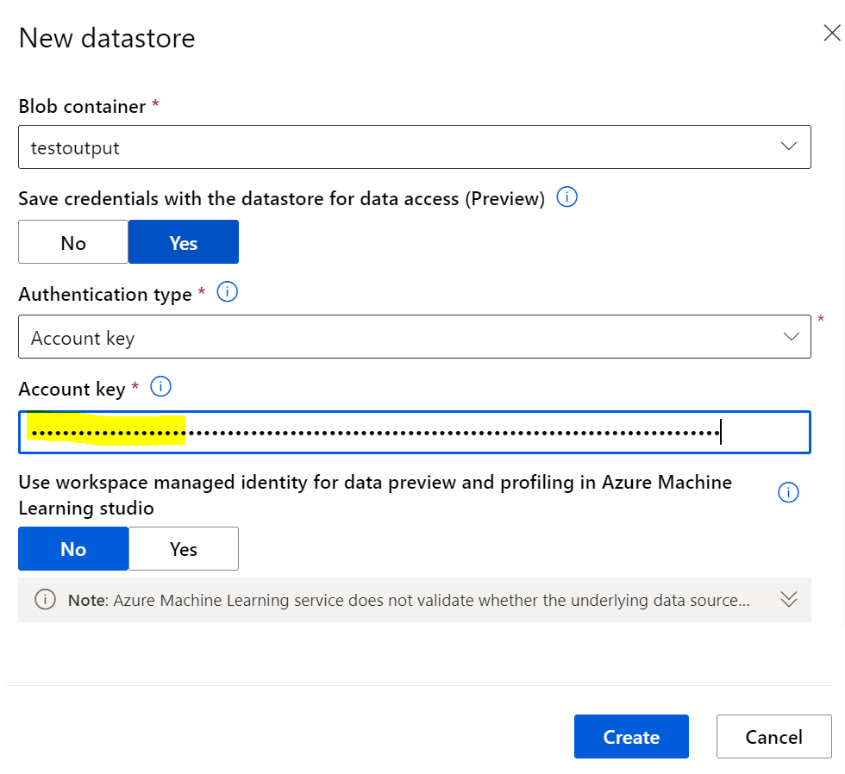

** Copy the Account key from sbadata storage account

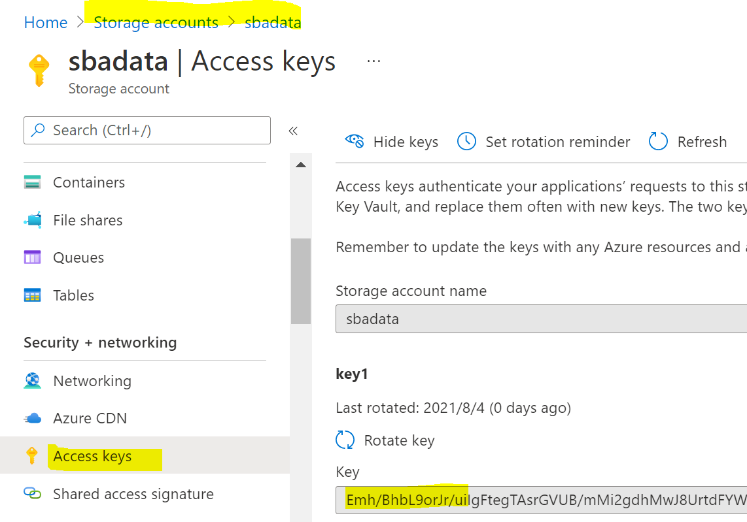

Create another datastore for test result

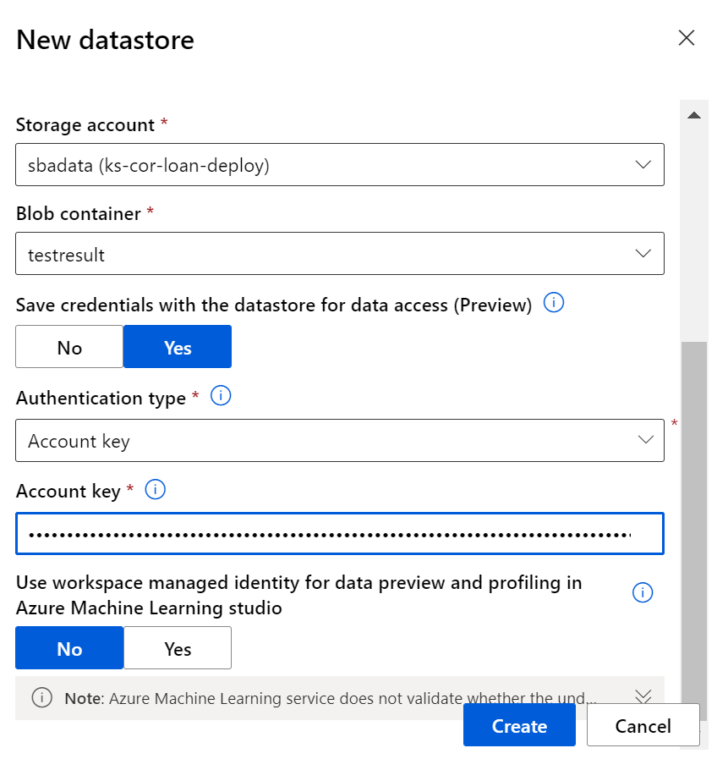

Create dataset

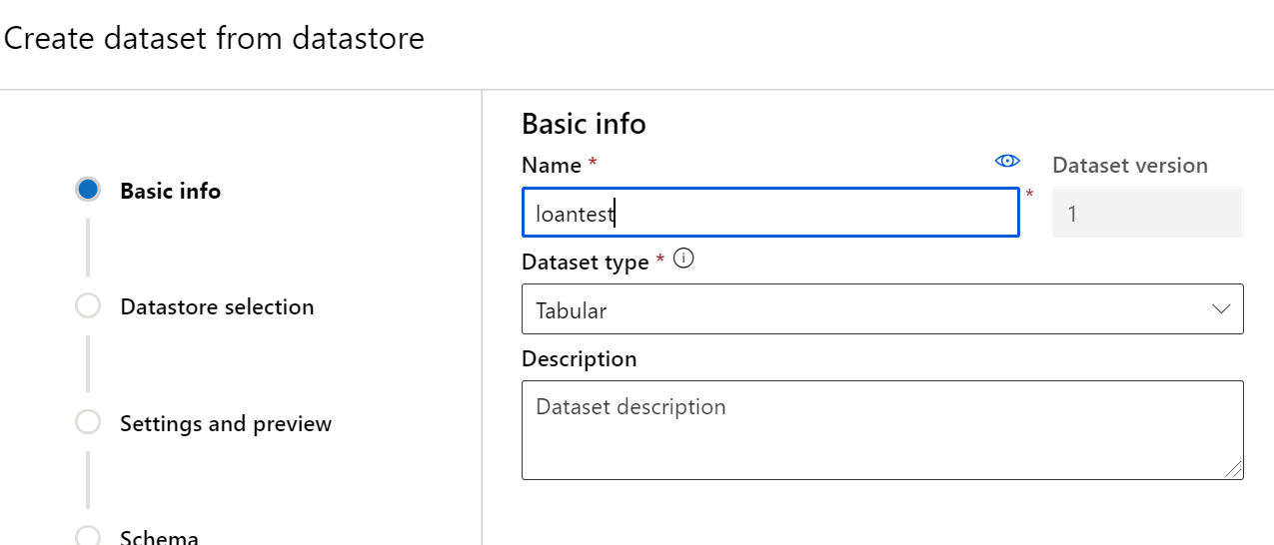

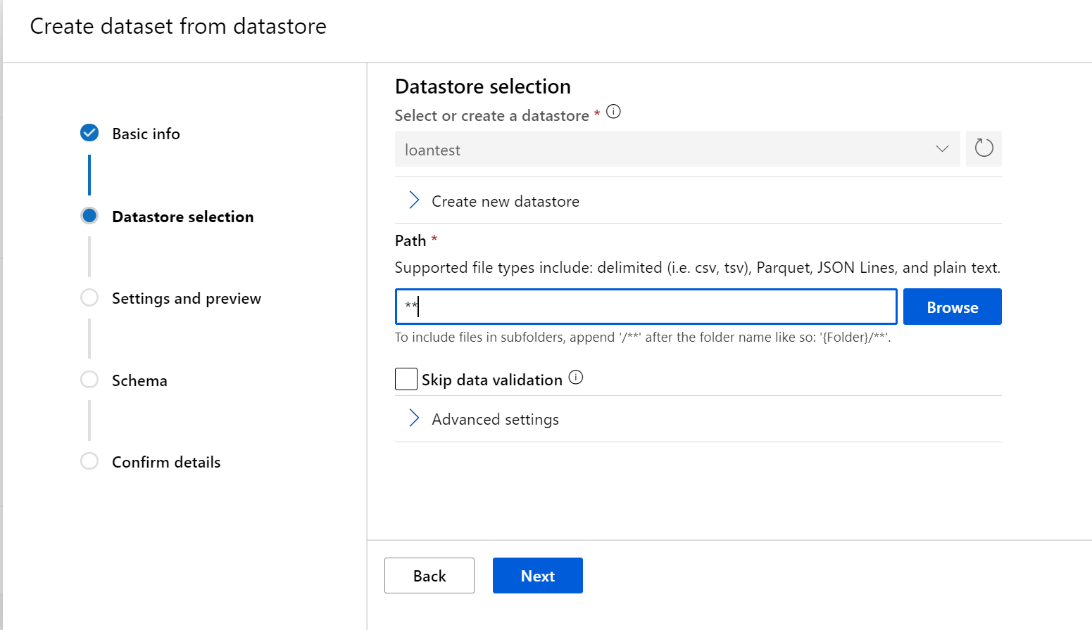

Click Next, Next, and check & correct the schema, make sure it is same to the dataset for SBADATA(Training dataset) and then click create.

Goto Dataset tab and explore the data:

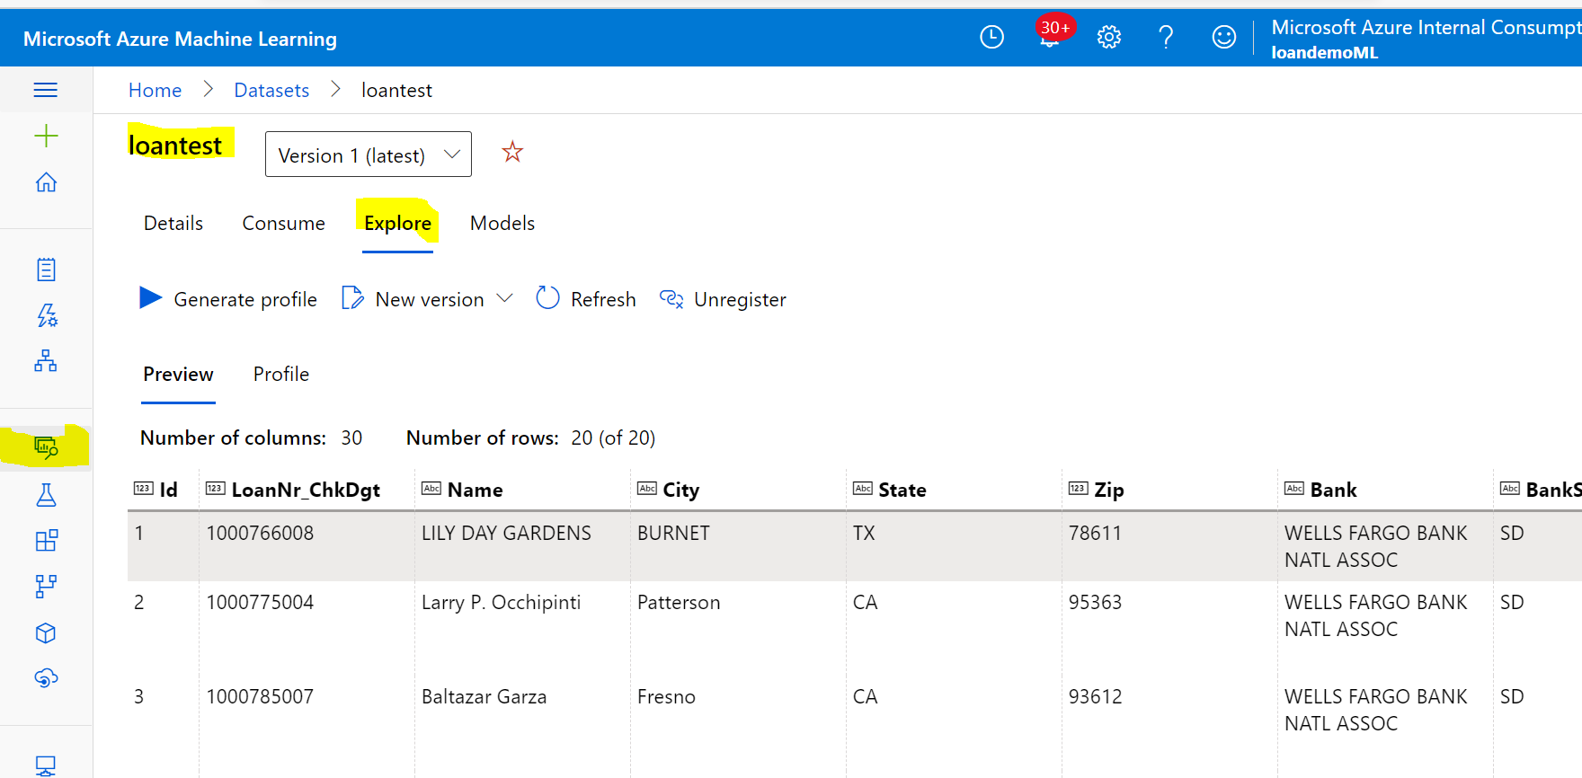

1. Loan Risk Prediction

Go to designer and deploy the batch processing data model

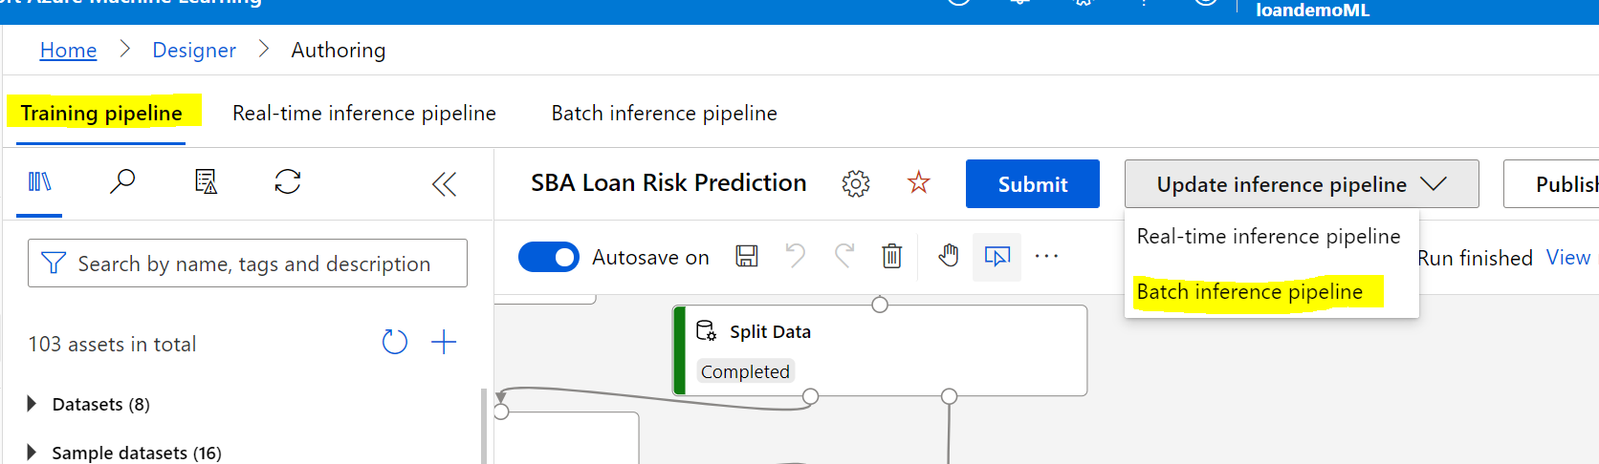

Goto Batch inference pipeline, replace SBADATA to loantest dataset:

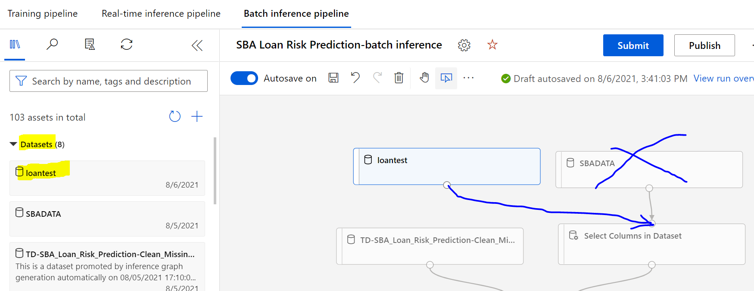

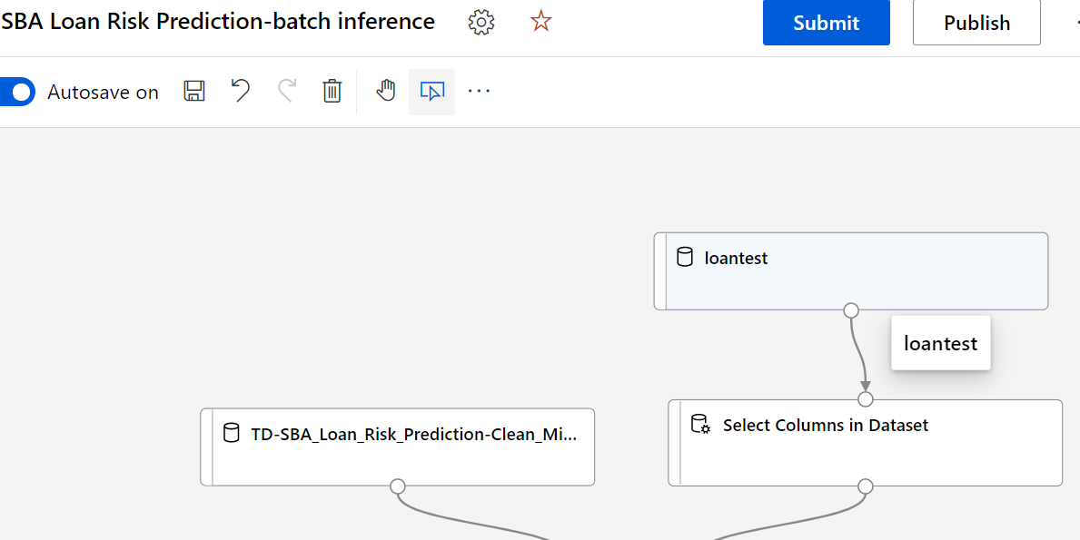

Remove ‘Evaluate Model’ step, change to Export Data ( Save test result to testresult folder)

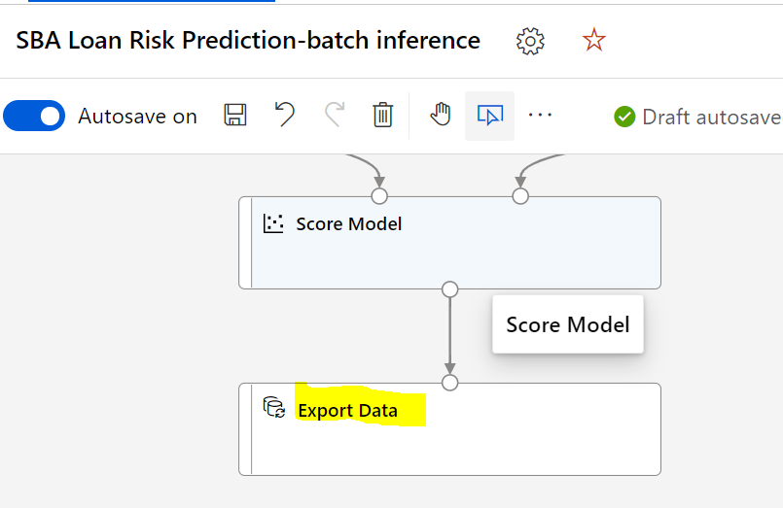

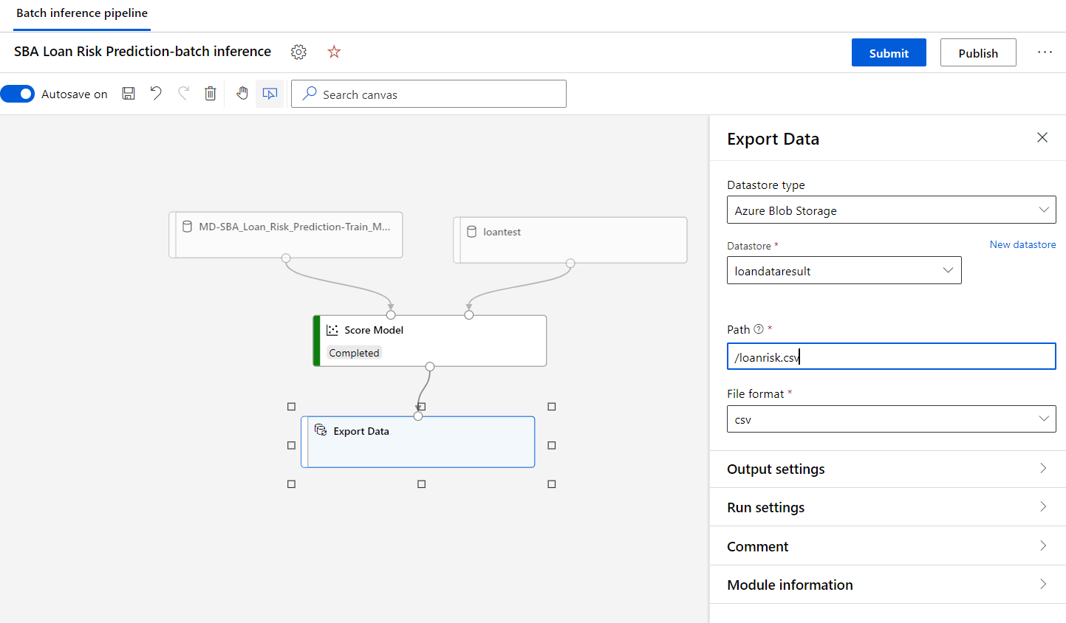

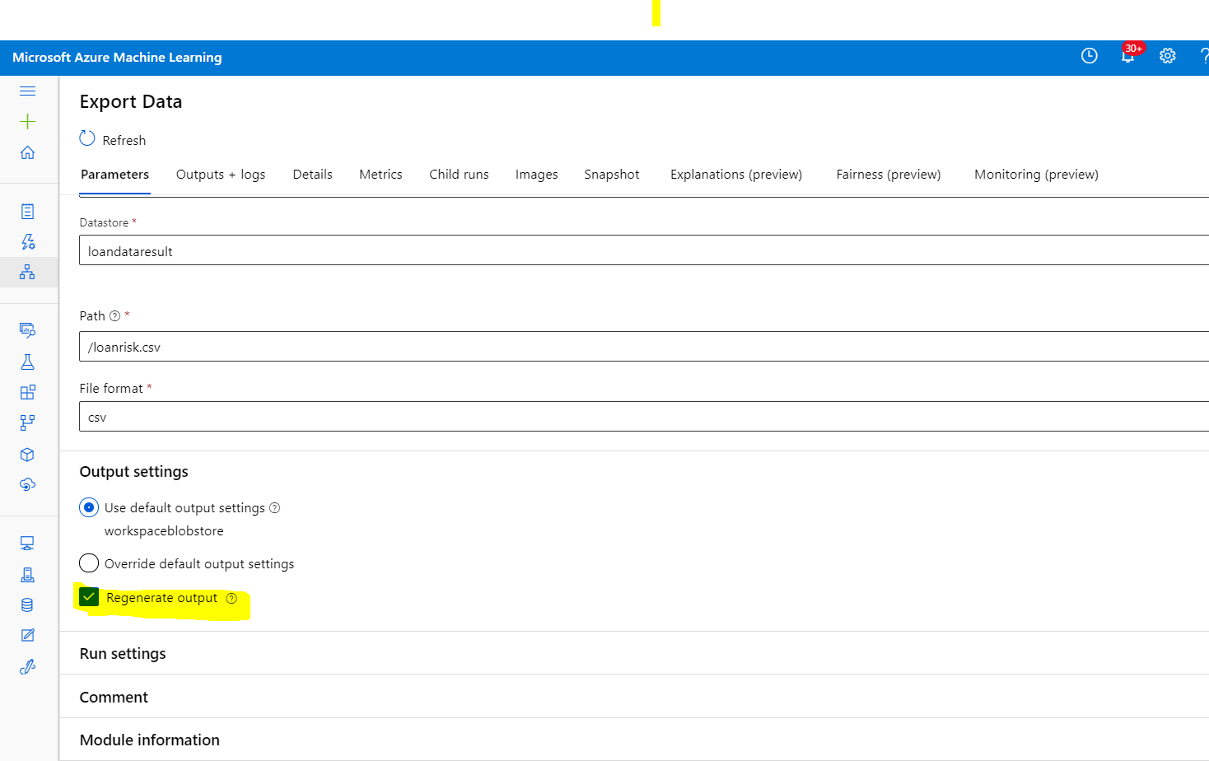

And also remove unnecessary steps (such as clean column steps)

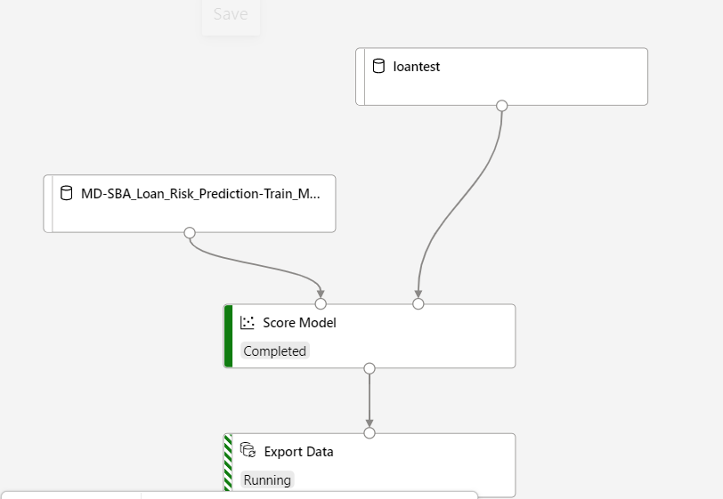

Change the pipeline description and submit:

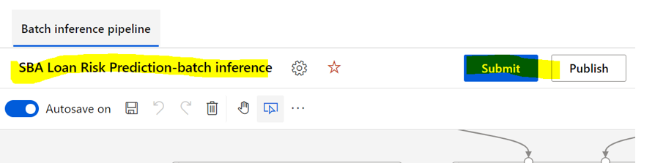

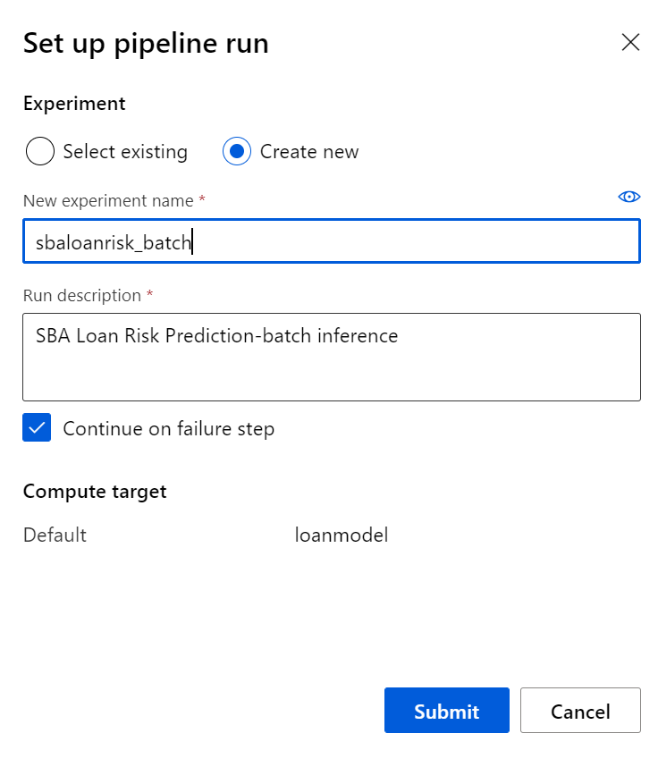

Once it is complete successfully, publish the pipeline.

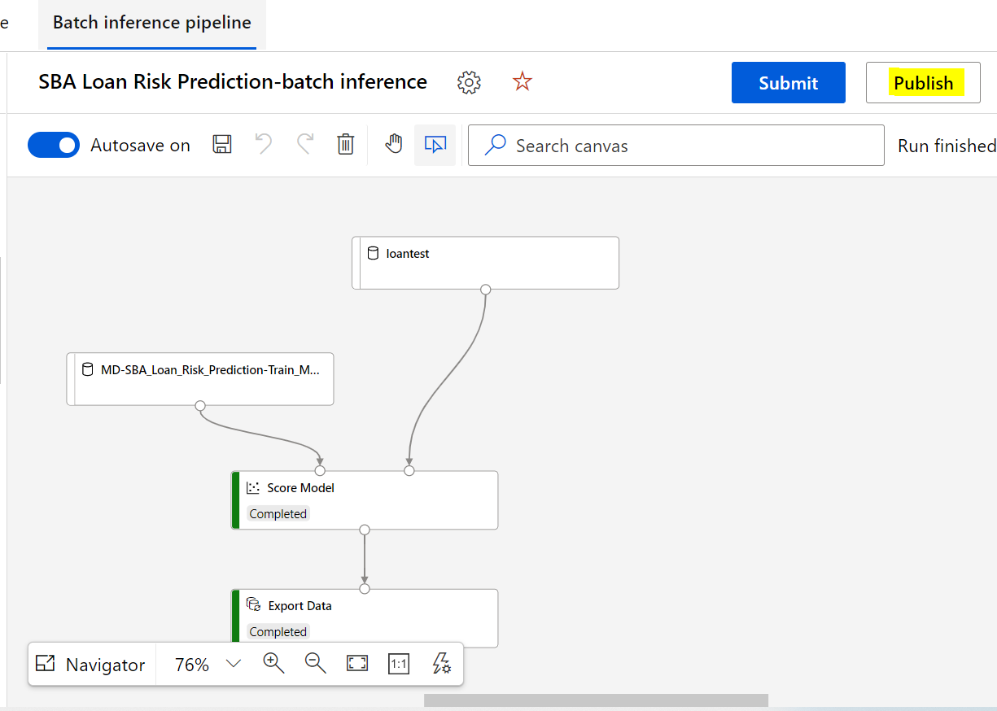

Go to SBADATA storage to check the result file.

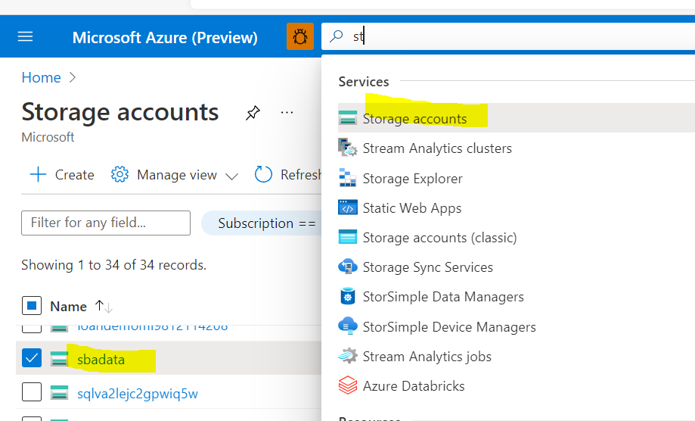

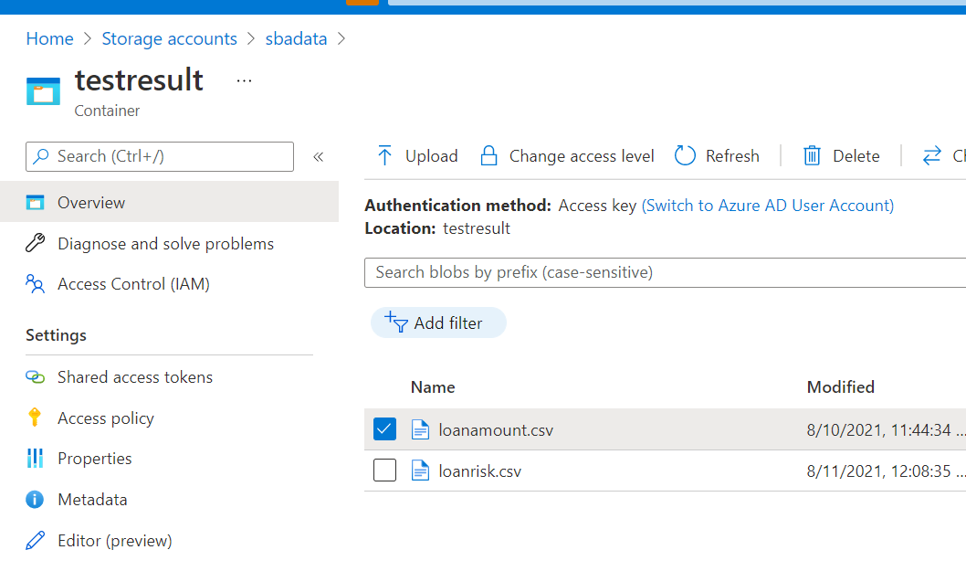 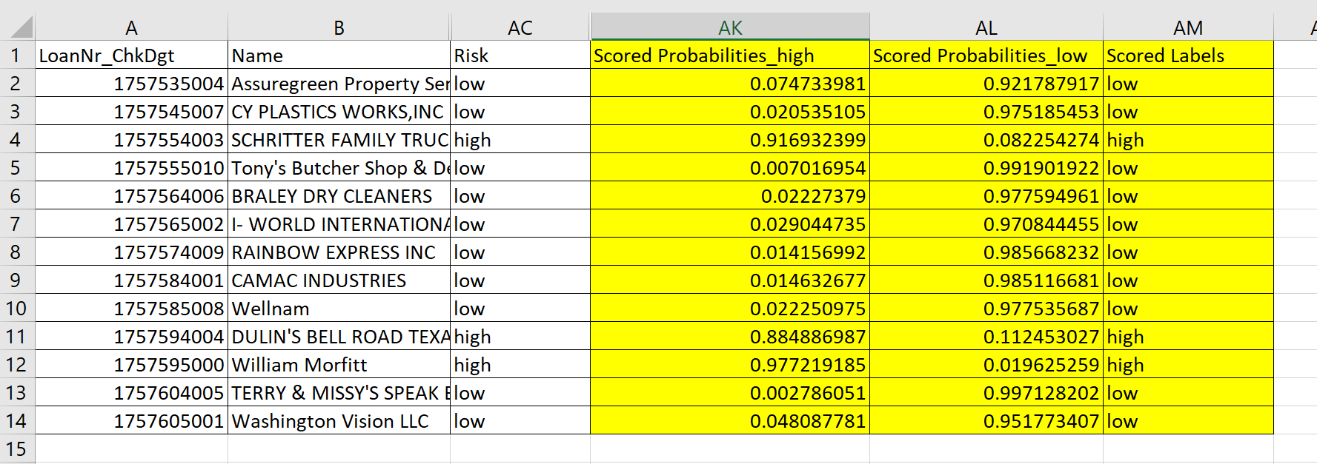

You can integrate to power BI or Synapse tool for further analysis.

1. SBA loan amount prediction

Use the similar way to deploy the SBA loan amount prediction to batch process:

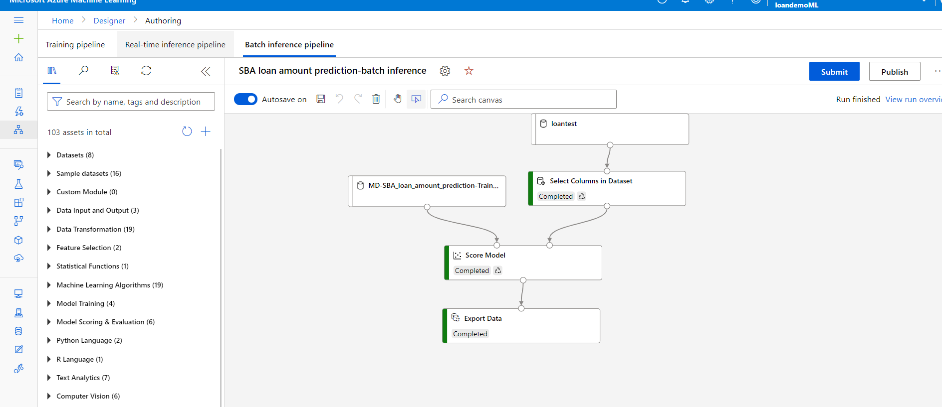

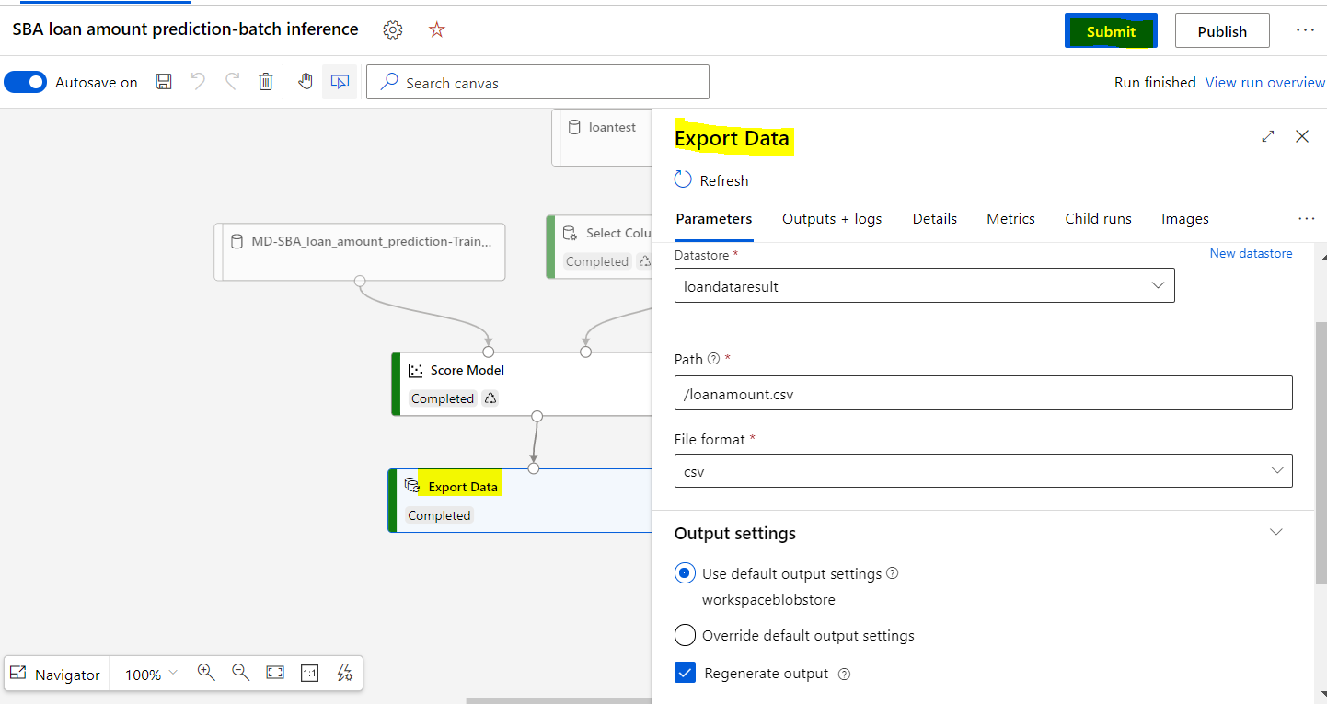

First submit, wait till the job complete successfully and then Publish.

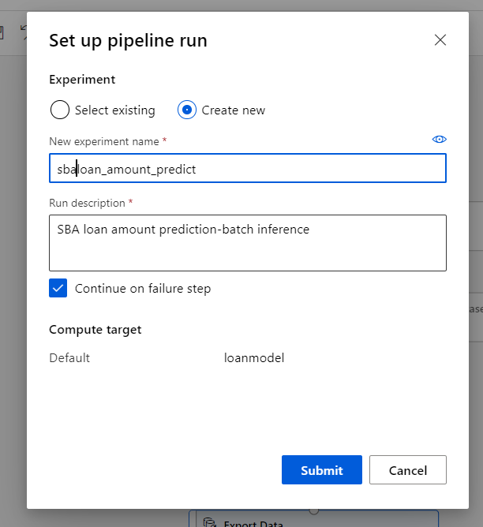

Launch to Synapse studio to add the step for auto trigger the ML pipeline

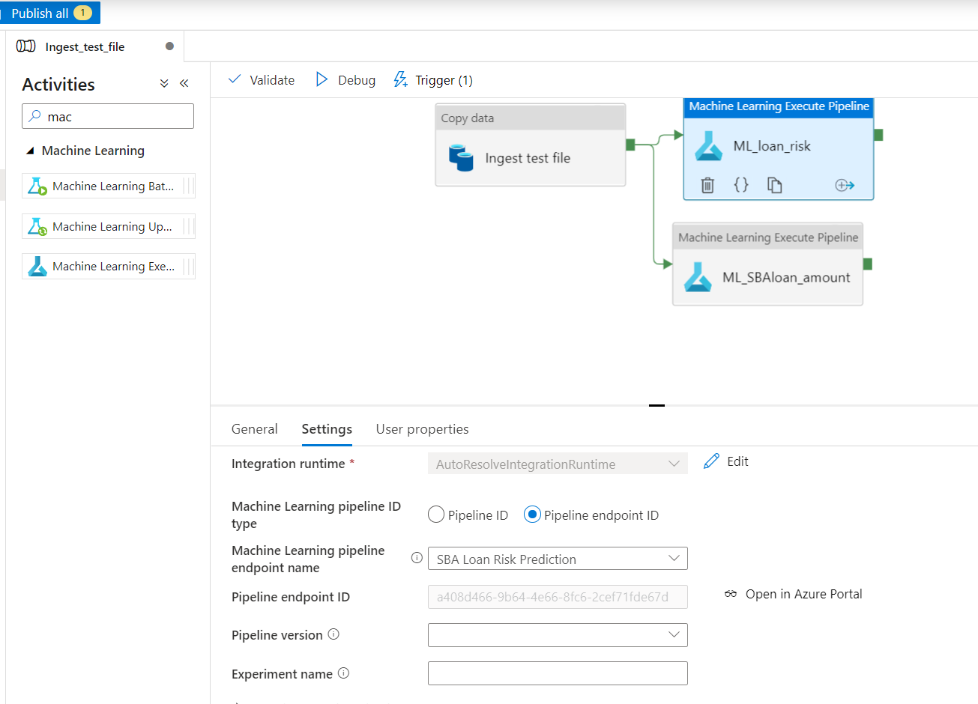

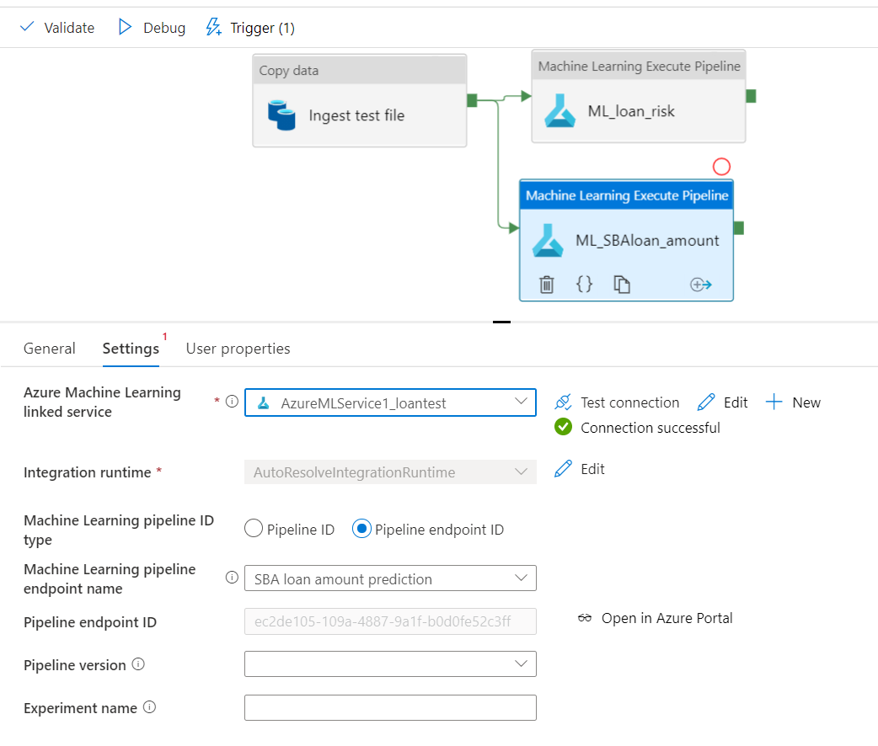

Publish the changes and add a manual trigger to test request:

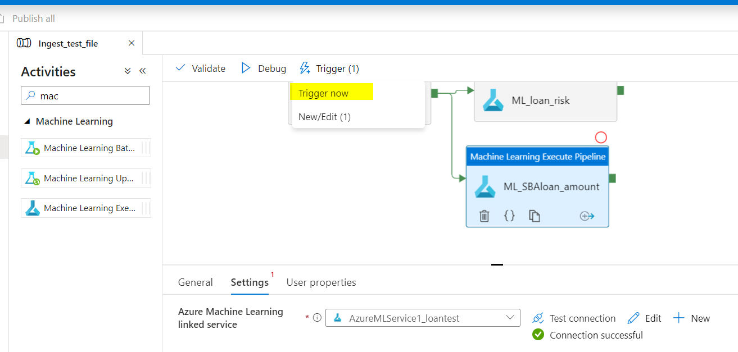

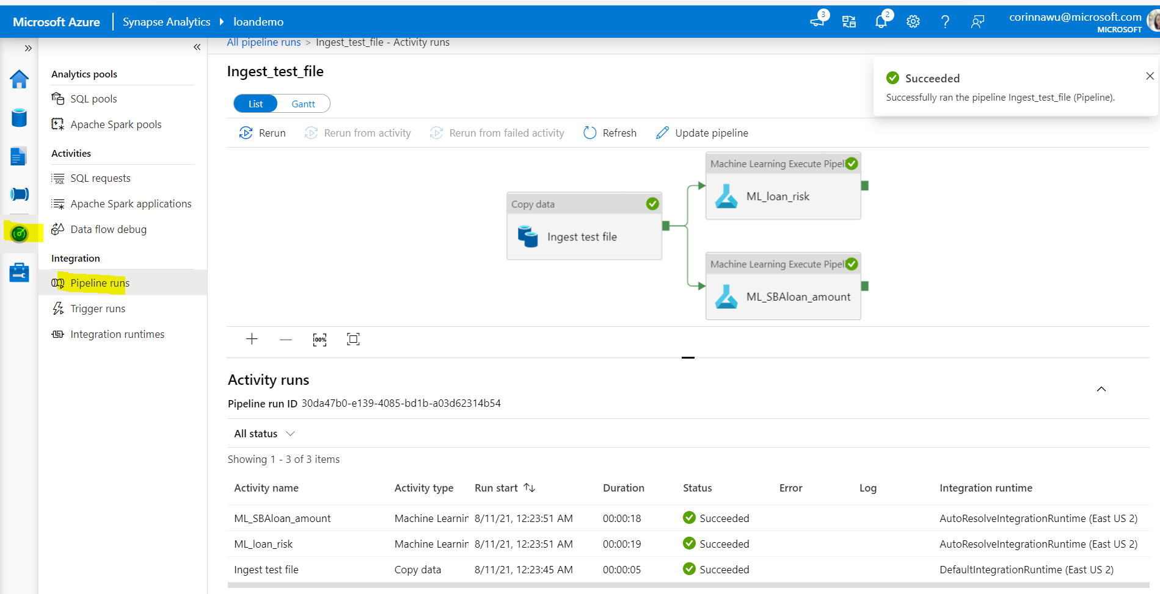

### Step 12: Deploy Real Time ML model

1. Loan Risk Prediction

Back to Machine Learning Studio, Designer:

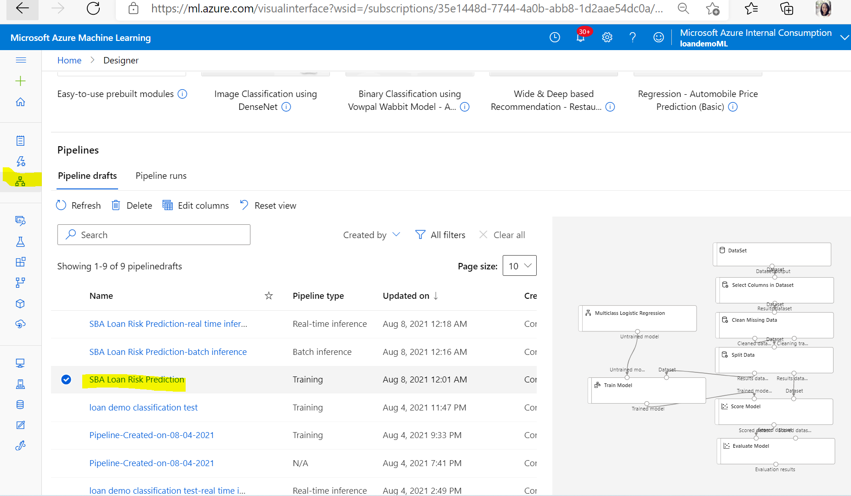

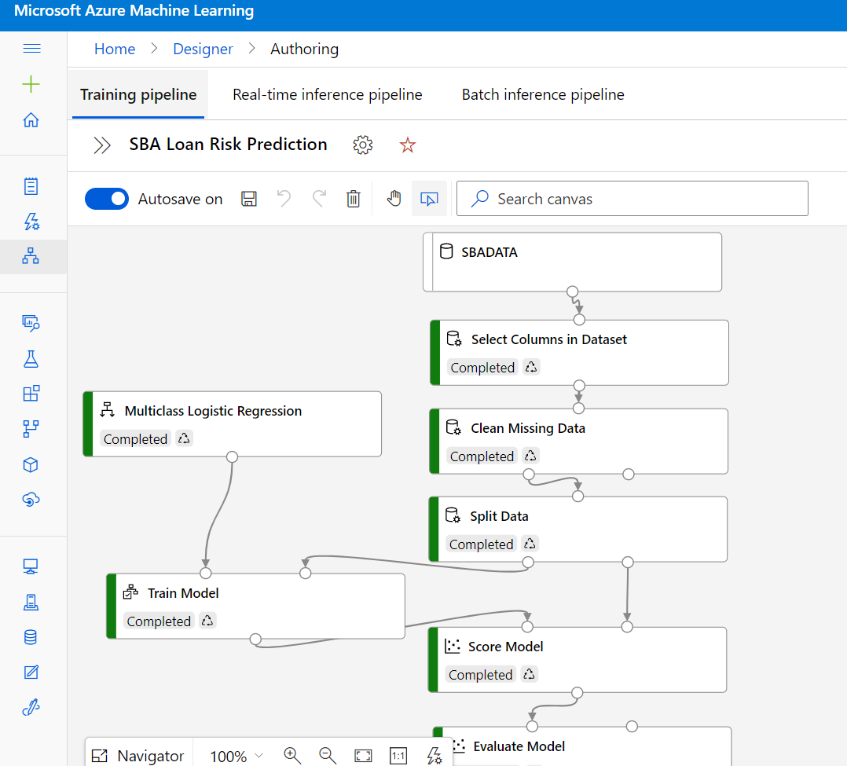

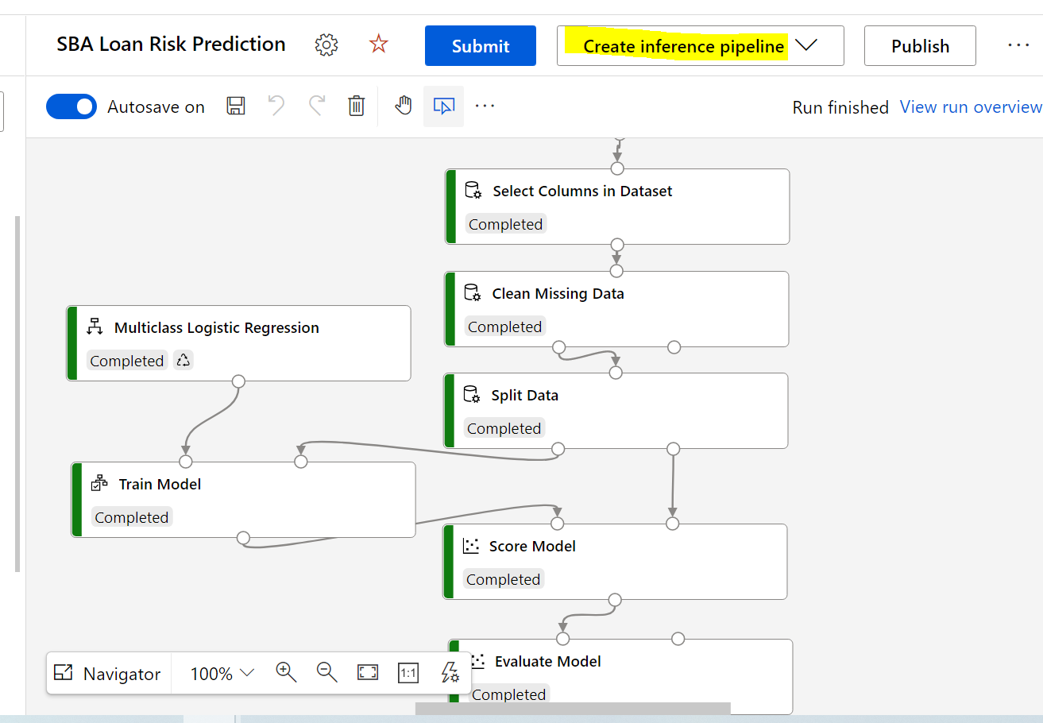

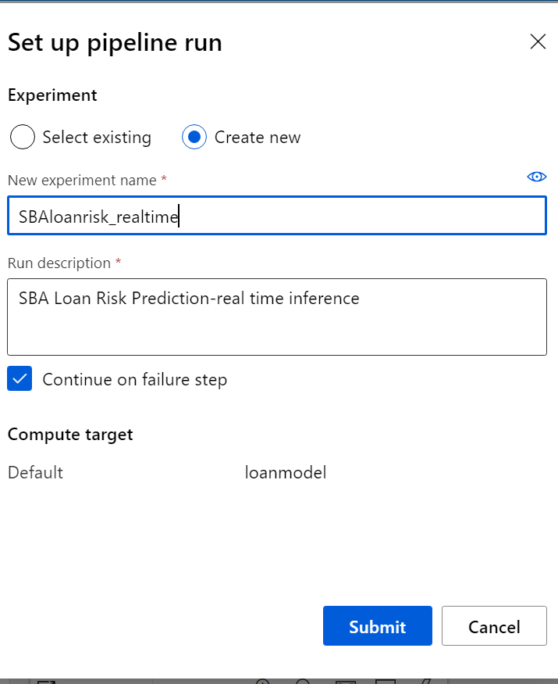

Remove the unnecessary steps, replace SBADATA to loantest dataset

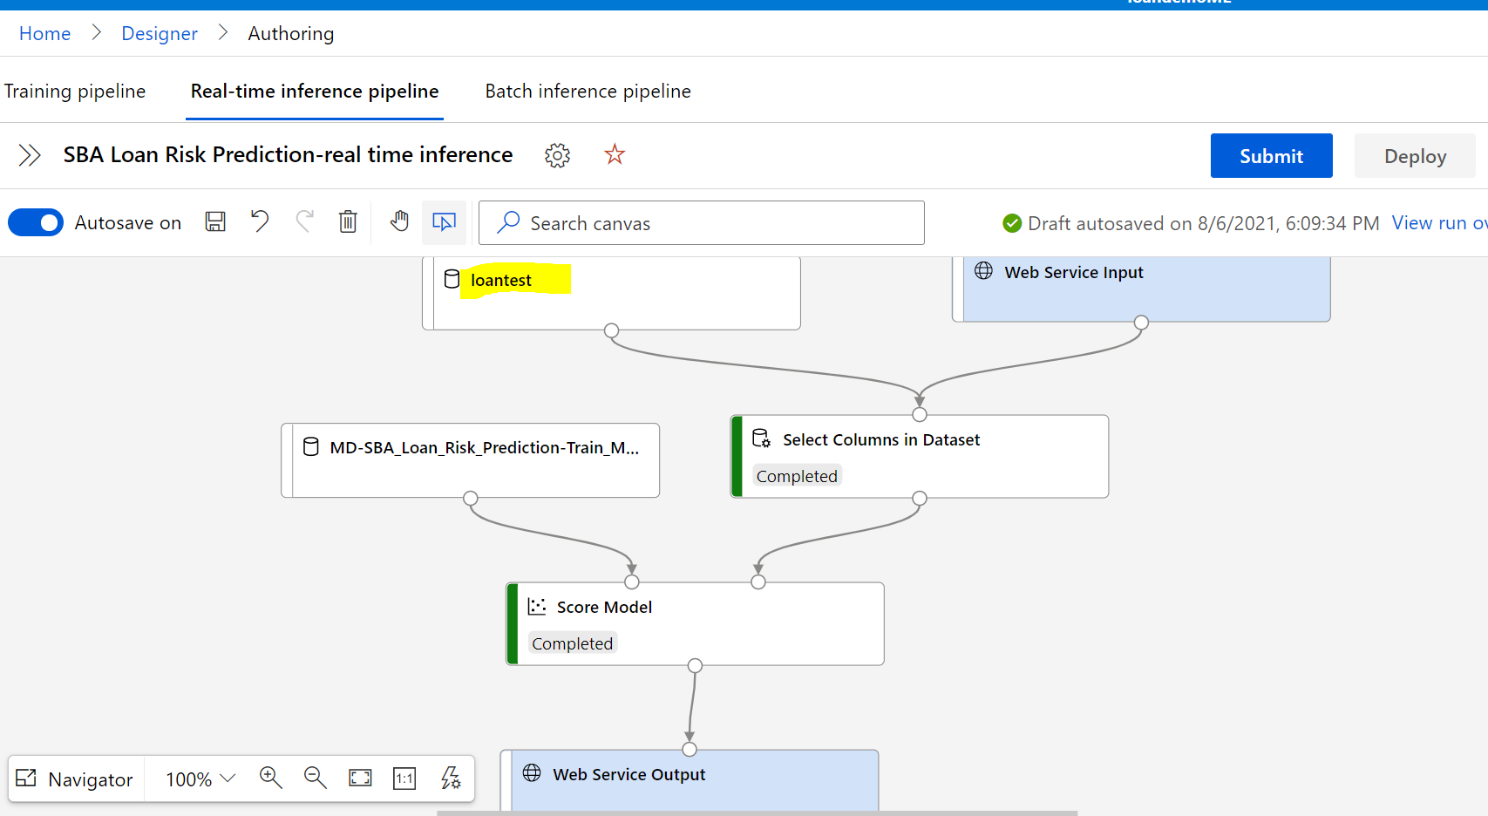

Then save the pipeline and submit the Real-time pipeline run

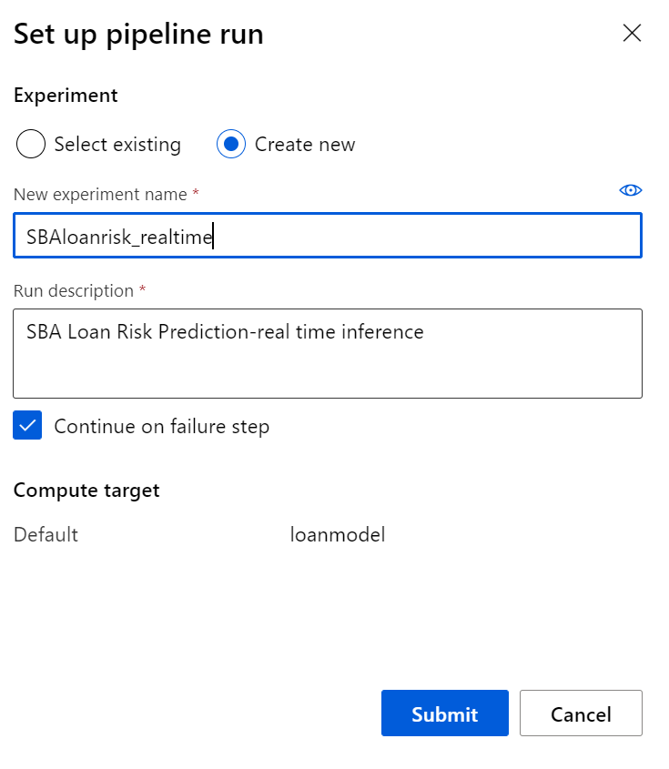

When job is complete successful, Deploy the Real time end point.

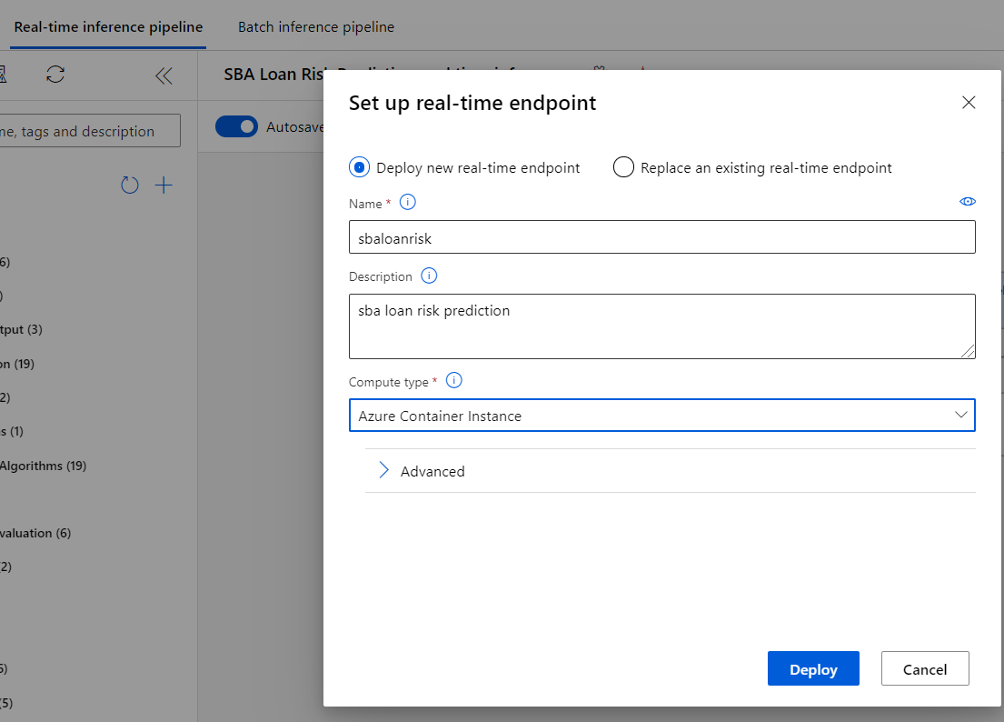

After deploy is complete, go to Endpoints and run test:

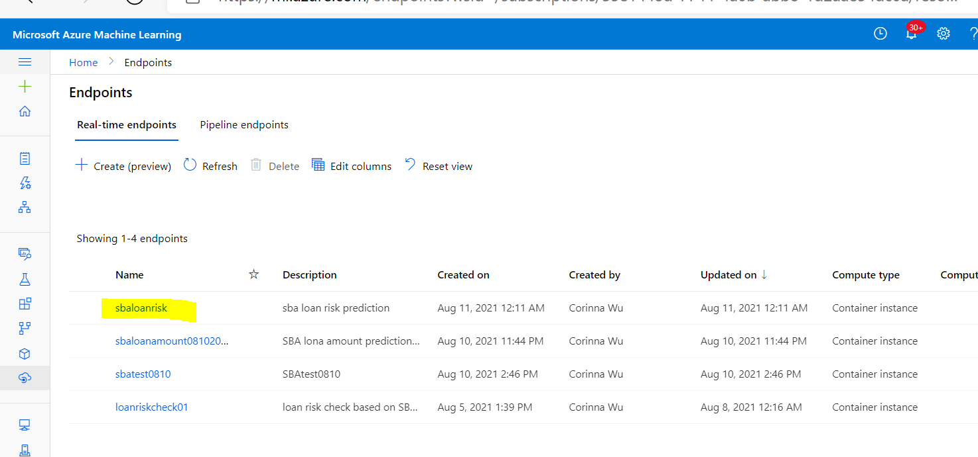

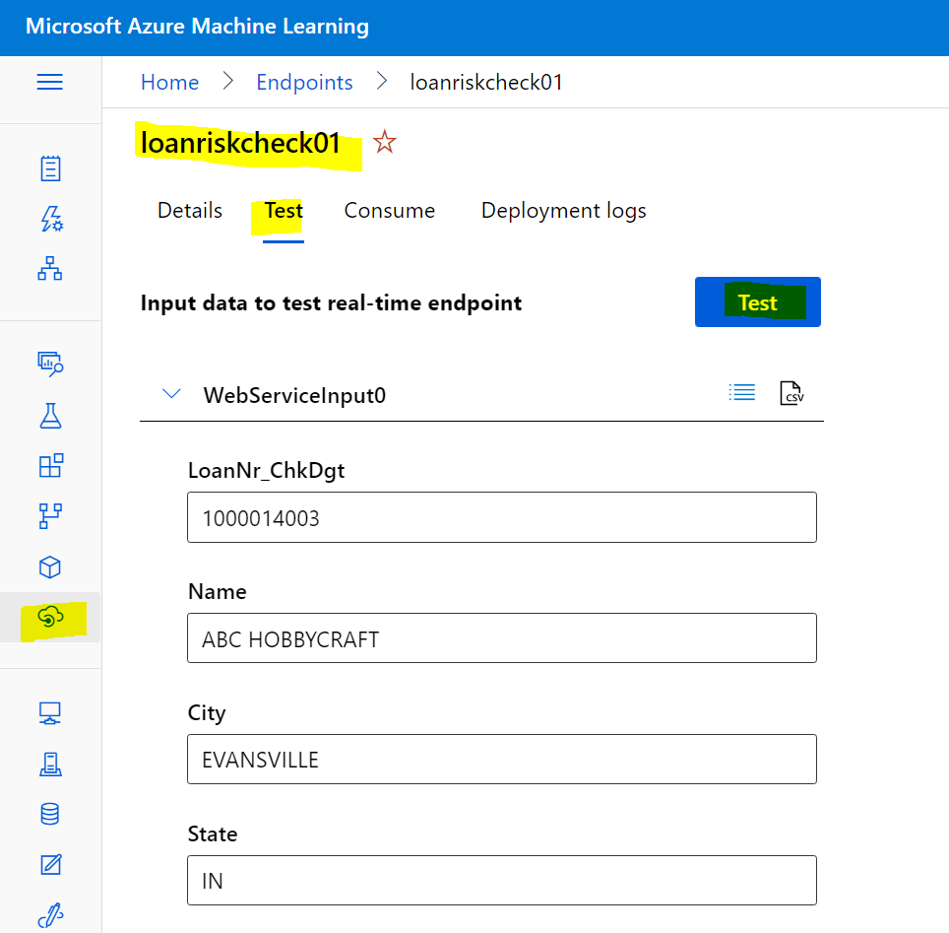

API call information:

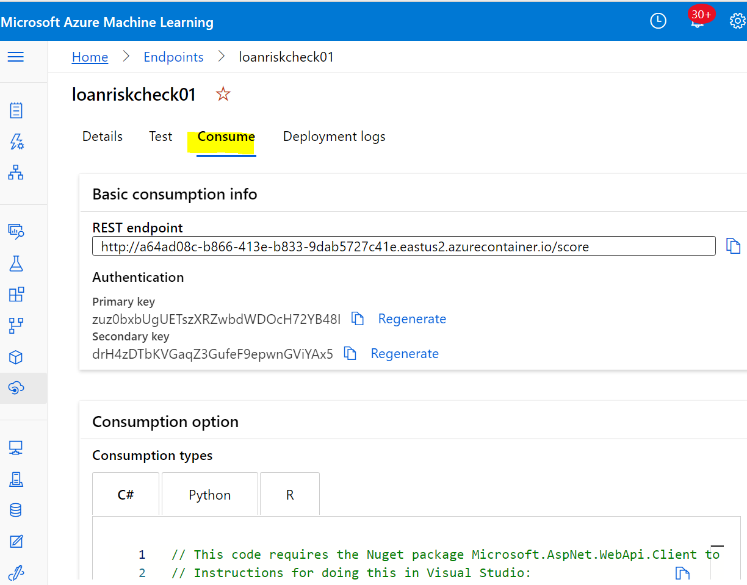

2) SBA loan amount prediction

Use similar way to deploy the SBA loan amount prediction real time pipeline:

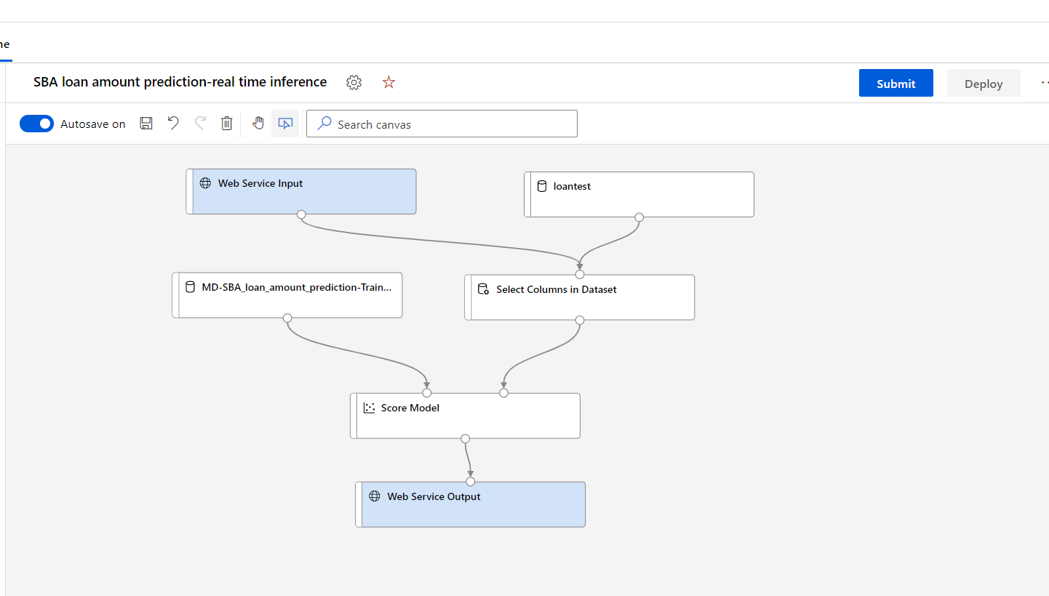

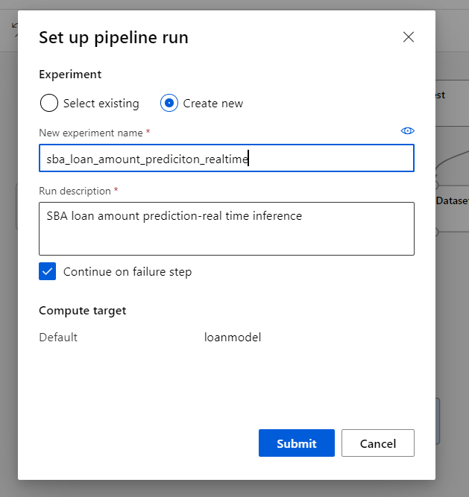

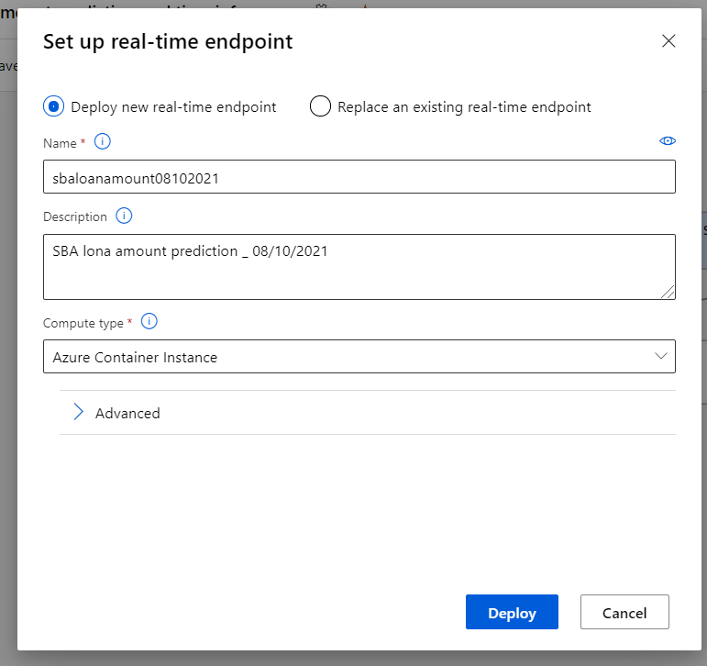

After job complete, go to the Endpoint to test the real time model:

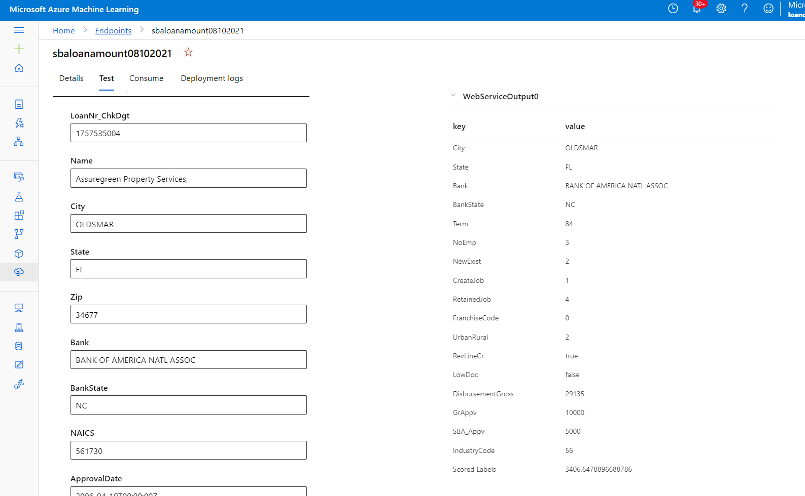

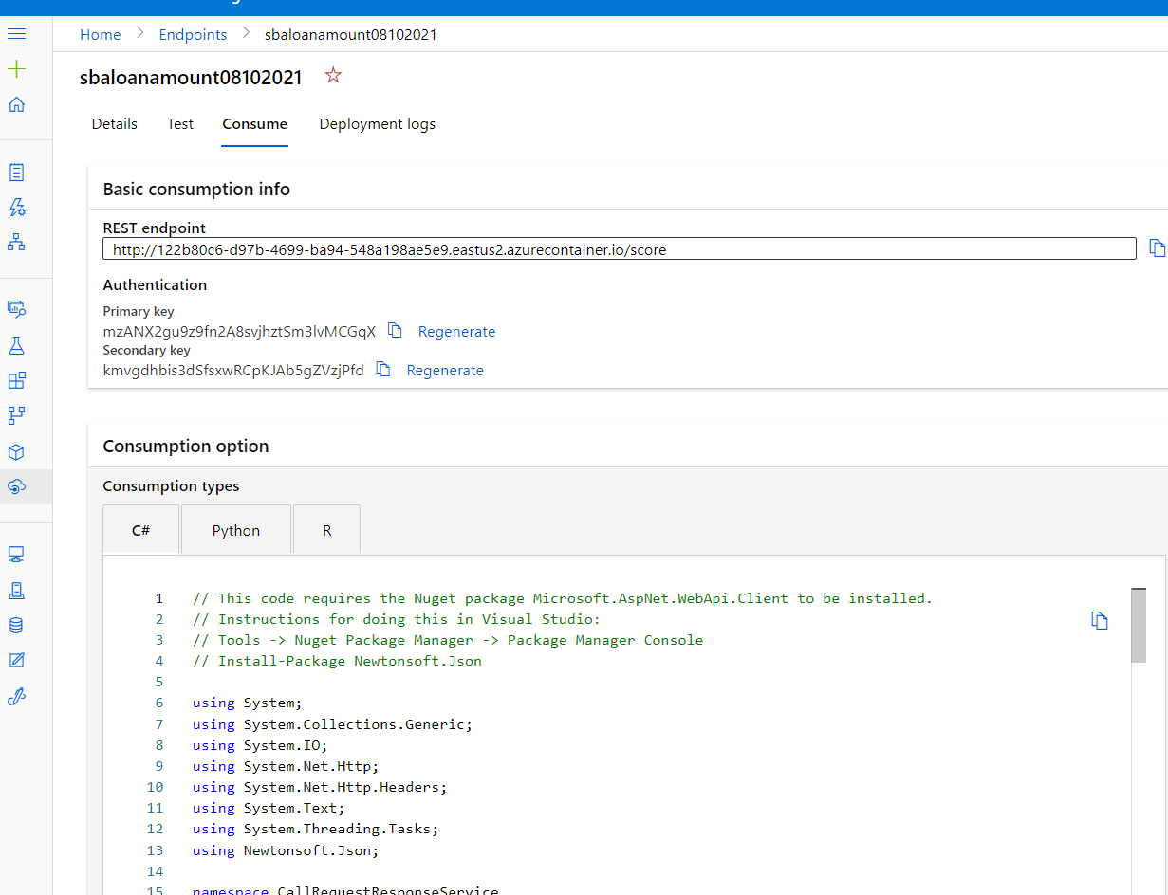

### ** Optional: link Azure Synapse to ML for Auto ML Process

#### Link Azure Machine Learning to Synapse

Go to Azure Active Directory and click App Registrations

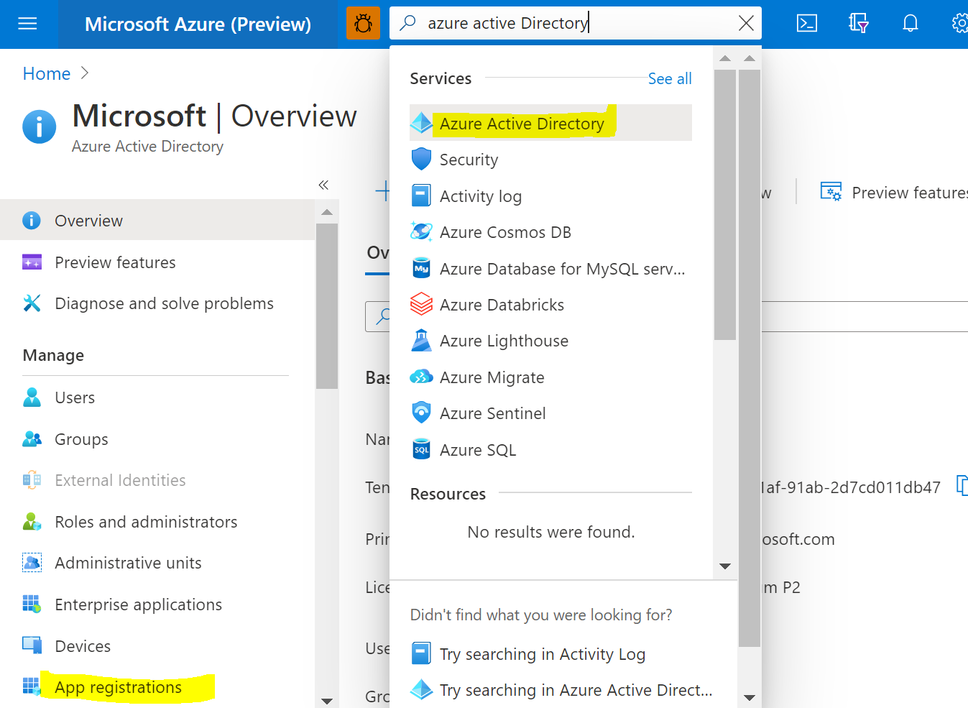

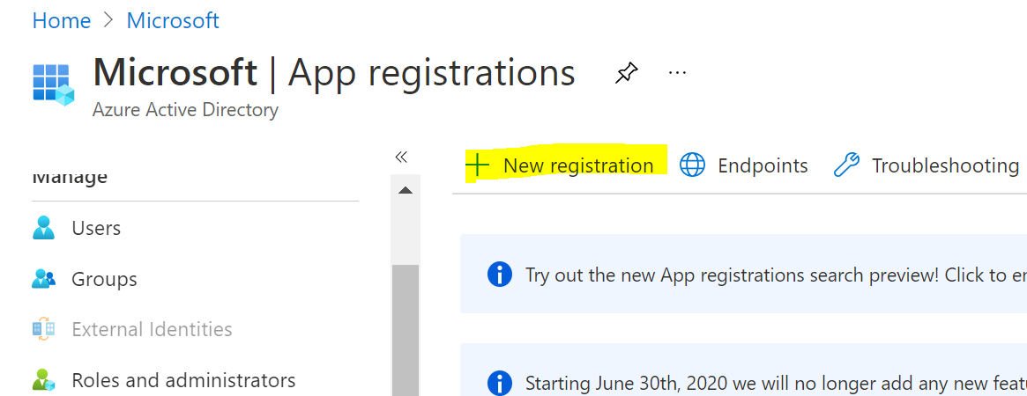

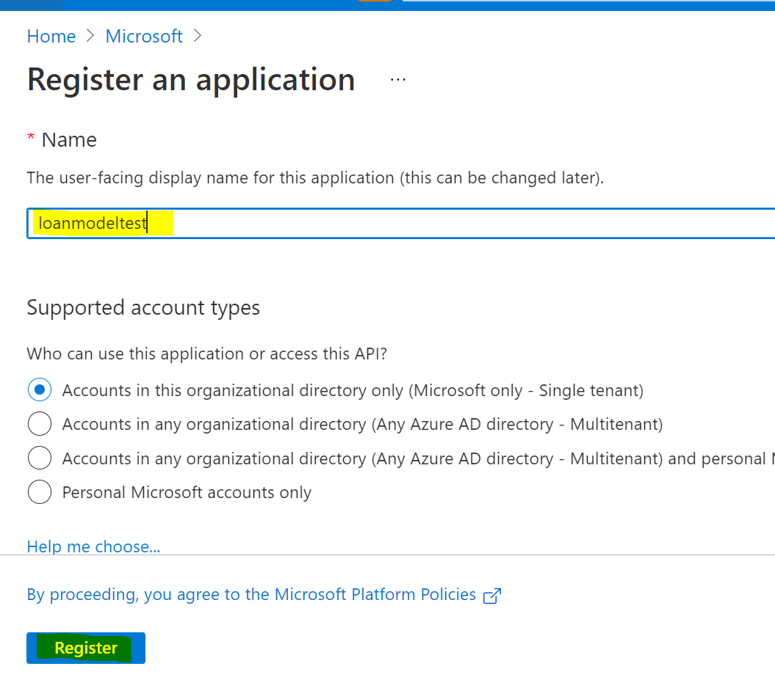

Copy the Application ID, then click Client credentials: add a certificate or secret

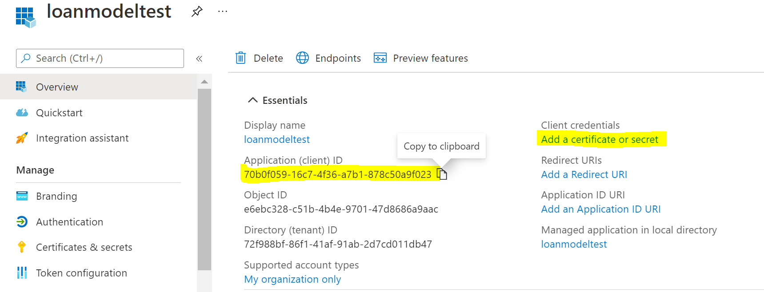

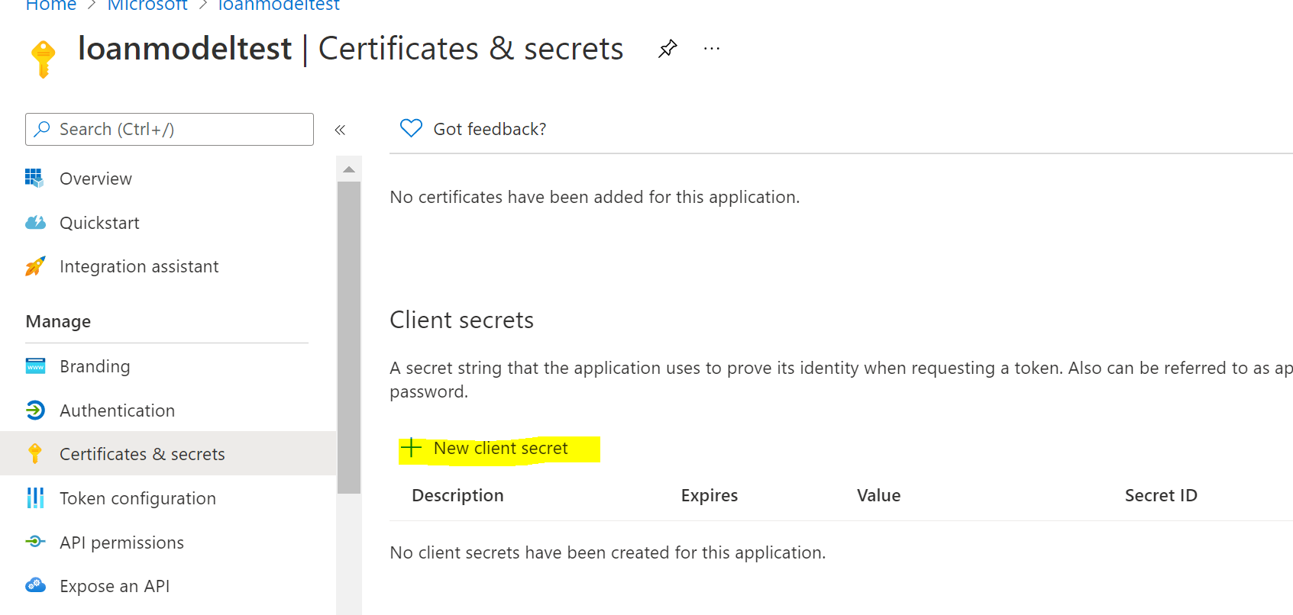

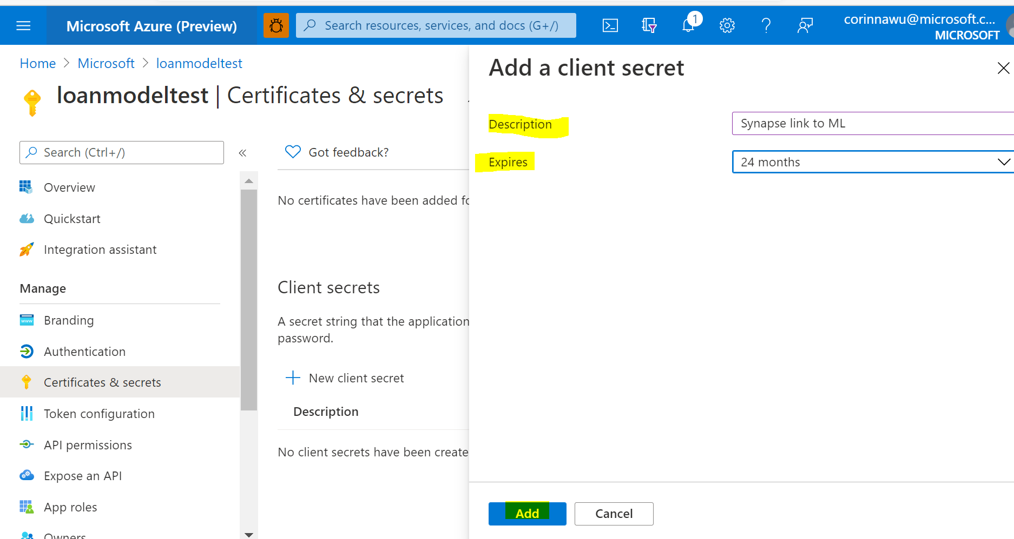

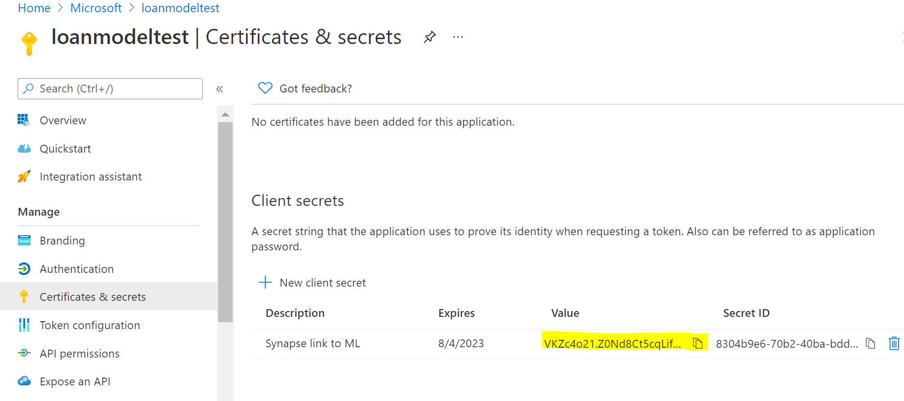

Go to Machine Learning:

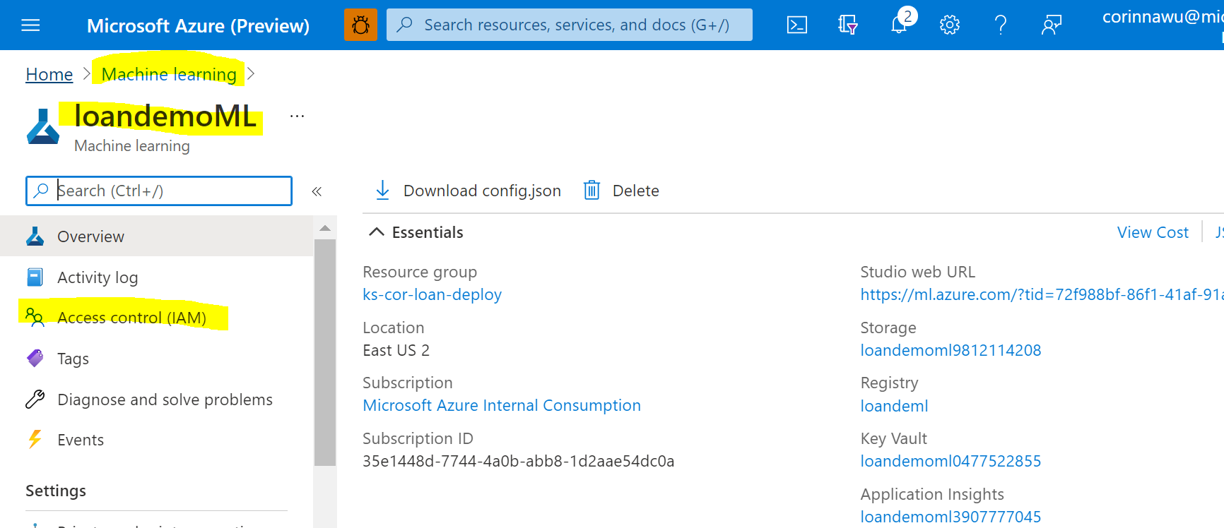

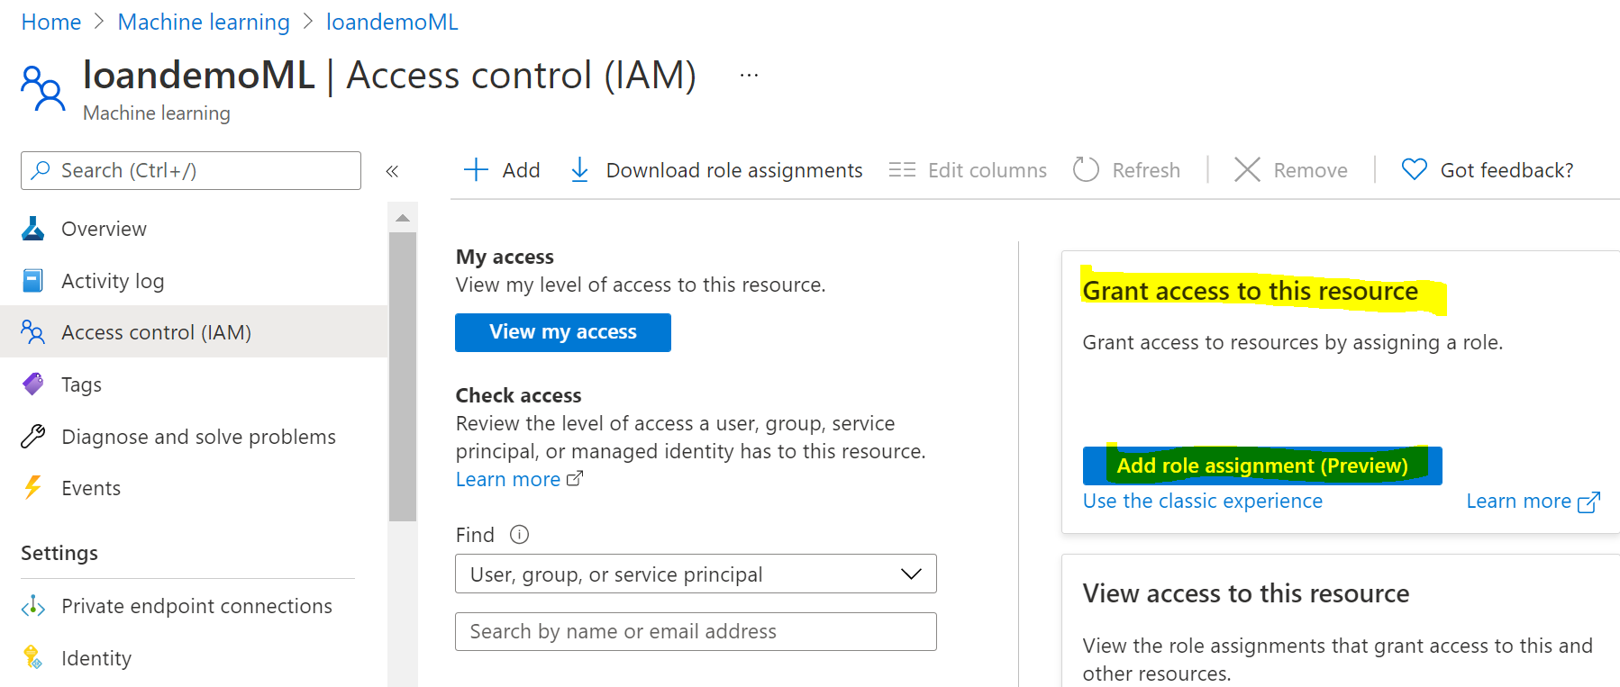

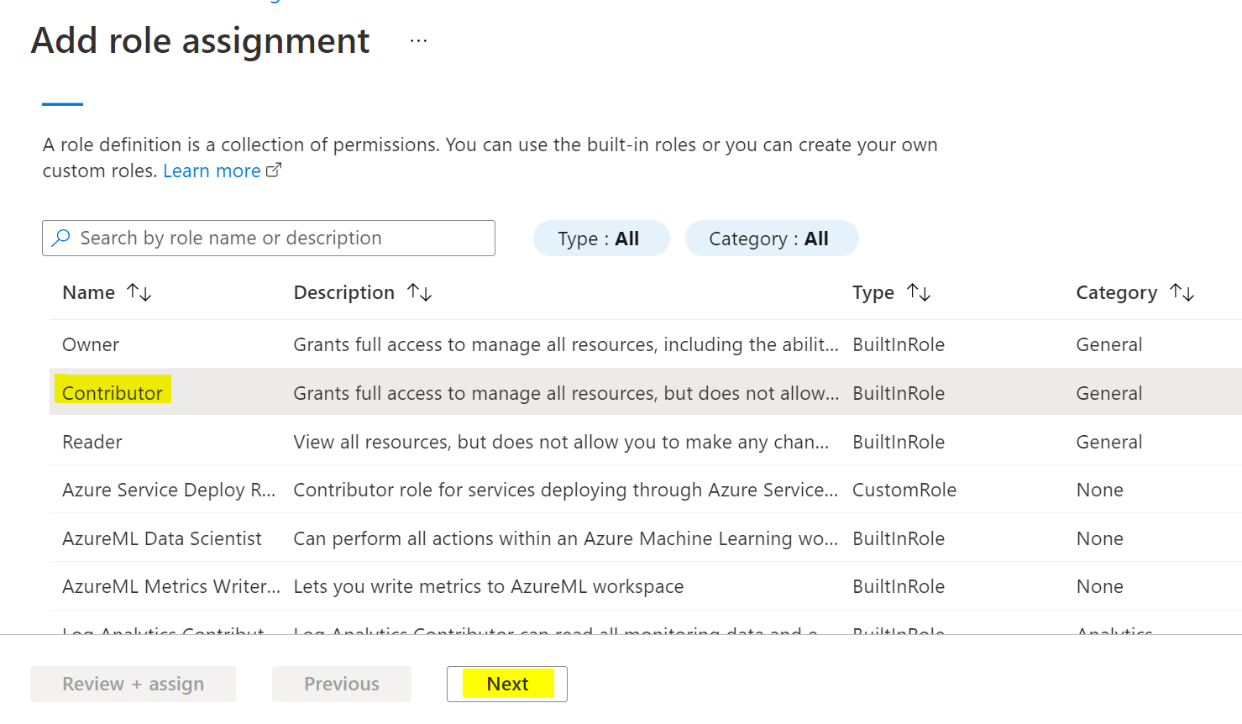

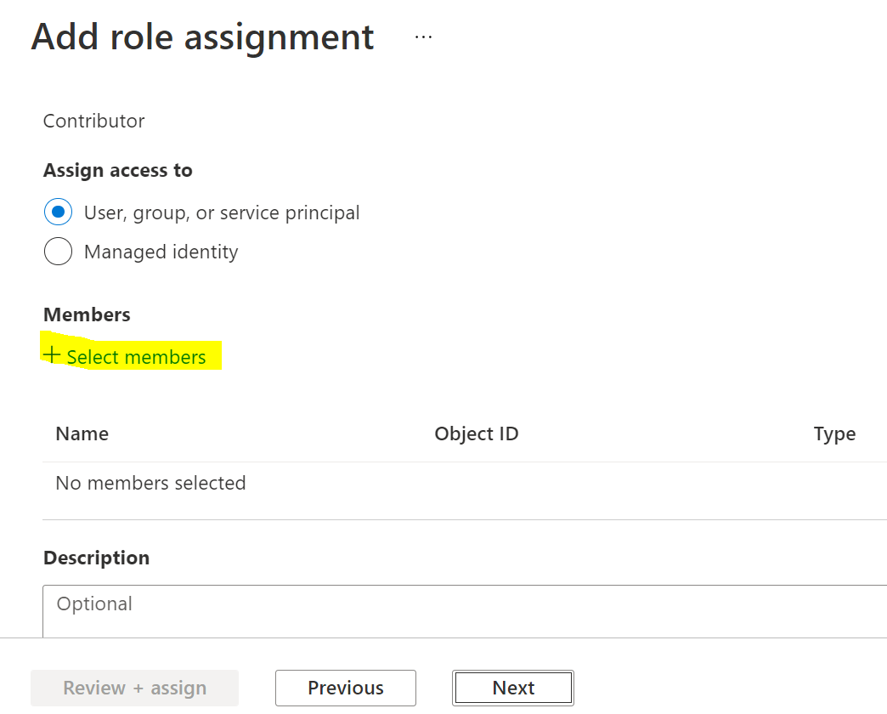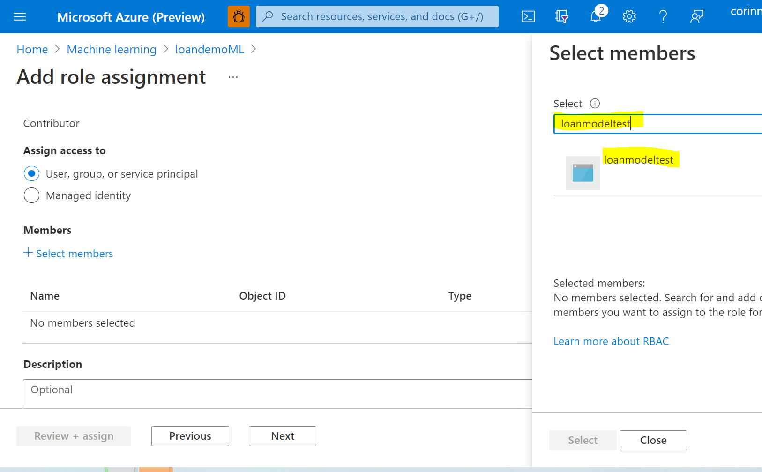

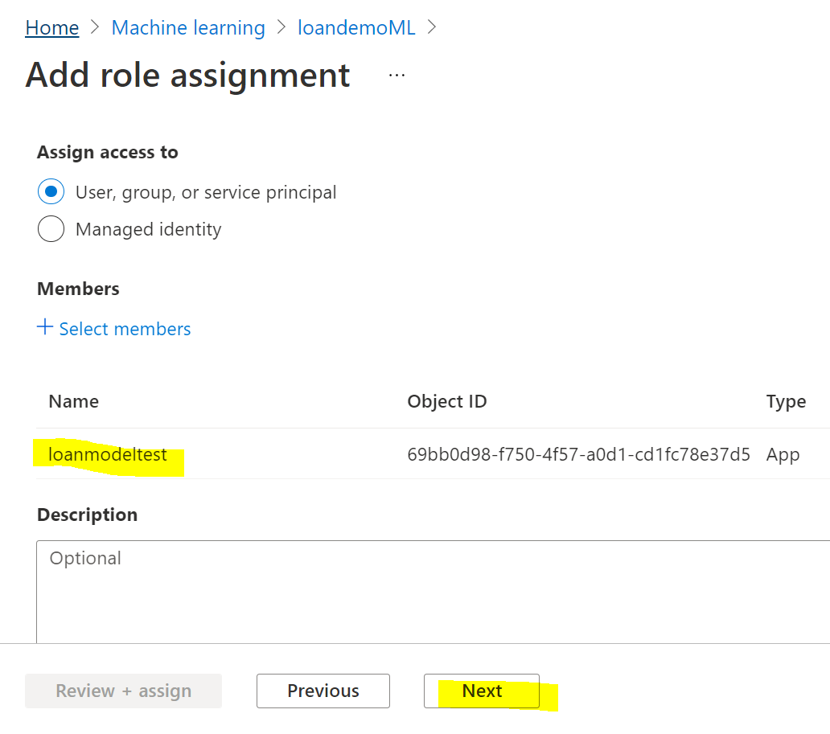

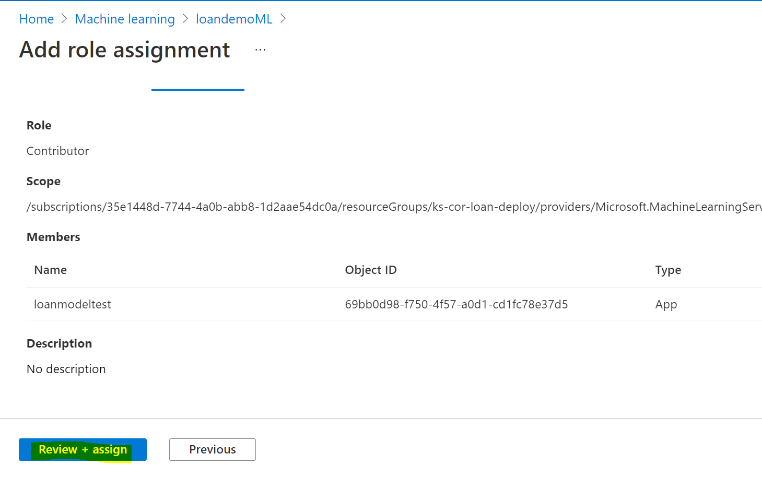

Go to Synapse

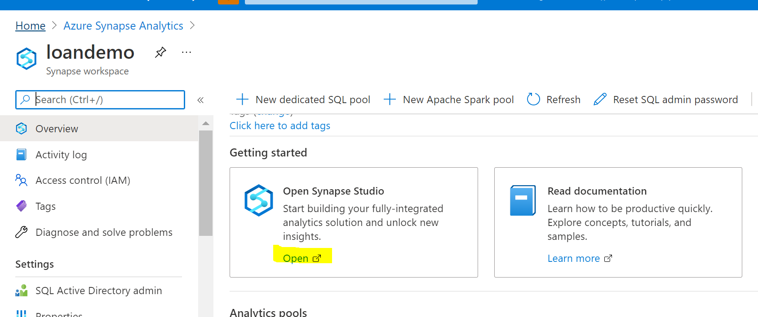

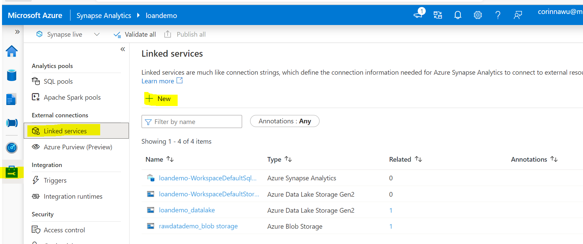

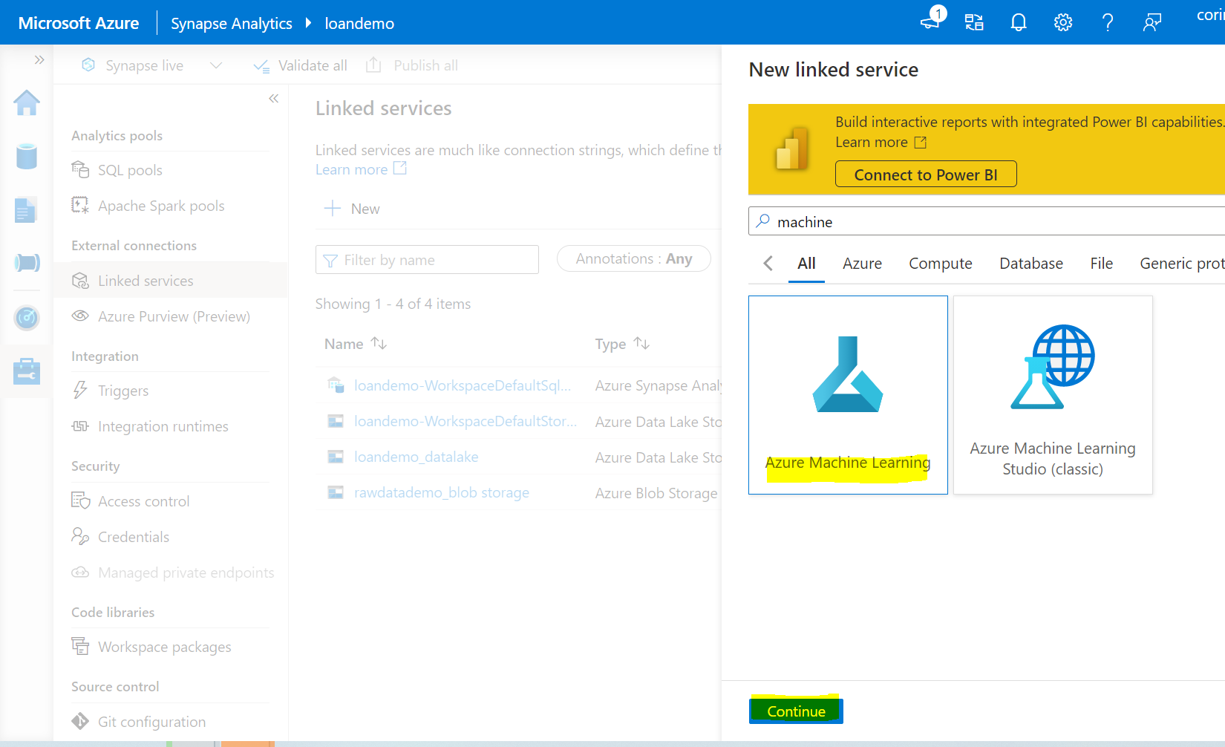

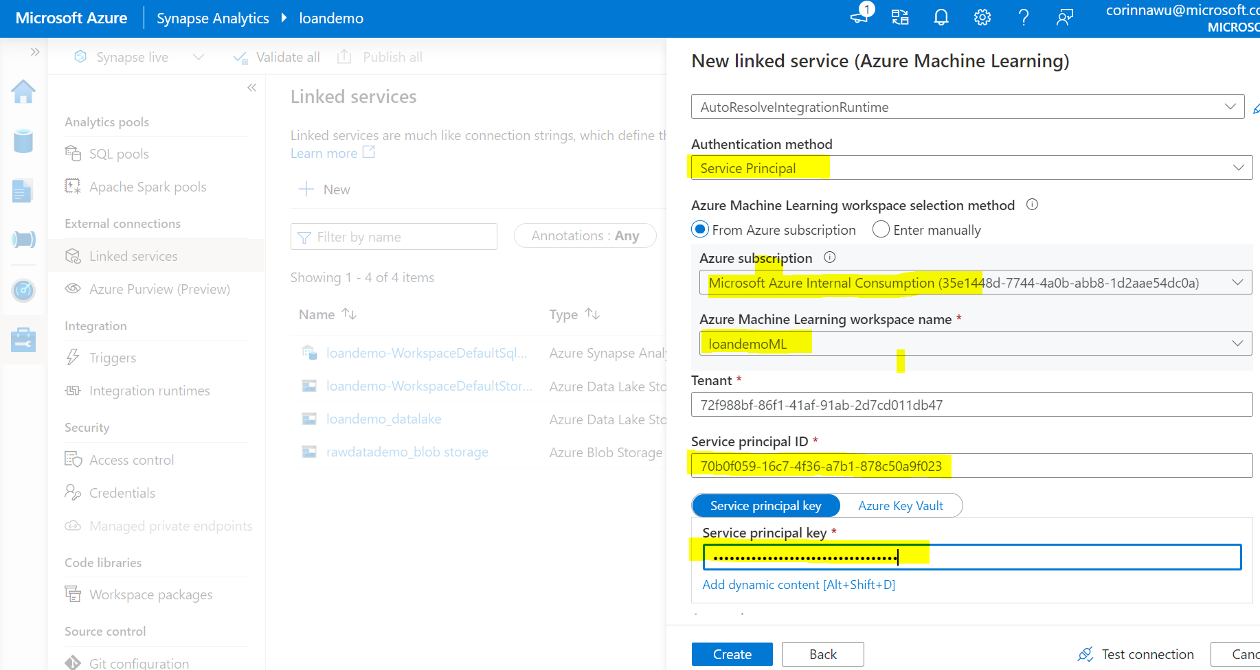

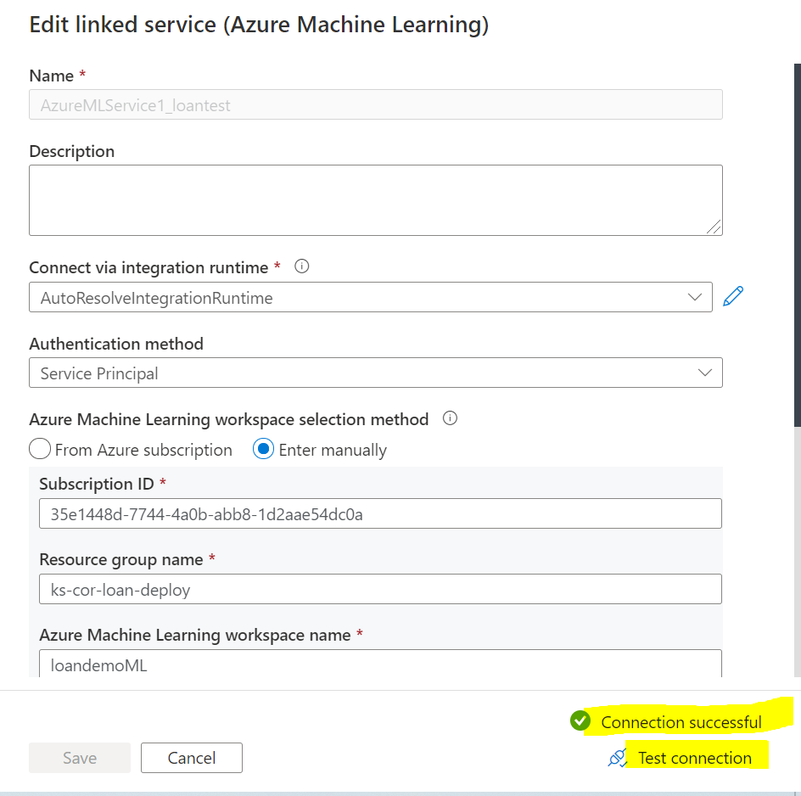

#### Link Synapse Spark Pool to Azure Machine Learning

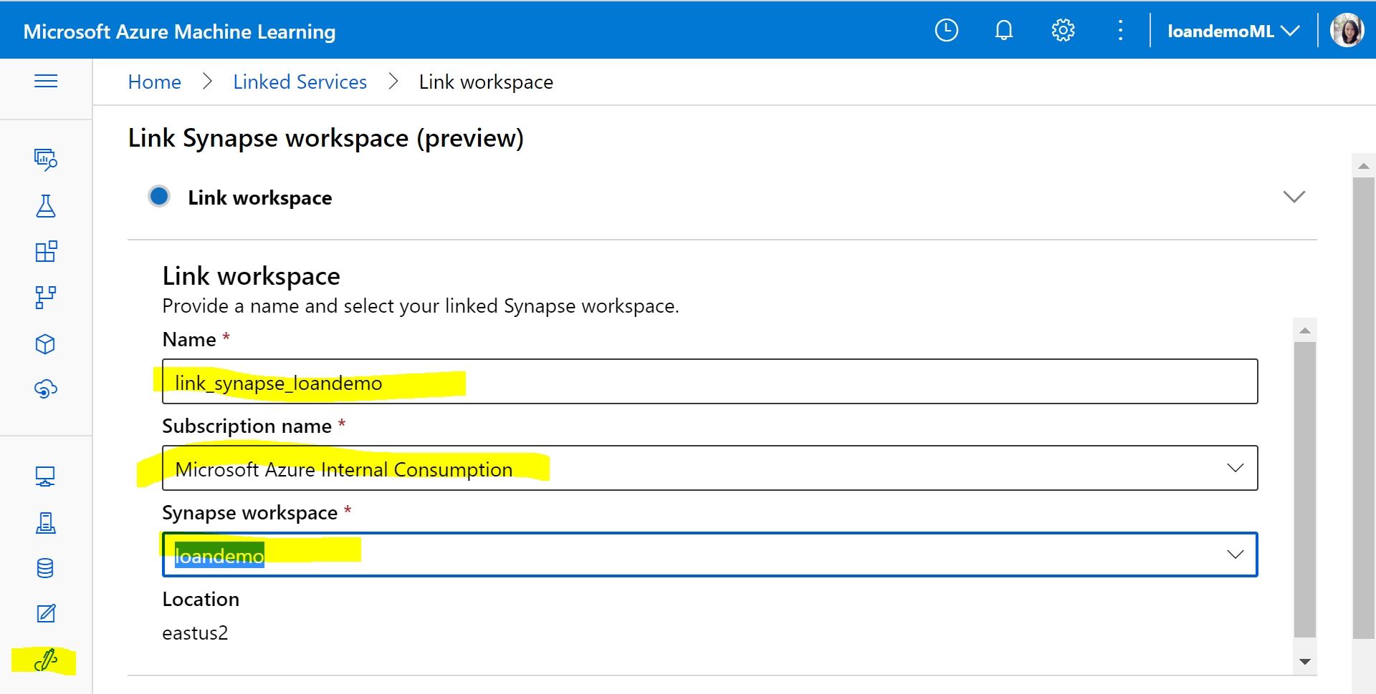

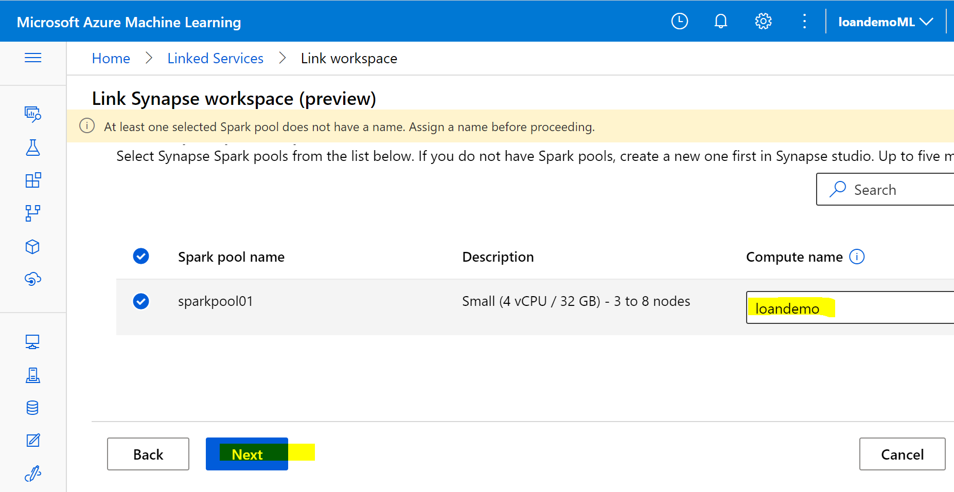

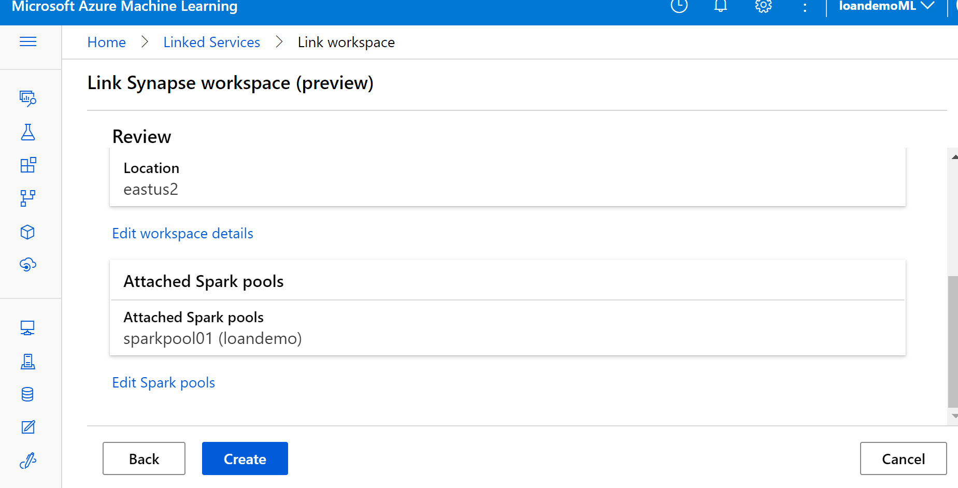

#### Deploy Auto Machine Learning Model

Launch to Synapse Studio

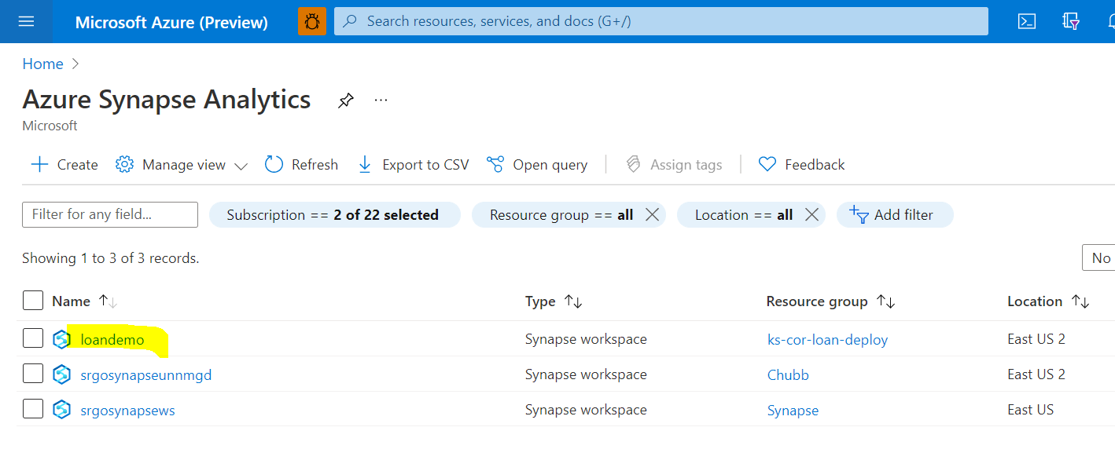

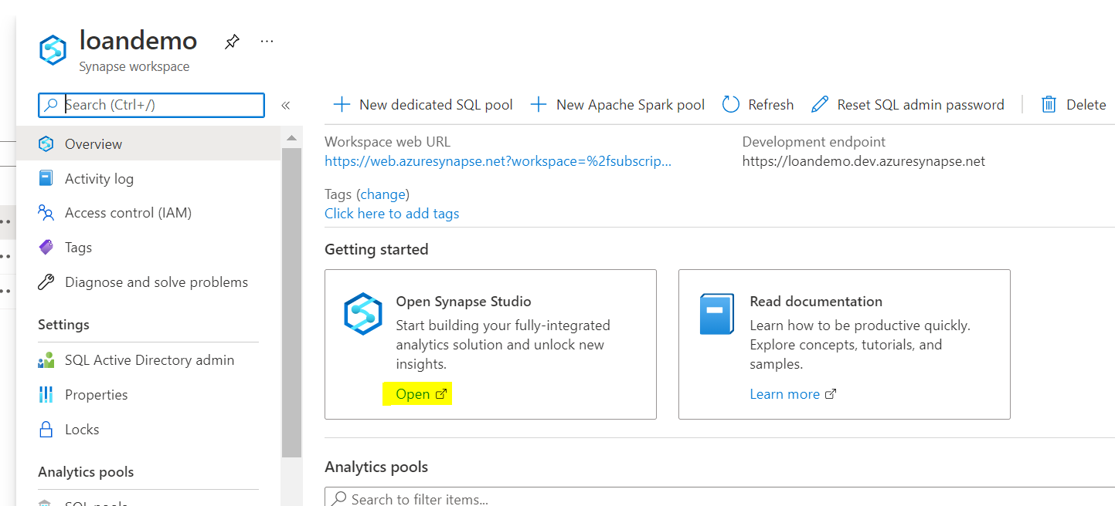

Go to Data, find table we created: sbahistory, Train a new model:

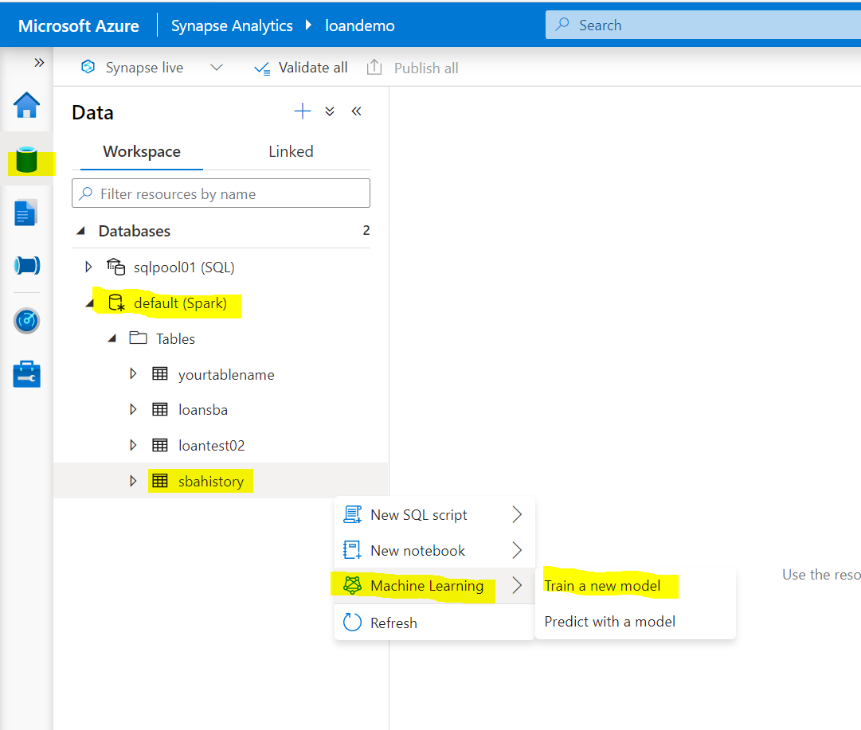

Schedule the job to train the model

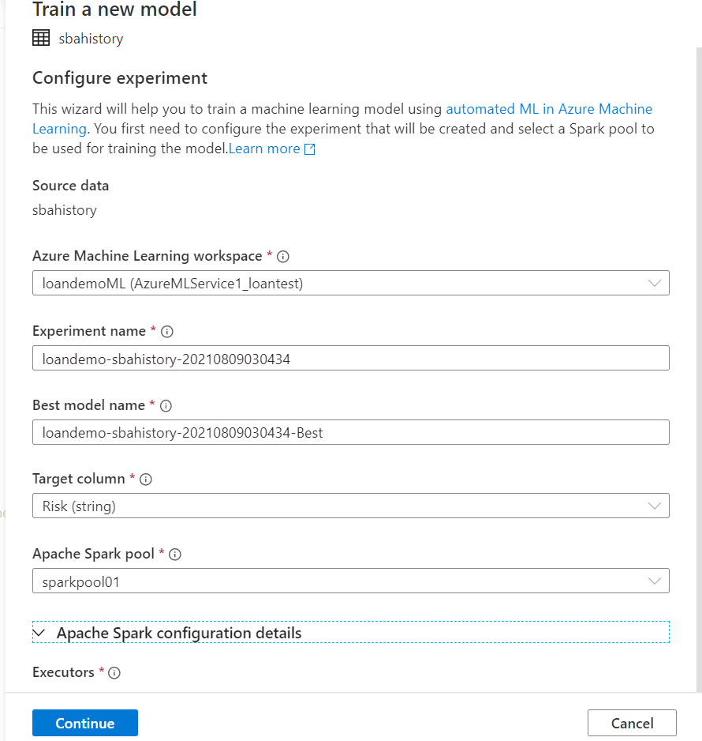

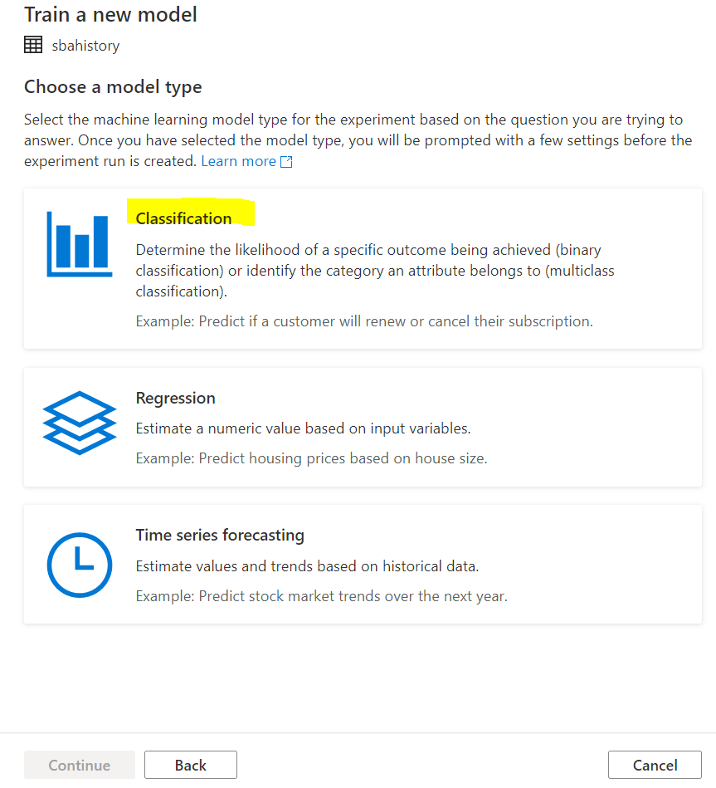

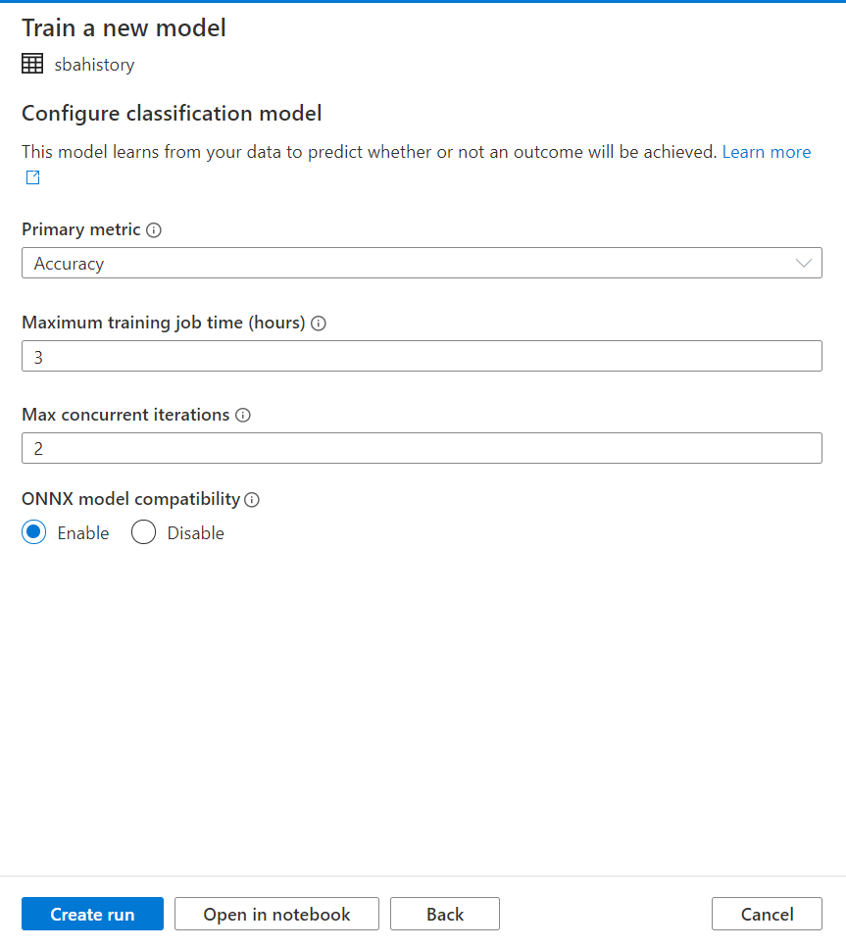

Additionally, you can also link to Azure Cognitive Services to use ML service

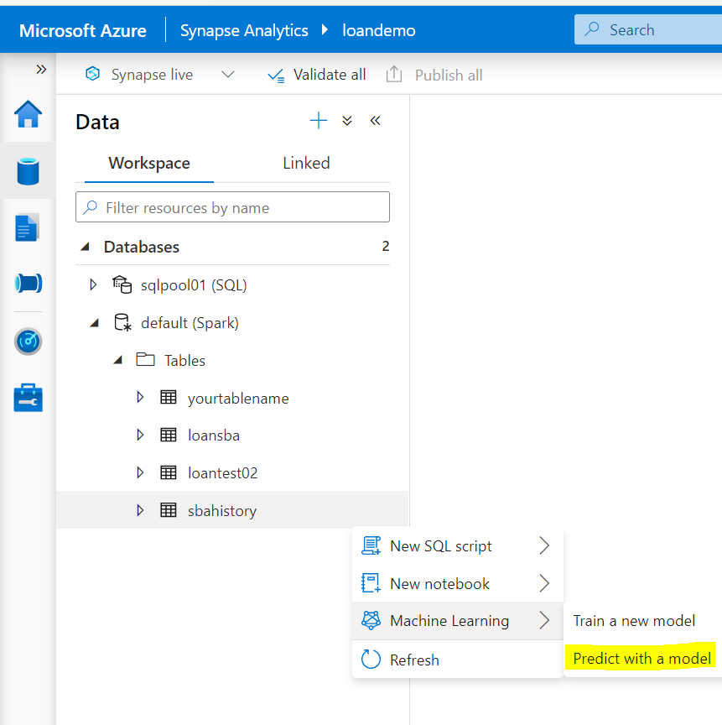

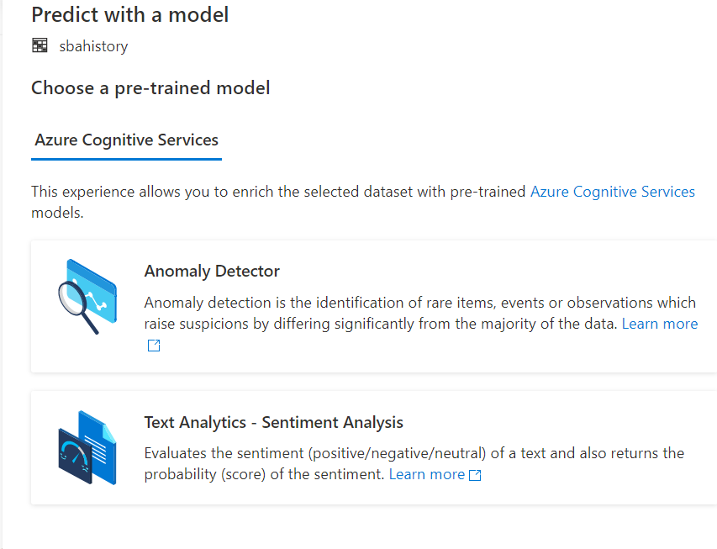

Try to create table and load data in SQL Pool and see more choice of auto ML.